Vendor Management (5 Sections Listed Below)
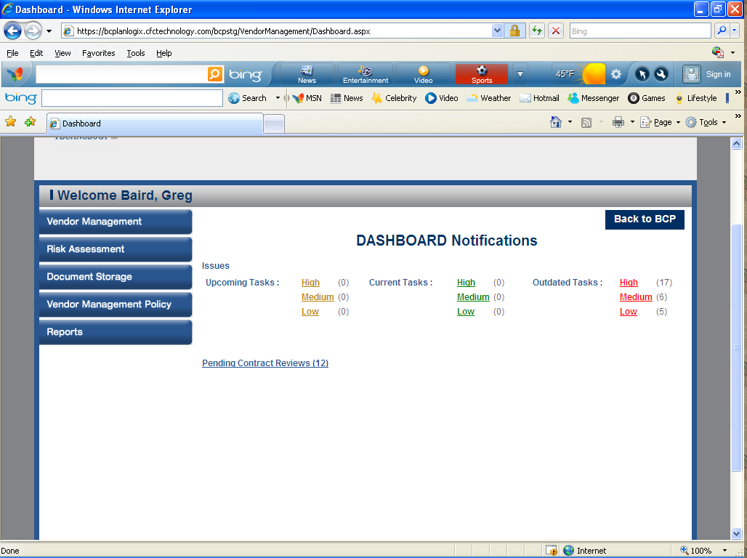

- Vendor Management (5 Sub Sections Listed Below)
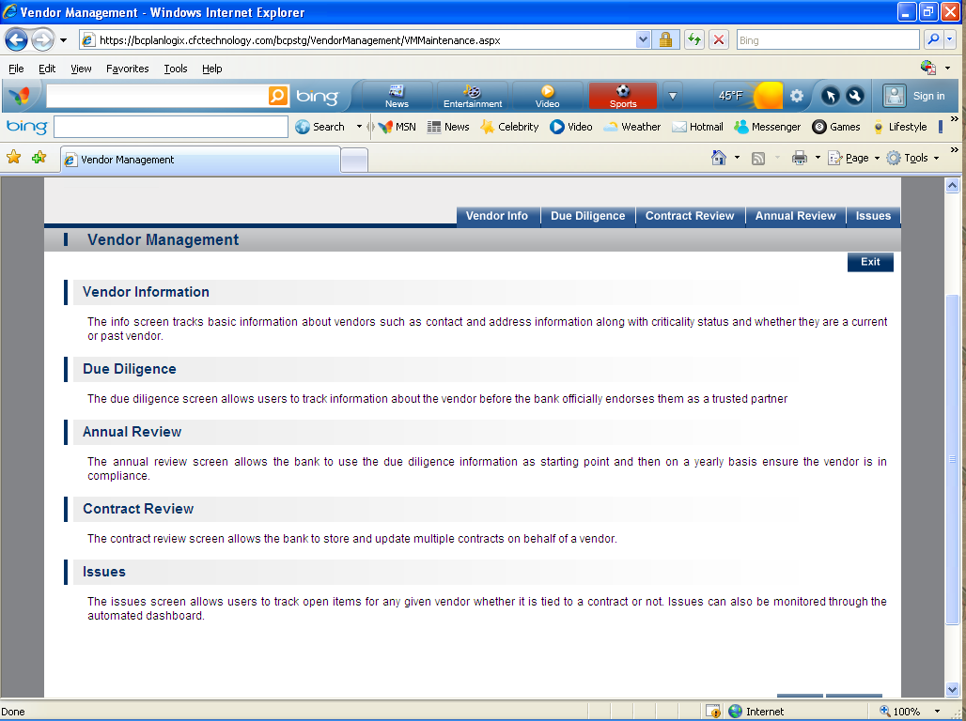

  - Vendor Information- The info screen tracks basic information about vendors such as contact and address information along with criticality status and whether they are a current or past vendor.
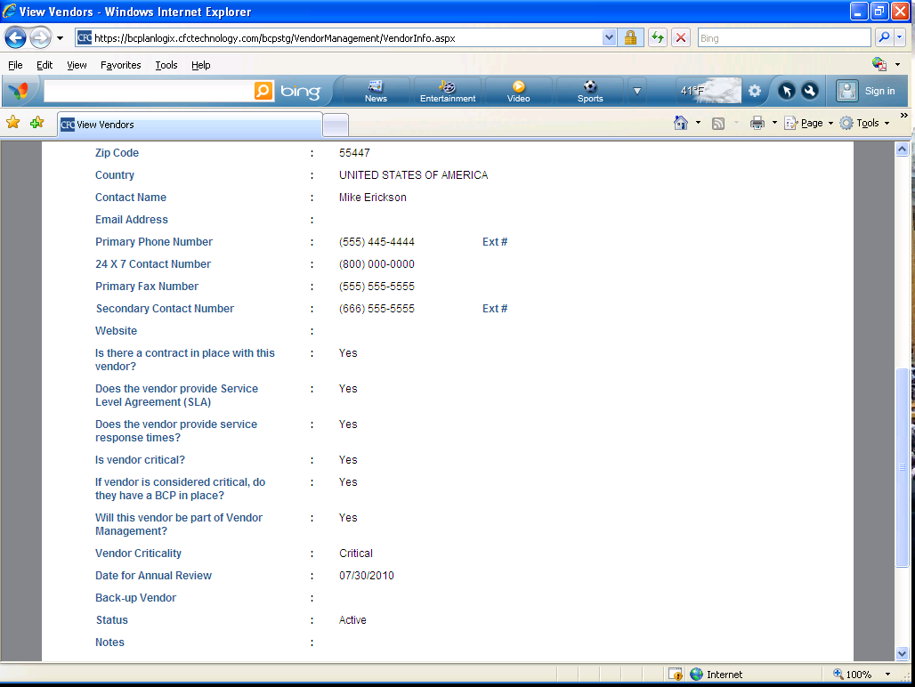

  - Due Diligence
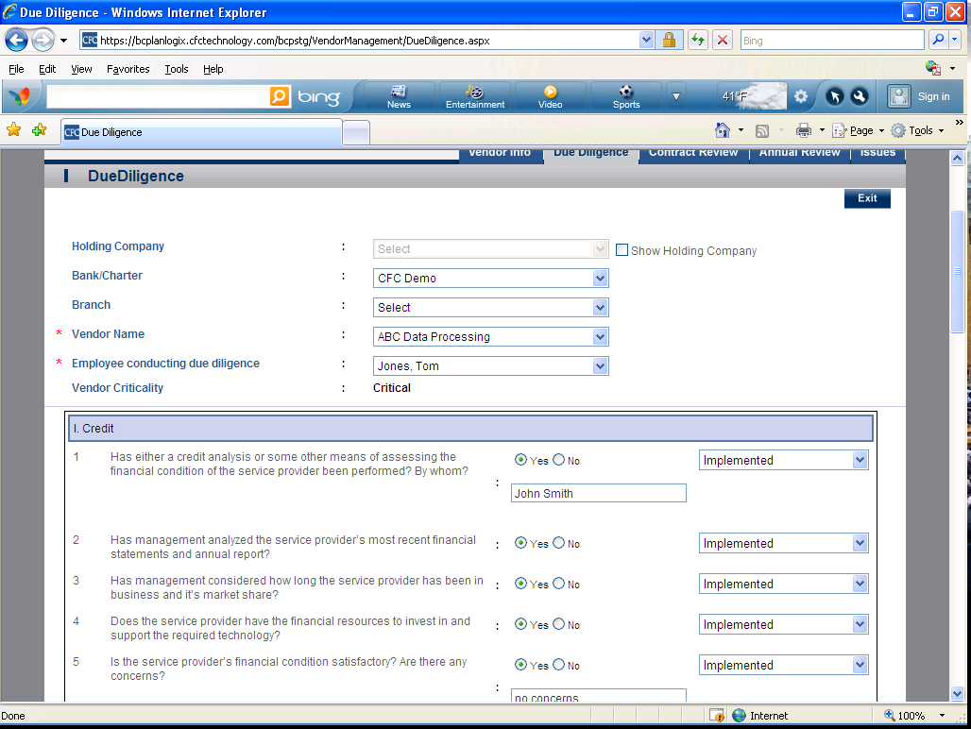

  - Annual Review
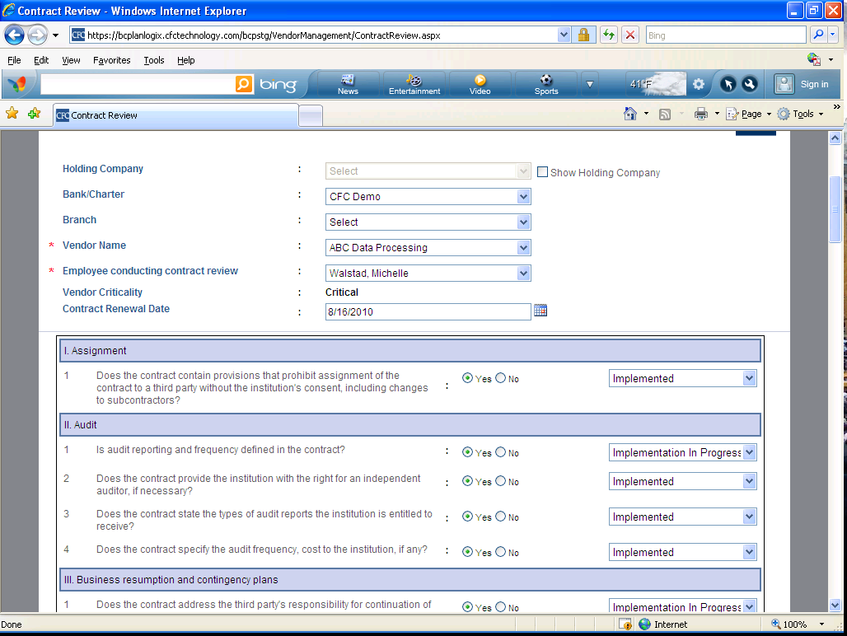

  - Contract Review
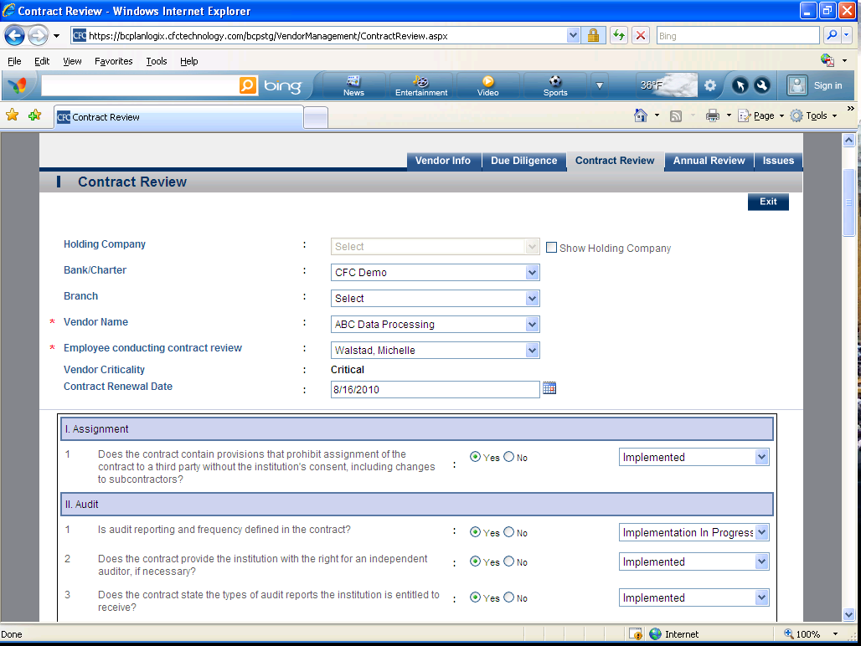

  - Issues
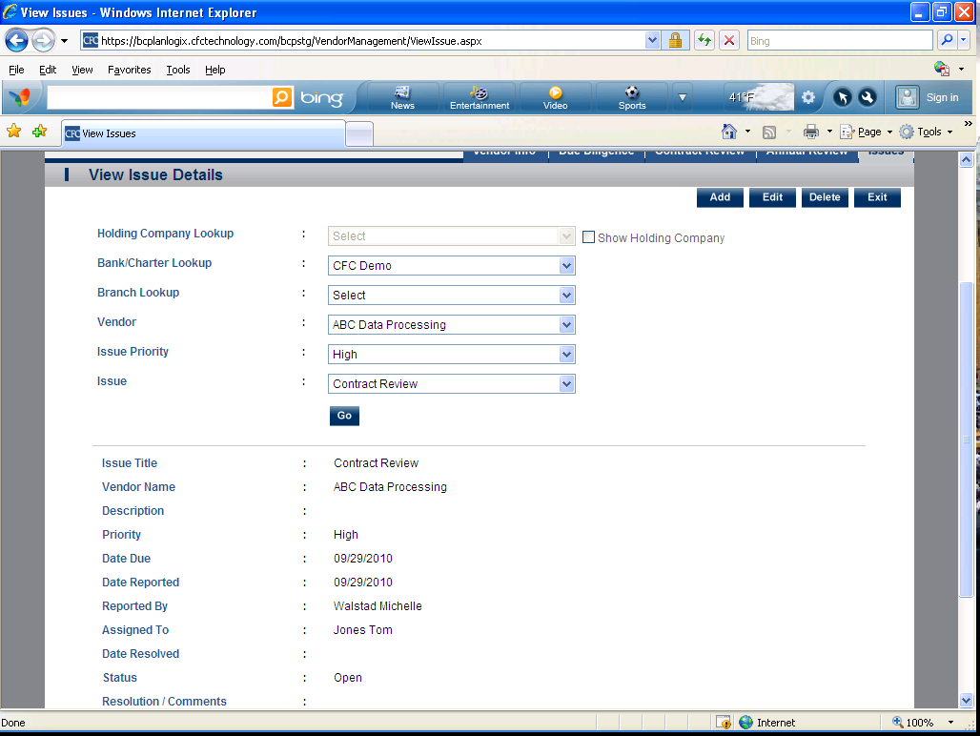
- Risk Assessment-This section describes the type and risk associated with this vendor.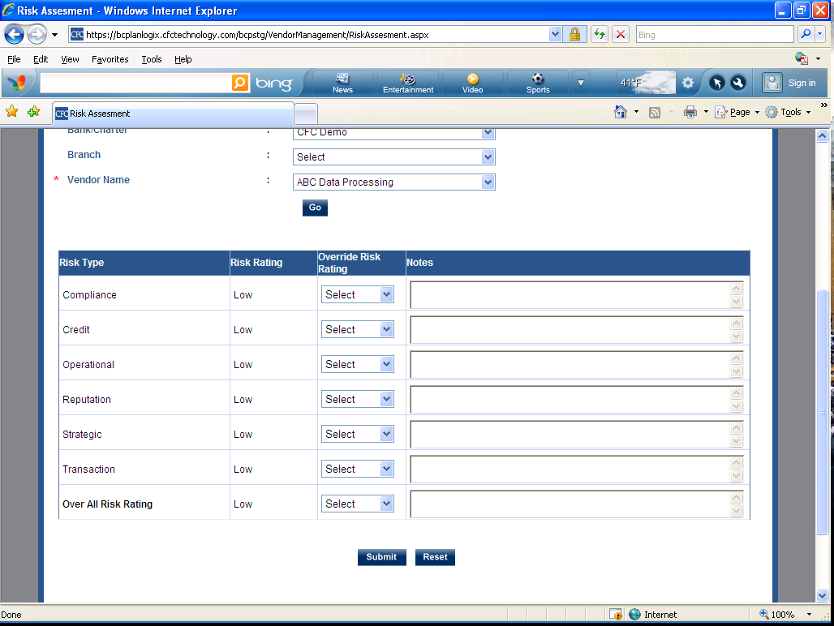

- Document Storage- This section allows you to upload and download the documents associated with this vendor.
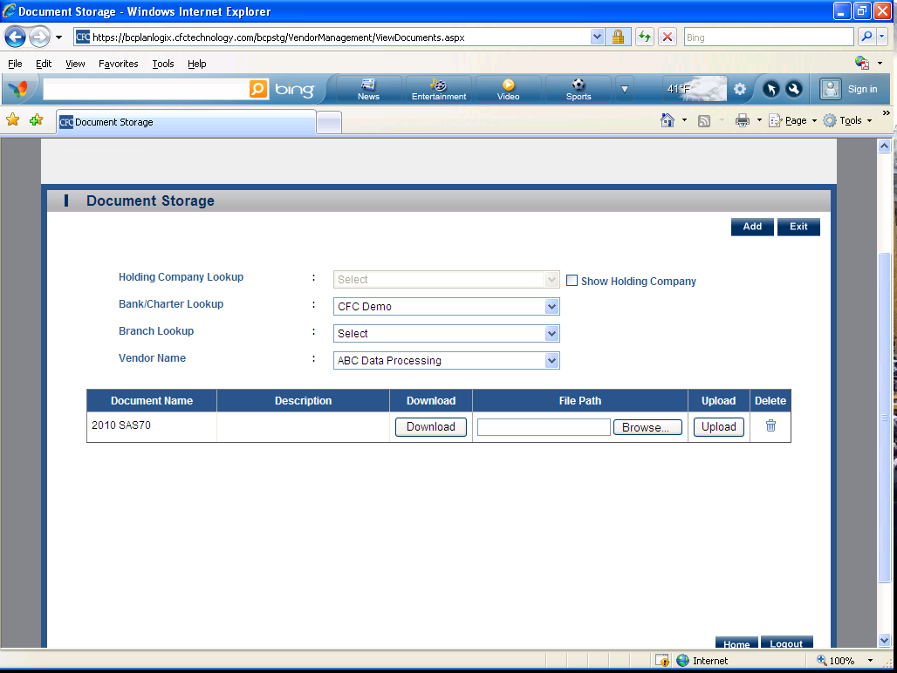
- Vendor Management Policy (5 Sub Sections Listed Below) 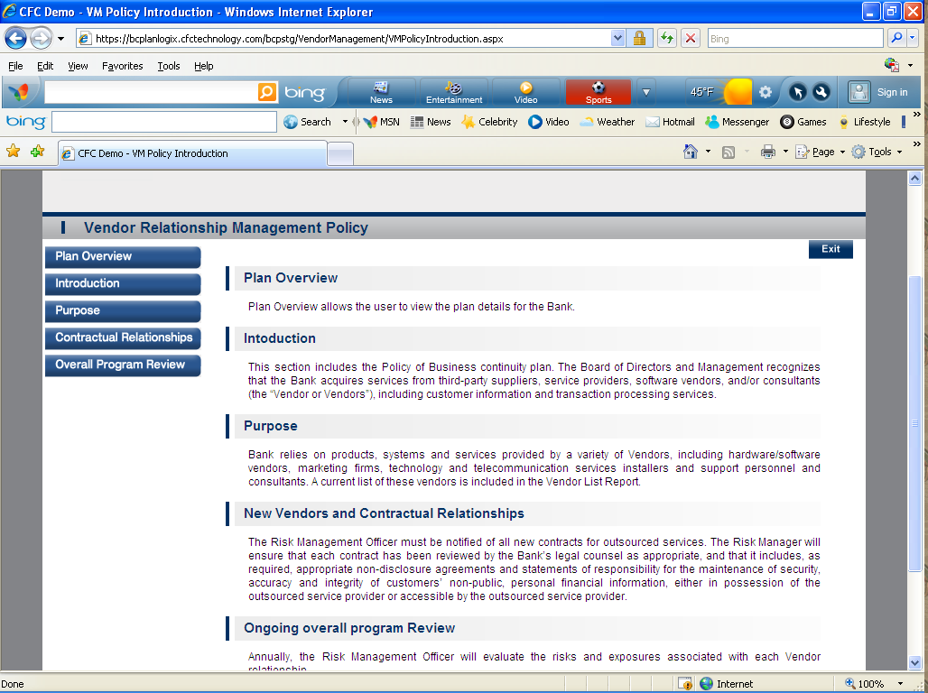

a. Vendor Relationship Management- Plan Overview
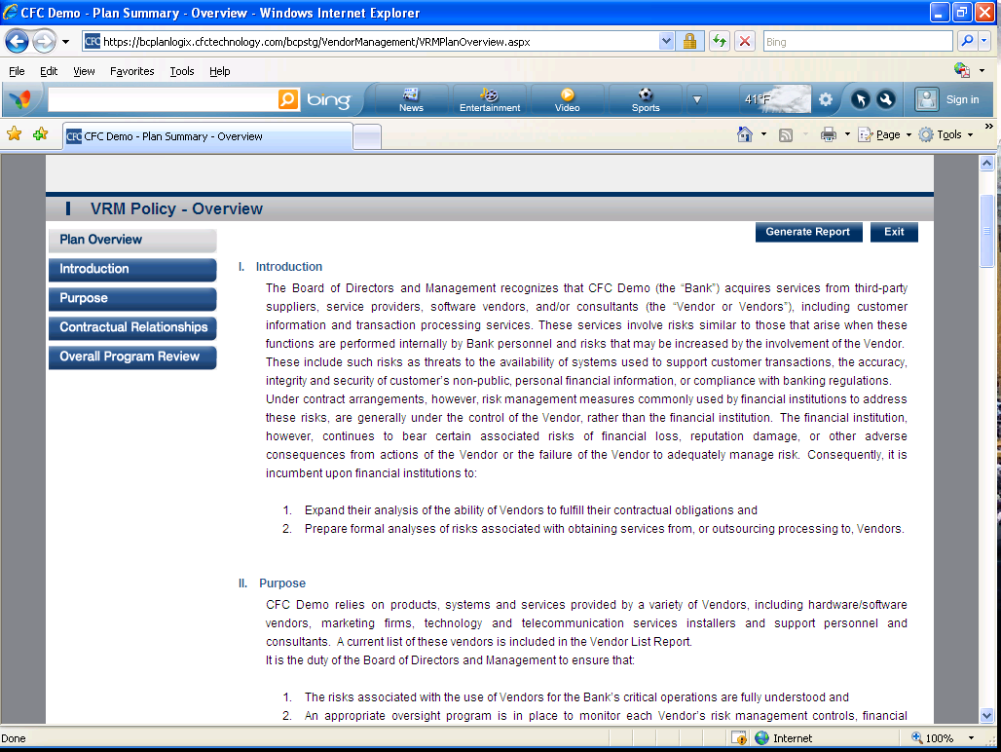

b. Introduction
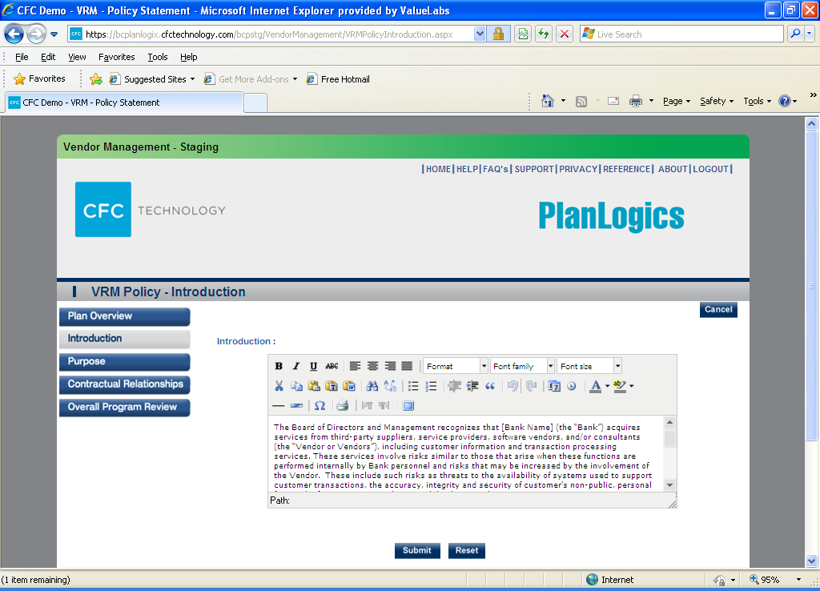

c. Purpose
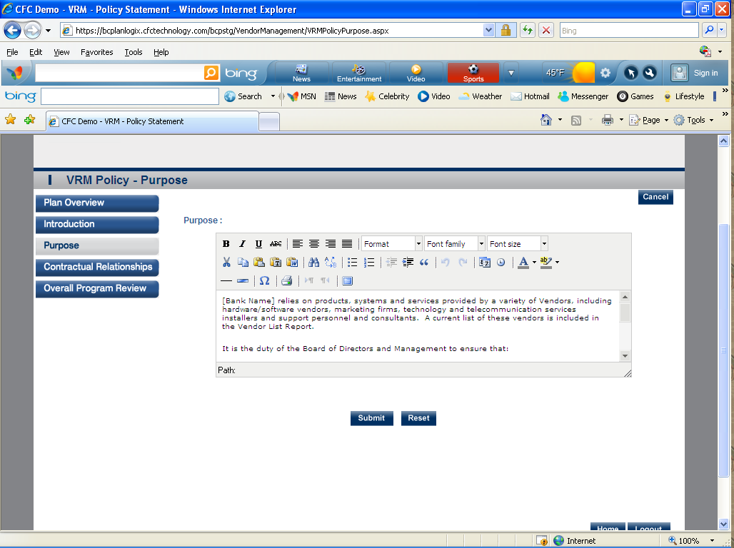

d. Contractual Relationships
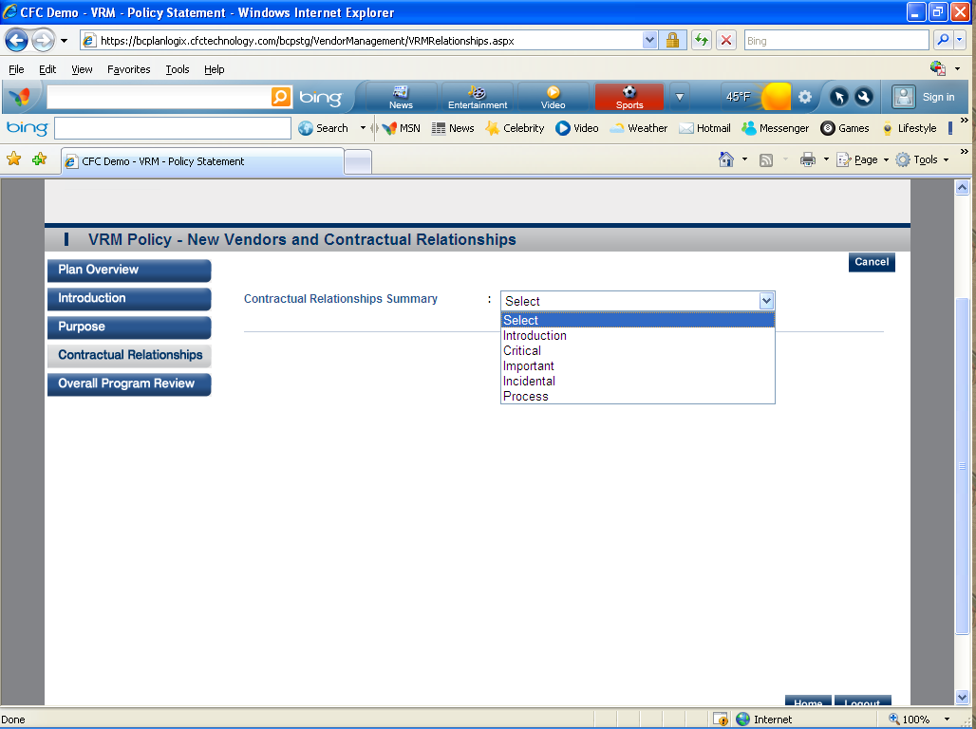

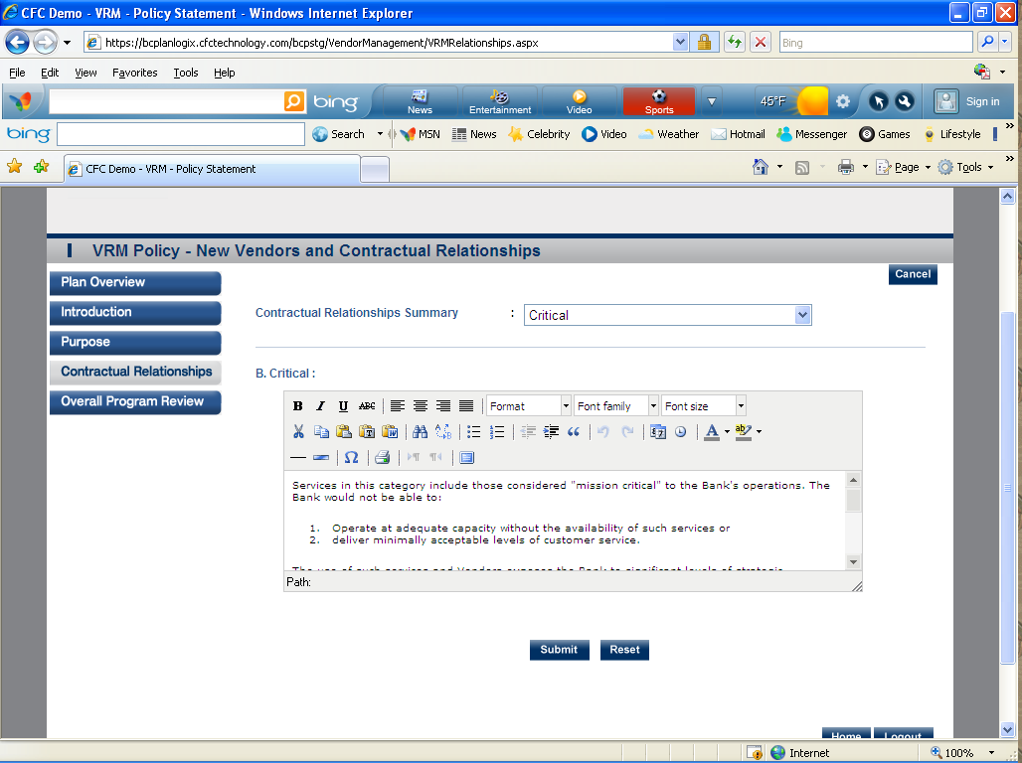

e. Overall Program Review
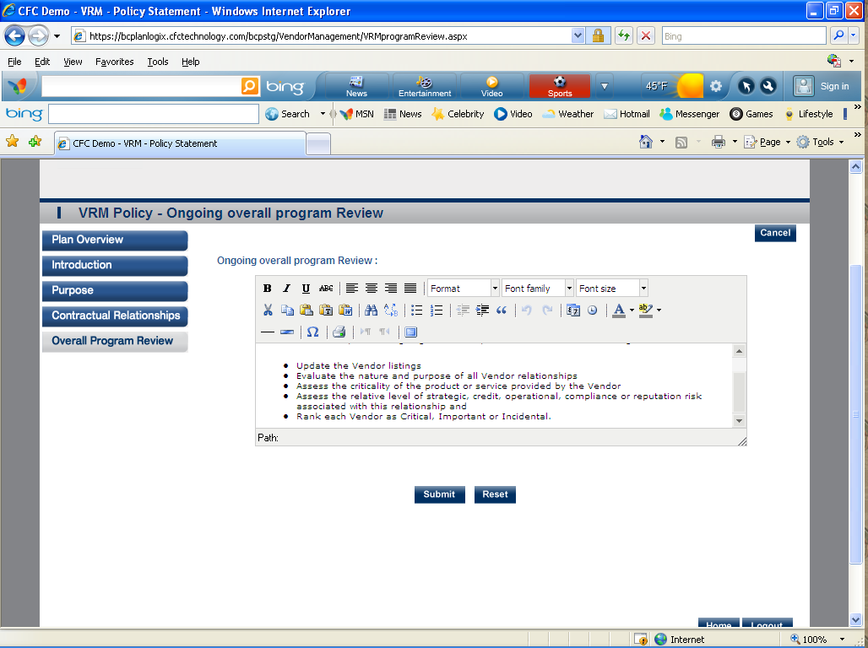

- Reports- Allows you to generate and print reports associated with Vendor Management. 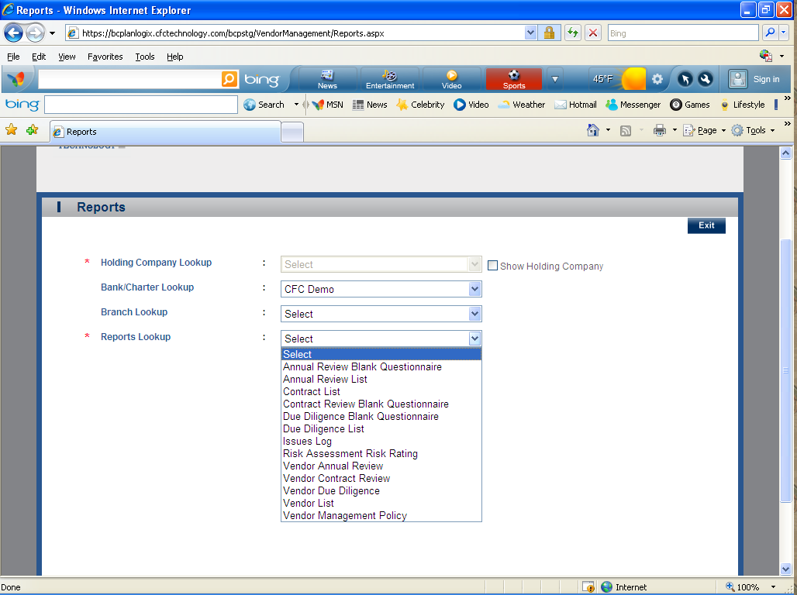

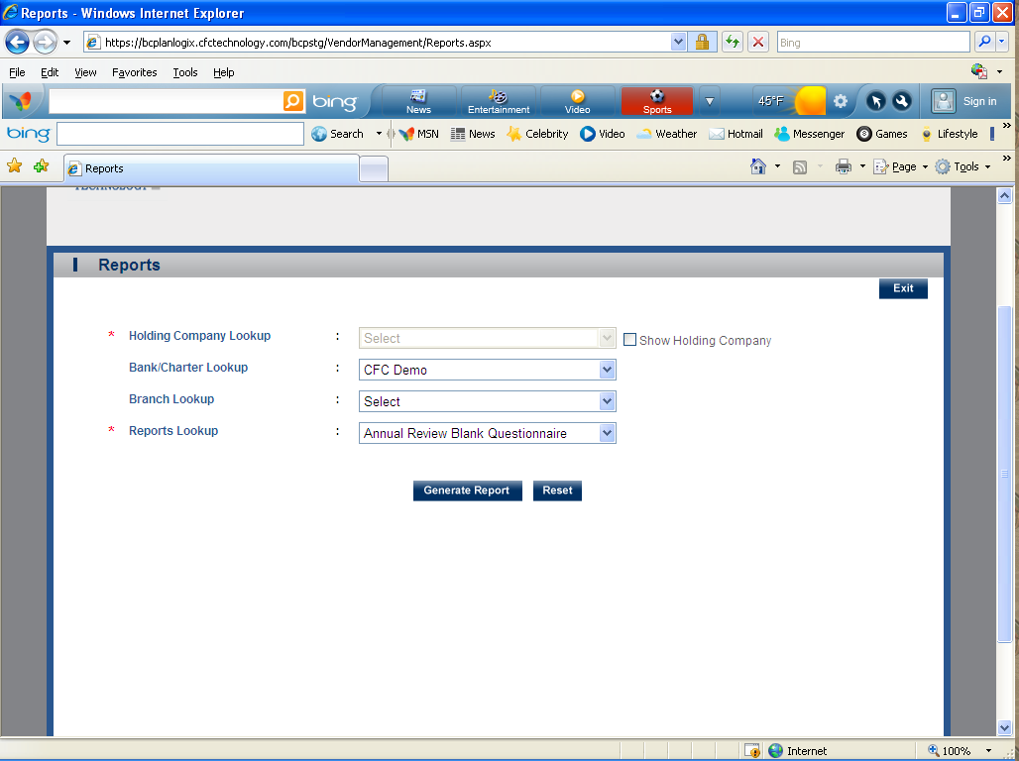

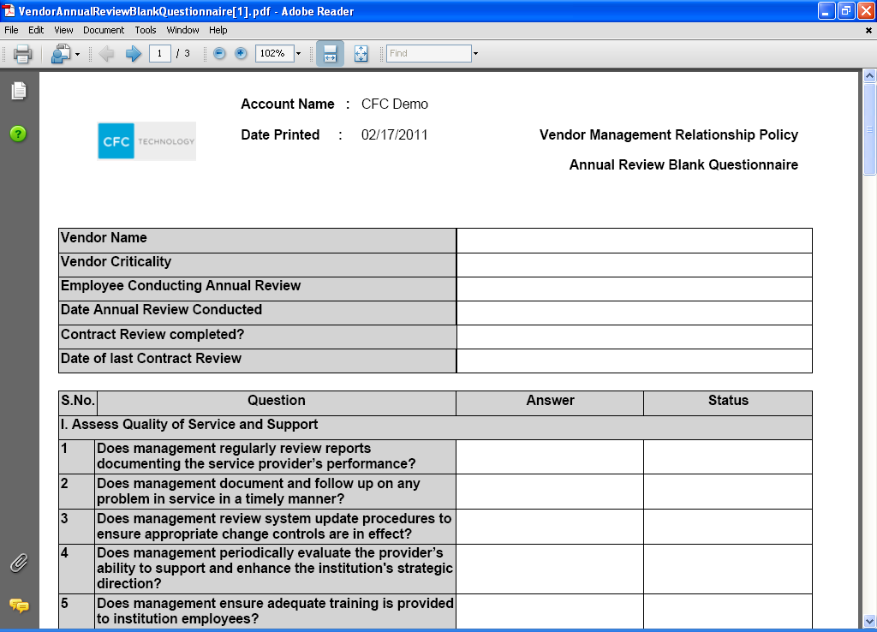

Typical Training Schedule:
1st Training Session - Maintenance, BIA – Risk Assessment, BIA – Business Impact Analysis, CBP (Reports)
2nd Training Session– Plan Summary, Team Plans and Plan Worksheets
3rd Training Session – Pandemic Flu
4th Training Session – Testing and Training
5th Training Session– Vendor Management

