Training (3 Sections Listed Below)
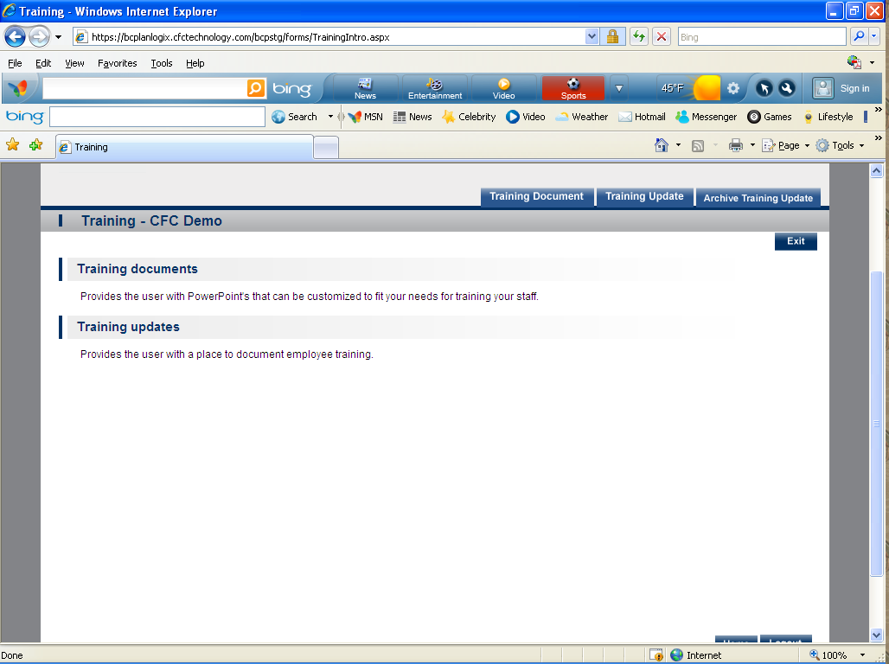

- Training Document- Provides the user with PowerPoint's that can be customized to fit your needs for training your staff.
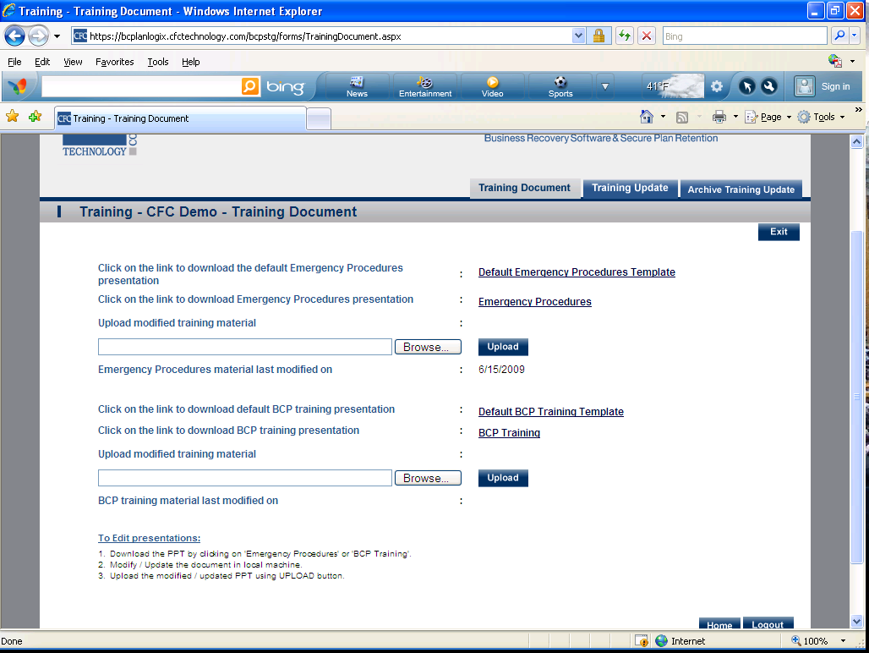

- Training Update- Provides the user with a place to document employee training. 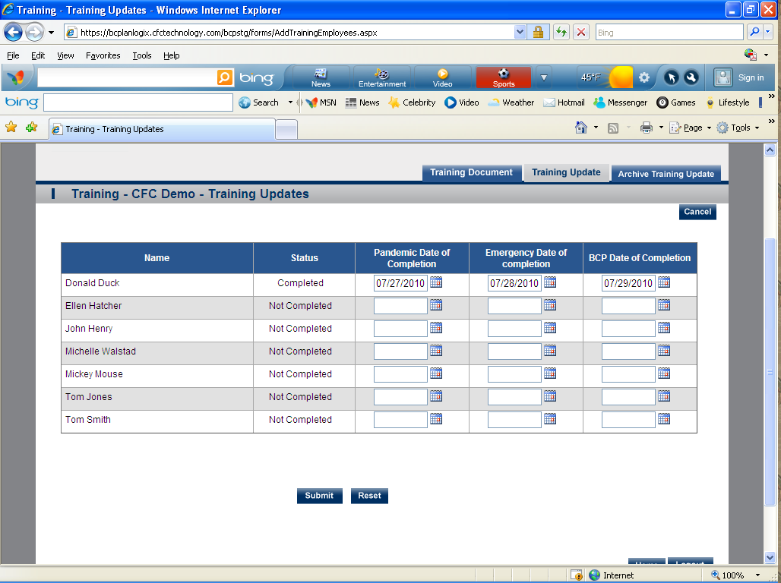
- Archive Training Update- Provides an archive of employee training and dates of completion. 