Testing (8 Sections Listed Below)
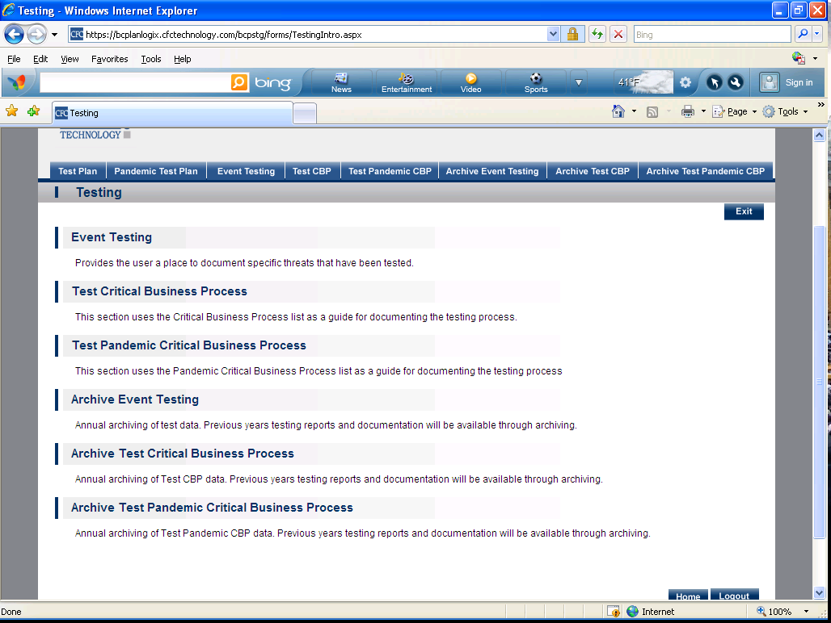
- Test Plan
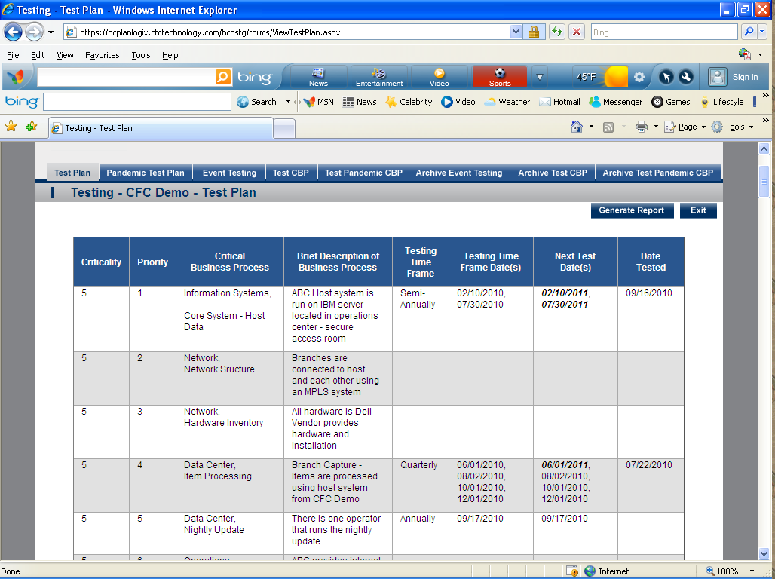

- Pandemic Test Plan
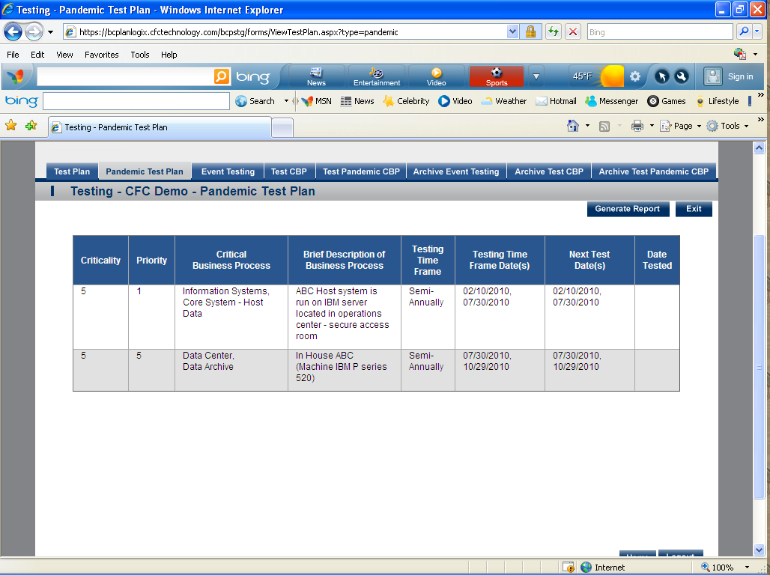

- Event Testing- Provides the user a place to document specific threats that have been tested. 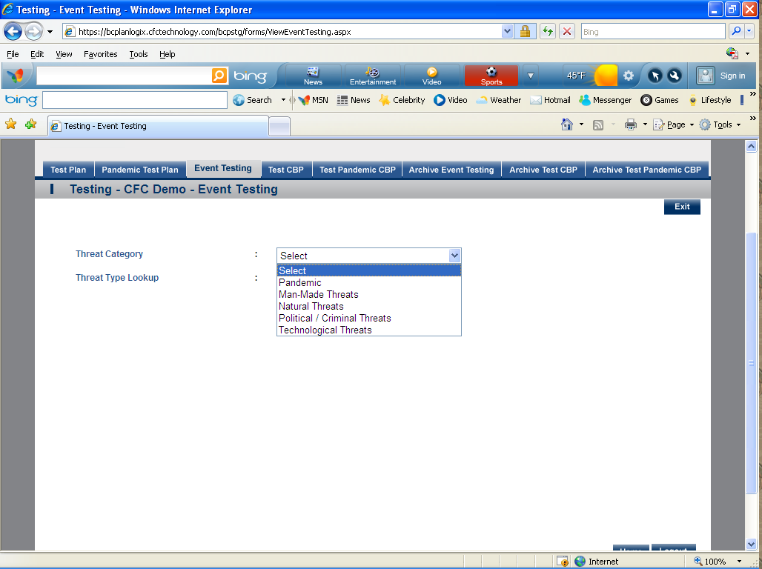
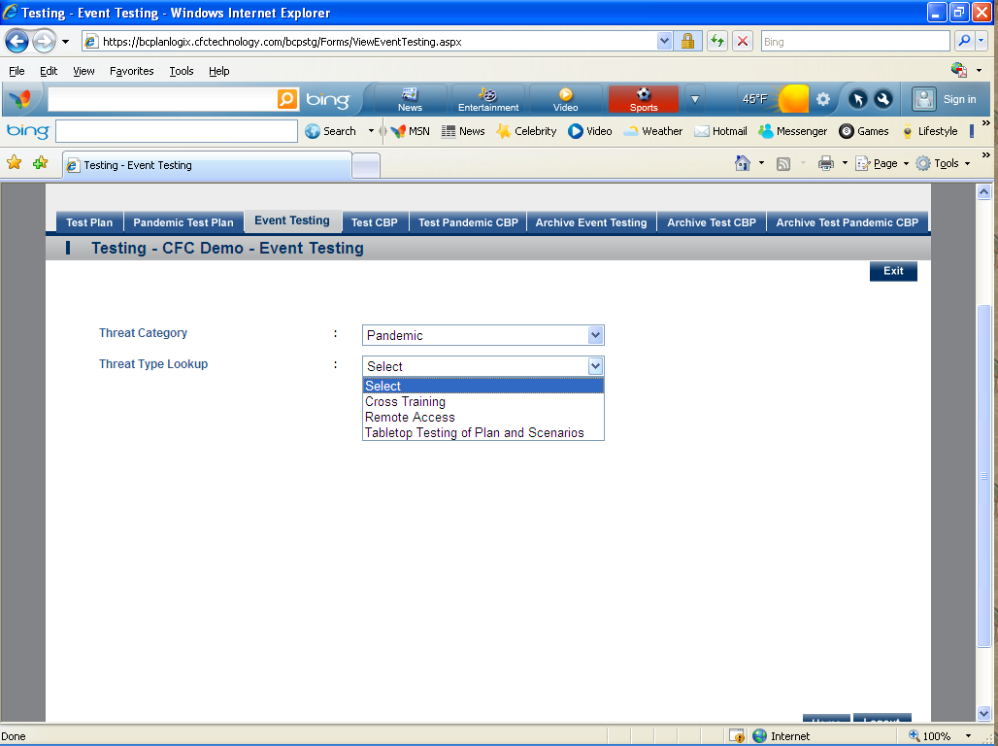

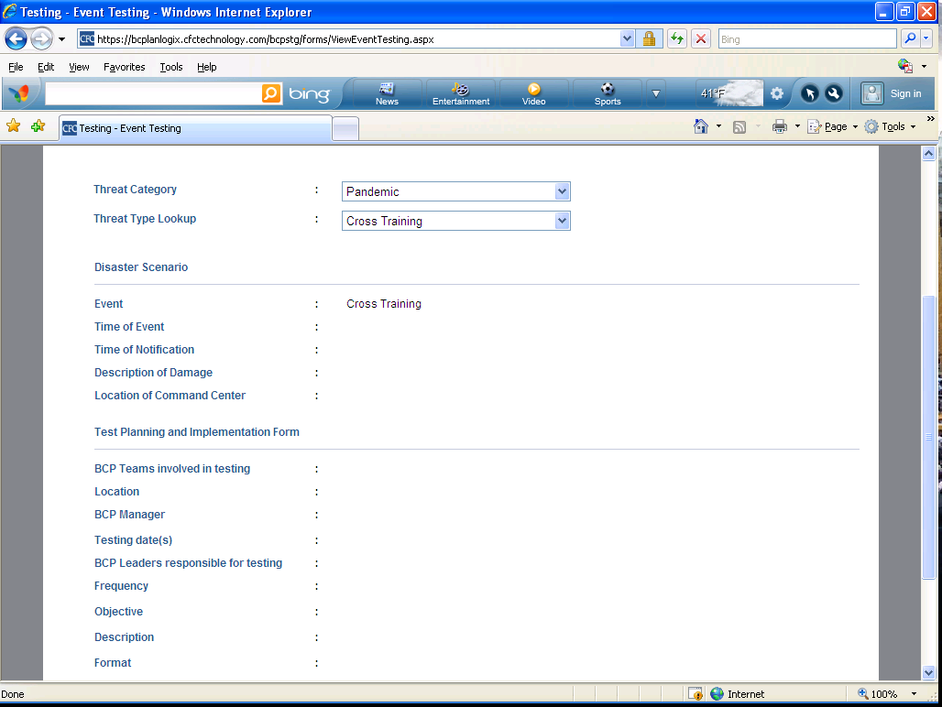
- Test CBP- This section uses the Critical Business Process list as a guide for documenting the testing process. 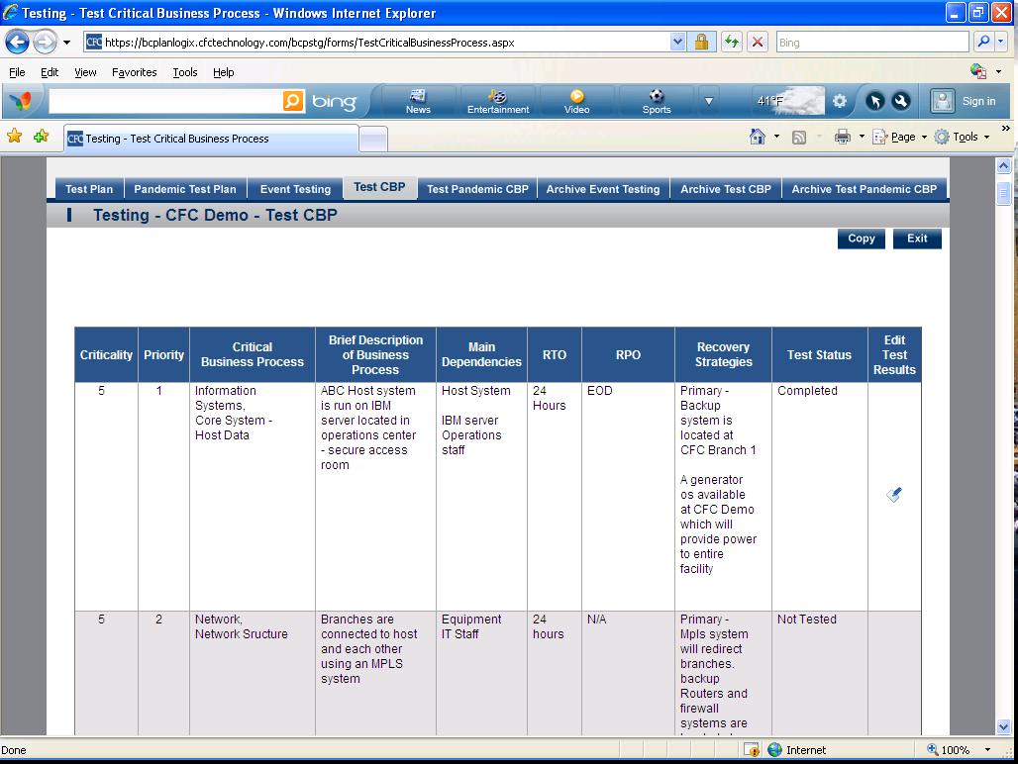

- Test Pandemic CBP- This section uses the Pandemic Critical Business Process list as a guide for documenting the testing process.
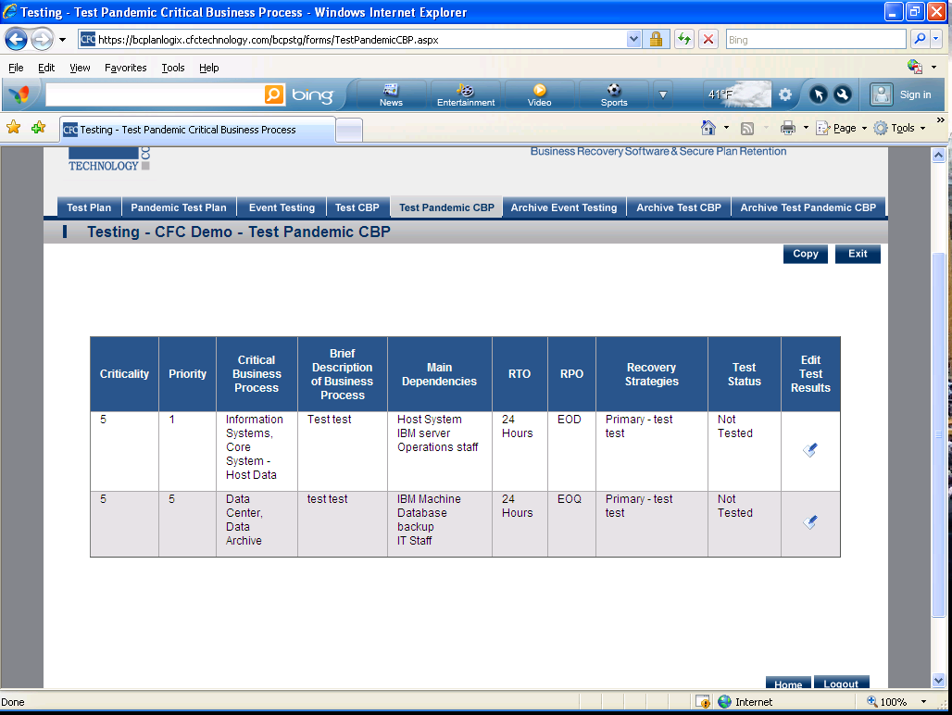

- Archive Event Testing- Annual archiving of test data. Previous years testing reports and documentation will be available through archiving.
- Archive Test CBP- Annual archiving of Test CBP data. Previous years testing reports and documentation will be available through archiving.
- Archive Test Pandemic CBP- Annual archiving of Test Pandemic CBP data. Previous years testing reports and documentation will be available through archiving.

