Team Plans
- BCP Teams – with view of Plan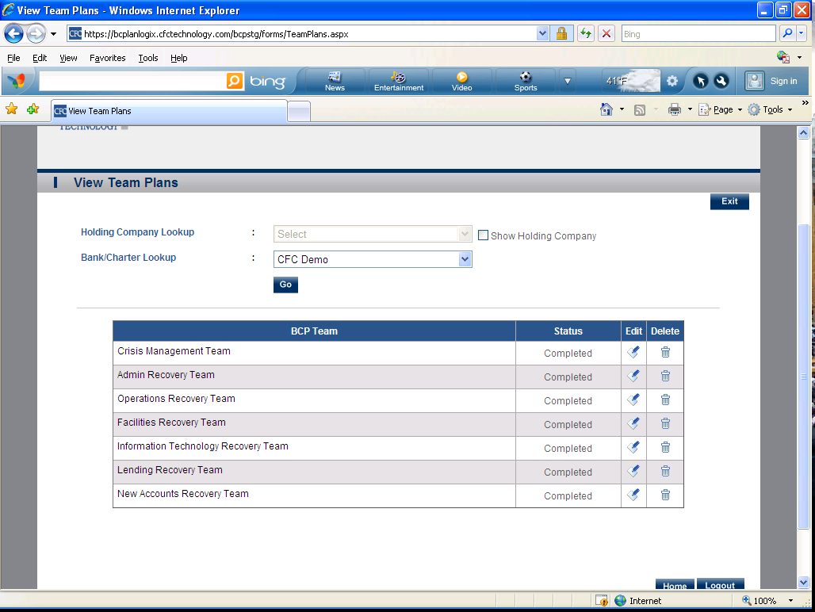

Plan Worksheets (3 Sections Listed Below)
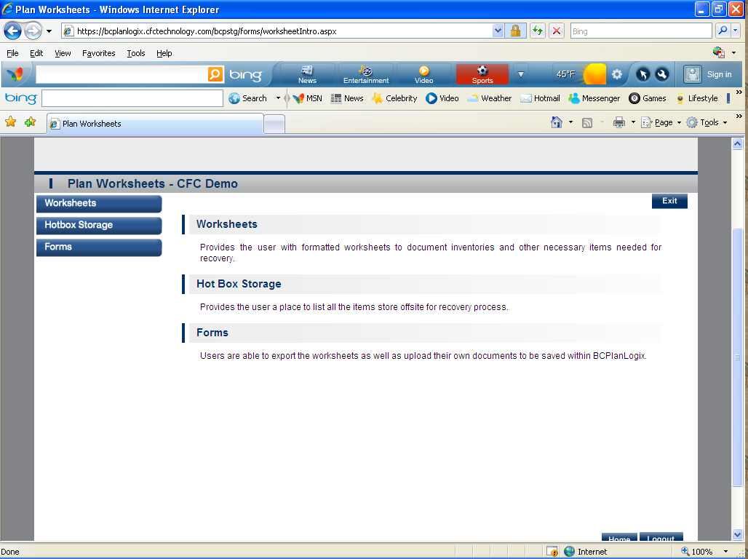
- Worksheets-Provides the user with formatted worksheets to document inventories and other necessary items needed for recovery.
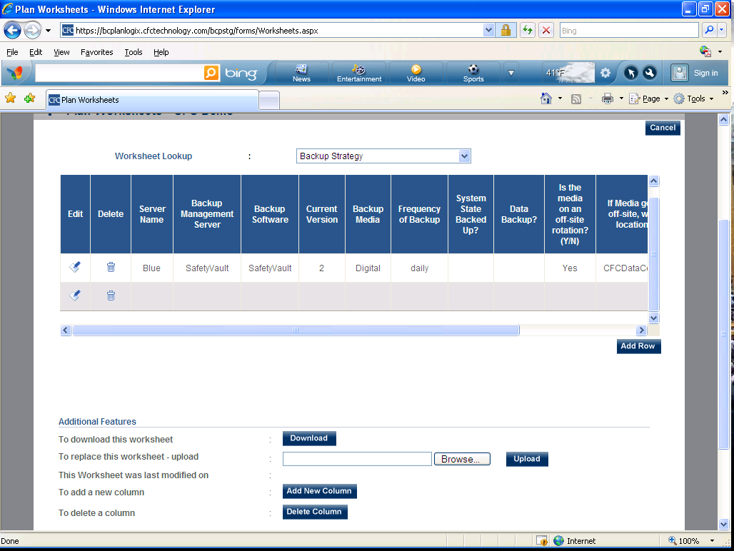

- Hotbox Storage-Provides the user a place to list all the items store offsite for recovery process.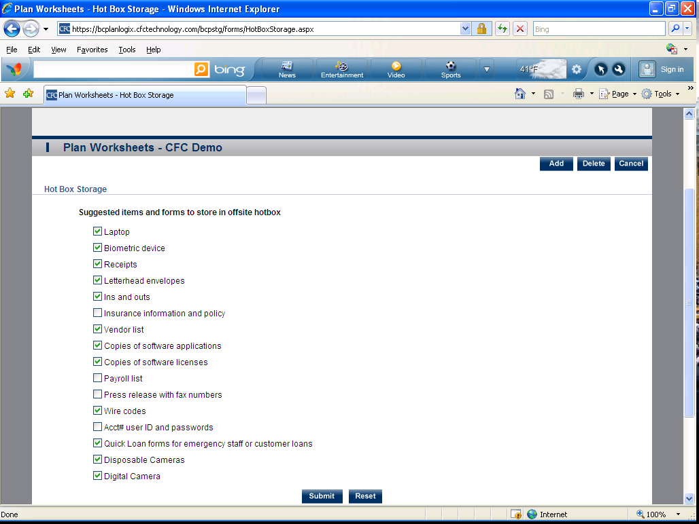
- Forms-Users are able to export the worksheets as well as upload their own documents to be saved within BCPlanLogix.
