Critical Business Process (2 Sections Listed Below)
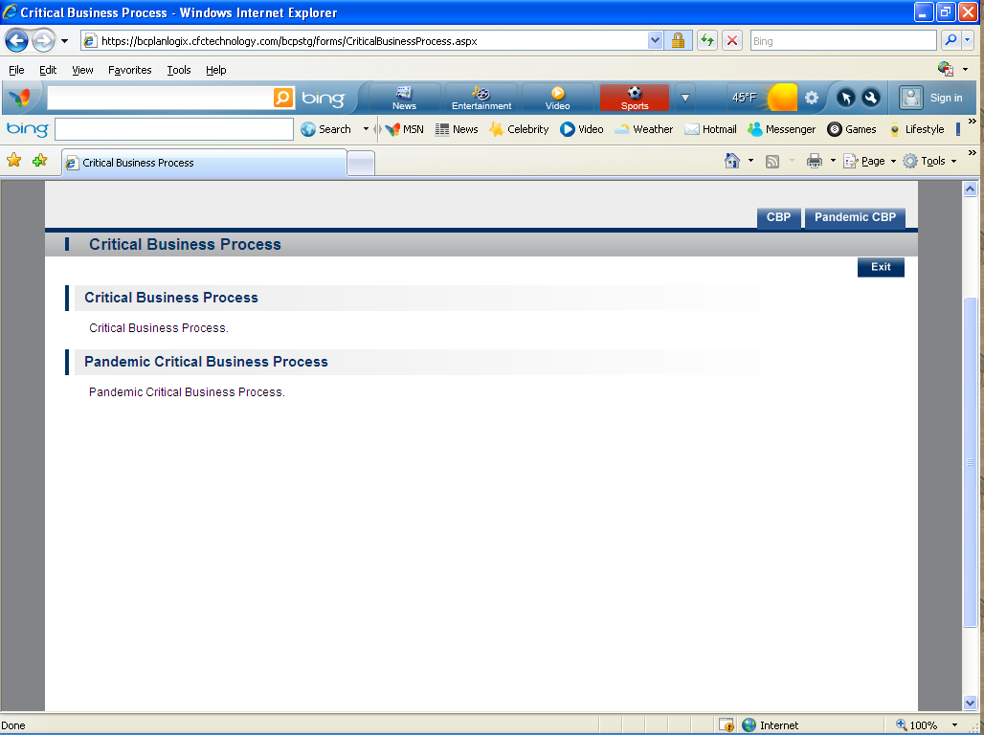
- CBP- This information is extracted from the Control screen. You can also set the “Priority “order from this module.
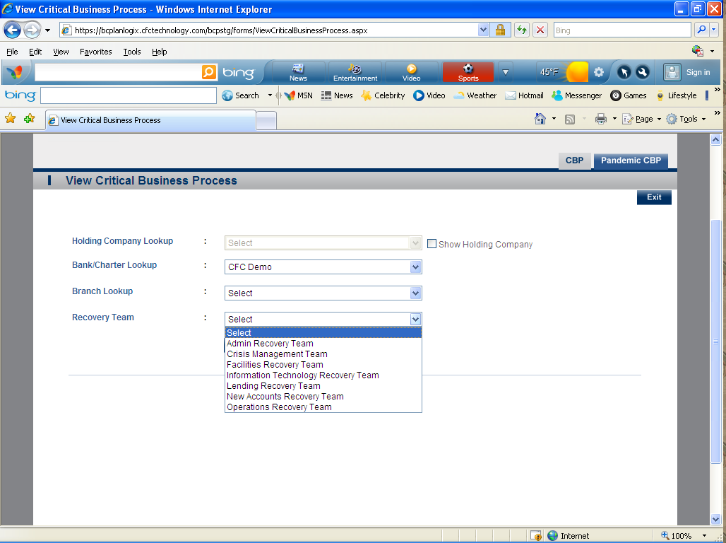
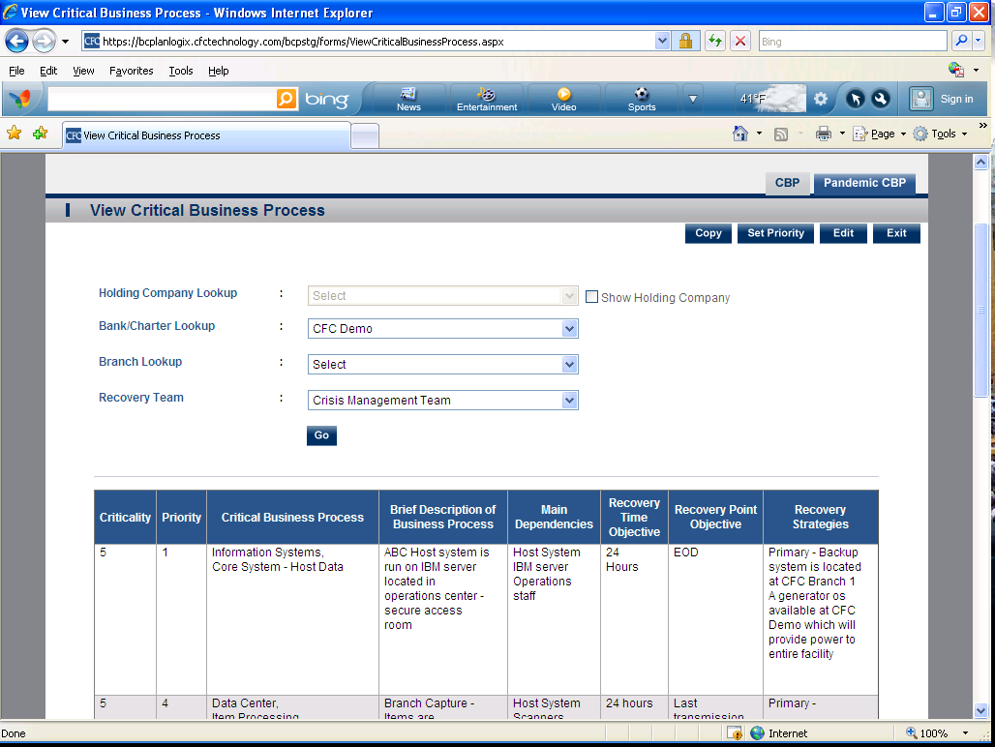

- Pandemic CBP (Same as regular CBP but for Pandemic )

