TABLE OF CONTENTS
BIA – RISK ASSESSMENT 4
Section 1 Threat Analysis 4
Section 2 Controls 5
Section 3 Risk Rating 5
Section 4 Pandemic Risk Ratings 6
BIA – BUSINESS IMPACT ANALYSIS 7
Section 1 Function Areas 7
CRITICAL BUSINESS PROCESS 8
Section 1 CBP 8
Section 2 Pandemic CBP 9
PLAN SUMMARY 9
Section 1 Plan Overview 10
Section 2 BCP Policy Statement 10
Section 3 Executive Summary 11
Section 4 Approving BCP Content 11
Section 5 Institution Overview 12
Section 6 TA and BCP Risk Assessment 12
Section 7 Business Impact Analysis 14
Section 8 Emergency Procedures 14
Section 9 Critical Business Process 16
Section 10 Plan Structure 16
Section 11 Recovery Teams 17
Section 12 Testing 18
Section 13 Questionnaire 19
TEAM PLANS 20
Section 1 BCP Teams 20
PLAN WORKSHEETS 20
Section 1 Worksheets 21
Section 2 Hotbox Storage 21
Section 3 Forms 22
PANDEMIC FLU 23
Section 1 Plan Overview 23
Section 2 Policy 23
Section 3 Purpose 24
Section 4 Objectives 24
Section 5 Team Members 25
Section 6 Background 25
Section 7 Assumptions 26
Section 8 Activation 26
Section 9 BIA and RA 27
Section 10 Critical Systems 28
Section 11 Cross Training 28
Section 12 Communication 29
Section 13 HR Policy 30
Section 14 Training 31
Section 15 Testing 31
Section 16 Other Plans 32
Section 17 Resources 33
Section 18 Tips and Examples 33
Section 19 Print Configurations 34
TESTING 35
Section 1 Test Plan 35
Section 2 Pandemic Test Plan 36
Section 3 Event Testing 36
Section 4 Test CBP 38
Section 5 Test Pandemic CBP 38
Section 6 Archive Event Testing 39
Section 7 Archive Test CBP 39
Section 8 Archive Test Pandemic CBP 39
TRAINING 39
Section 1 Training Document 40
Section 2 Training Update 40
Section 3 Archive Training Update 41
MAINTENANCE 41
Section 1 Accounts 42
Section 2 Threats 42
Section 3 System Category 43
Section 4 System Sub Category 43
Section 5 Vendors 44
Section 6 Users 44
Section 7 Department 45
Section 8 Roles 45
Section 9 Security 46
Section 10 Recovery Teams 46
REPORTS 47
Section 1 Risk Assessments 47
Section 2 Business Impact Analysis 47
Section 3 Critical Business Process 47
Section 4 Plan Summary 47
Section 5 Team Plans 47
Section 6 Plan Worksheets 47
Section 7 Pandemic Flu 47
Section 8 Testing 47
Section 9 Training 47
Section 10 Maintenance 47

VENDOR MANAGEMENT 48
Section 1 Vendor Management 48
Subsection a) Vendor Information 49
Subsection b) Due Diligence 50
Subsection c) Annual Review 50
Subsection d) Contract Review 51
Subsection e) Issues 51
Section 2 Risk Assessments 52
Section 3 Document Storage 52
Section 4 Vendor Management Policy 53
Subsection a) VRM Plan Review 53
Subsection b) Introduction 54
Subsection c) Purpose 54
Subsection d) Contractual Relationships 55
Subsection e) Overall Program Review 56
Section 5 Reports 56

RIA – Risk Assessment (4 Sections Listed Below)
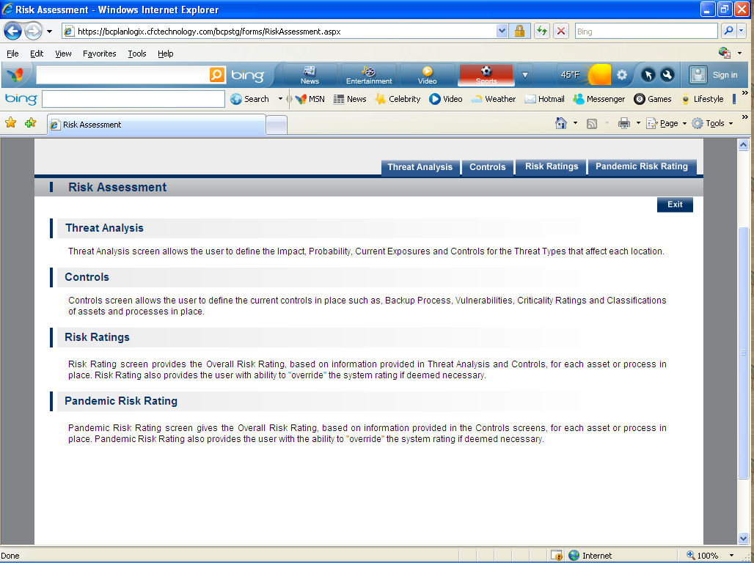
- Threat Analysis-Threat Analysis screen allows the user to define the Impact, Probability, Current Exposures and Controls for the Threat Types that affect each location. 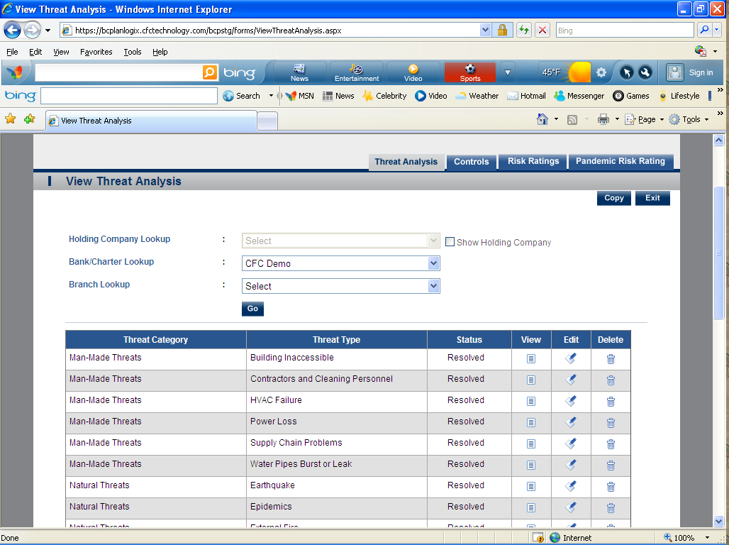
- Controls-Controls screen allows the user to define the current controls in place such as, Backup Process, Vulnerabilities, Criticality Ratings and Classifications of assets and processes in place.
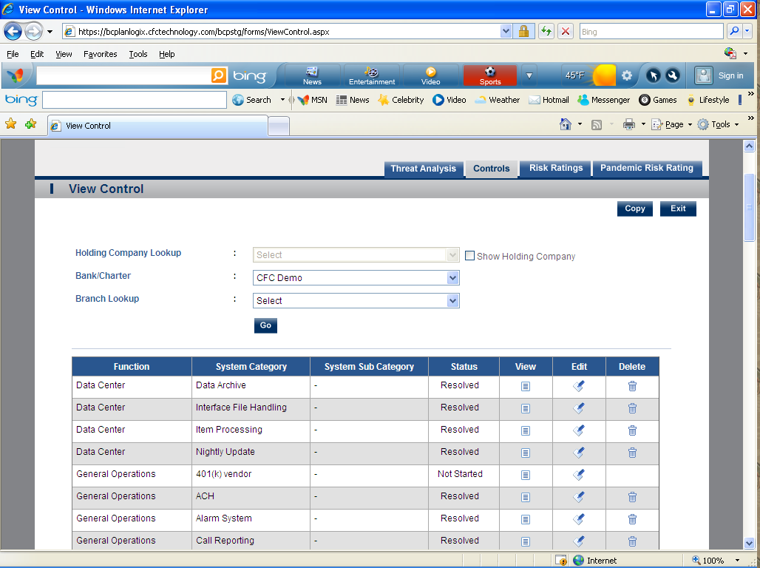

- Risk Ratings-Risk Rating screen provides the Overall Risk Rating, based on information provided in Threat Analysis and Controls, for each asset or process in place. Risk Rating also provides the user with ability to "override" the system rating if deemed necessary. 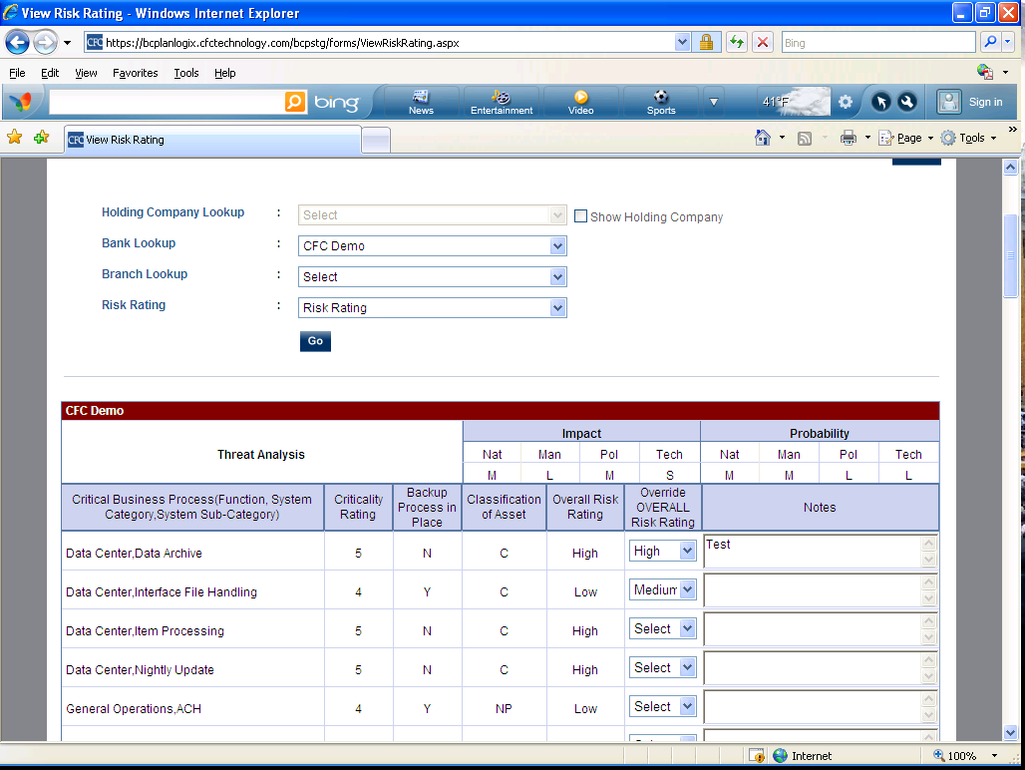
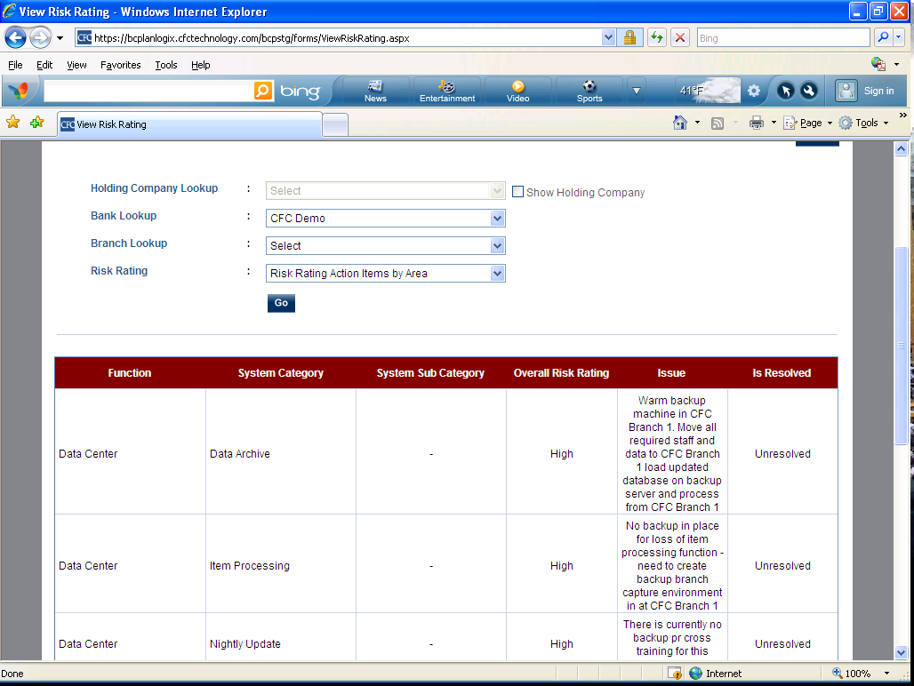
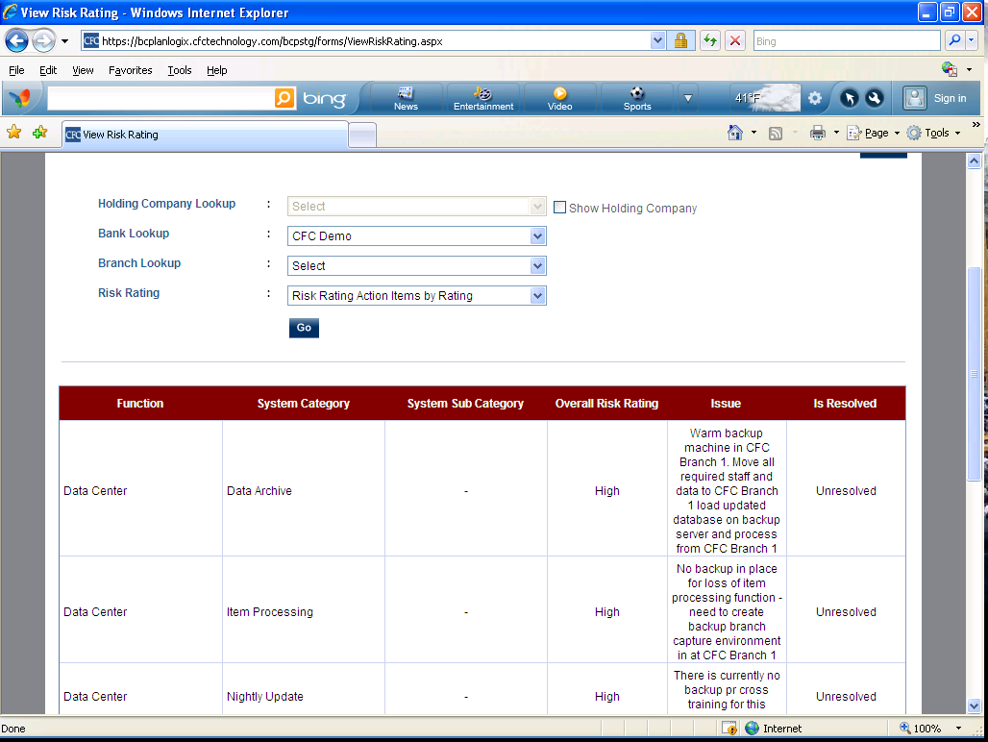

- Pandemic Risk Ratings –Pandemic Risk Rating screen gives the Overall Risk Rating, based on information provided in the Controls screens, for each asset or process in place. Pandemic Risk Rating also provides the user with the ability to "override" the system rating if deemed necessary.

BIA – Business Impact Analysis
- Function Areas – with view of Analysis Plan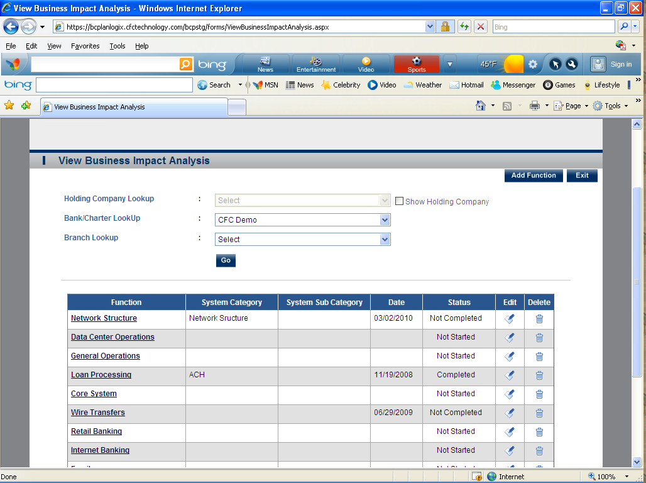
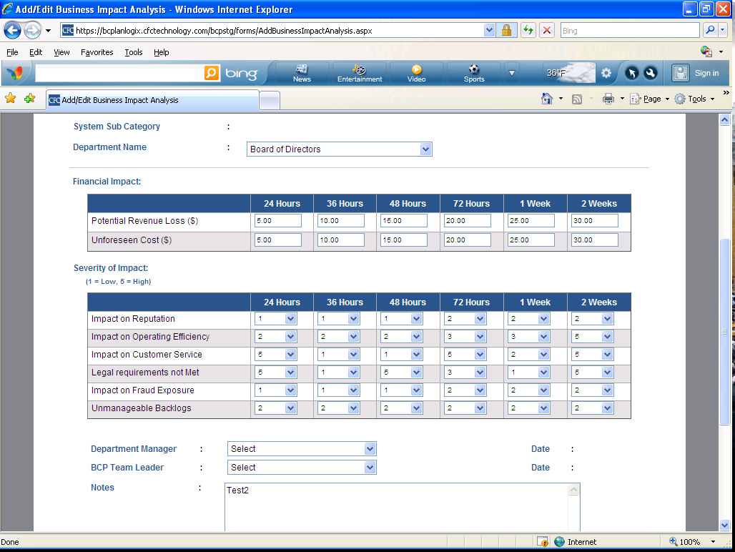

Critical Business Process (2 Sections Listed Below)
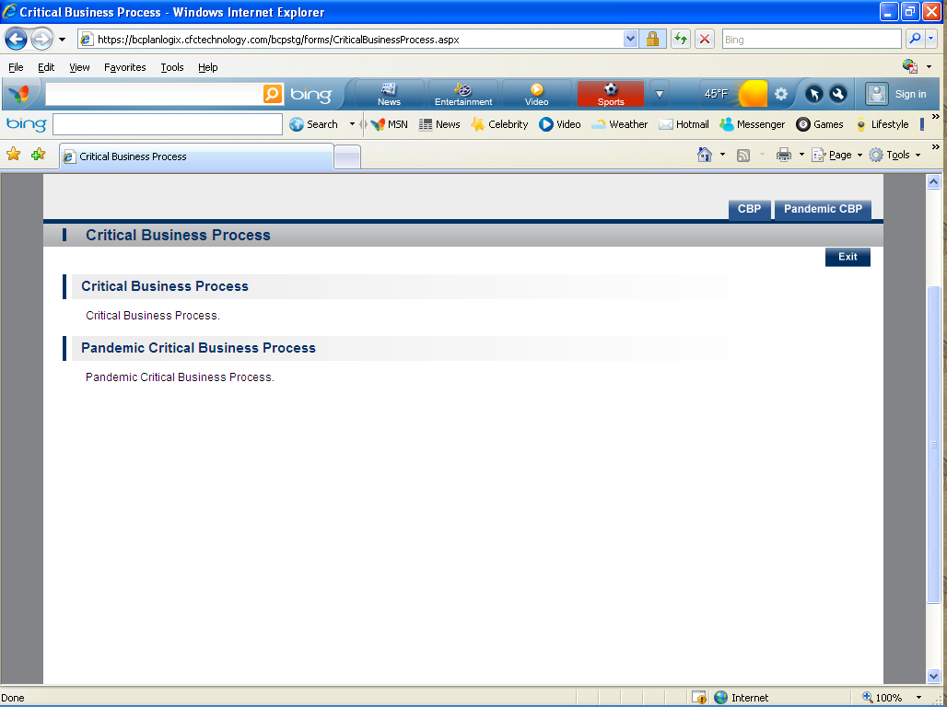
- CBP- This information is extracted from the Control screen. You can also set the “Priority “order from this module.
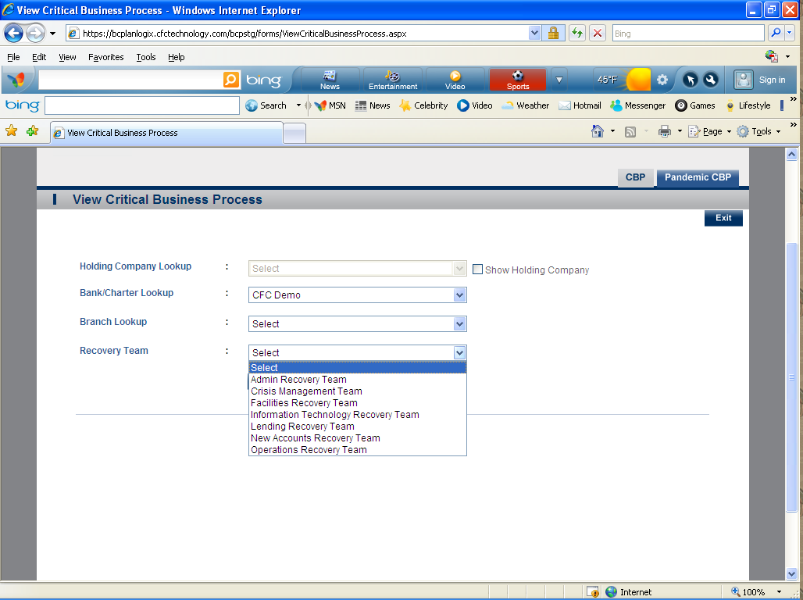
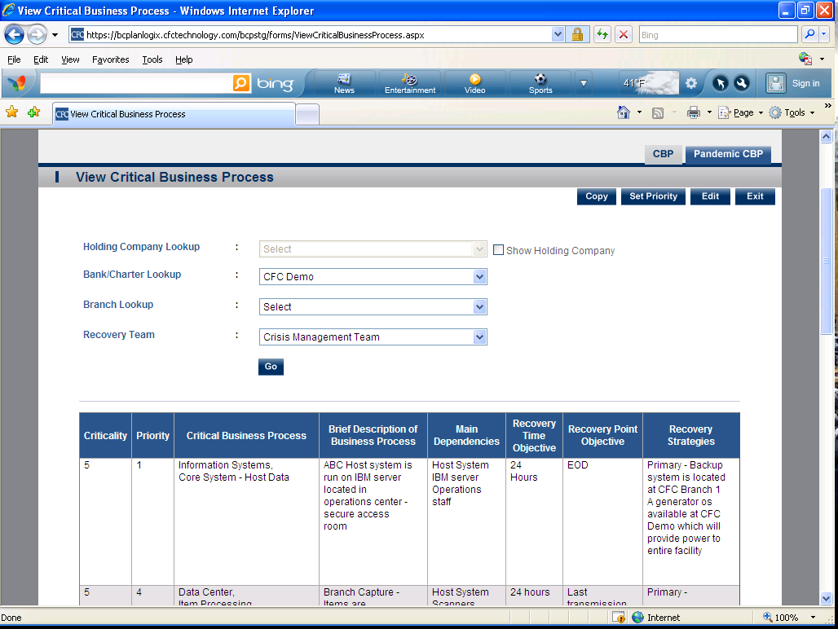

- Pandemic CBP (Same as regular CBP but for Pandemic )

Maintenance (10 Sections Listed Below)
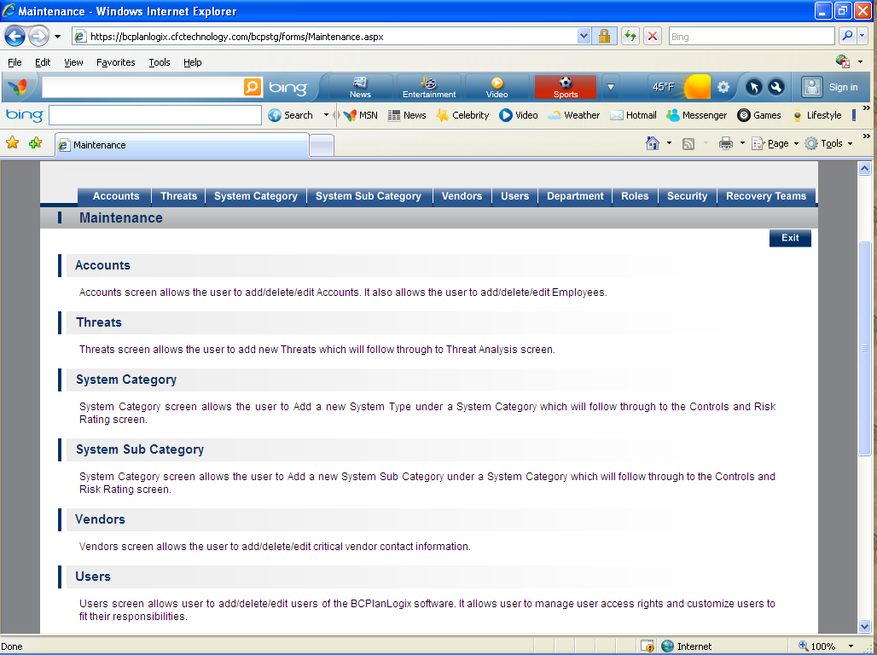
- Accounts- Accounts screen allows the user to add/delete/edit Accounts. It also allows the user to add/delete/edit Employees.
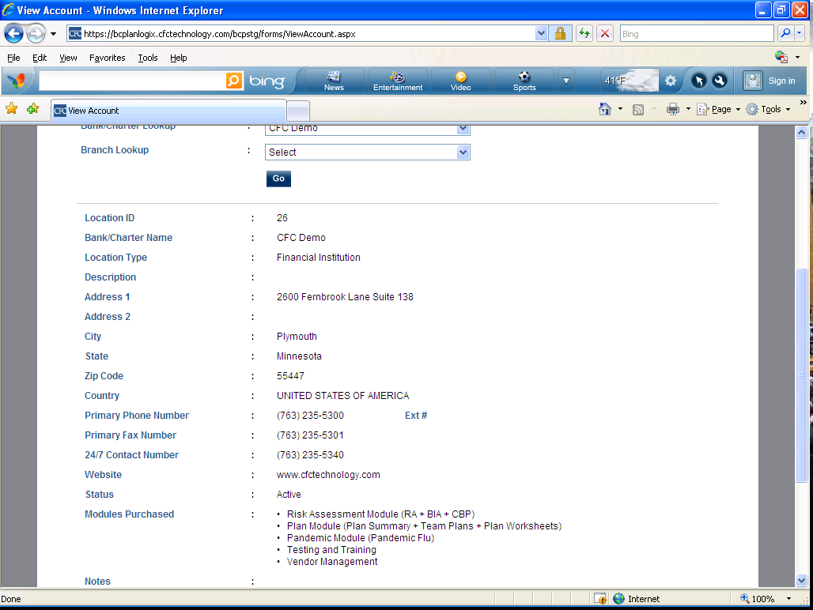

- Threats- Threats screen allows the user to add new Threats which will follow through to Threat Analysis screen. 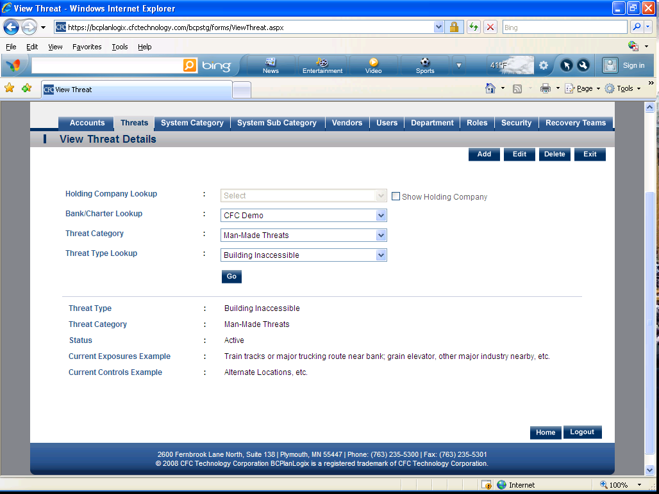
- System Category- System Category screen allows the user to Add a new System Type under a System Category which will follow through to the Controls and Risk Rating screen. 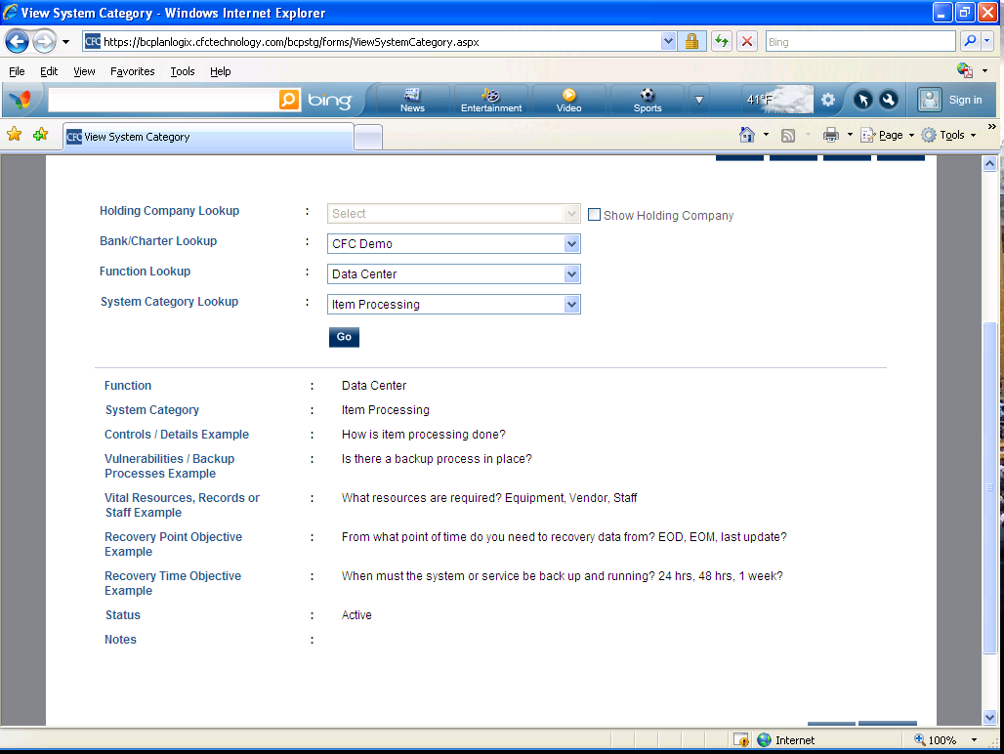

- System Sub Category- System Category screen allows the user to Add a new System Sub Category under a System Category which will follow through to the Controls and Risk Rating screen. 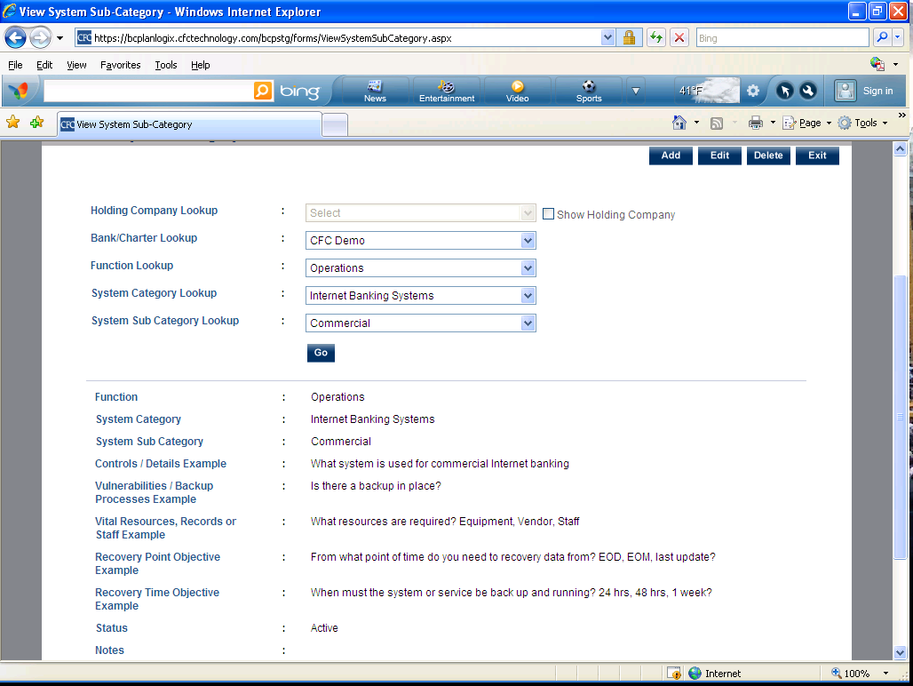
- Vendors- Vendors screen allows the user to add/delete/edit critical vendor contact information. 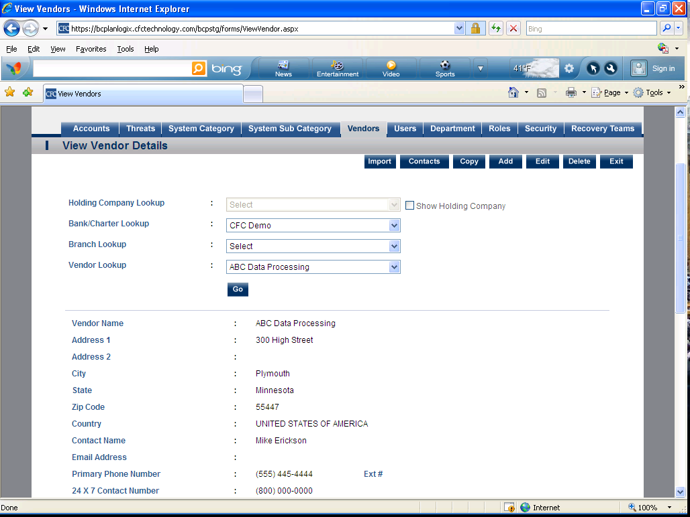

- Users- Users screen allows user to add/delete/edit users of the BCPlanLogix software. It allows user to manage user access rights and customize users to fit their responsibilities. 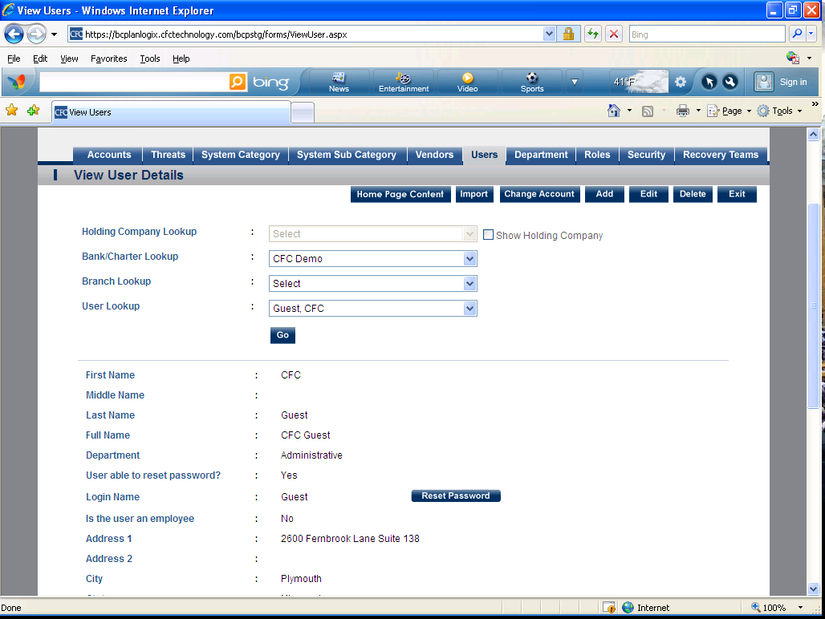
- Department- Departments is used to create custom departments for the institution. 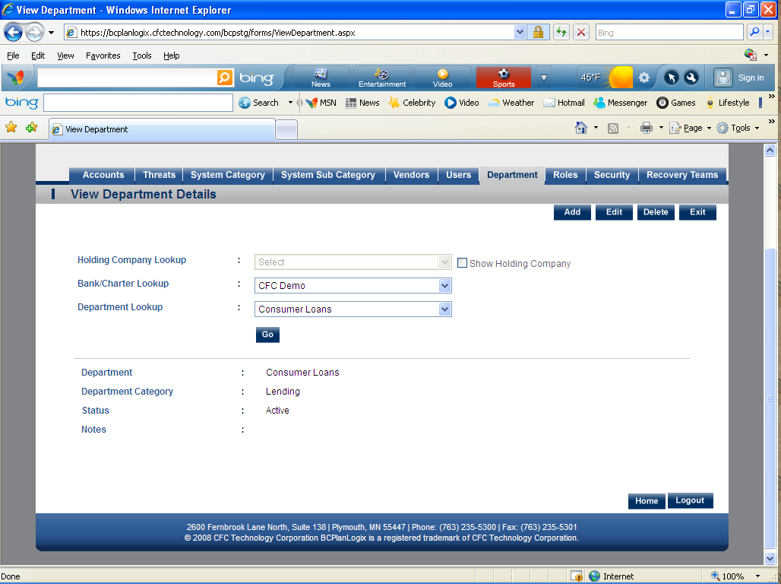

- Roles- Role provides the user the ability to customize the user access roles. 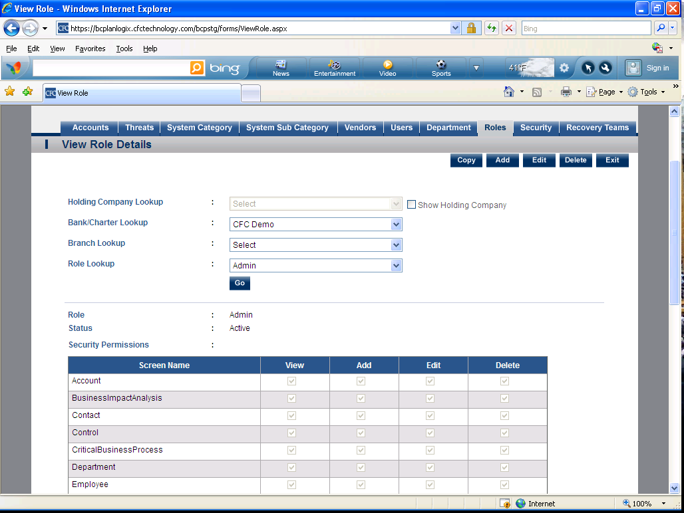
- Security- Security allows the user to link system users and access roles. 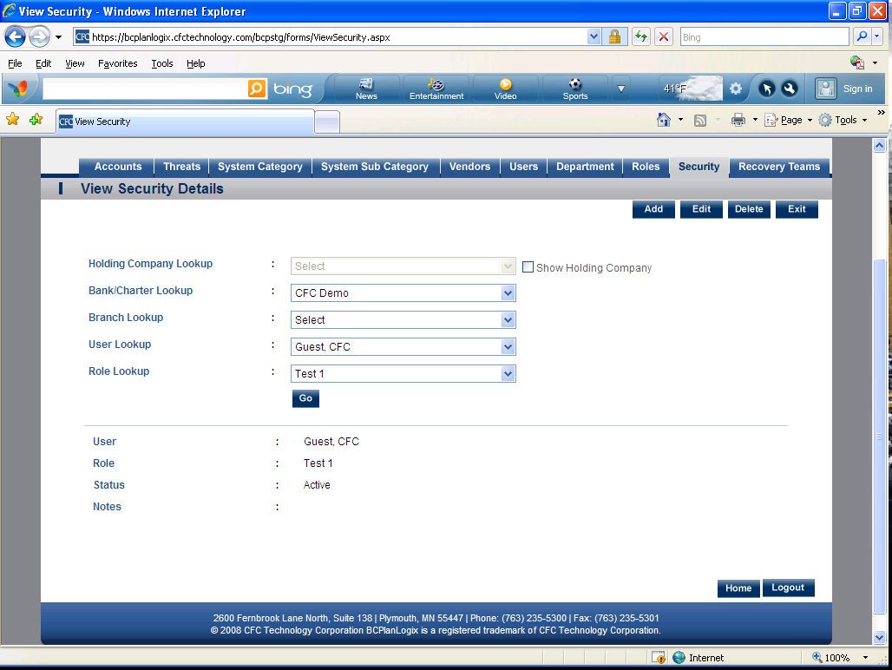

- Recovery Teams- Recovery Teams allows the user to customize the recovery team names and link departments to recovery teams. 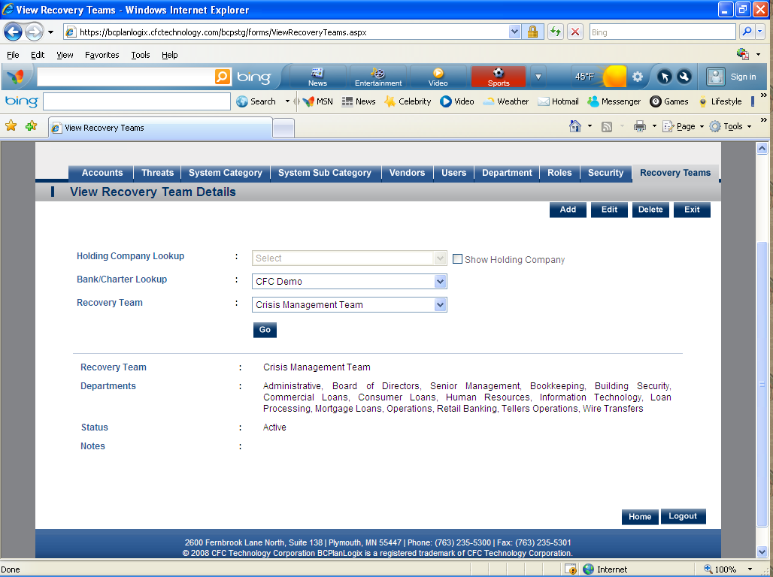

Reports (Modules)
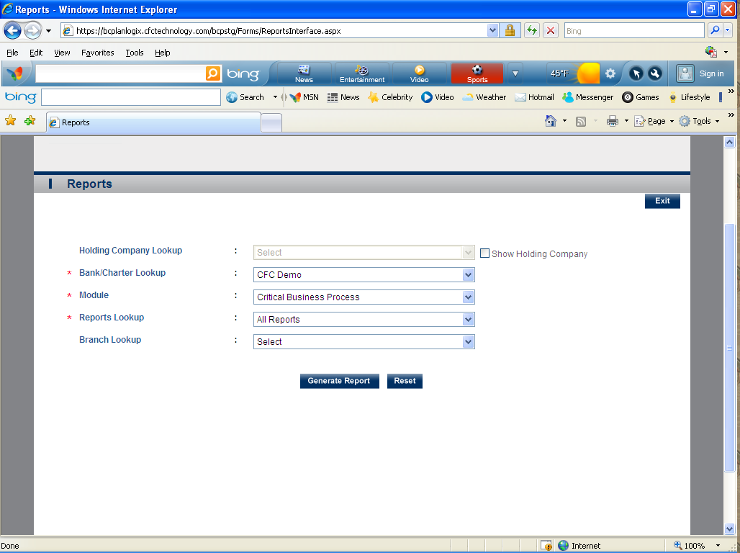
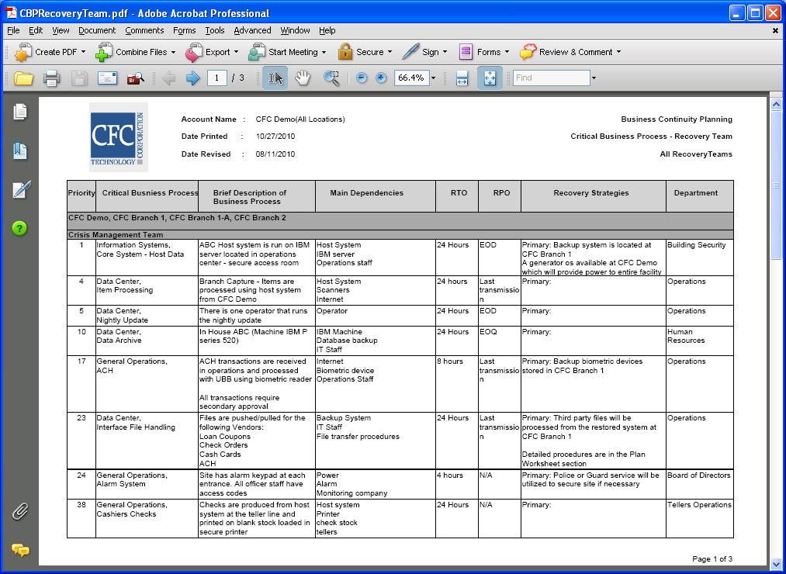

This is a module that allows you to generate reports for:
- Risk Assessments-
- Business Impact Analysis
- Critical Business Process
- Plan Summary
- Team Plans
- Plan Worksheets
- Pandemic Flu
- Testing
- Training
- Maintenance

