Plan Summary (13 Sections Listed Below)
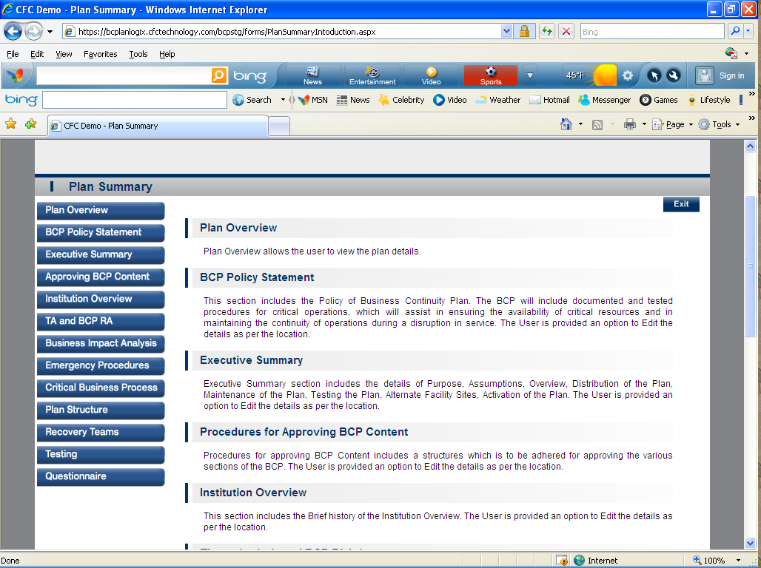
- Plan Overview-Plan Overview allows the user to view the plan details. You can customize the different parts of the plan in this module.
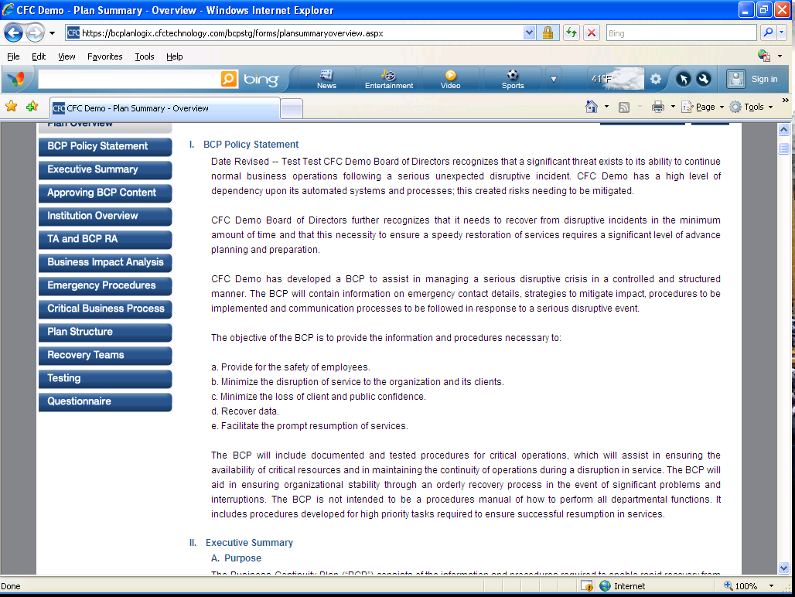
- BCP Policy Statement-This section includes the Policy of Business Continuity Plan. The BCP will include documented and tested procedures for critical operations, which will assist in ensuring the availability of critical resources and in maintaining the continuity of operations during a disruption in service. The User is provided an option to edit the details as per the location. 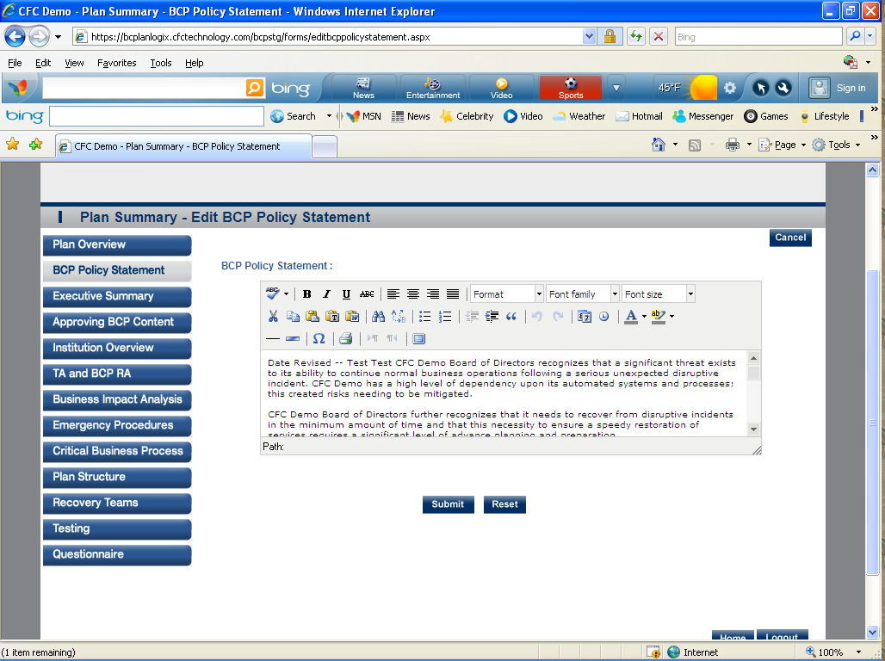
- Executive Summary-Executive Summary section includes the details of Purpose, Assumptions, Overview, and Distribution of the Plan, Maintenance of the Plan, Testing the Plan, Alternate Facility Sites, and Activation of the Plan. The User is provided an option to Edit the details as per the location. 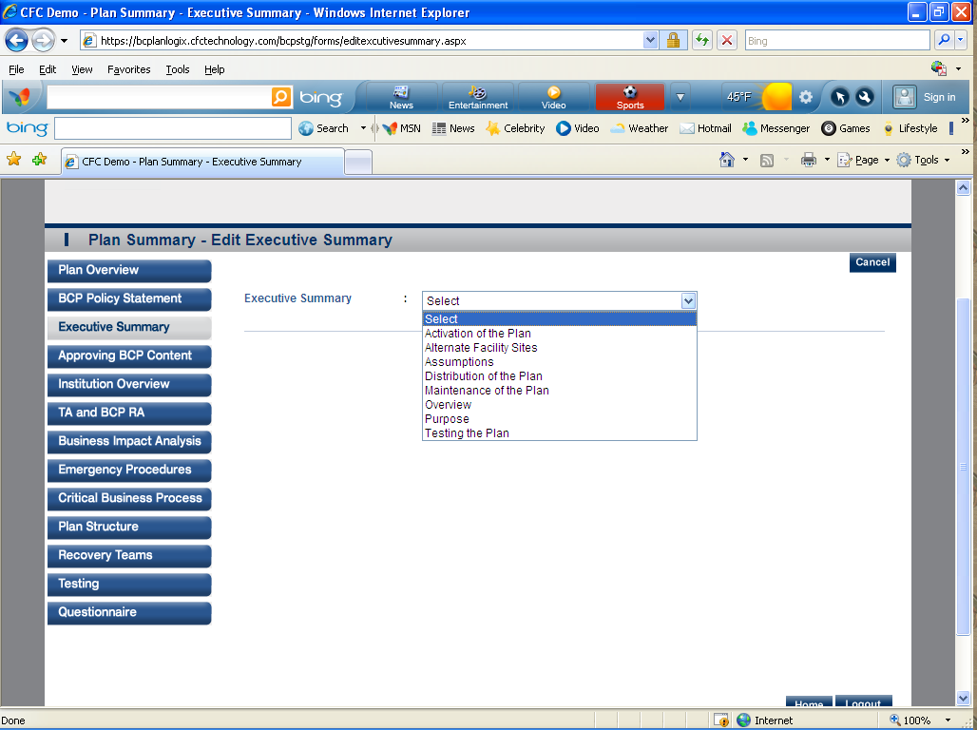
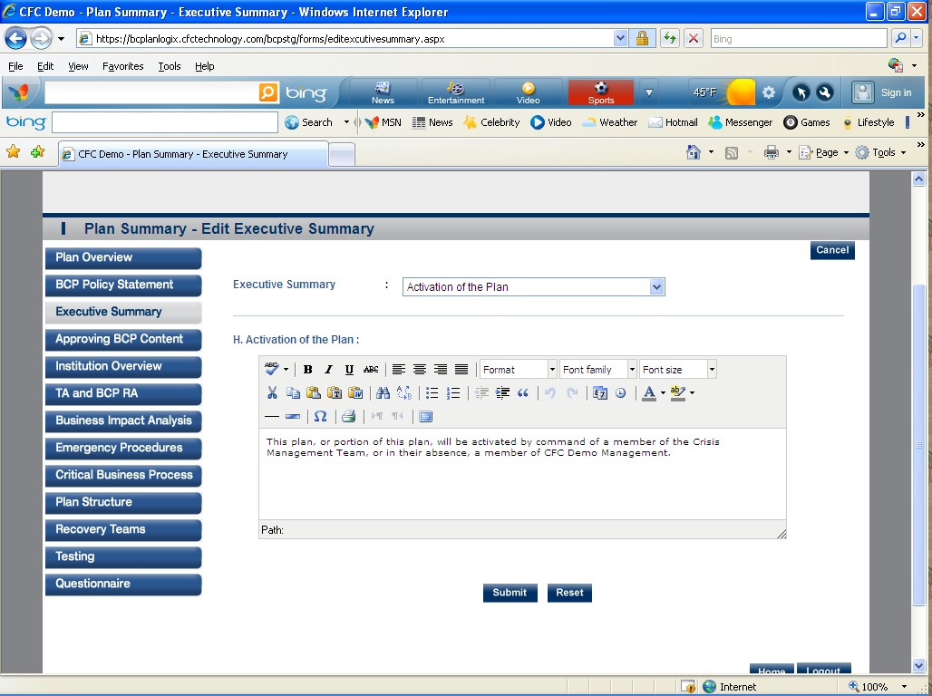

- Approving BCP Content-Procedures for approving BCP Content includes a structure which is to be adhered for approving the various sections of the BCP. The User is provided an option to Edit the details as per the location.
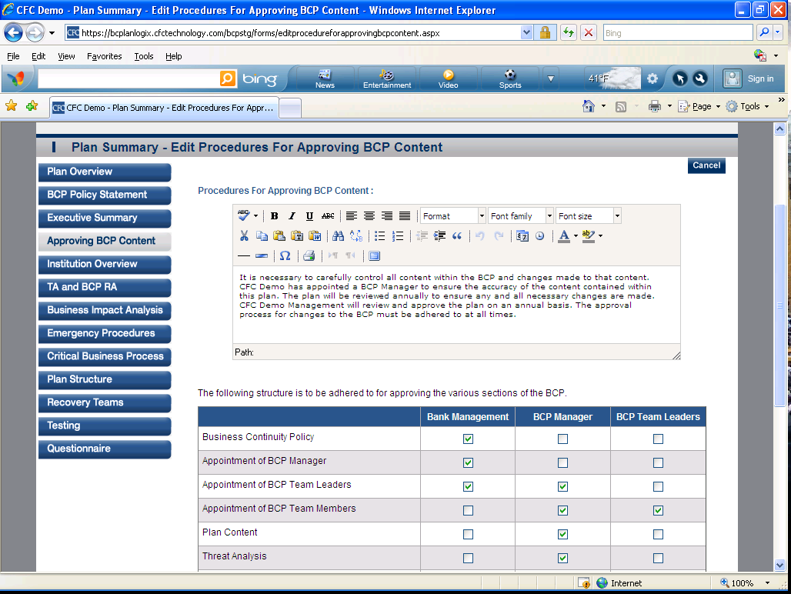
- Institution Overview-This section includes the Brief history of the Institution Overview. The User is provided an option to edit the details as per the location. 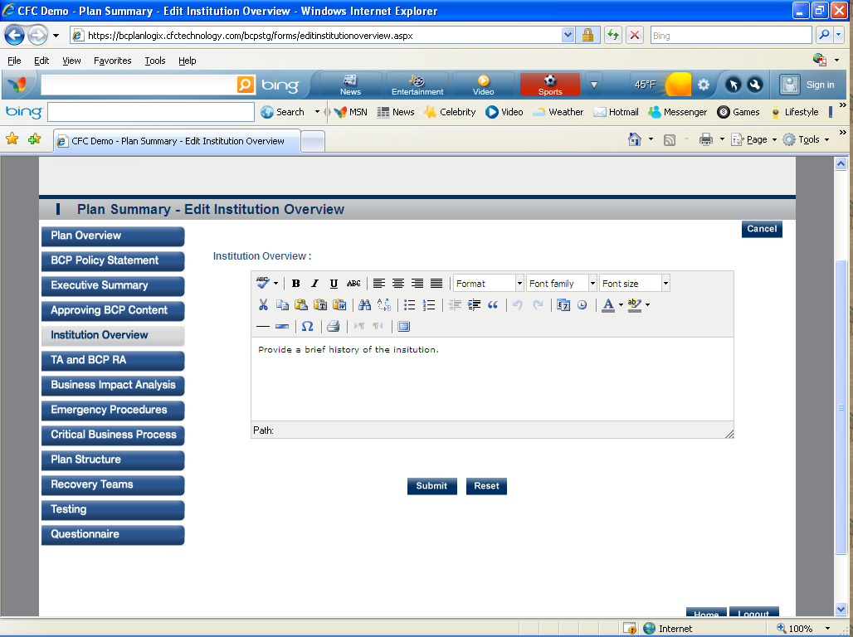
- TA and BCP RA-This section includes the Overview of Threat Analysis and BCP Risk assessment. The User is provided an option to edit the details as per the location. 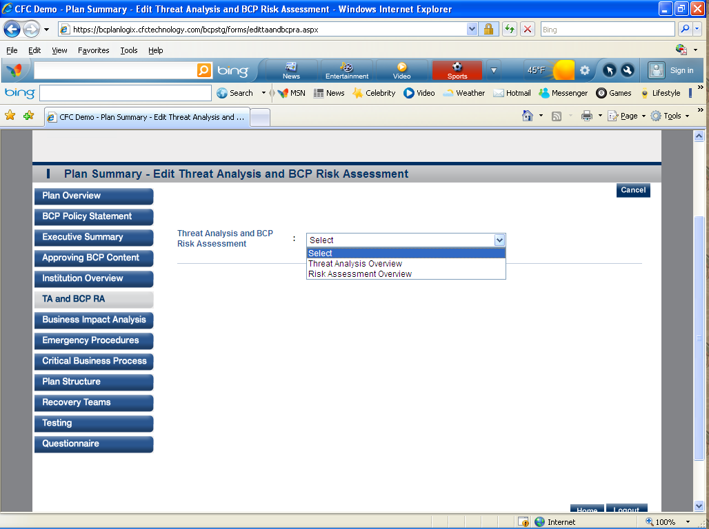

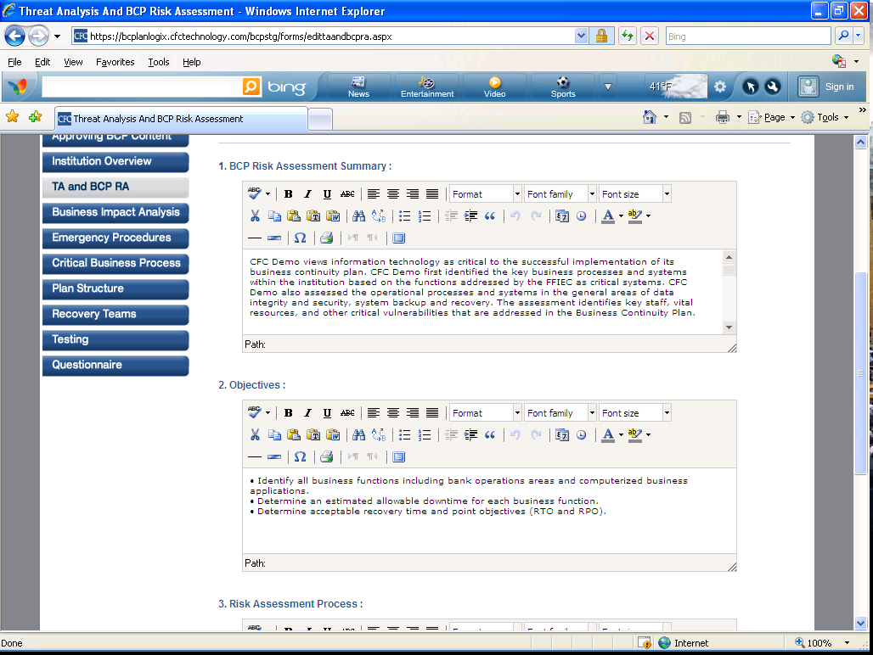
- Business Impact Analysis-This section includes an overview of Business Impact Analysis Process. The user is provided an option to Edit the details as per the location.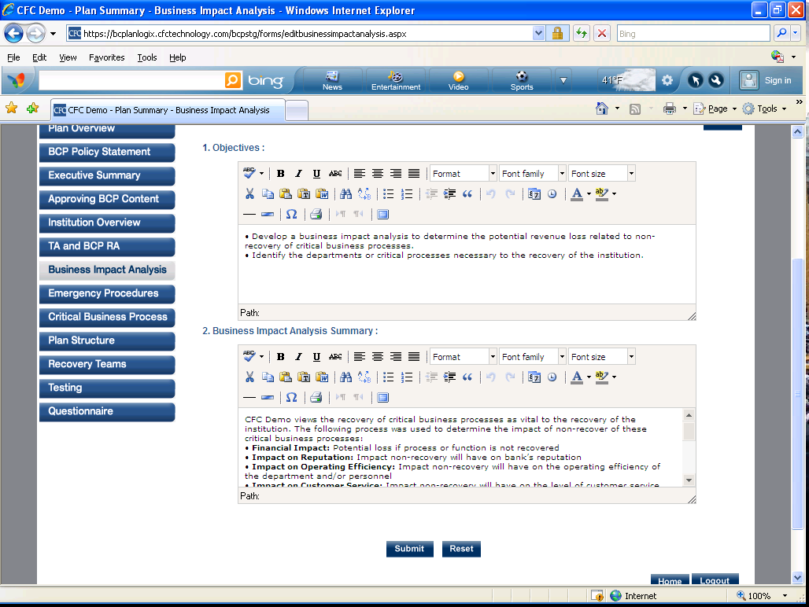
- Emergency Procedures-This section includes the details of Potential Emergency Events response such as Bomb Threat, Kidnapping Threat, Chemical Spill Release, Fire / Explosion, Flood, Power Outage, Telecommunications Failure, Severe Weather/ Tornado, Severe Weather/Winter Storm. The user is provided an option to edit the details as per the location. 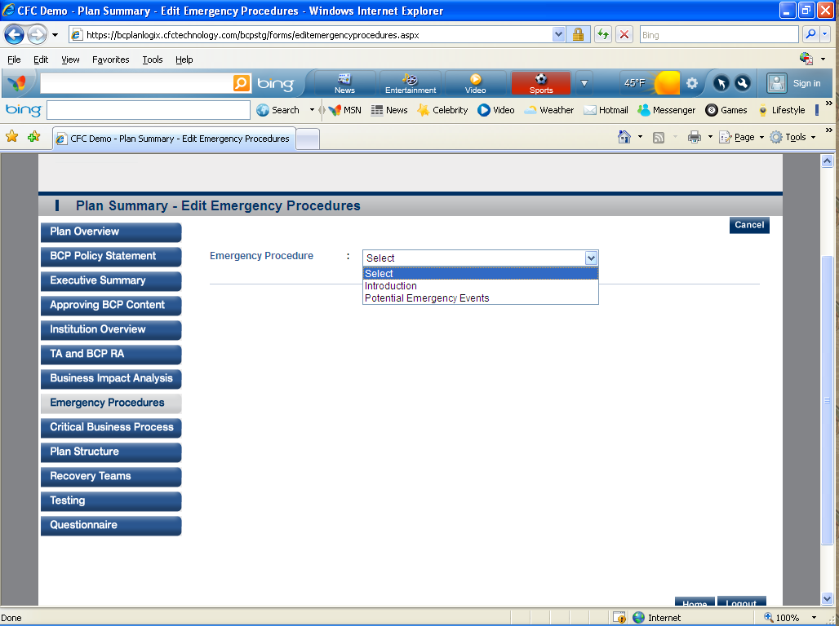
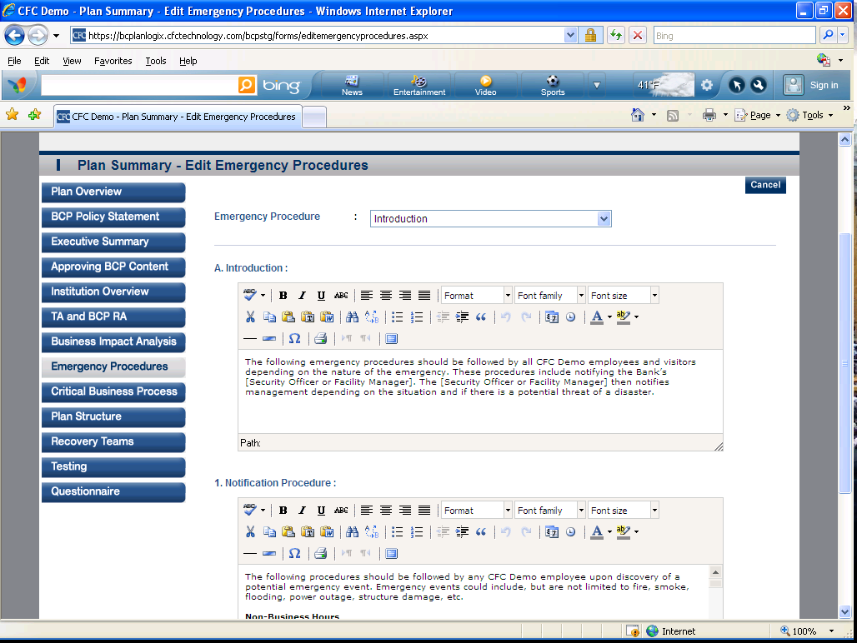
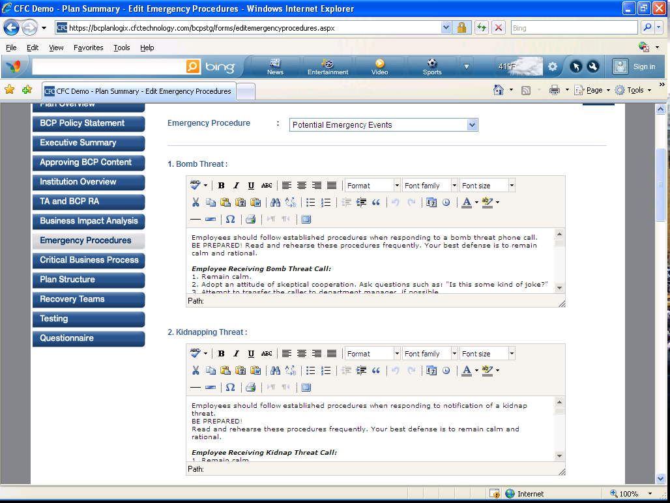

- Critical Business Process-This section includes an overview of Critical Business Processes including a brief description of the business process. The user is provided an option to edit the details as per the location. 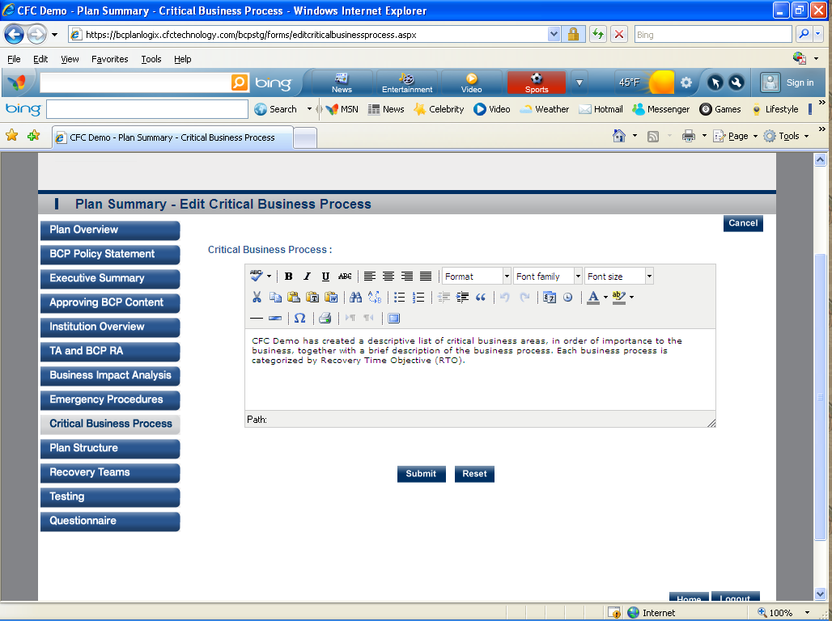
- Plan Structure-This section includes the details for Pre-Disaster Planning and Preparation, Alternate Facilities/Emergency Operations Center, Emergency Preparation, Emergency Situations, Immediate Communication, Information and Assets, Business Recovery. The user is provided an option to Edit the details as per the location.
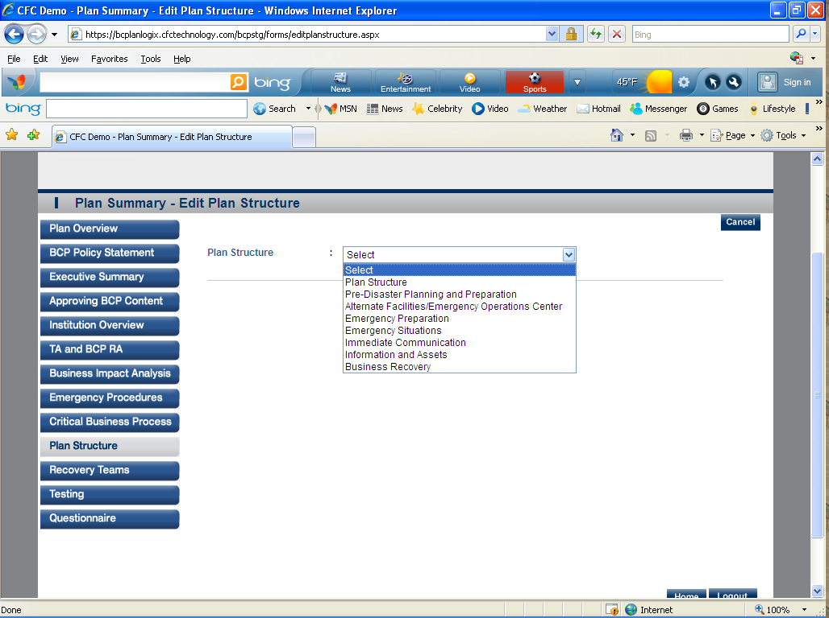
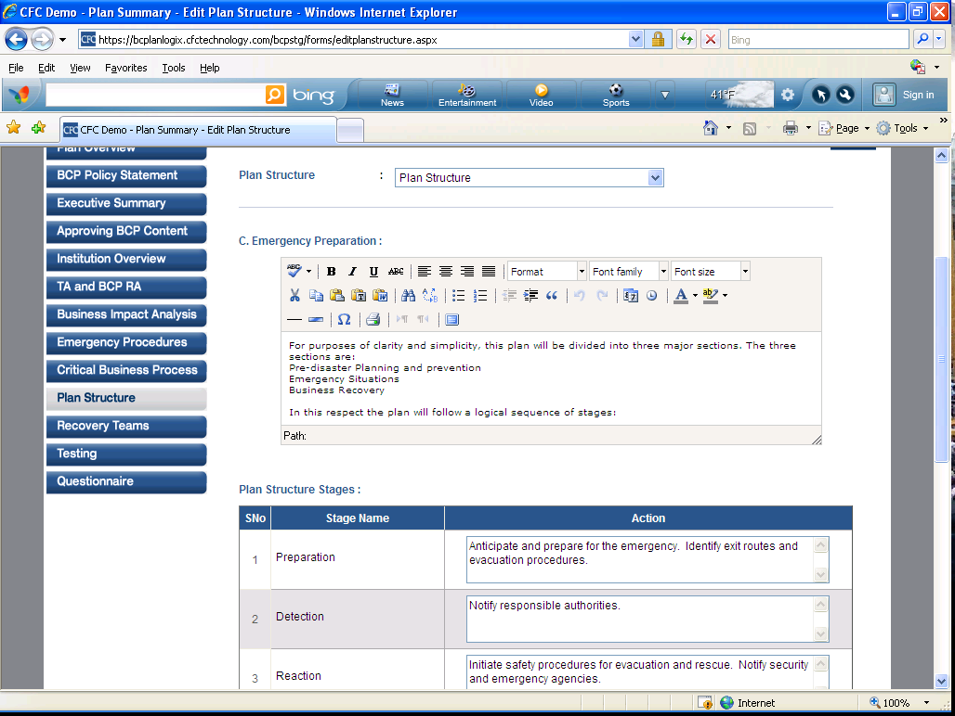

- Recovery Teams-This section includes the Recovery Teams which expand the capabilities and divide the responsibilities of the recovery effort. Each Recovery Team has a specific Recovery Team plan. In the event of a disaster, the procedures included in this plan are designed to assist in the recovery of the individual departments. The user is provided an option to Edit the details as per the location.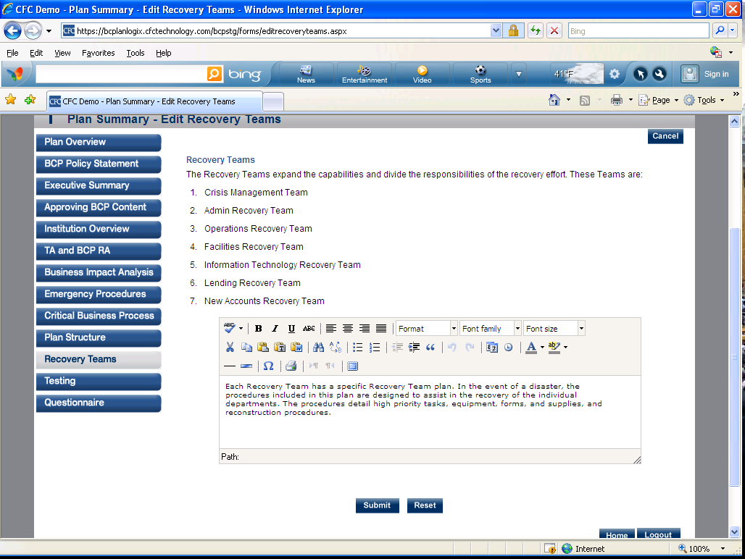
- Testing-This section includes the details of Considerations for Developing Testing Plans, Types of Tests, Development of Testing Plans, Structured Walk-Through Test Example, Current Testing. The user is provided an option to edit the details as per the location. 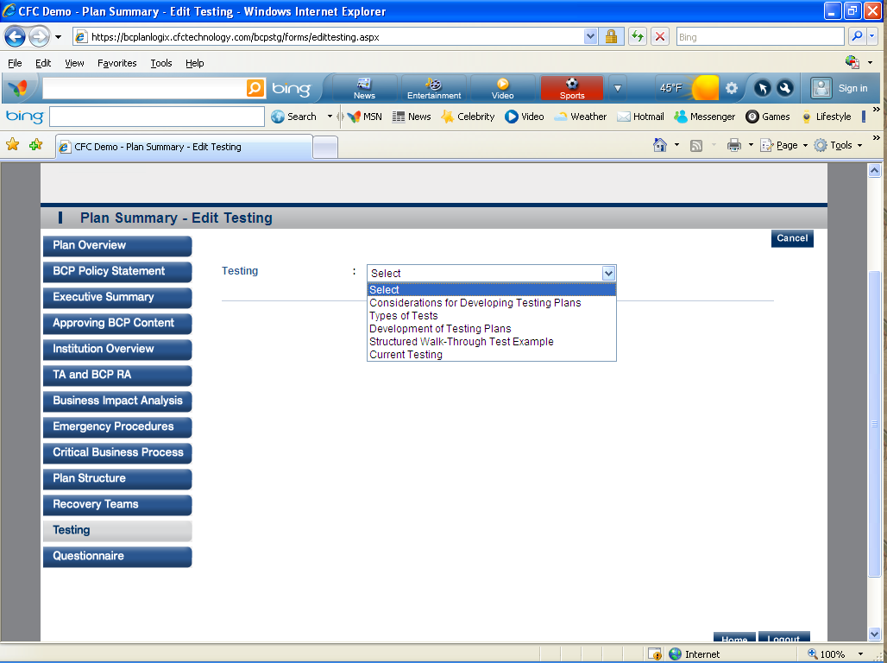

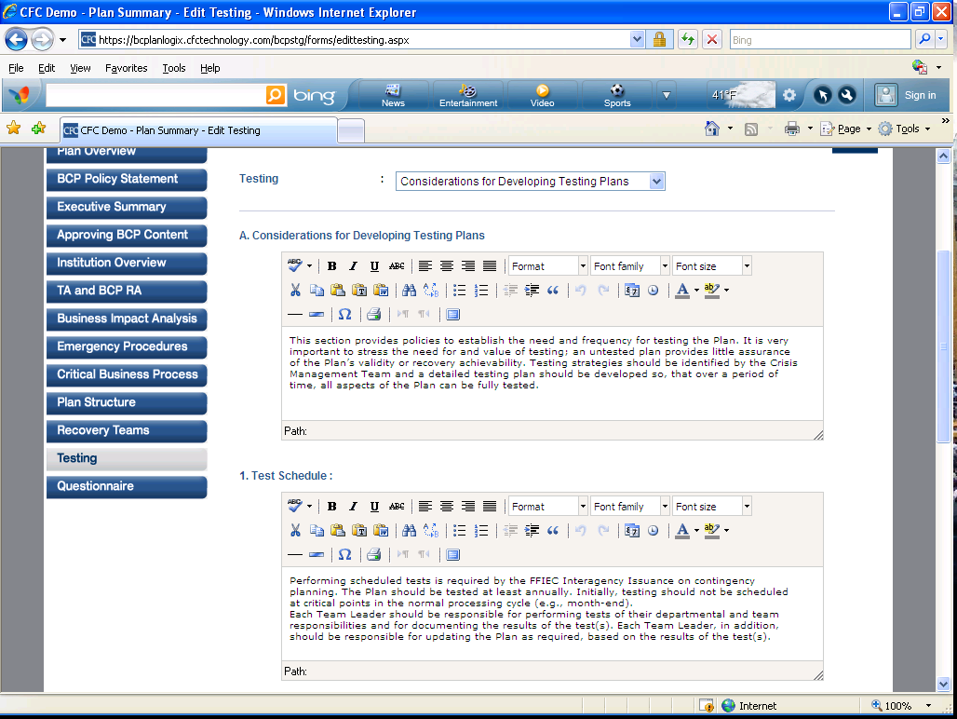
- Questionnaire- The questionnaire is a form to help you establish the information that you will need for an emergency.
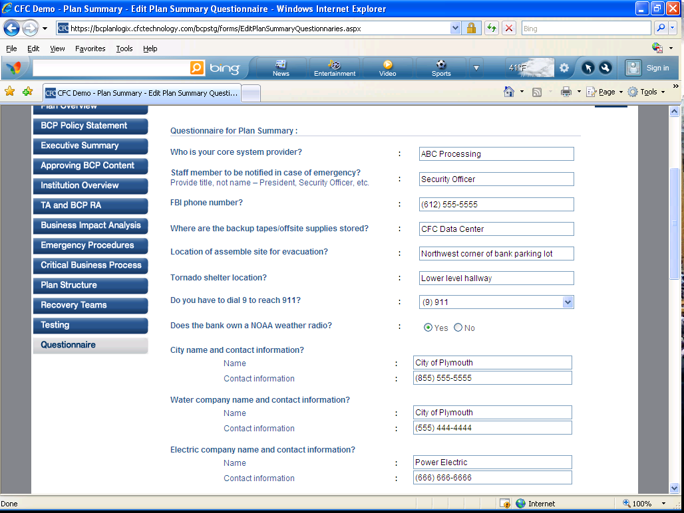

Team Plans
- BCP Teams – with view of Plan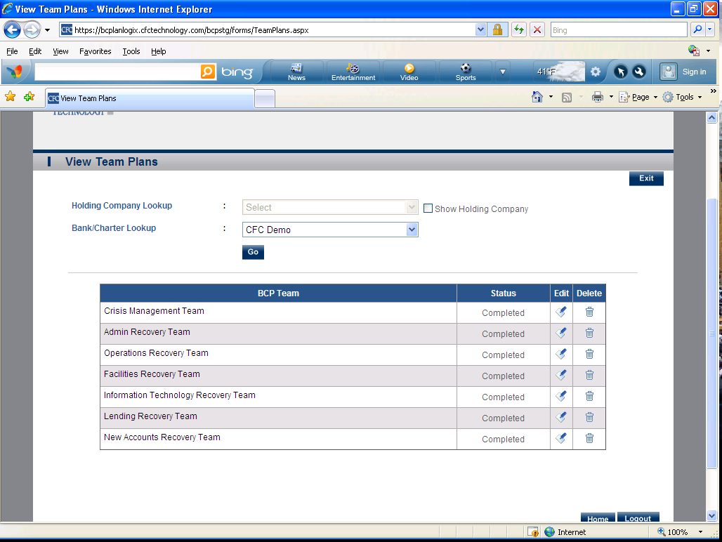

Plan Worksheets (3 Sections Listed Below)
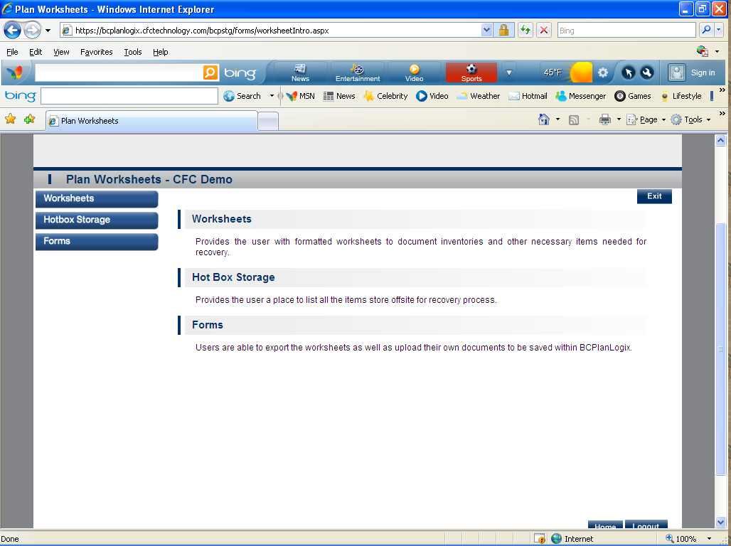
- Worksheets-Provides the user with formatted worksheets to document inventories and other necessary items needed for recovery.
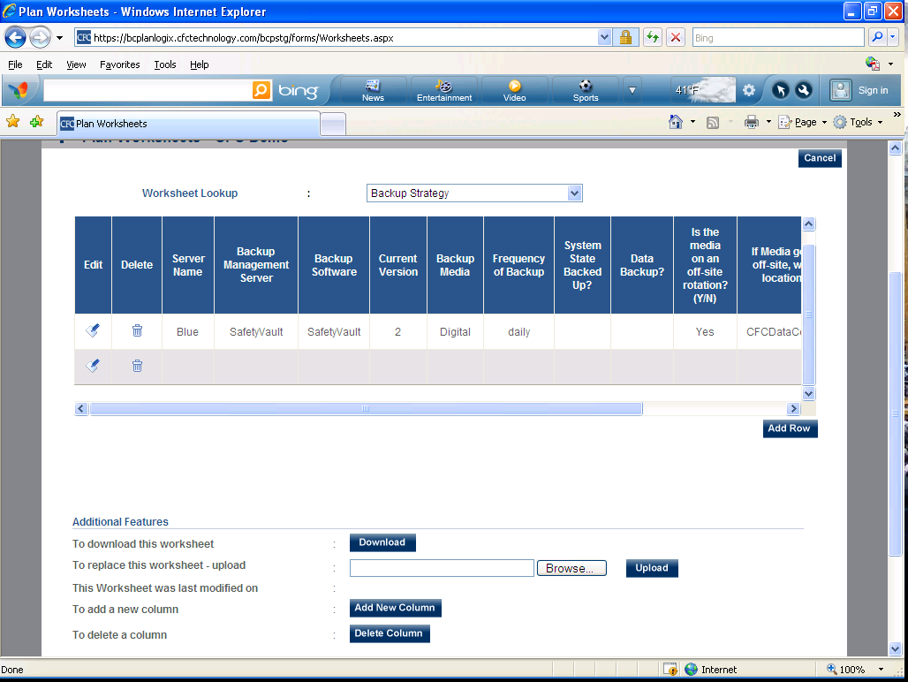

- Hotbox Storage-Provides the user a place to list all the items store offsite for recovery process.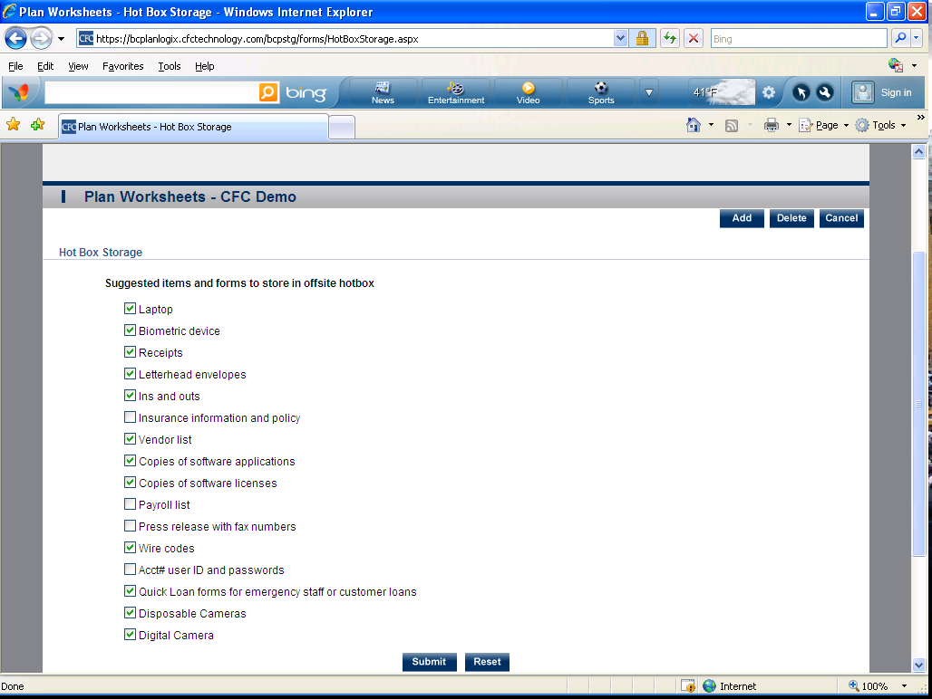
- Forms-Users are able to export the worksheets as well as upload their own documents to be saved within BCPlanLogix.
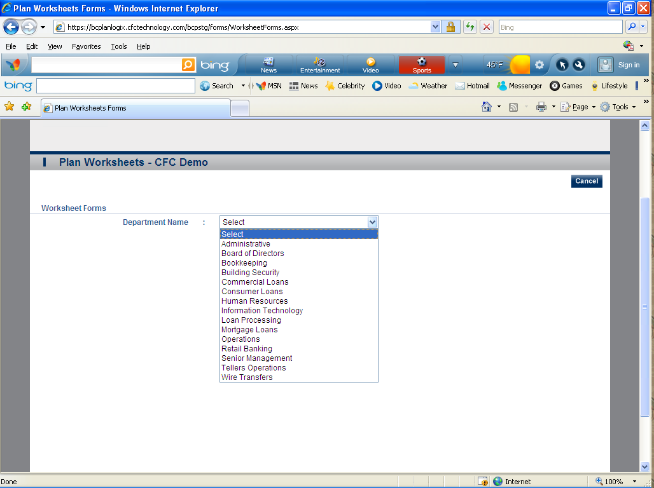

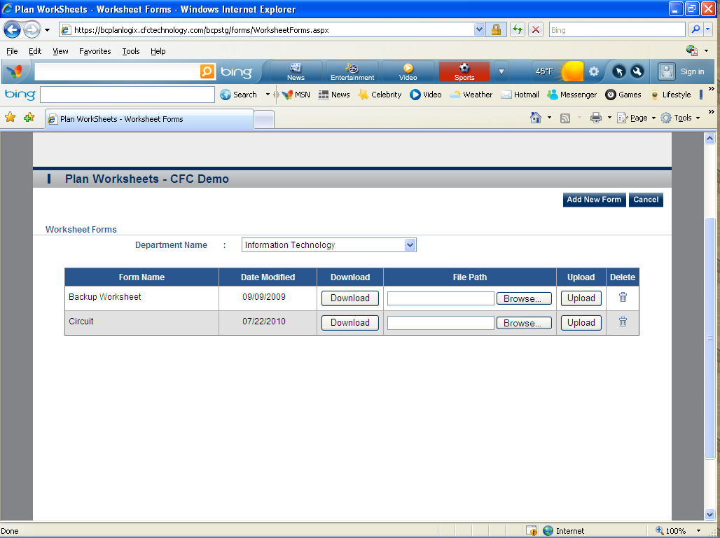

Maintenance (10 Sections Listed Below)
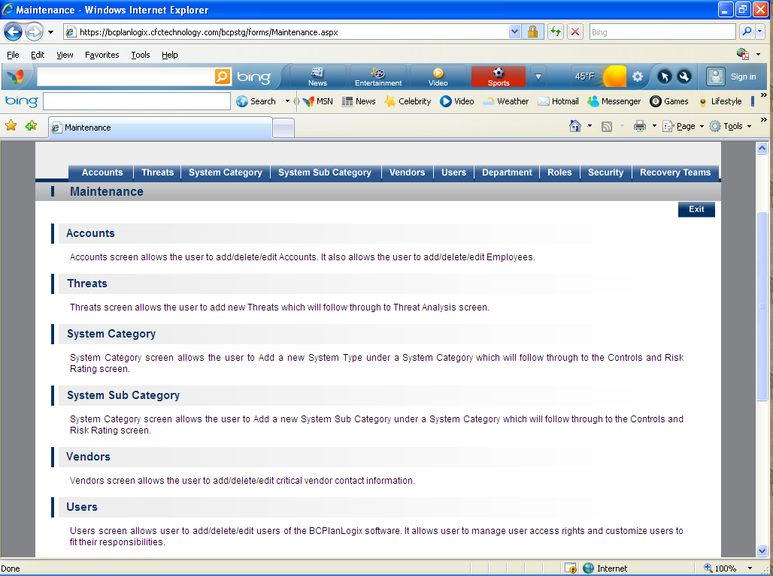
- Accounts- Accounts screen allows the user to add/delete/edit Accounts. It also allows the user to add/delete/edit Employees.
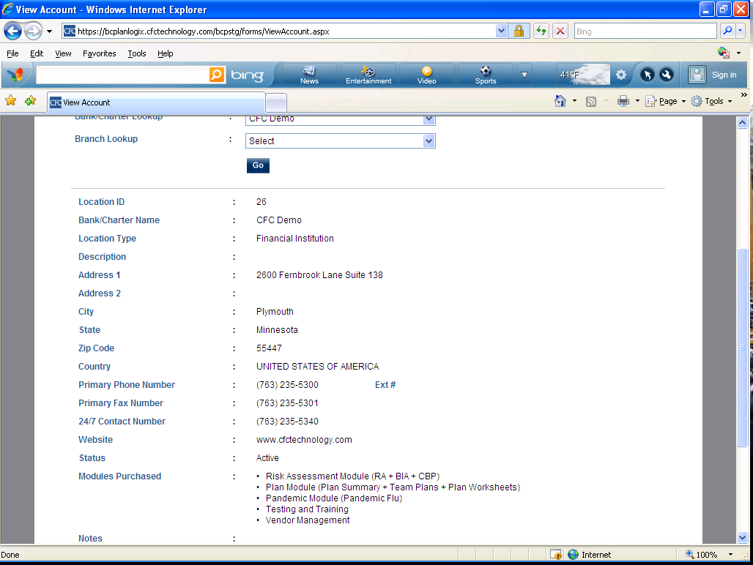

- Threats- Threats screen allows the user to add new Threats which will follow through to Threat Analysis screen. 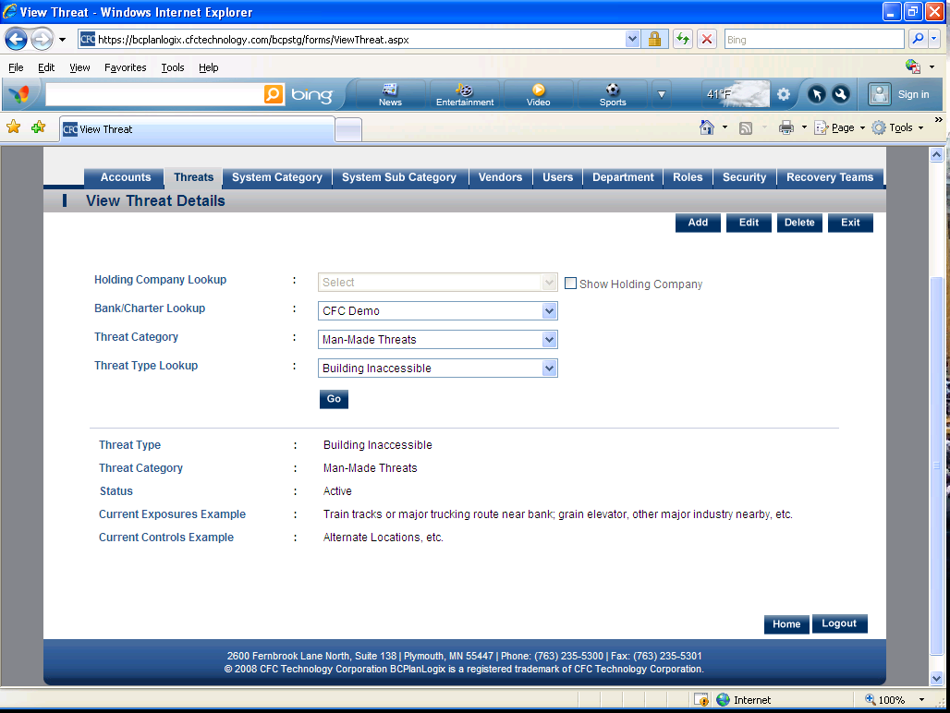
- System Category- System Category screen allows the user to Add a new System Type under a System Category which will follow through to the Controls and Risk Rating screen. 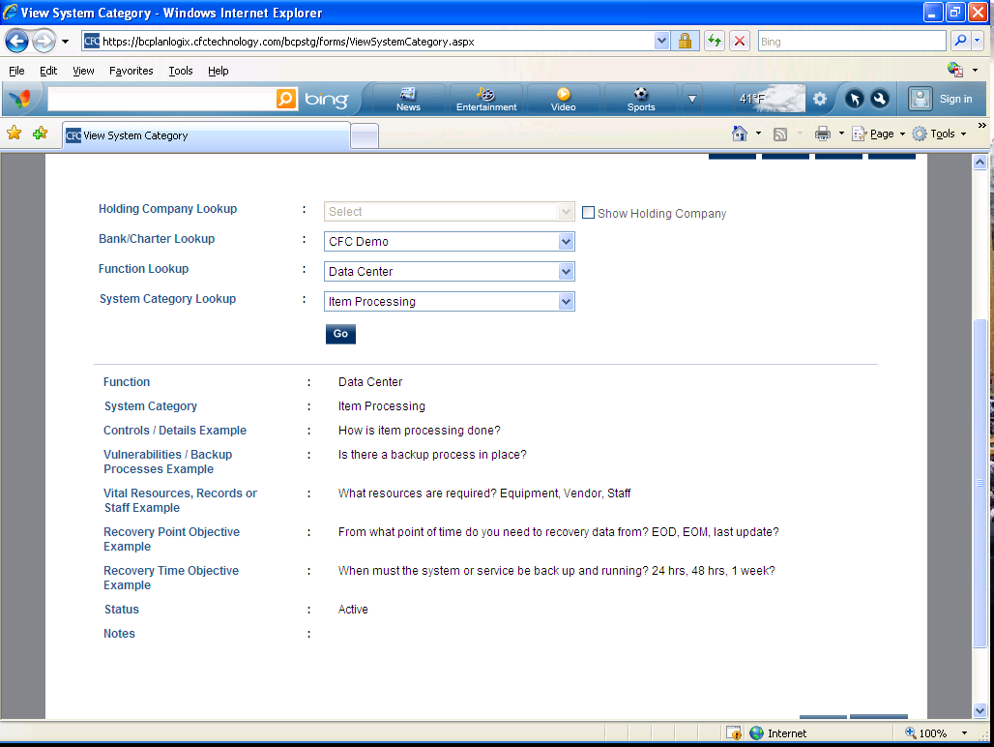

- System Sub Category- System Category screen allows the user to Add a new System Sub Category under a System Category which will follow through to the Controls and Risk Rating screen. 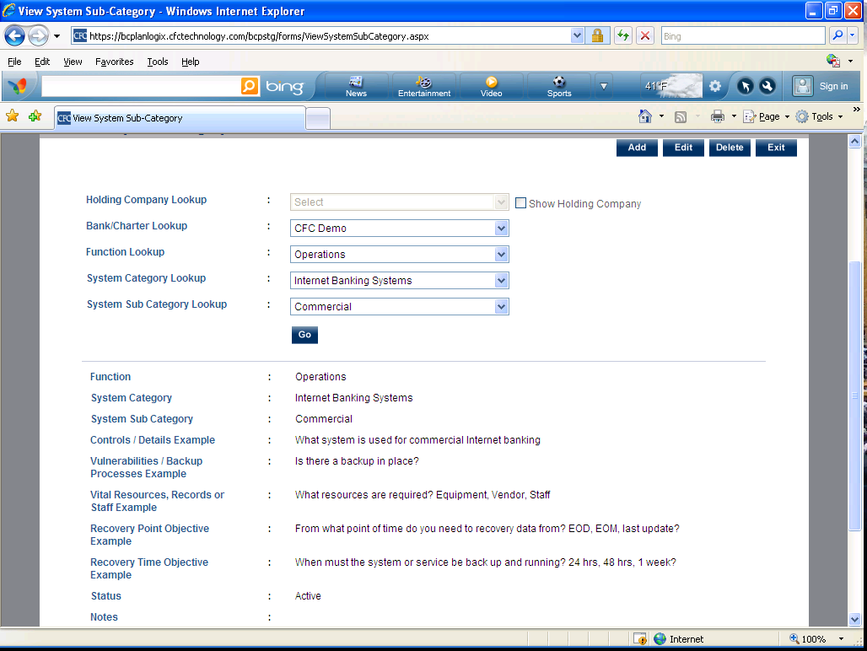
- Vendors- Vendors screen allows the user to add/delete/edit critical vendor contact information. 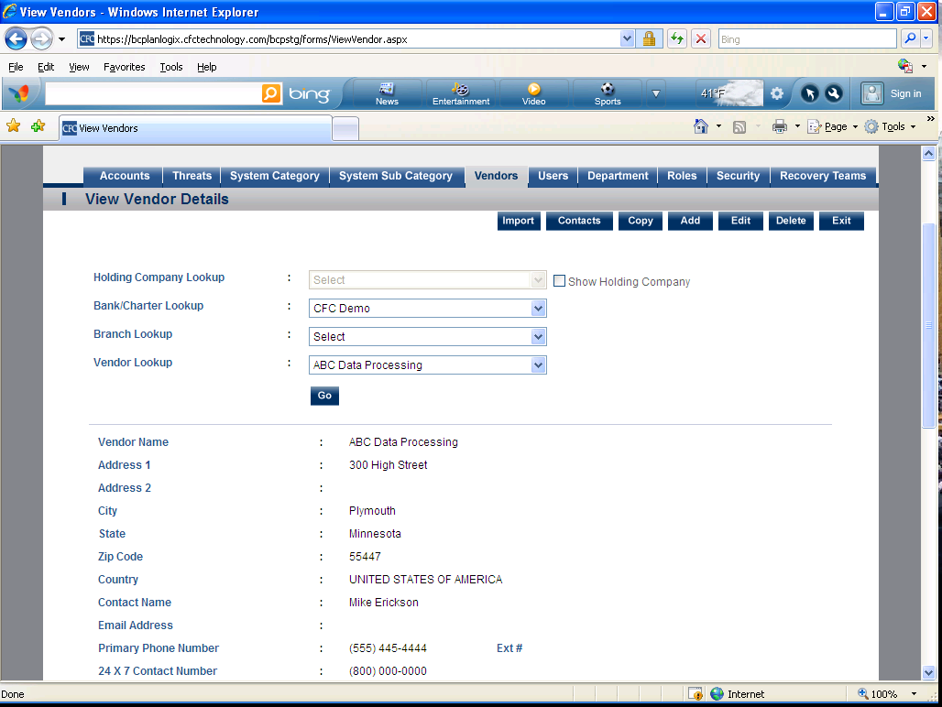

- Users- Users screen allows user to add/delete/edit users of the BCPlanLogix software. It allows user to manage user access rights and customize users to fit their responsibilities. 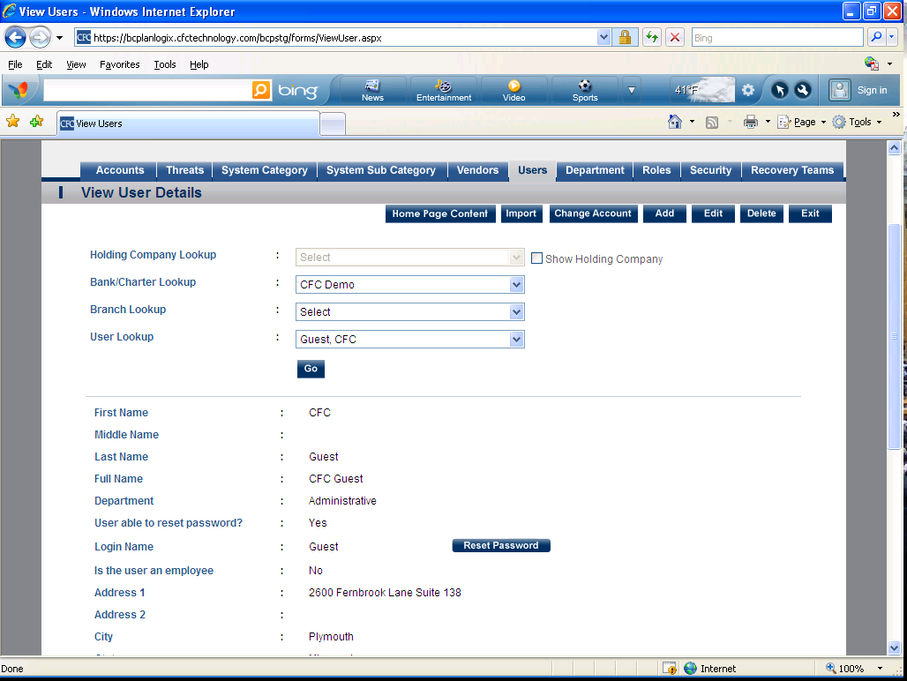
- Department- Departments is used to create custom departments for the institution. 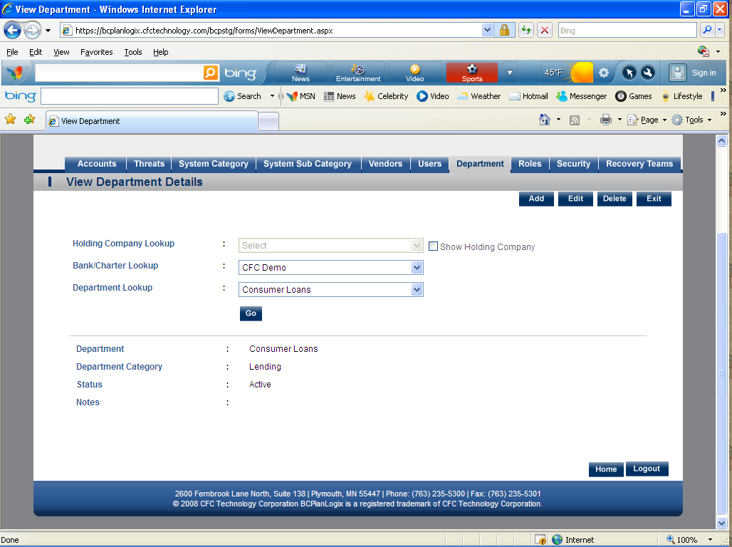

- Roles- Role provides the user the ability to customize the user access roles. 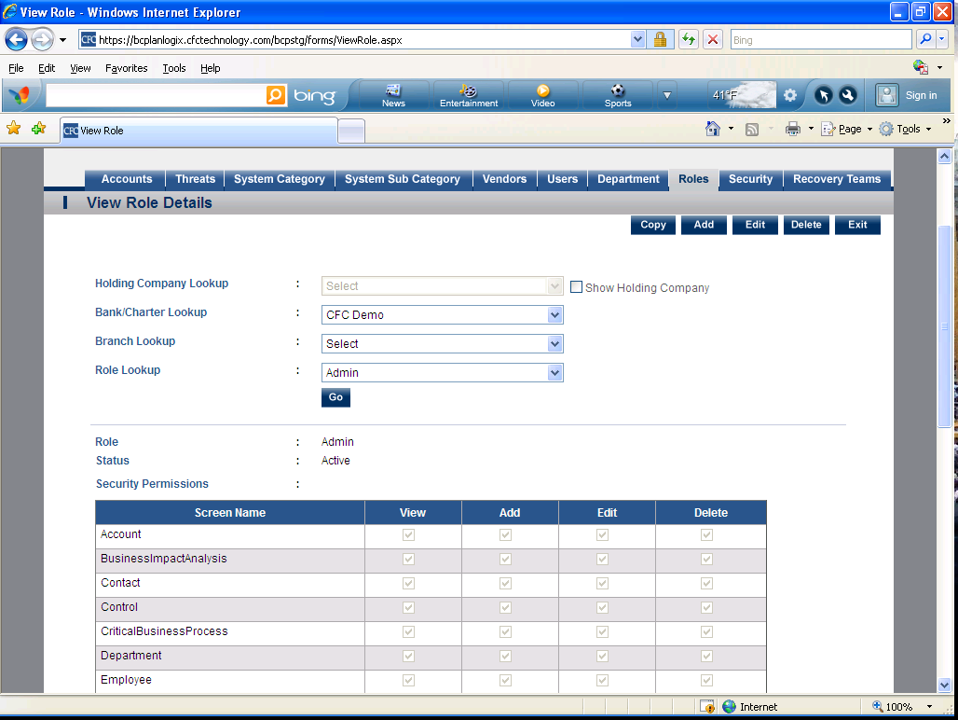
- Security- Security allows the user to link system users and access roles. 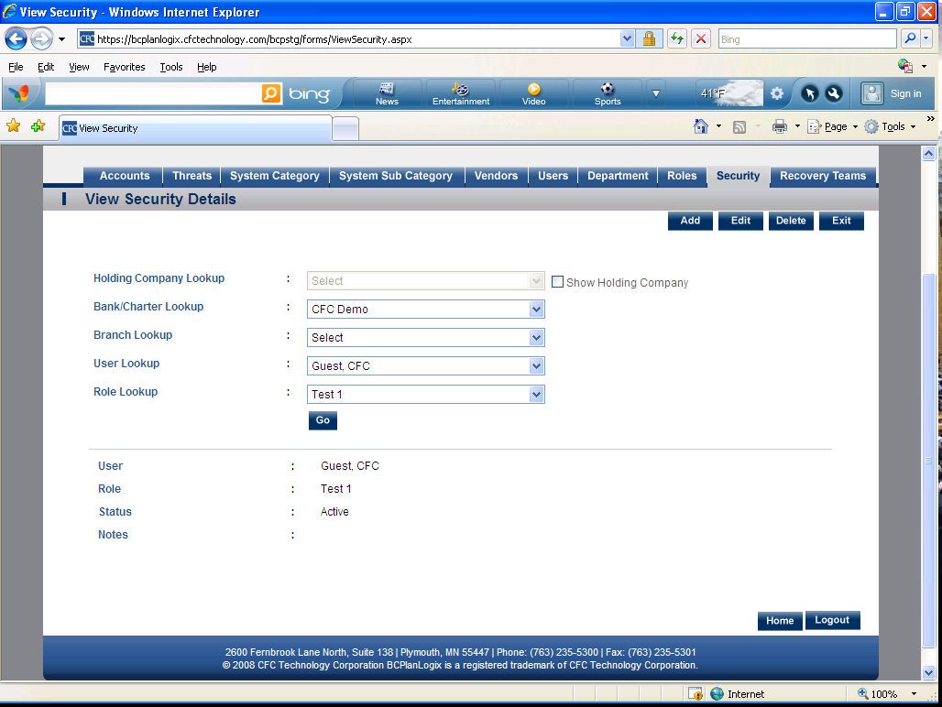

- Recovery Teams- Recovery Teams allows the user to customize the recovery team names and link departments to recovery teams. 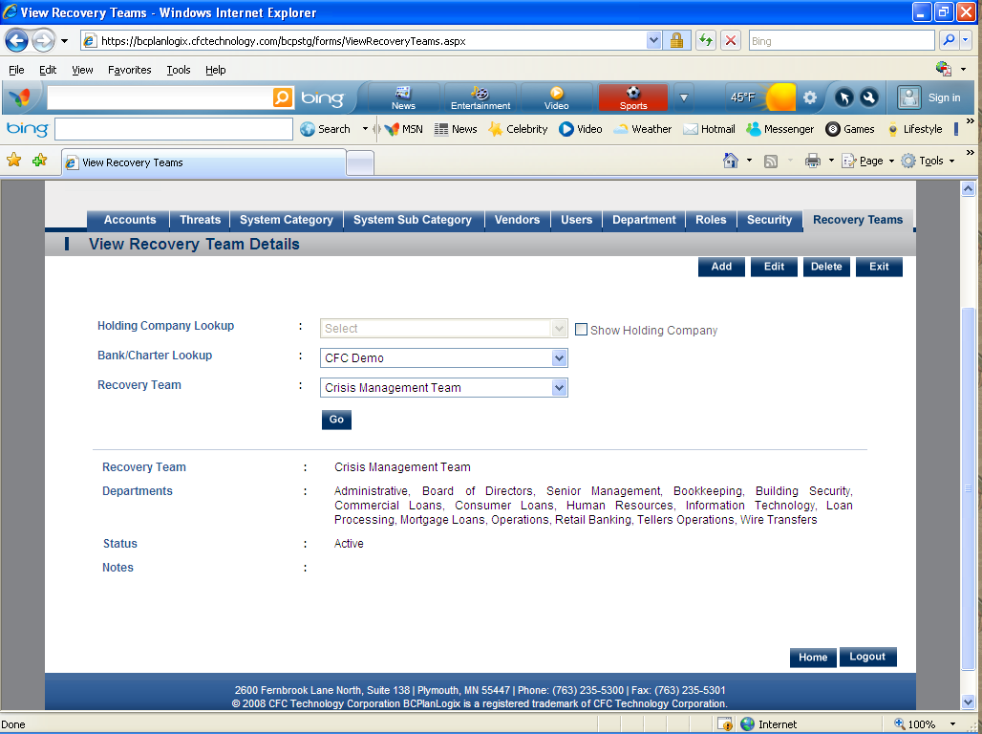

Reports (Modules)
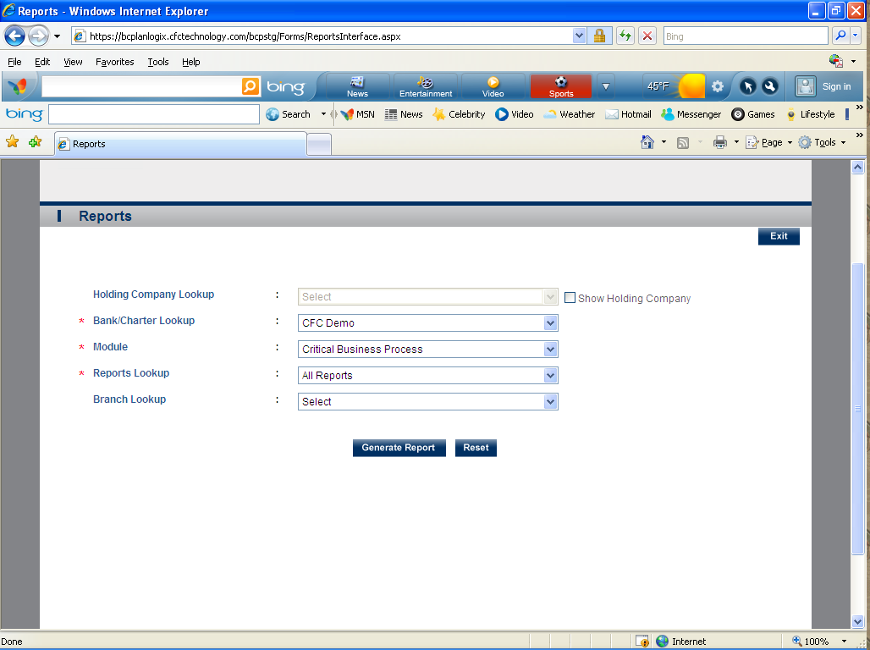
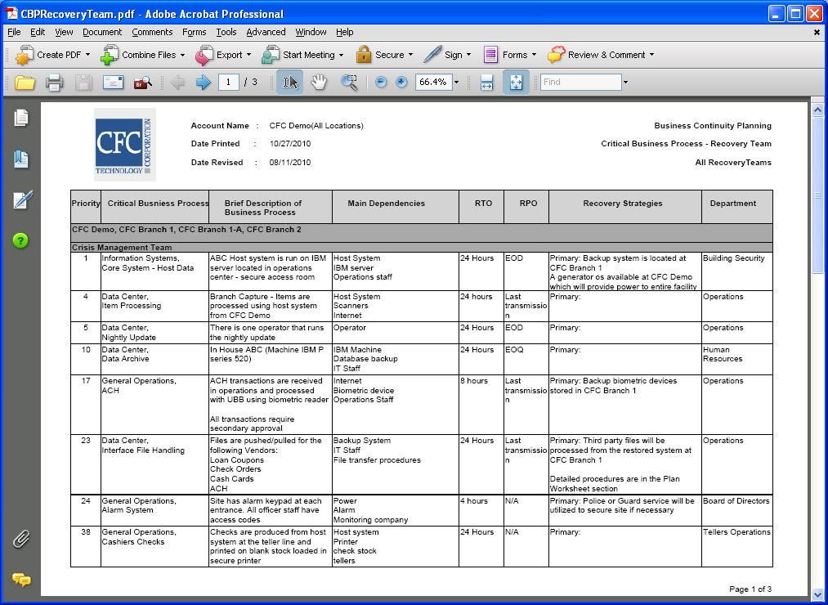

This is a module that allows you to generate reports for:
- Risk Assessments-
- Business Impact Analysis
- Critical Business Process
- Plan Summary
- Team Plans
- Plan Worksheets
- Pandemic Flu
- Testing
- Training
- Maintenance

