Pandemic Flu (19 Sections Listed Below)
- Plan Overview-Plan Overview allows the user to view the plan details.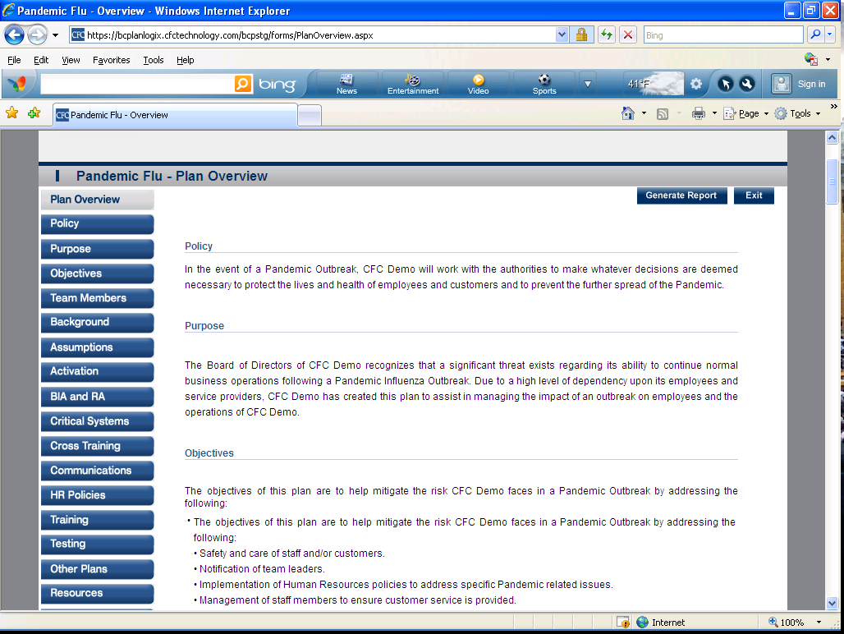

- Policy-This section includes the Policy of Pandemic Plan response. 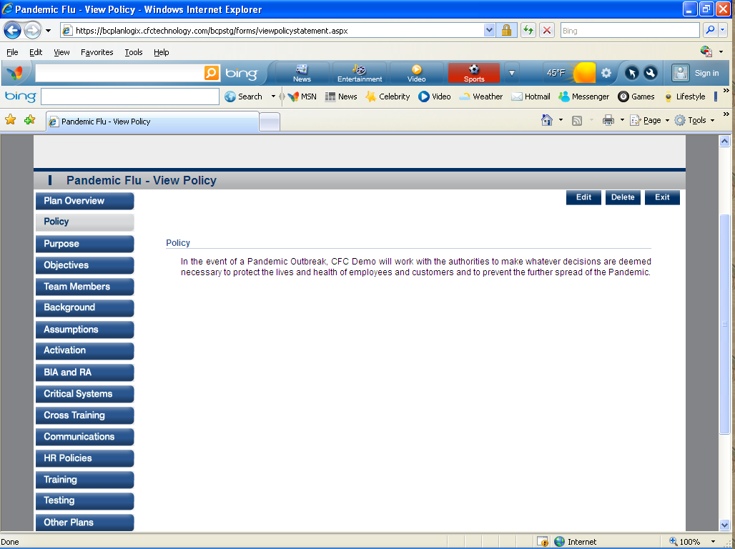
- Purpose-This section allows the user to define the purpose of the Pandemic Plan. 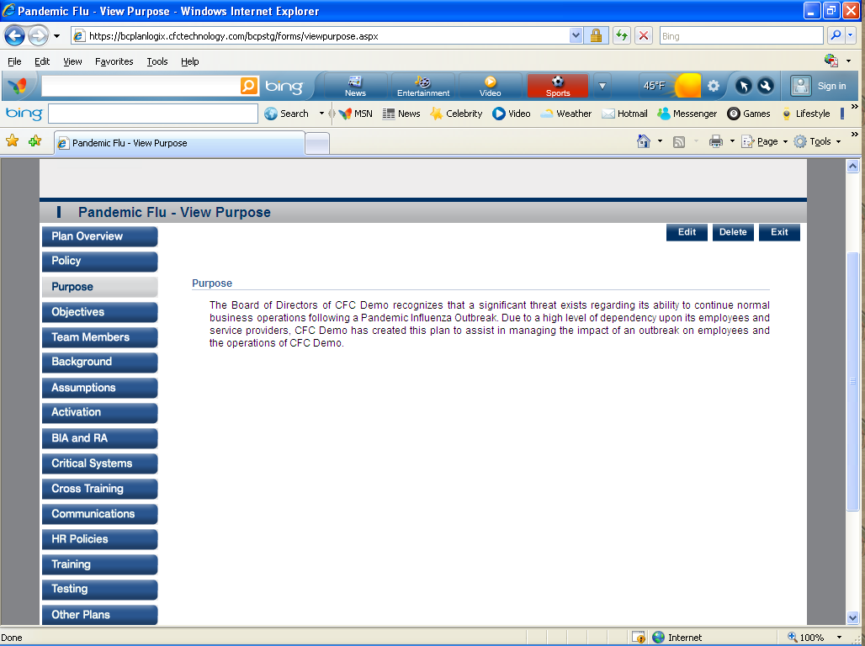

- Objectives-This section allows user to define objectives of the Pandemic Plan. 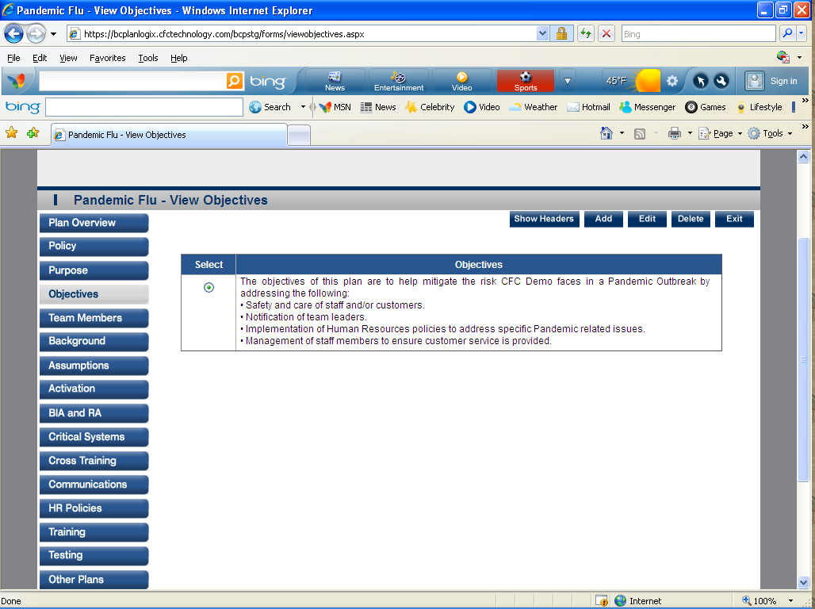

- Team Members- Teams Members allow user to assign employees to the Pandemic Recovery process.
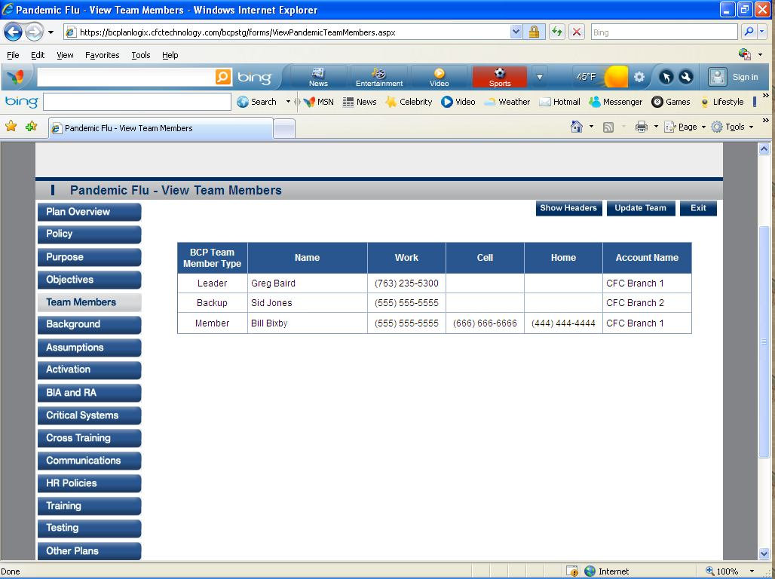

- Background- Background helps in finding the probability of the occurrences of Pandemic Flu and it’s in the past.
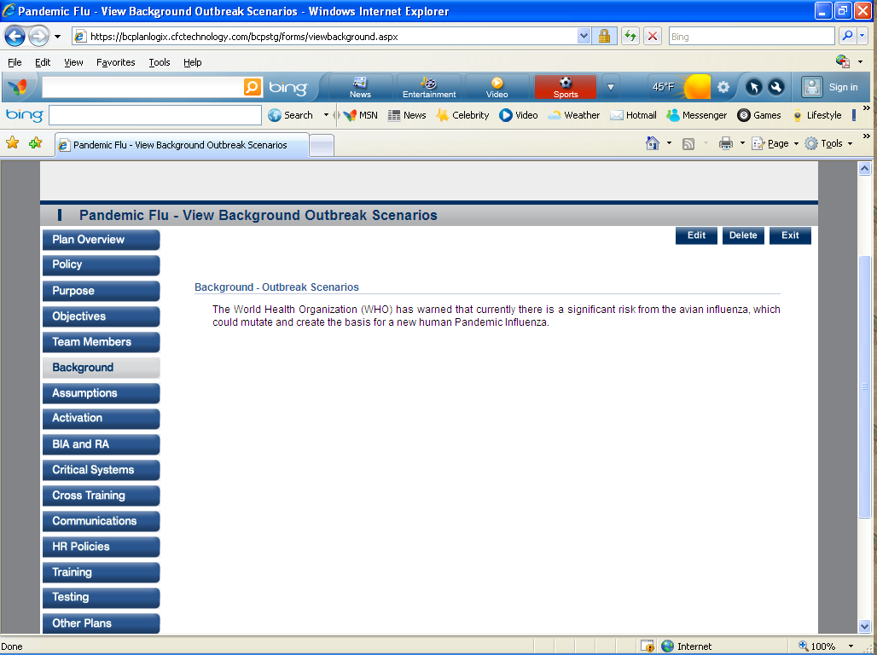
- Assumptions- This allows the user to add assumptions that are to be considered when there is a Pandemic Outbreak.
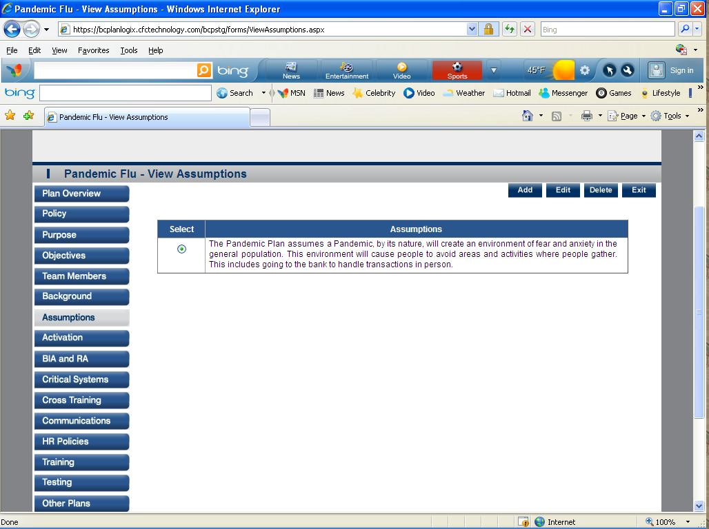

- Activation- Defines the way the Pandemic Plan will be activated. 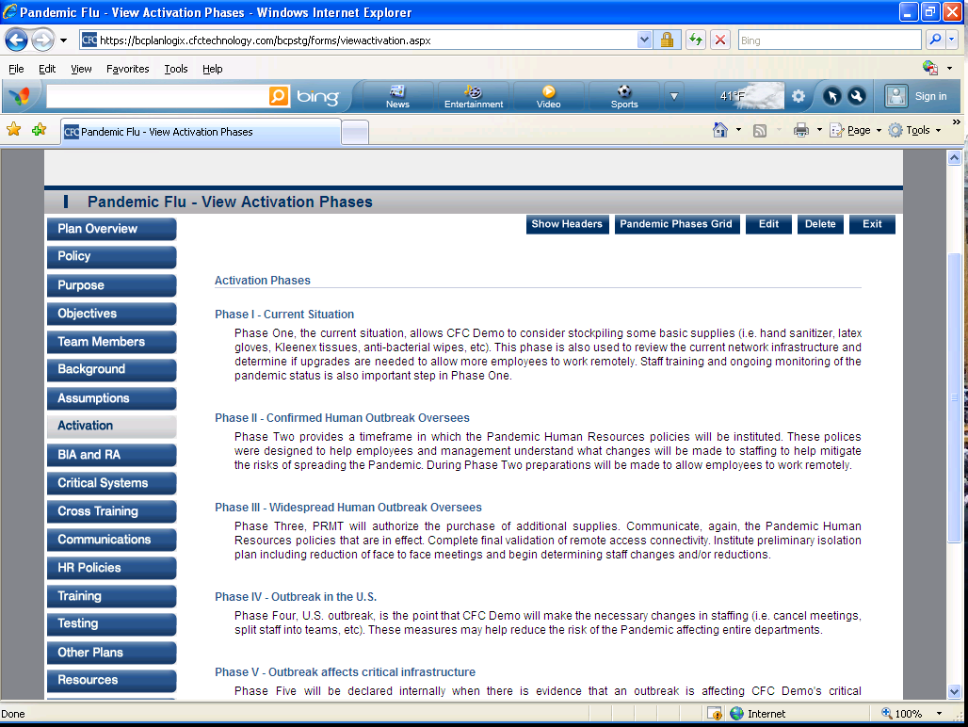

- BIA and RA- BIA and RA help to identify the risks the bank faces with regard to Pandemic Planning.
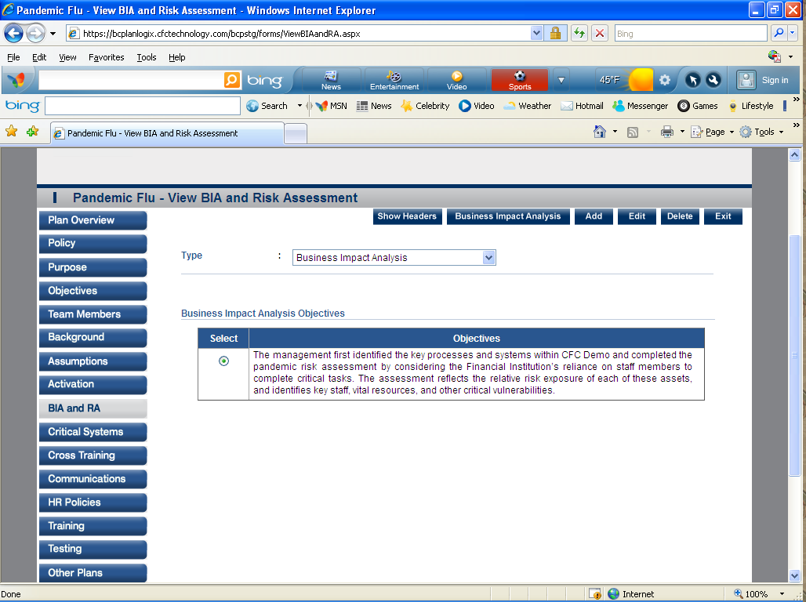

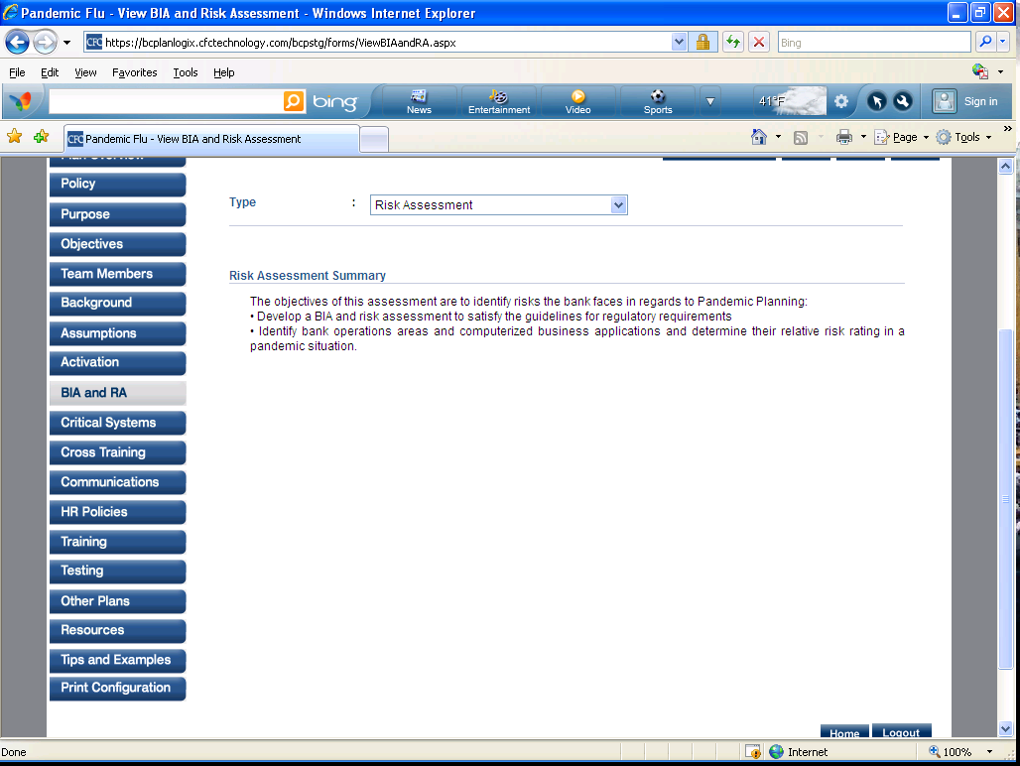
- Critical Systems- This section includes an overview of Critical Business Processes including a brief description of the business process.
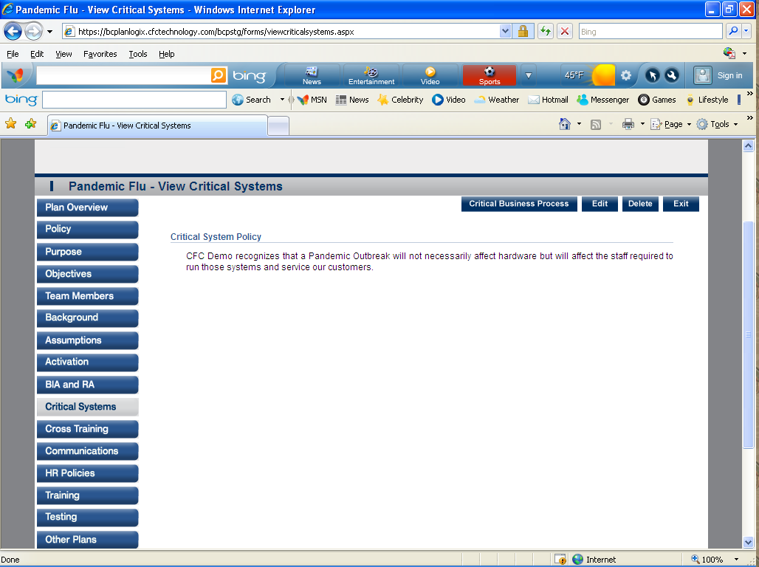

- Cross Training- This section will allow user to define critical processes and the document the cross training in place.
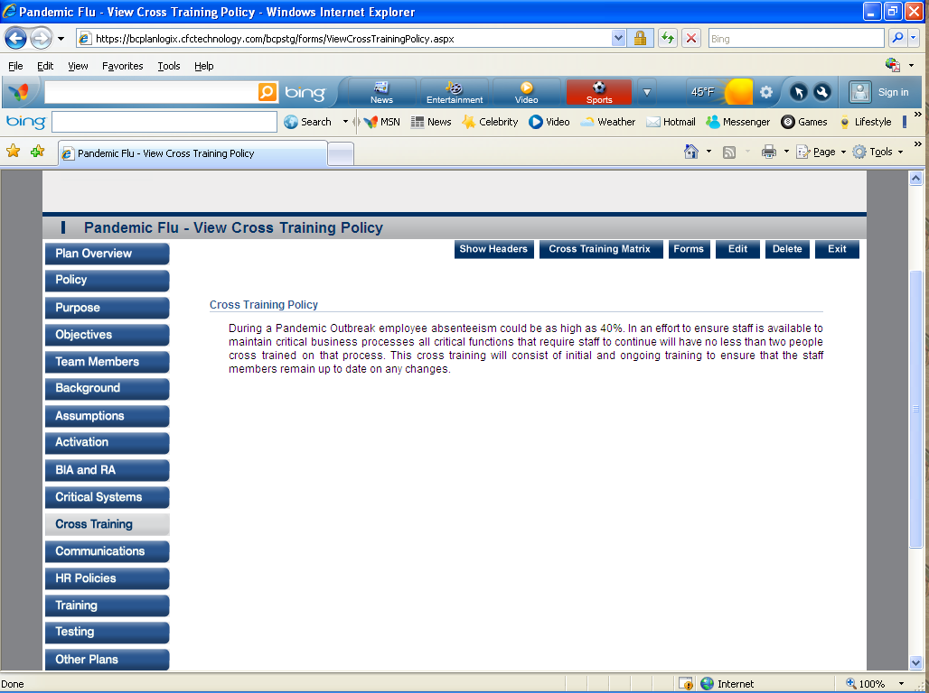
- Communication- This section allows the user to define how the Pandemic Plan will be communicated to customers.
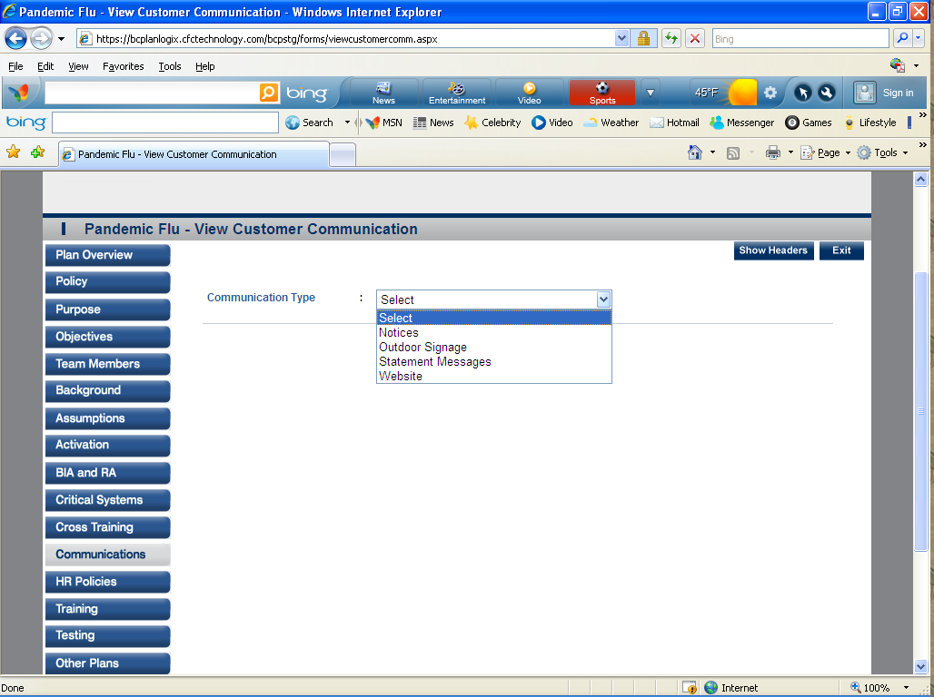

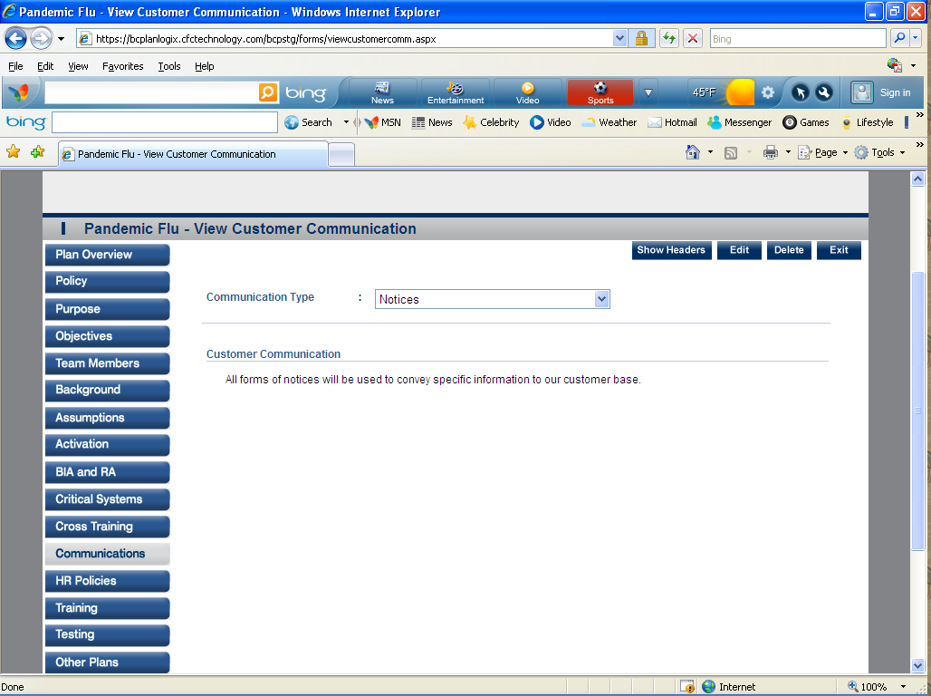
- HR Policy- Human Resource policies are an important part of your Pandemic Plan. This section will allow you define and document your Pandemic HR policies. 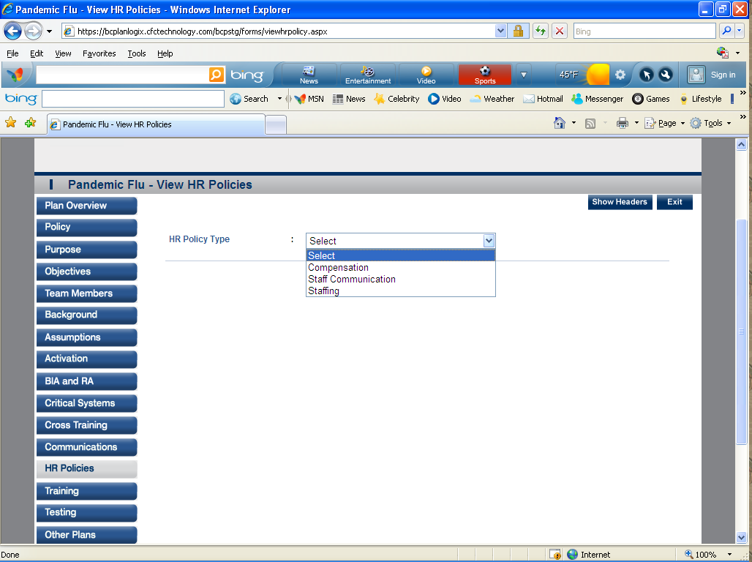

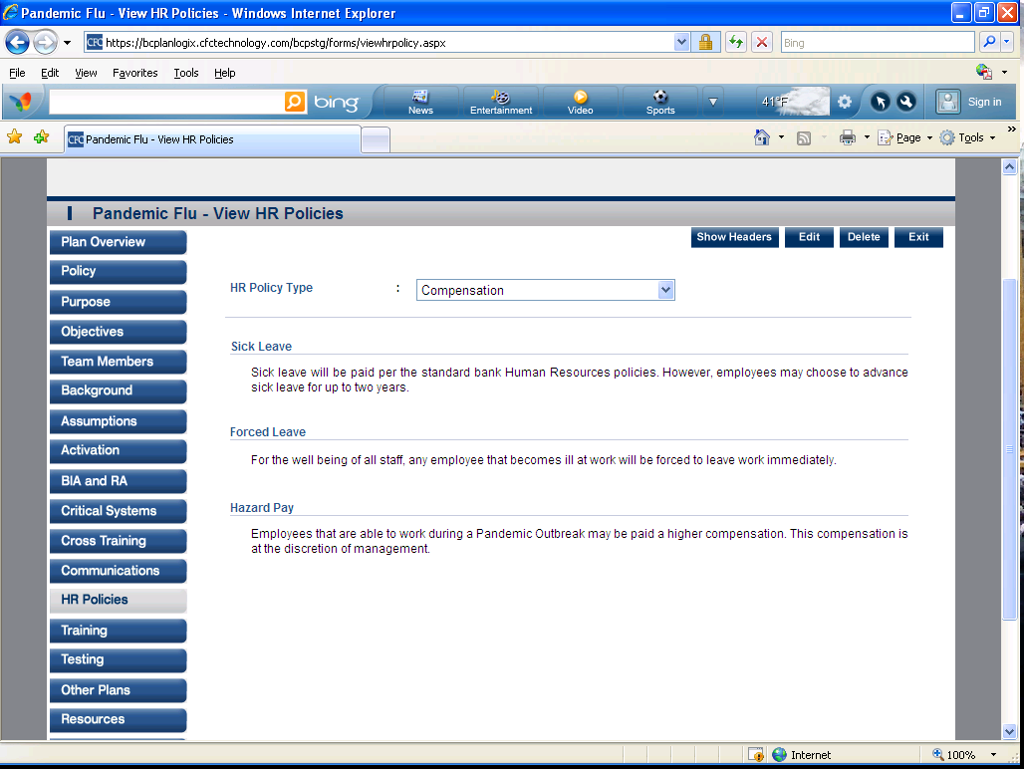

Training- This section will be used to define the training required to keep the staff informed and prepared for a Pandemic outbreak.

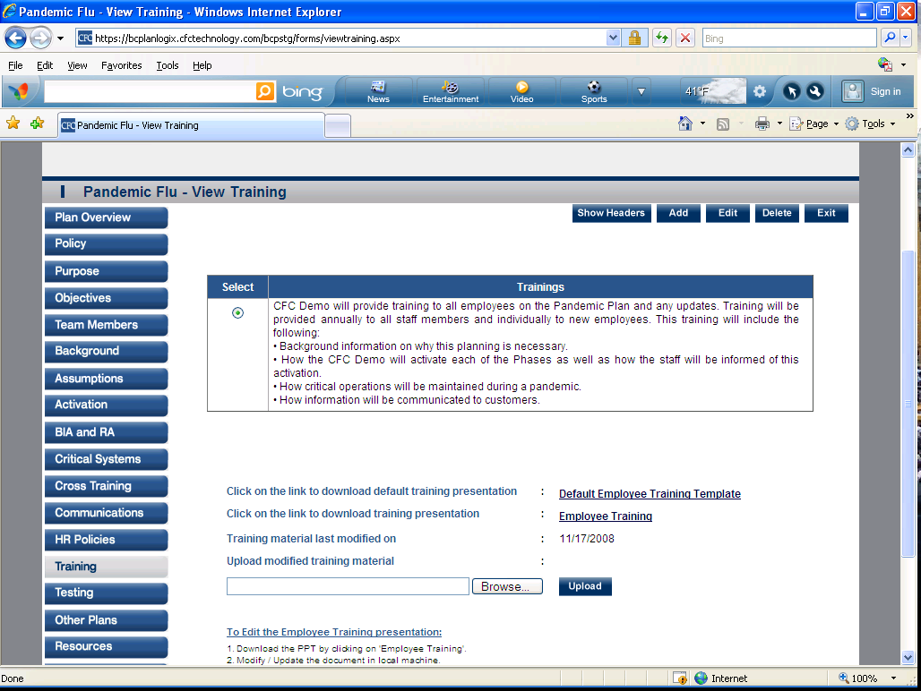

- Testing- This section includes allows the user to define the testing methodologies for the Pandemic Plan. 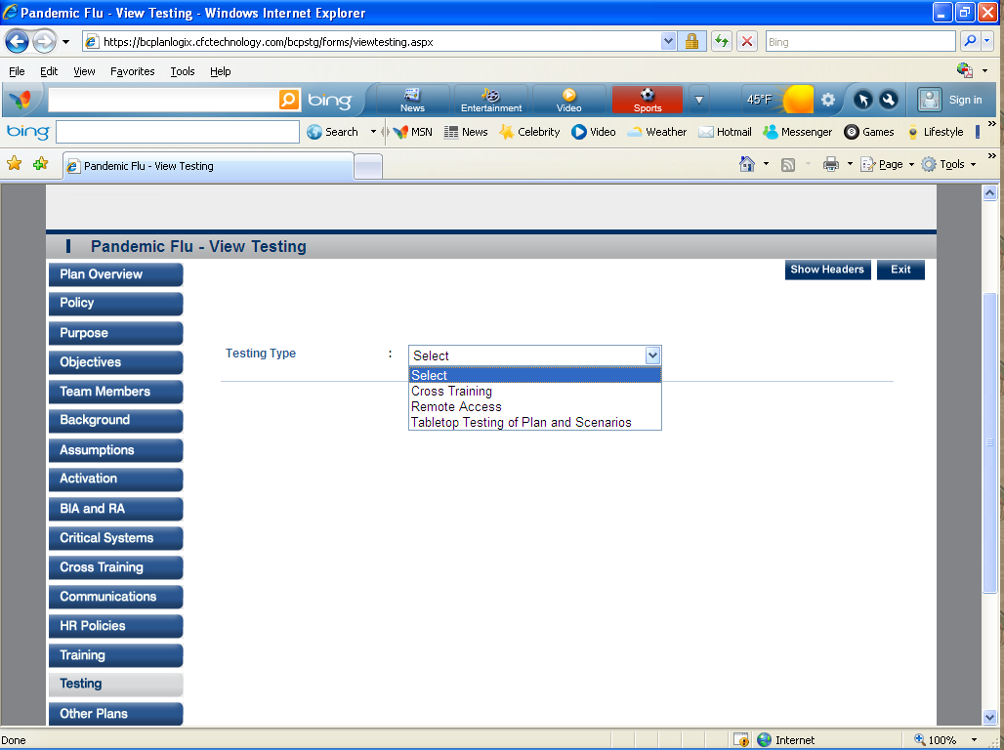
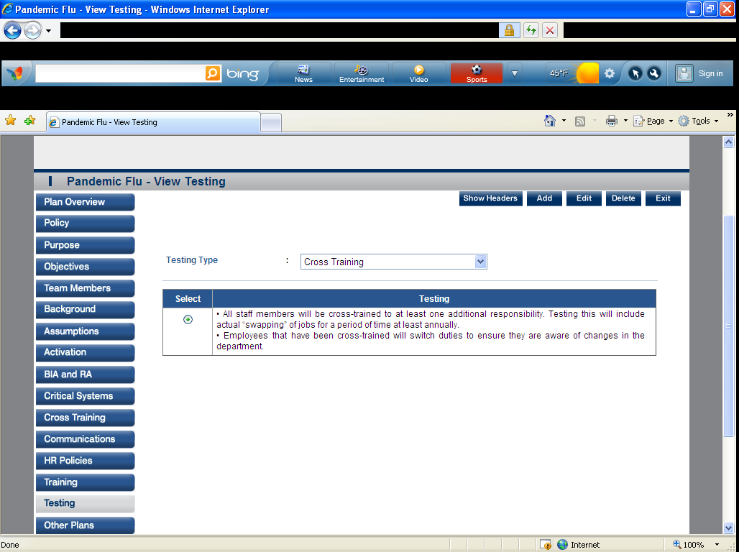

- Other Plans- This section provides a series of questions that will help determine the institutions position on
these topics.
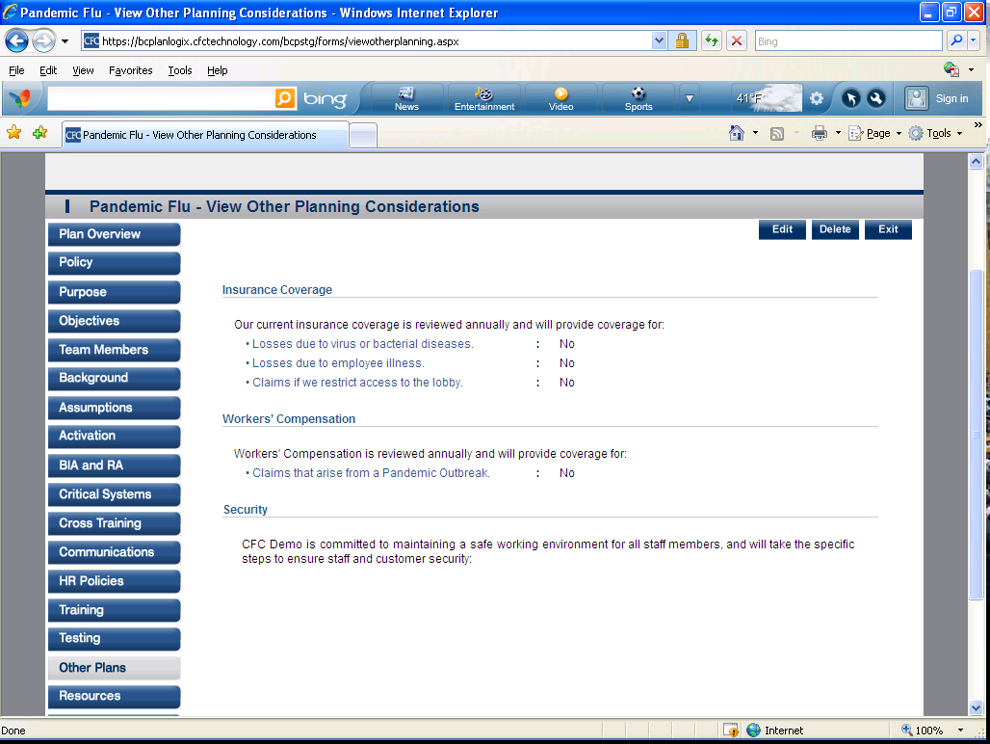
- Resources- This section is a reporting form for staff communications. 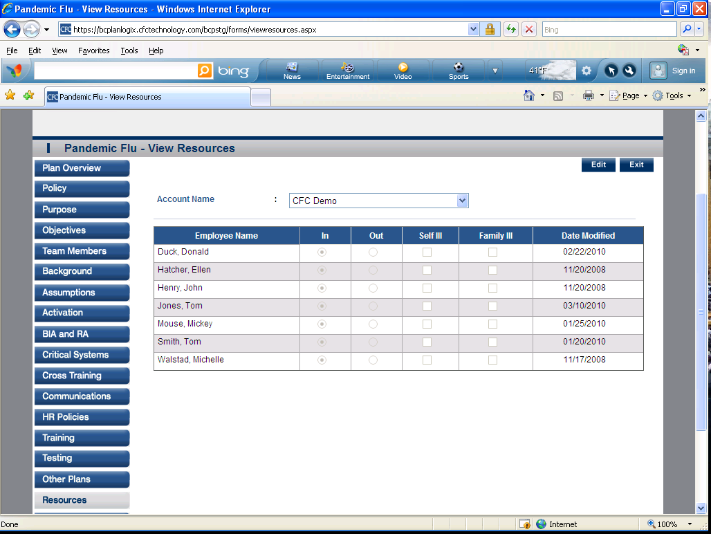

- Tips and Examples-This section gives you tips and examples for your Pandemic overview. 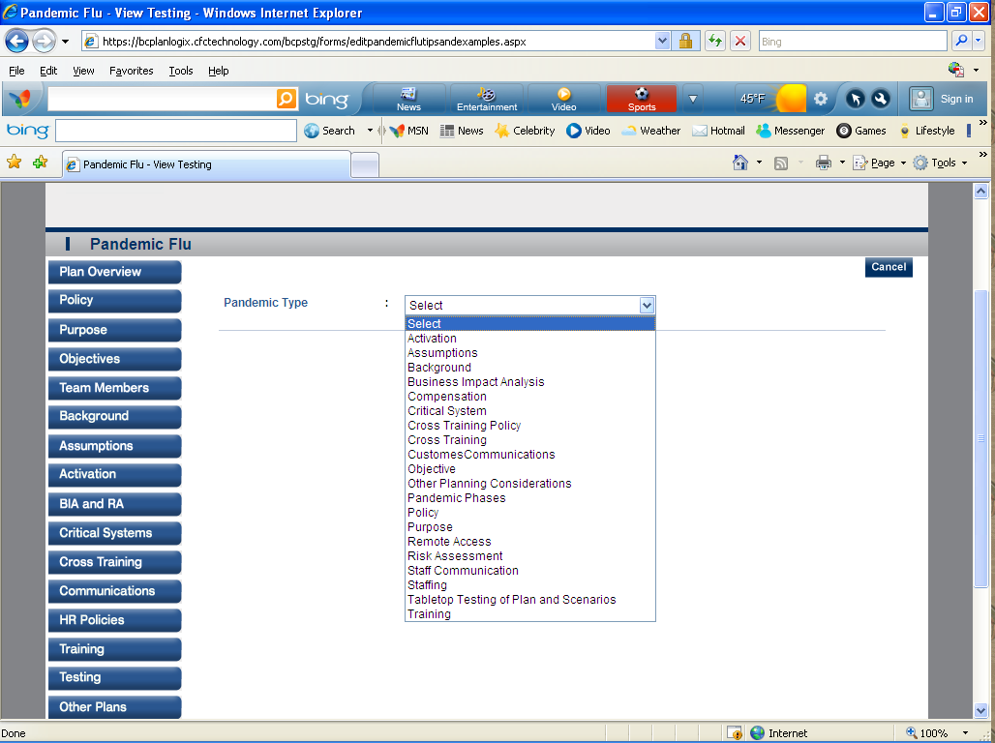
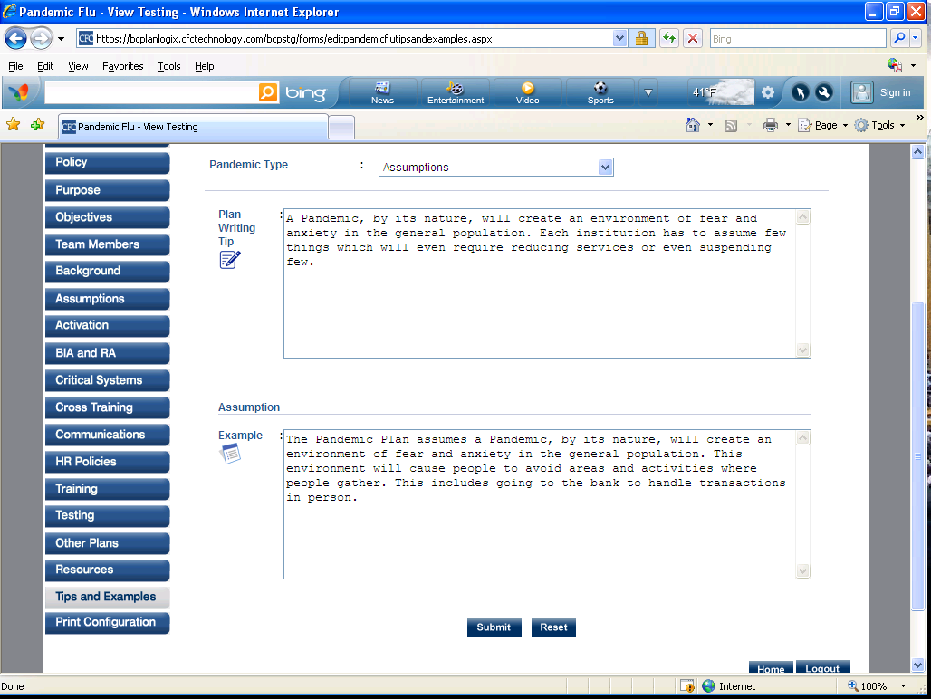

- Print Configurations-This section allows you to print the section that you want printed.