Milestone Manager
This is the login screen for the institution to enter their setup for Email\Text Notification.
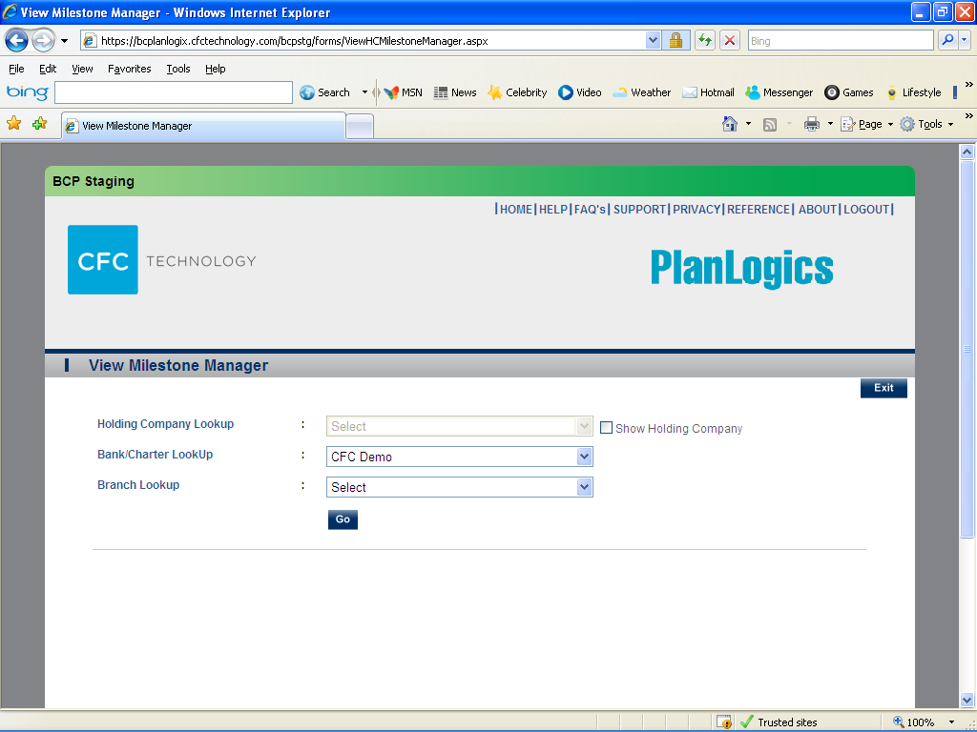
This is screen number one to setup the notification for emails and text (SMS) messages.
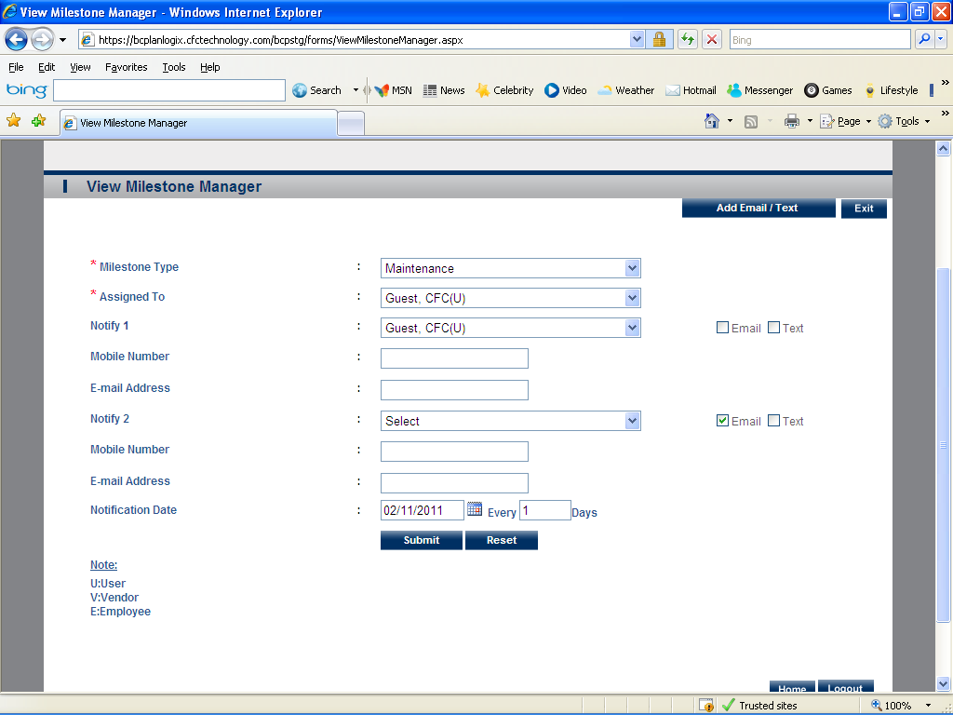
This is screen number two. It is where you will edit your emails and text messages for the notifications.
