Maintenance (10 Sections Listed Below)
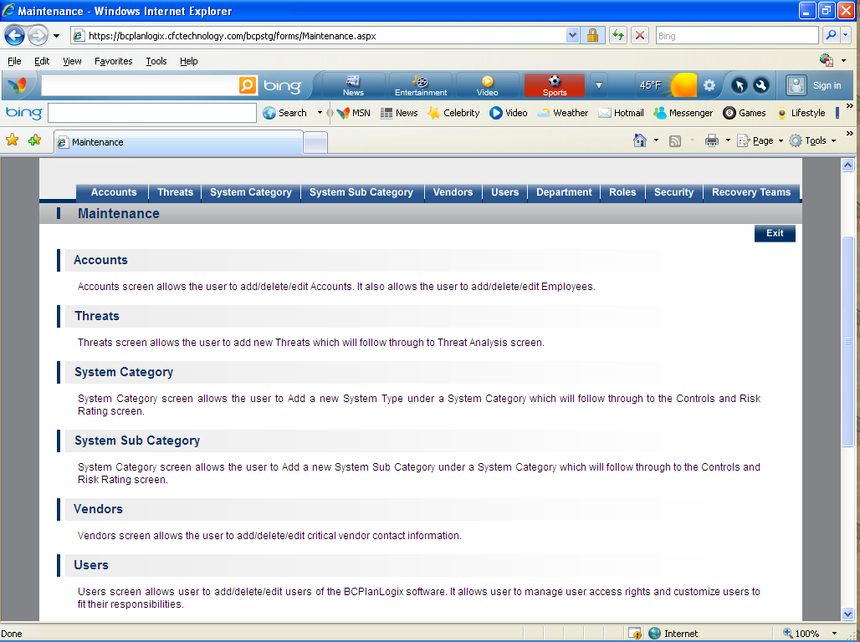
- Accounts- Accounts screen allows the user to add/delete/edit Accounts. It also allows the user to add/delete/edit Employees.
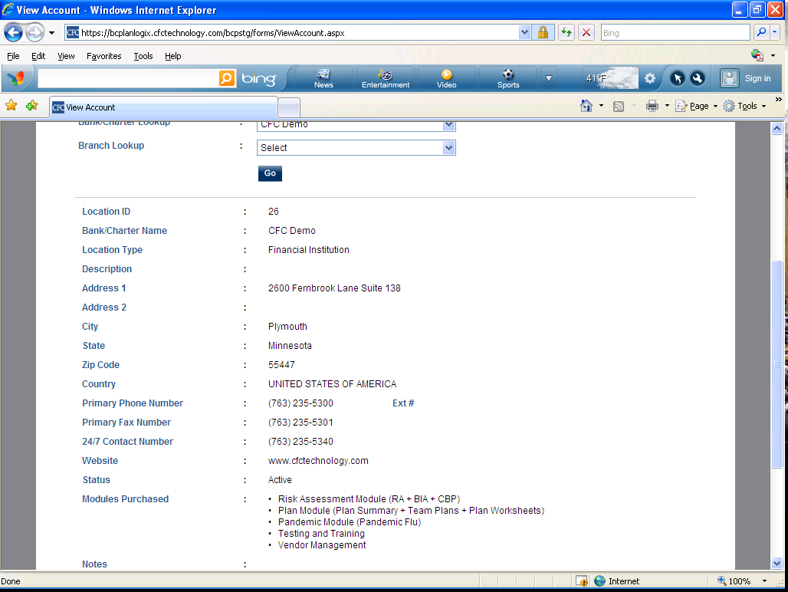

- Threats- Threats screen allows the user to add new Threats which will follow through to Threat Analysis screen. 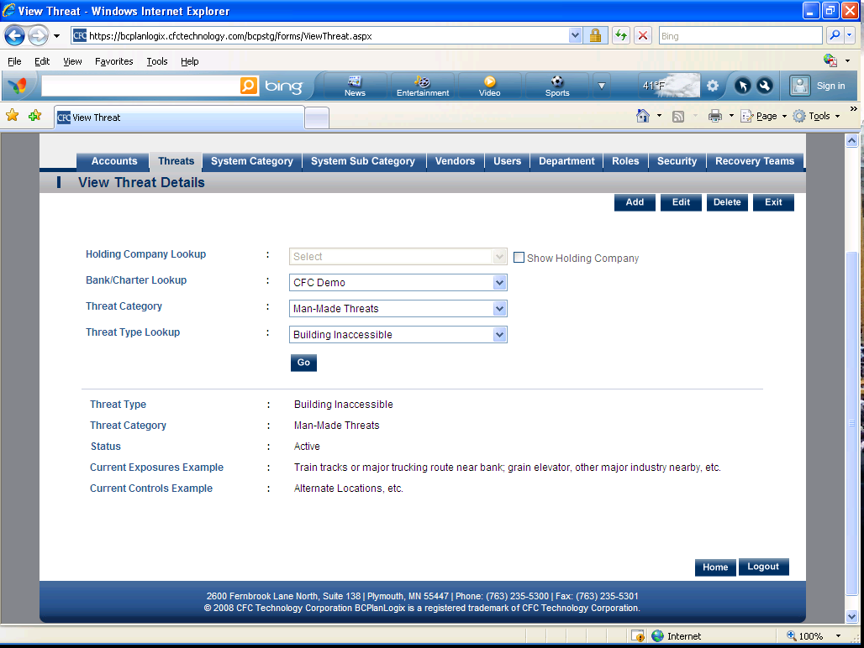
- System Category- System Category screen allows the user to Add a new System Type under a System Category which will follow through to the Controls and Risk Rating screen. 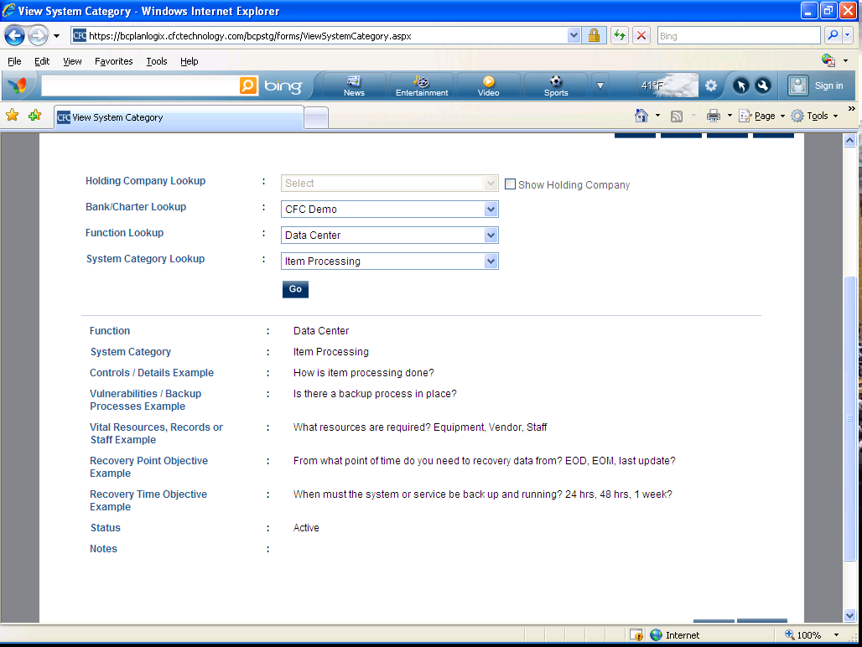

- System Sub Category- System Category screen allows the user to Add a new System Sub Category under a System Category which will follow through to the Controls and Risk Rating screen. 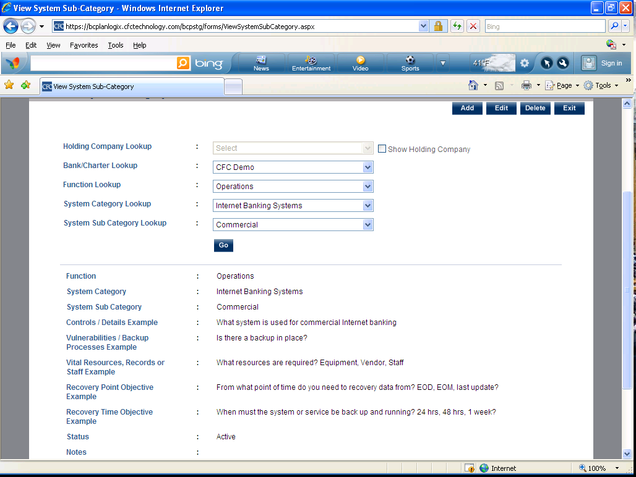
- Vendors- Vendors screen allows the user to add/delete/edit critical vendor contact information. 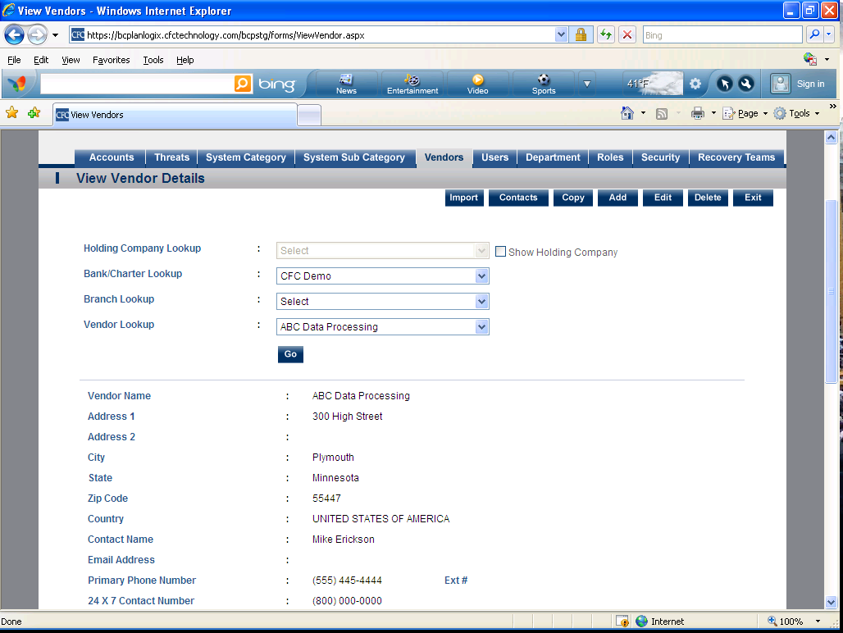

- Users- Users screen allows user to add/delete/edit users of the BCPlanLogix software. It allows user to manage user access rights and customize users to fit their responsibilities. 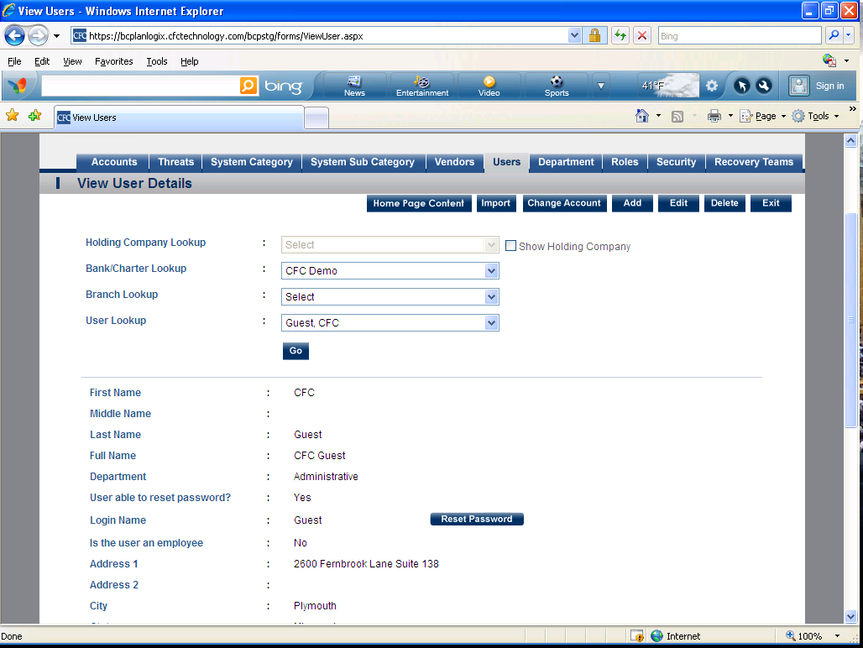
- Department- Departments is used to create custom departments for the institution. 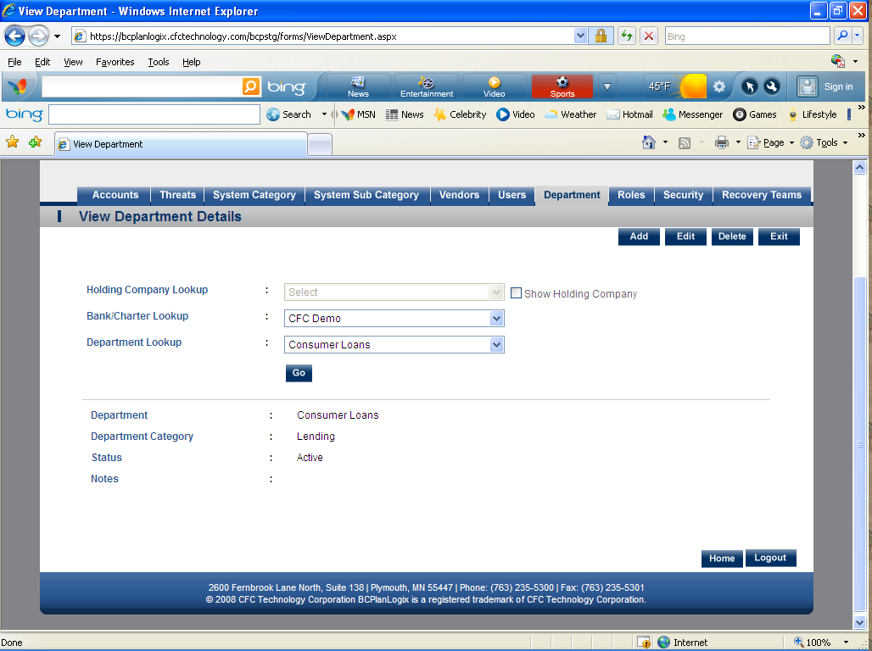

- Roles- Role provides the user the ability to customize the user access roles. 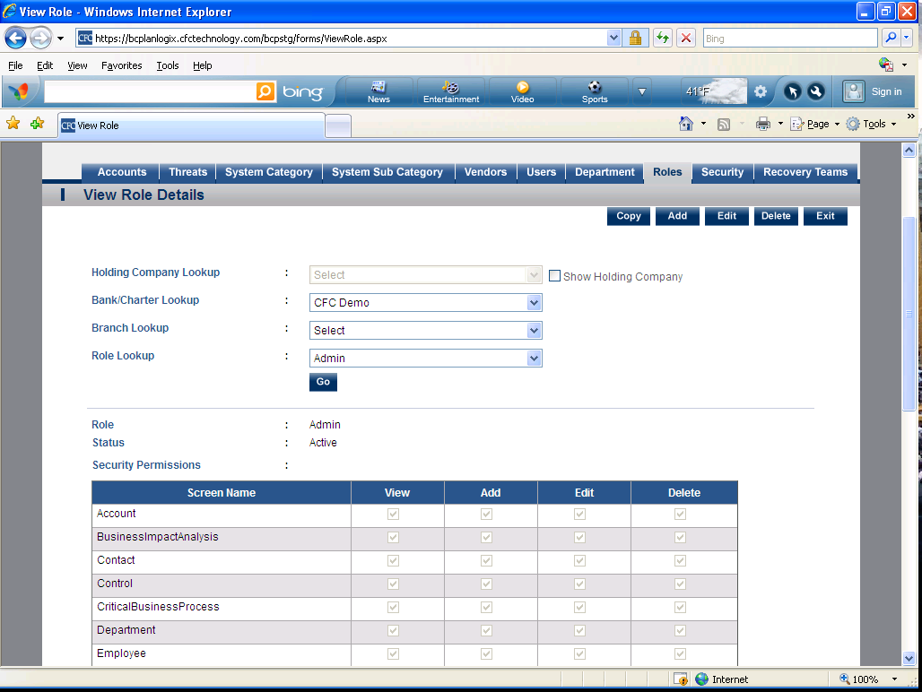
- Security- Security allows the user to link system users and access roles. 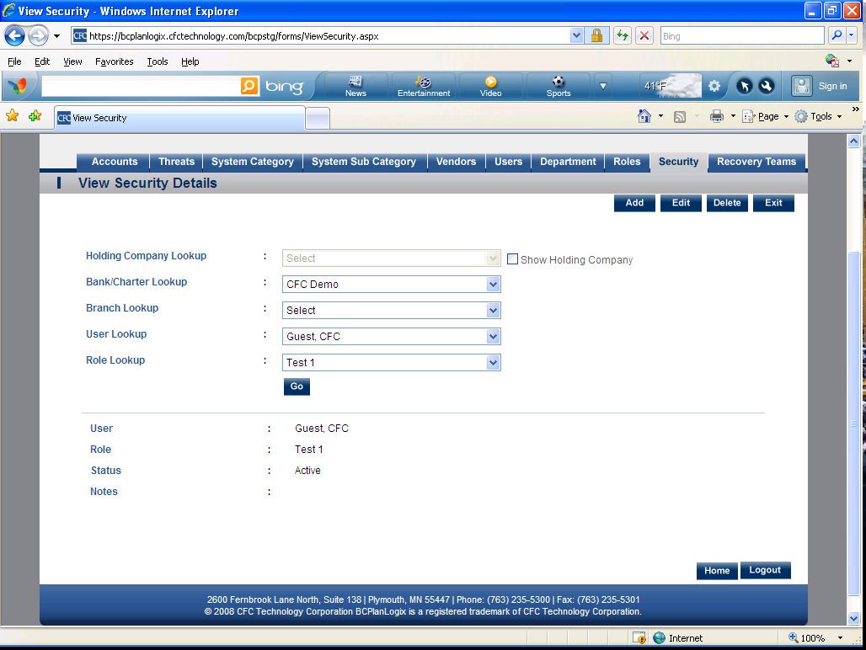

- Recovery Teams- Recovery Teams allows the user to customize the recovery team names and link departments to recovery teams. 