BIA – Risk Assessment (4 Sections Listed Below)
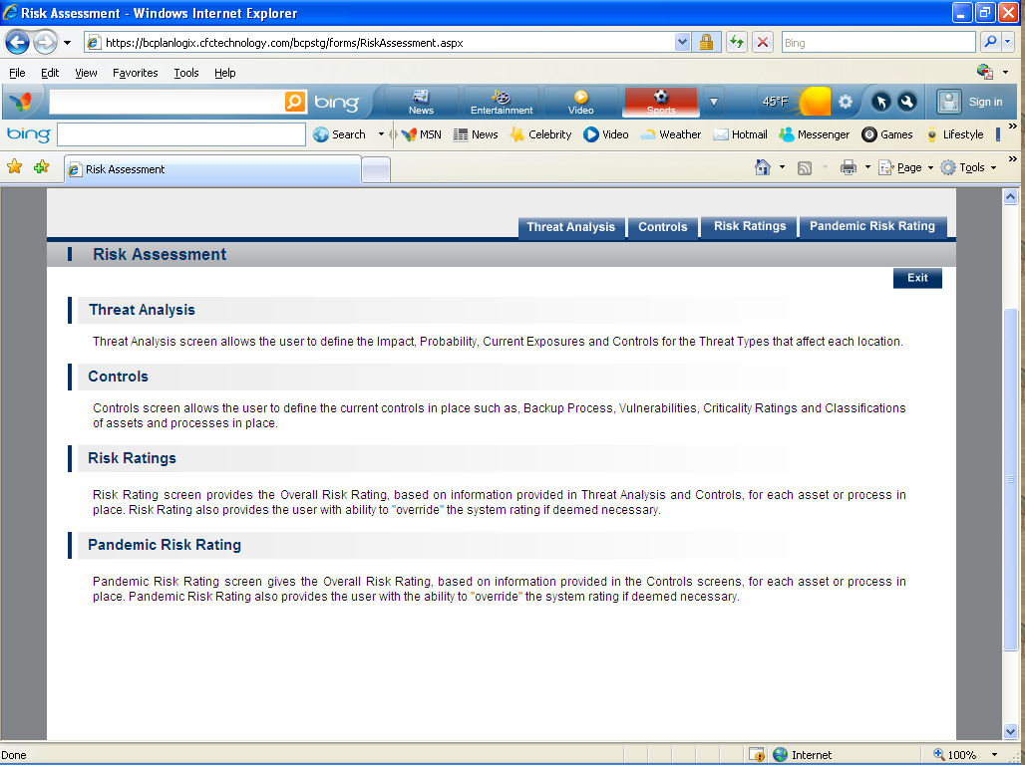
- Threat Analysis-Threat Analysis screen allows the user to define the Impact, Probability, Current Exposures and Controls for the Threat Types that affect each location. 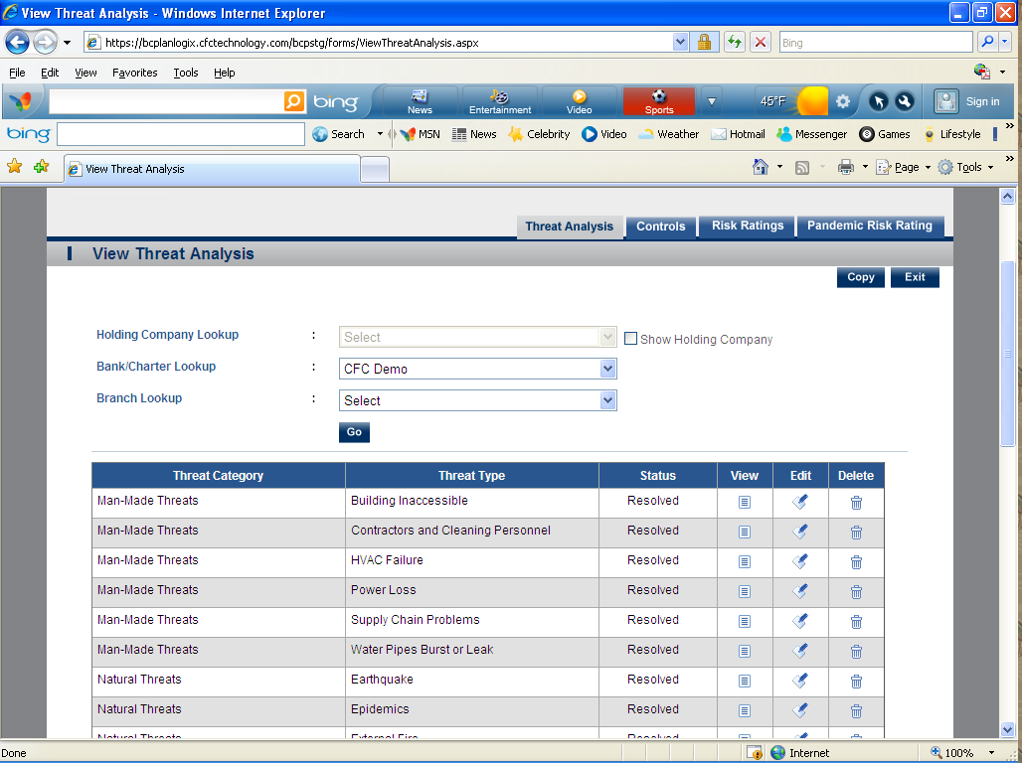
- Controls-Controls screen allows the user to define the current controls in place such as, Backup Process, Vulnerabilities, Criticality Ratings and Classifications of assets and processes in place.
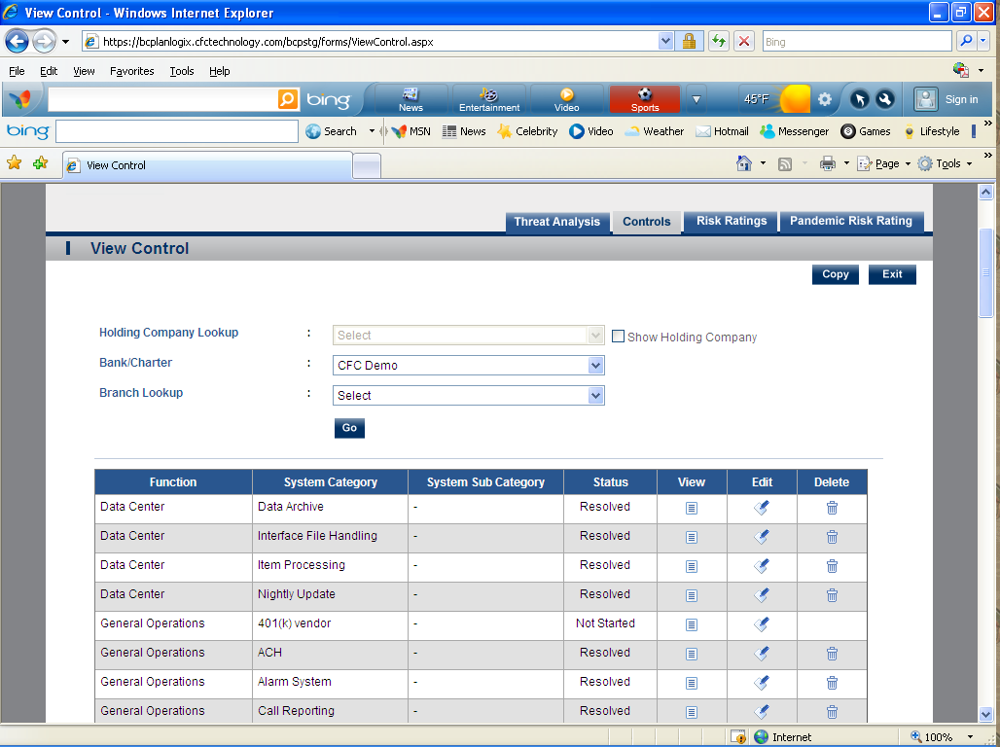

- Risk Ratings-Risk Rating screen provides the Overall Risk Rating, based on information provided in Threat Analysis and Controls, for each asset or process in place. Risk Rating also provides the user with ability to "override" the system rating if deemed necessary. 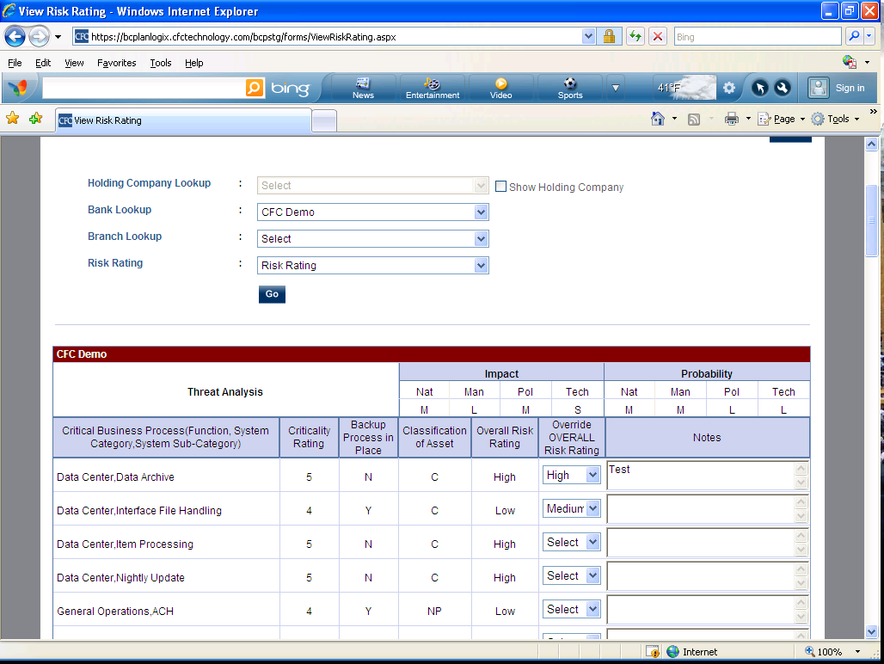
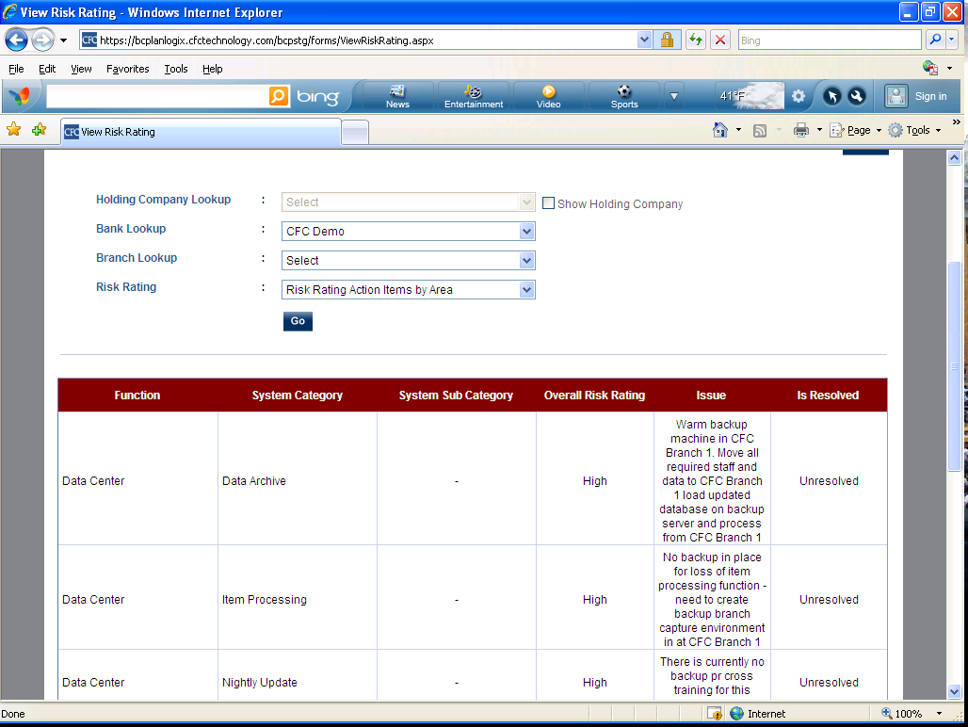
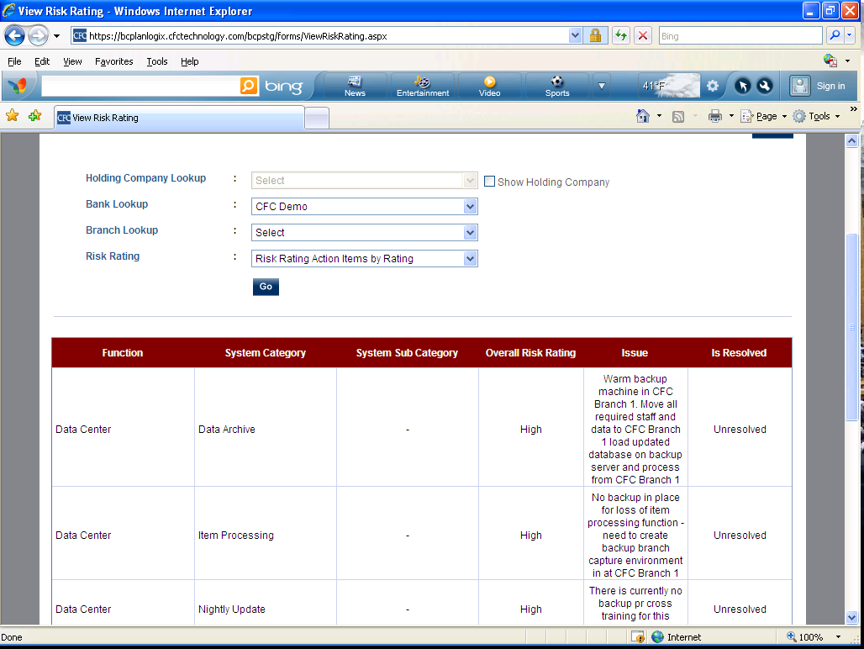

- Pandemic Risk Ratings –Pandemic Risk Rating screen gives the Overall Risk Rating, based on information provided in the Controls screens, for each asset or process in place. Pandemic Risk Rating also provides the user with the ability to "override" the system rating if deemed necessary.

BIA – Business Impact Analysis
- Function Areas – with view of Analysis Plan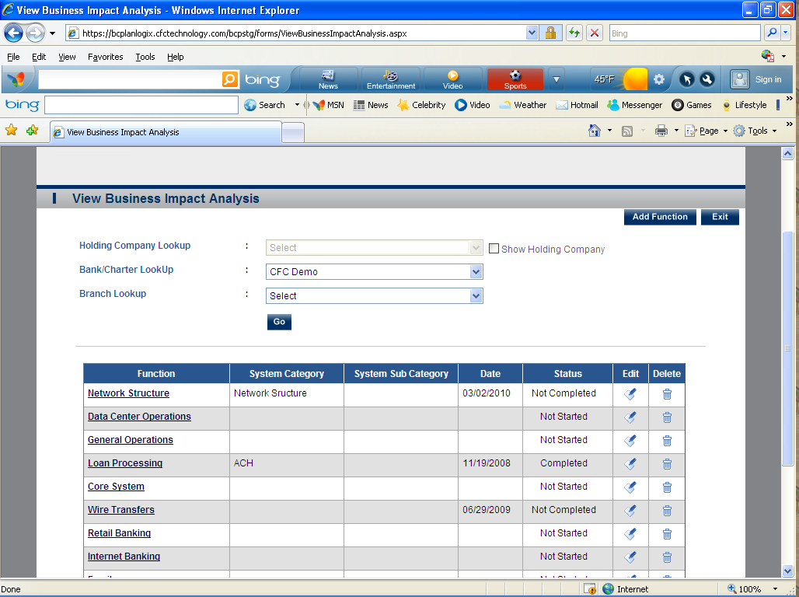
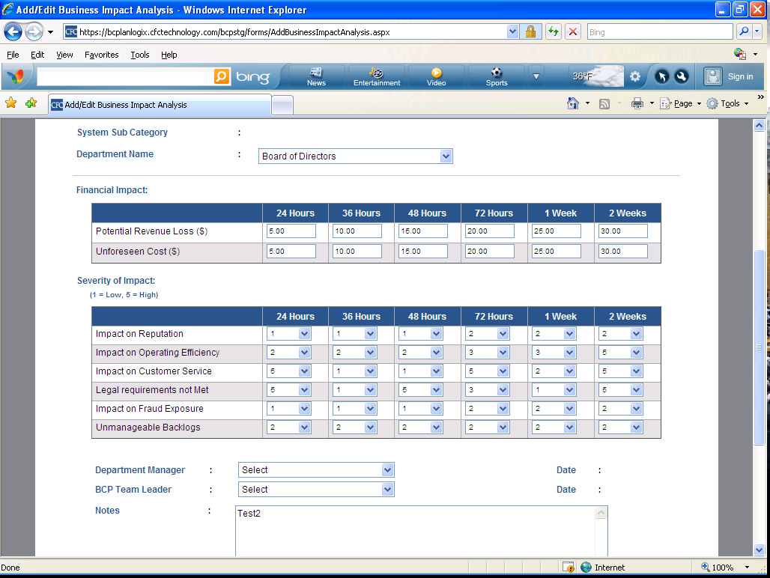

Critical Business Process (2 Sections Listed Below)
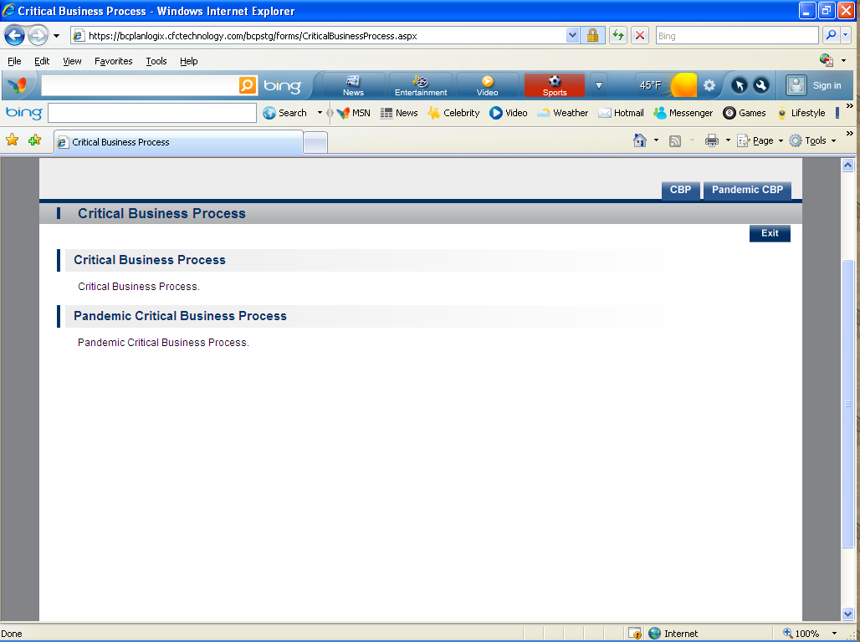
- CBP- This information is extracted from the Control screen. You can also set the “Priority “order from this module.
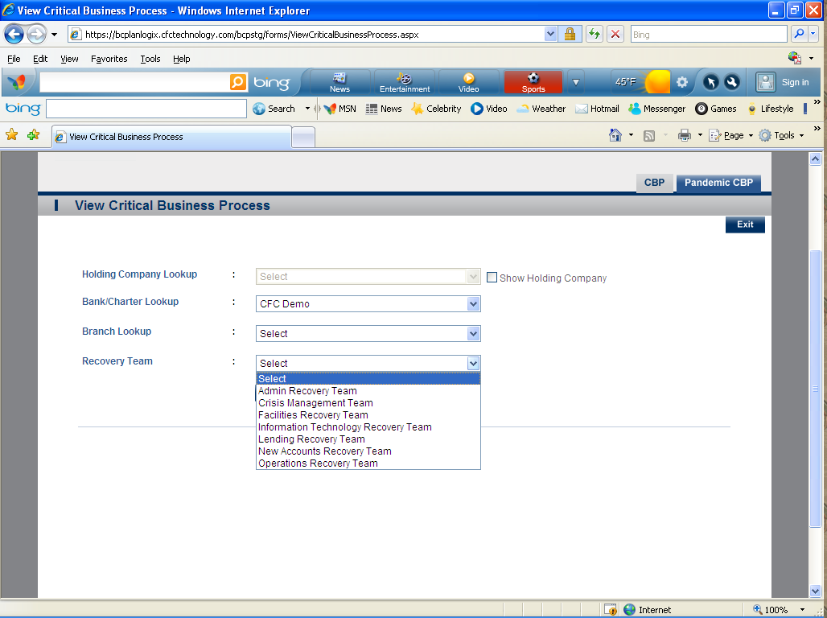
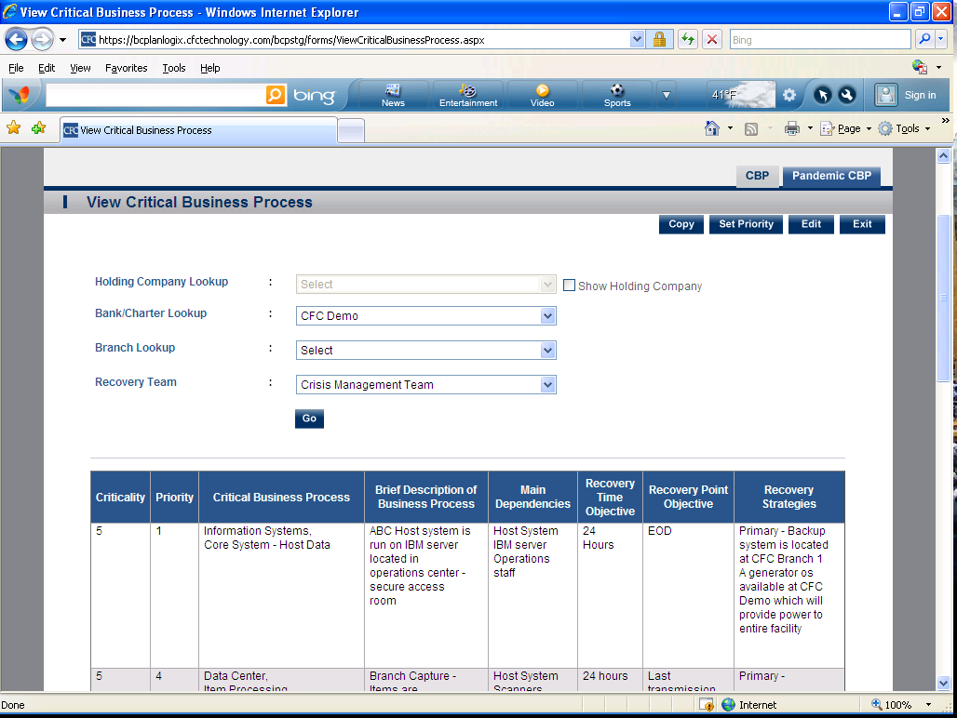

- Pandemic CBP (Same as regular CBP but for Pandemic )

