Testing (8 Sections Listed Below)
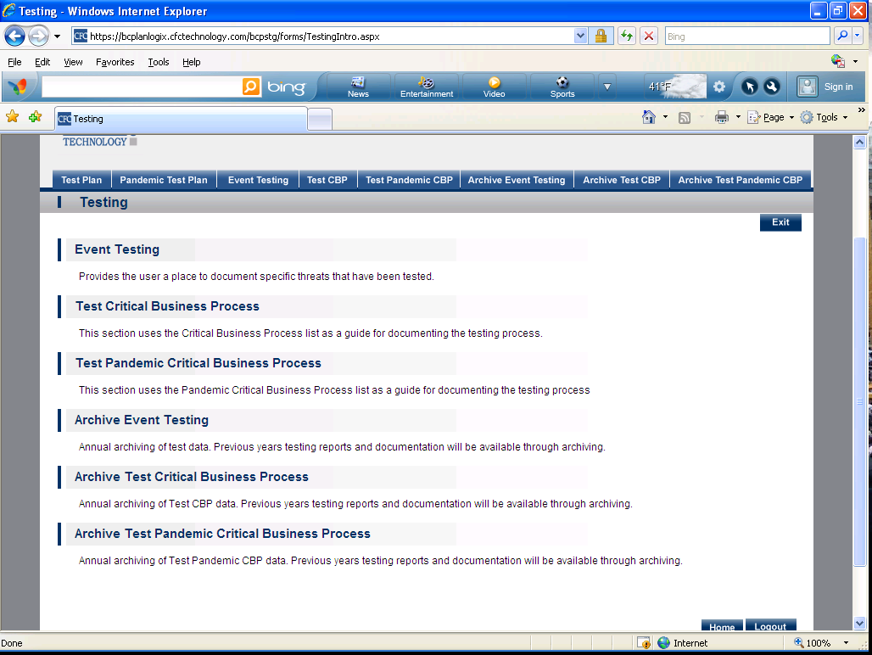
- Test Plan
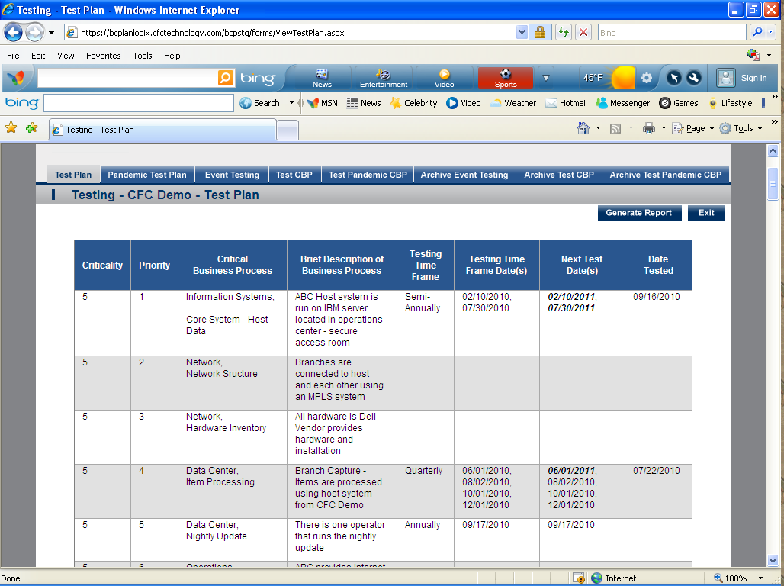

- Pandemic Test Plan
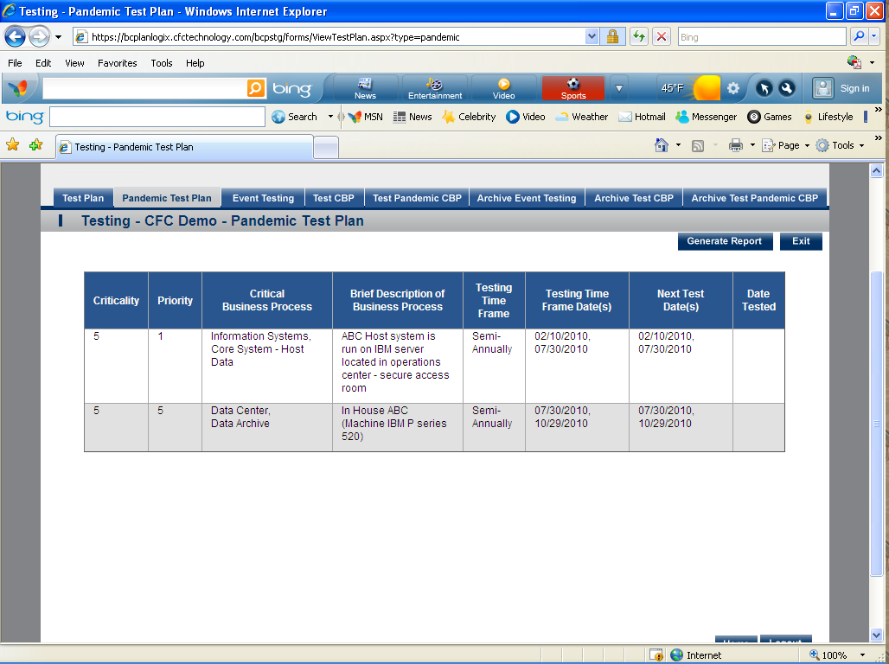

- Event Testing- Provides the user a place to document specific threats that have been tested. 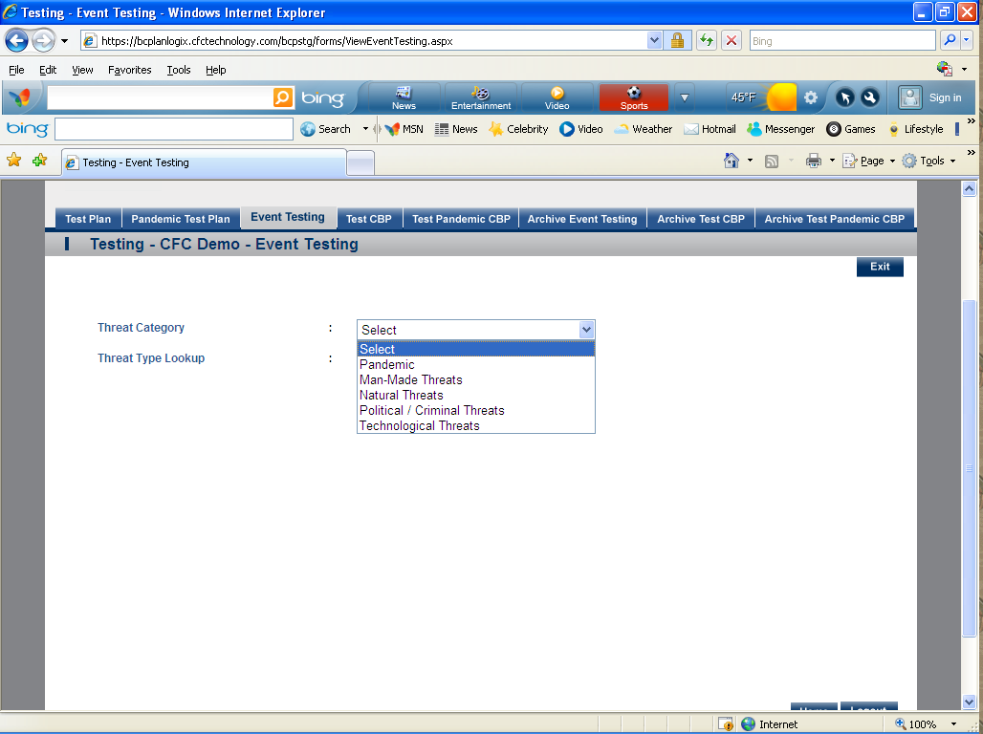
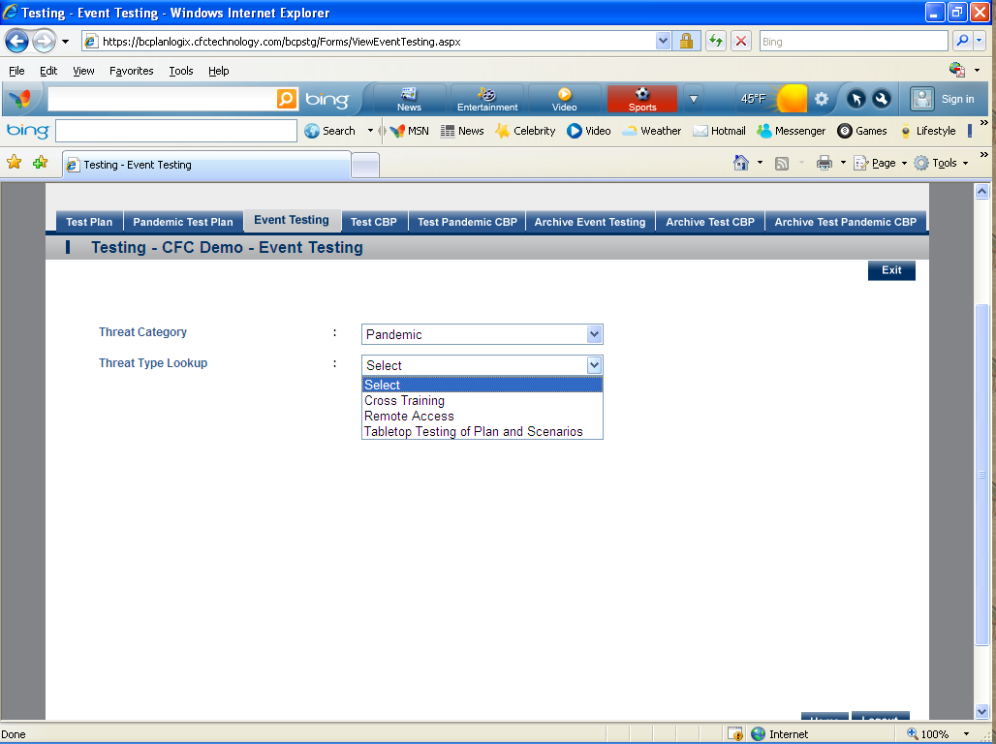

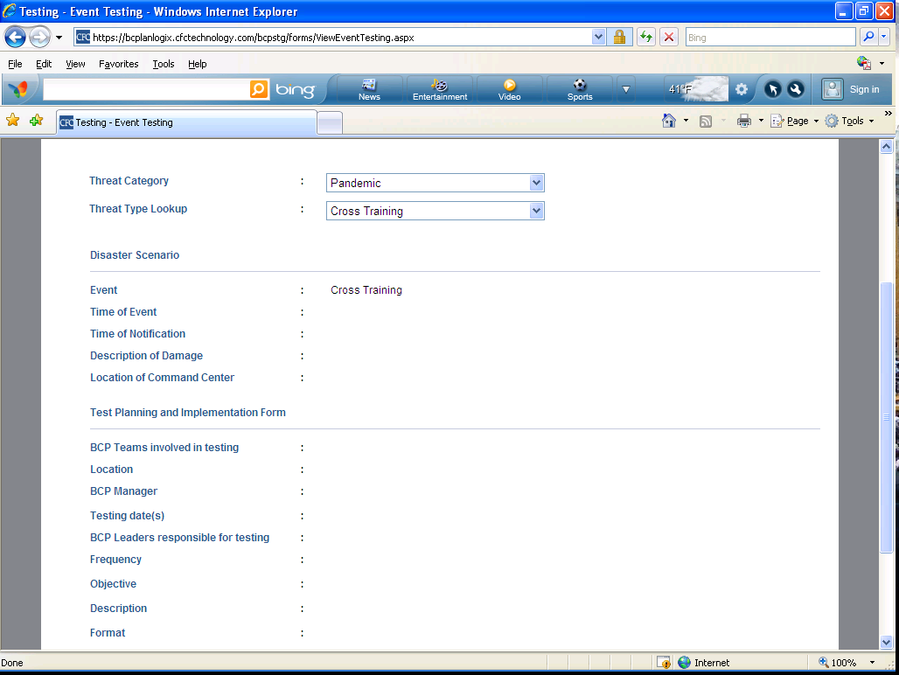
- Test CBP- This section uses the Critical Business Process list as a guide for documenting the testing process. 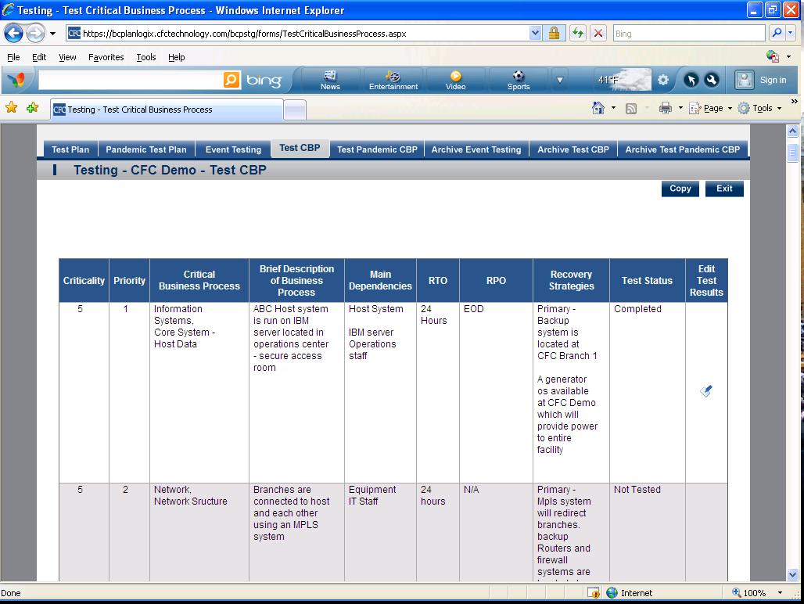

- Test Pandemic CBP- This section uses the Pandemic Critical Business Process list as a guide for documenting the testing process.
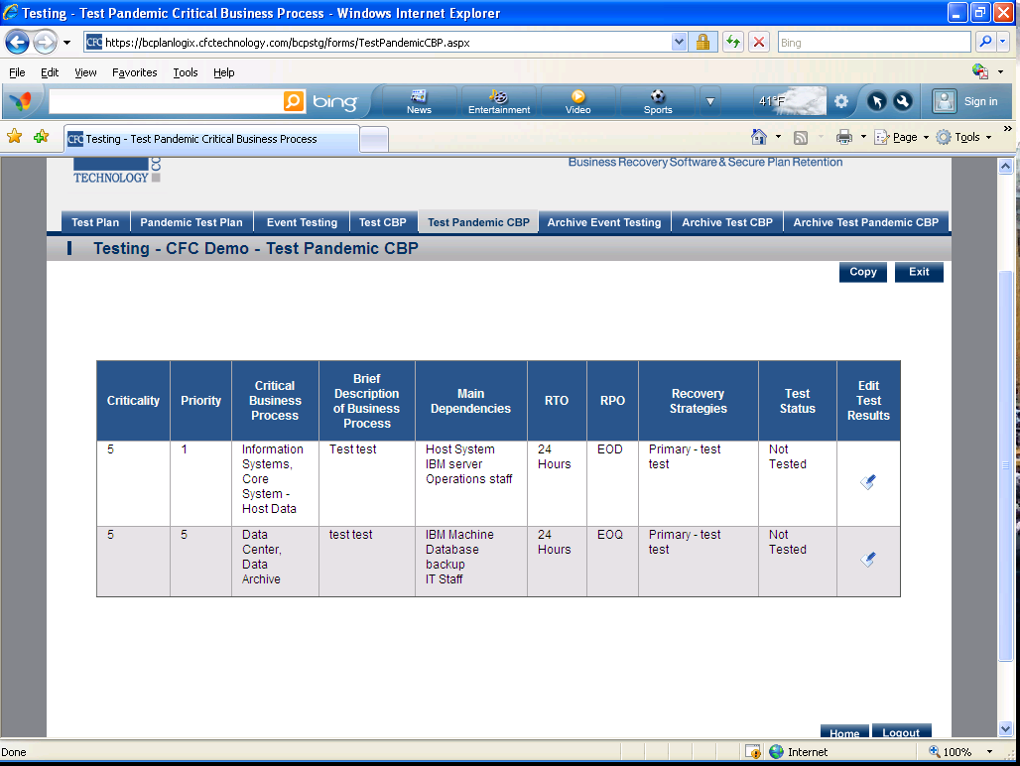

- Archive Event Testing- Annual archiving of test data. Previous years testing reports and documentation will be available through archiving.
- Archive Test CBP- Annual archiving of Test CBP data. Previous years testing reports and documentation will be available through archiving.
- Archive Test Pandemic CBP- Annual archiving of Test Pandemic CBP data. Previous years testing reports and documentation will be available through archiving.

Training (3 Sections Listed Below)
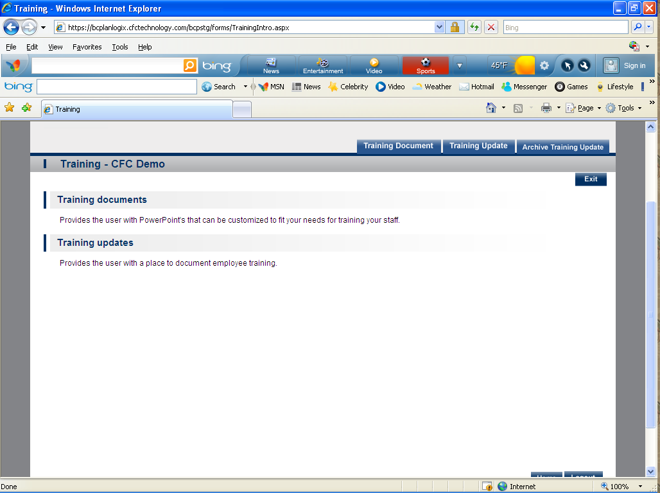

- Training Document- Provides the user with PowerPoint's that can be customized to fit your needs for training your staff.
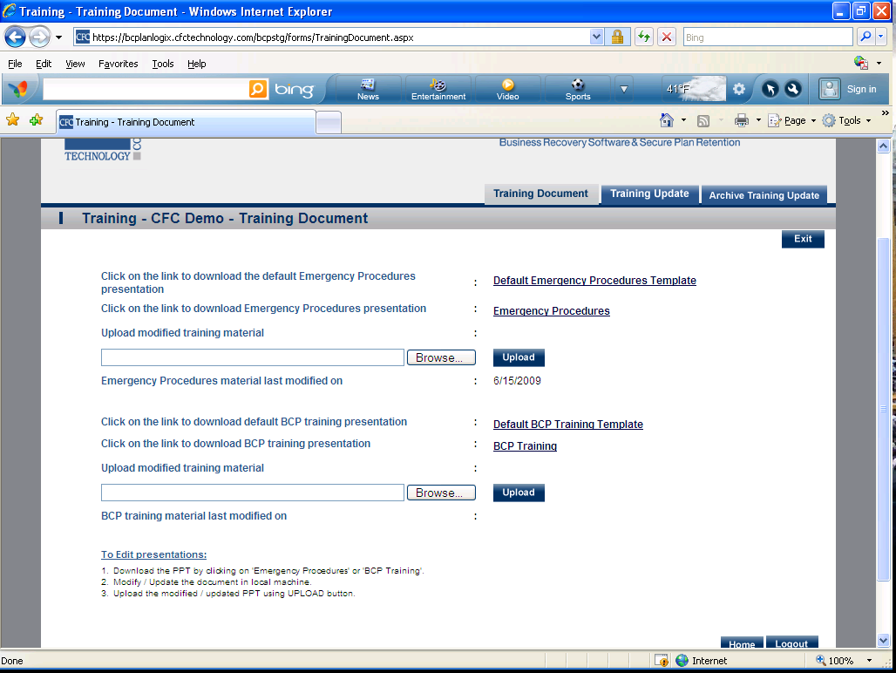

- Training Update- Provides the user with a place to document employee training. 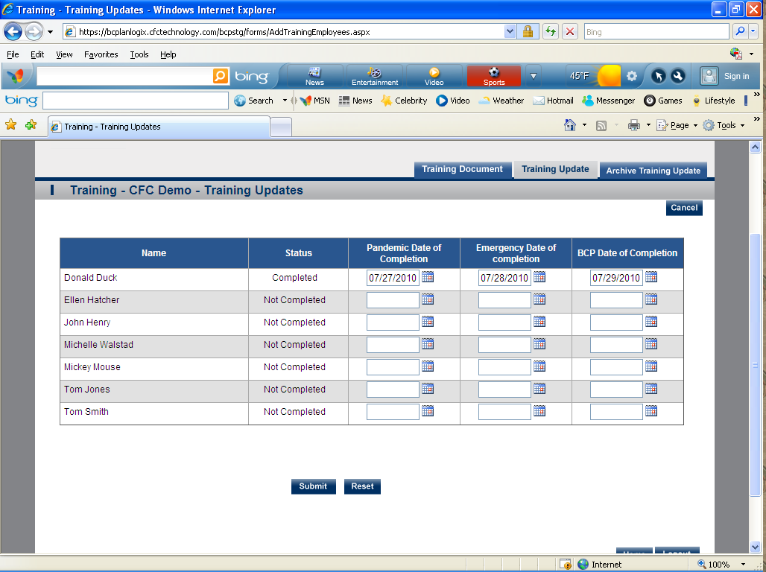
- Archive Training Update- Provides an archive of employee training and dates of completion. 