Reports (Modules)
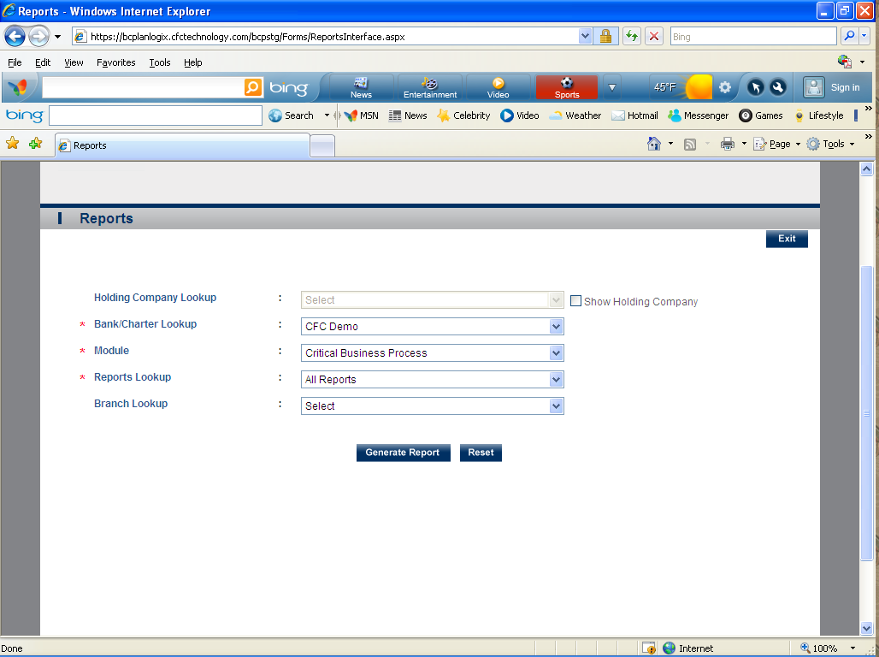
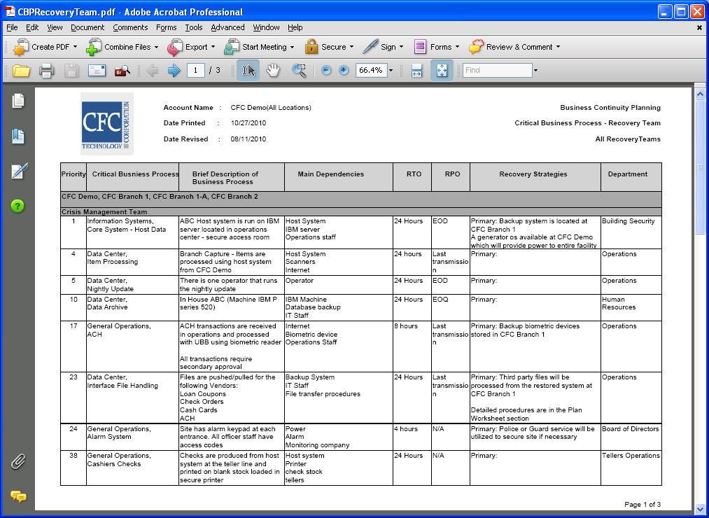

This is a module that allows you to generate reports for:
- Risk Assessments-
- Business Impact Analysis
- Critical Business Process
- Plan Summary
- Team Plans
- Plan Worksheets
- Pandemic Flu
- Testing
- Training
- Maintenance

