BIA – Risk Assessment (4 Sections Listed Below)
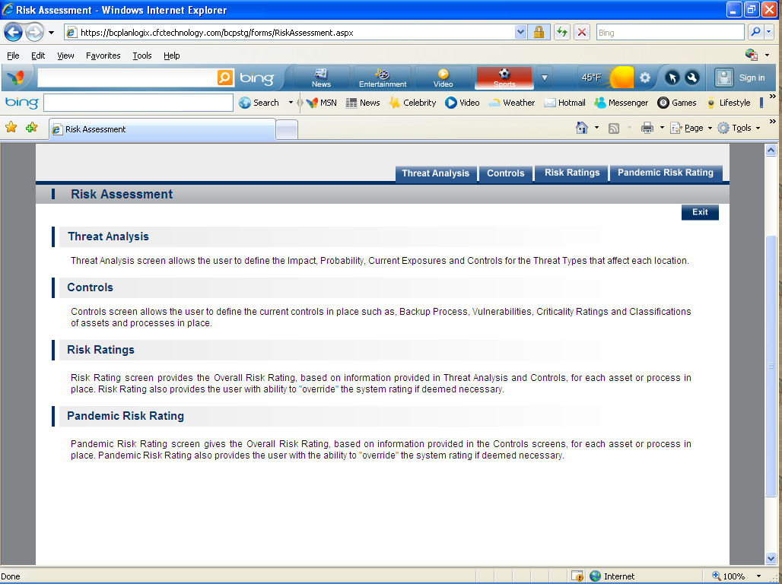
- Threat Analysis-Threat Analysis screen allows the user to define the Impact, Probability, Current Exposures and Controls for the Threat Types that affect each location. 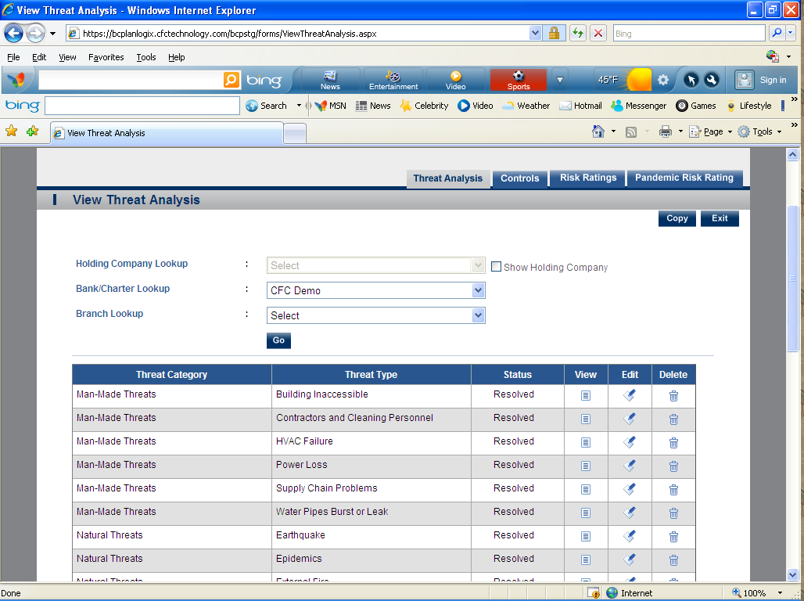
- Controls-Controls screen allows the user to define the current controls in place such as, Backup Process, Vulnerabilities, Criticality Ratings and Classifications of assets and processes in place.
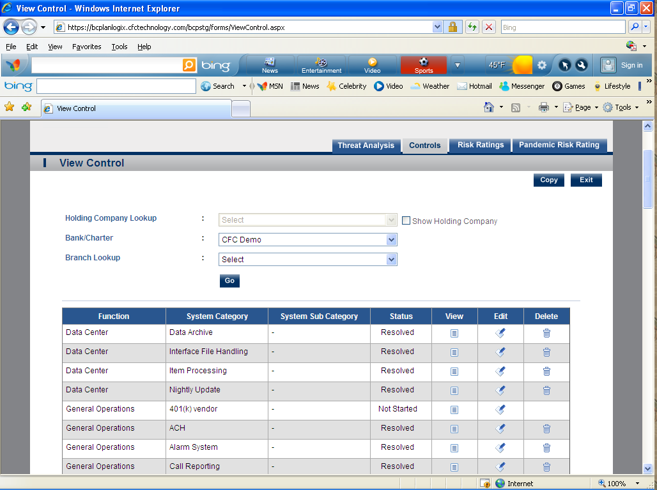

- Risk Ratings-Risk Rating screen provides the Overall Risk Rating, based on information provided in Threat Analysis and Controls, for each asset or process in place. Risk Rating also provides the user with ability to "override" the system rating if deemed necessary. 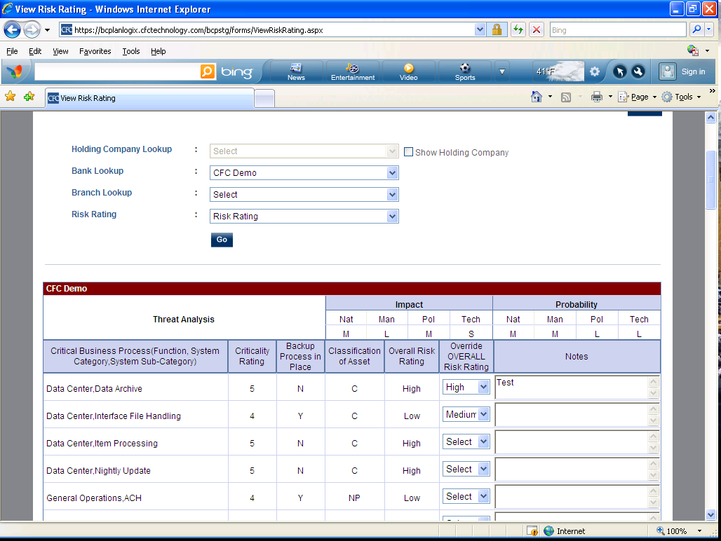
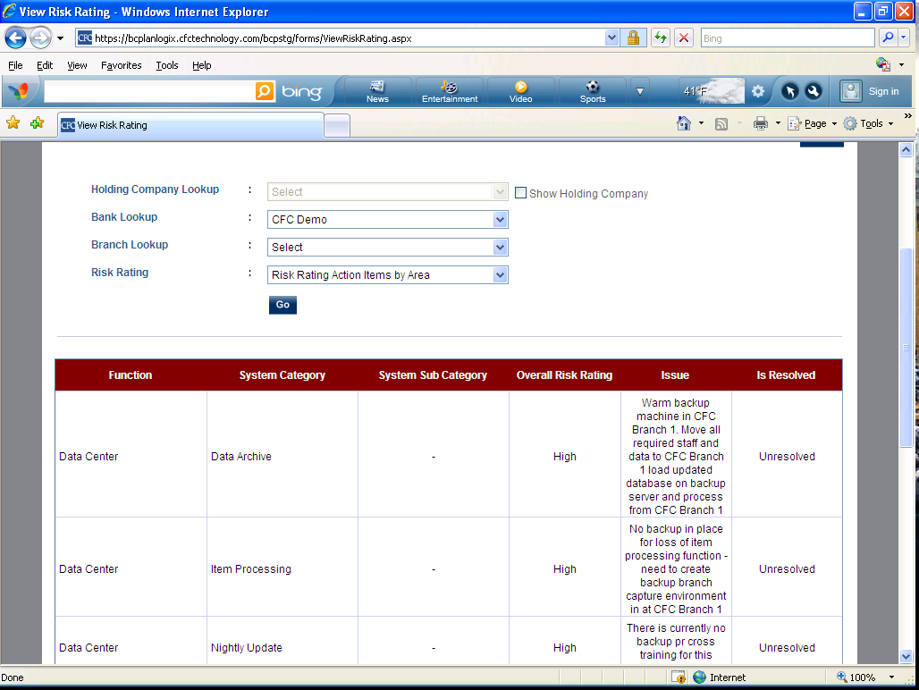
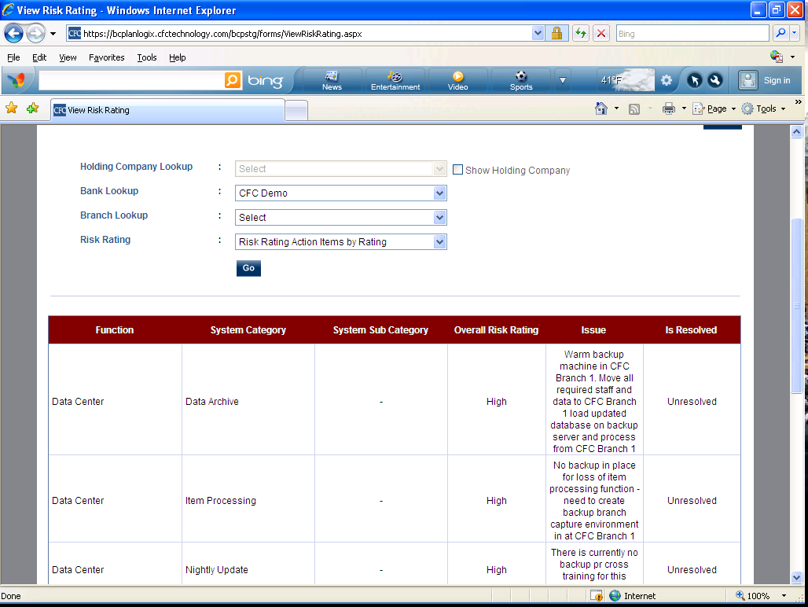

- Pandemic Risk Ratings –Pandemic Risk Rating screen gives the Overall Risk Rating, based on information provided in the Controls screens, for each asset or process in place. Pandemic Risk Rating also provides the user with the ability to "override" the system rating if deemed necessary.

BIA – Business Impact Analysis
- Function Areas – with view of Analysis Plan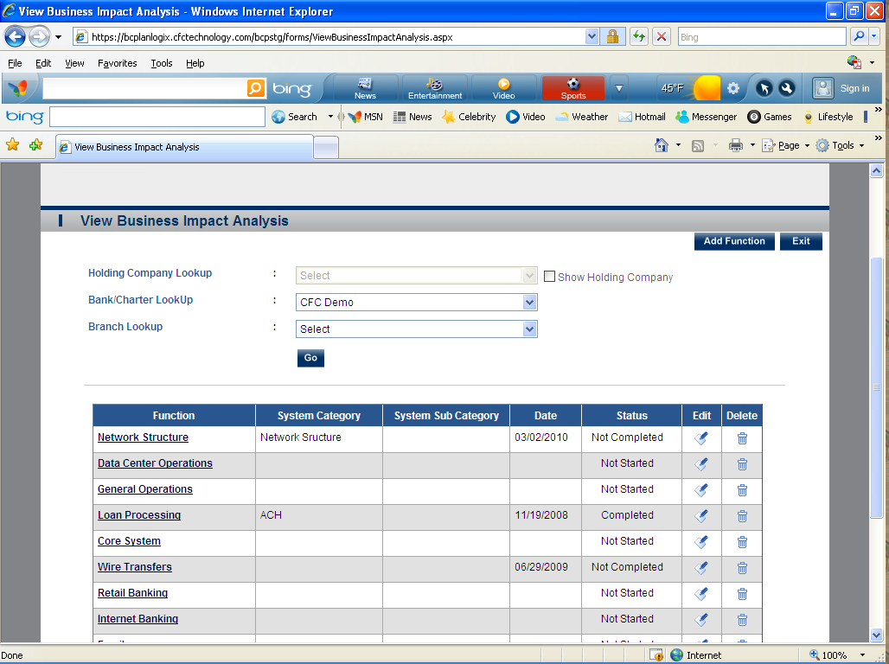
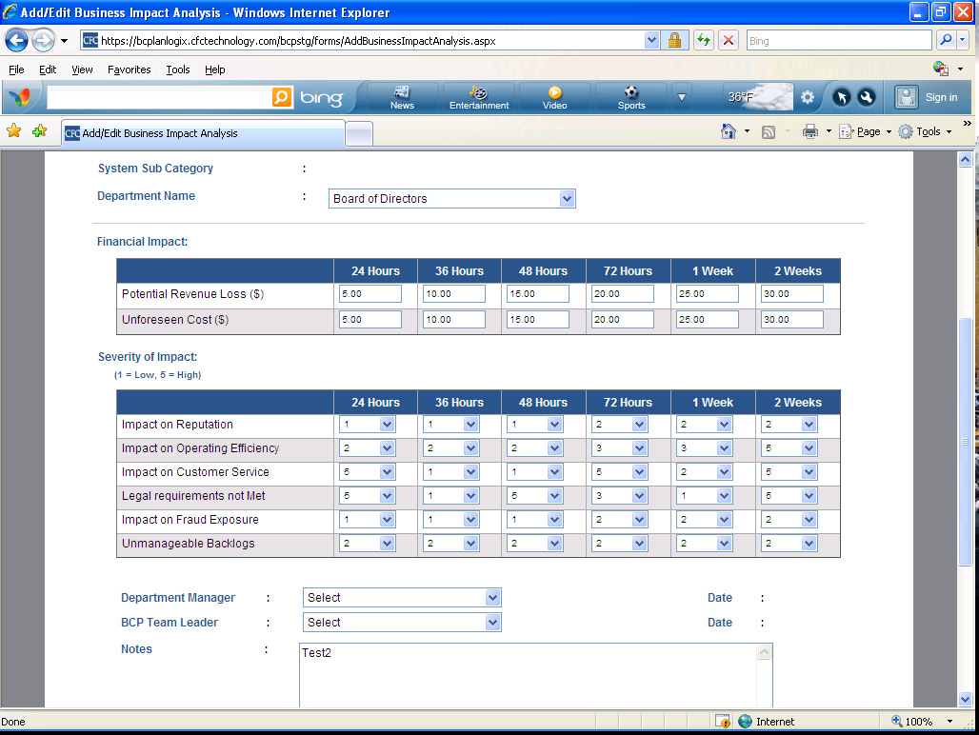

Critical Business Process (2 Sections Listed Below)
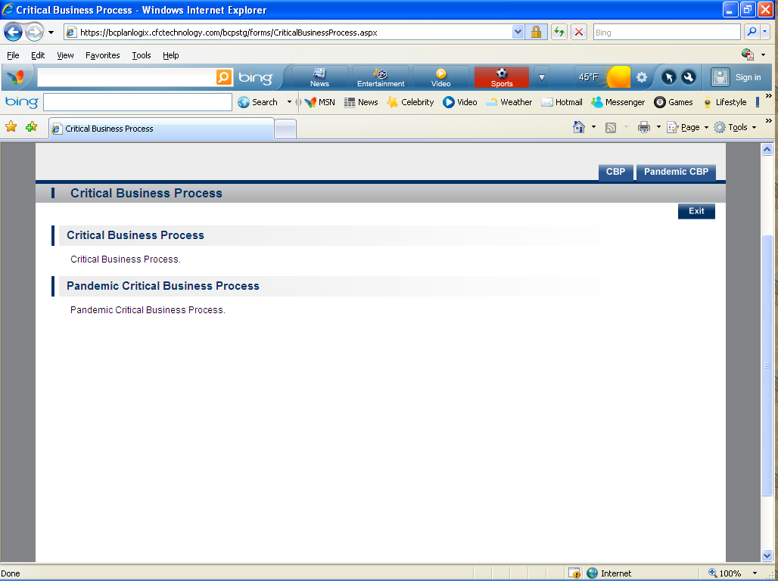
- CBP- This information is extracted from the Control screen. You can also set the “Priority “order from this module.
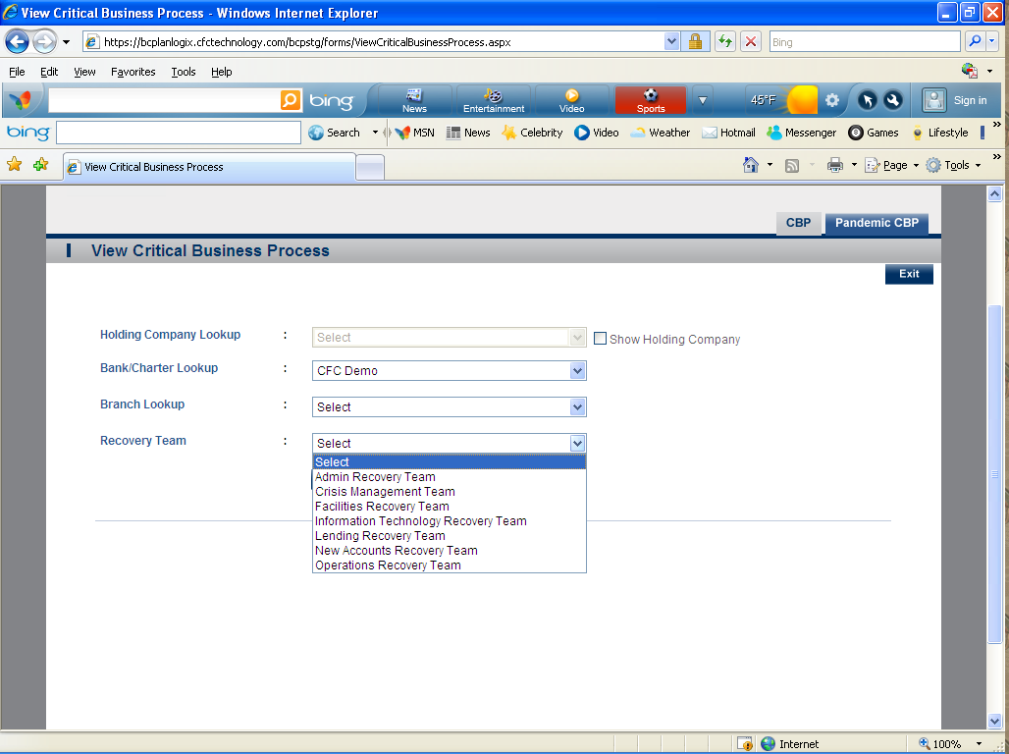
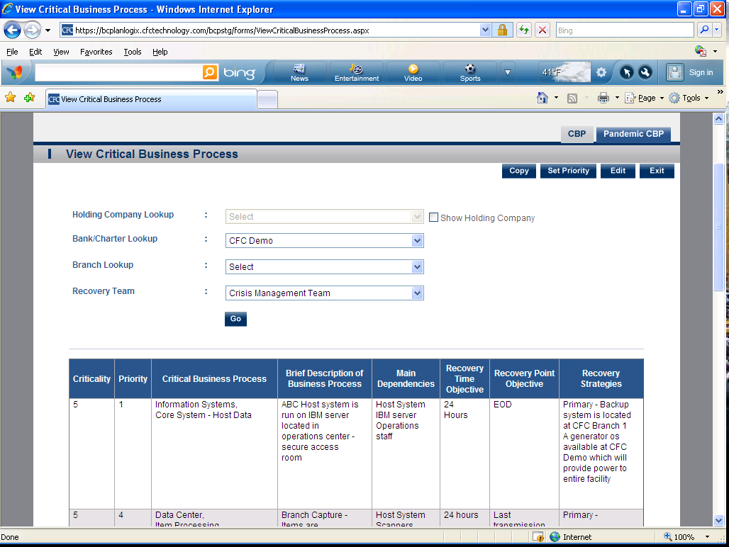

- Pandemic CBP (Same as regular CBP but for Pandemic )

Plan Summary (13 Sections Listed Below)
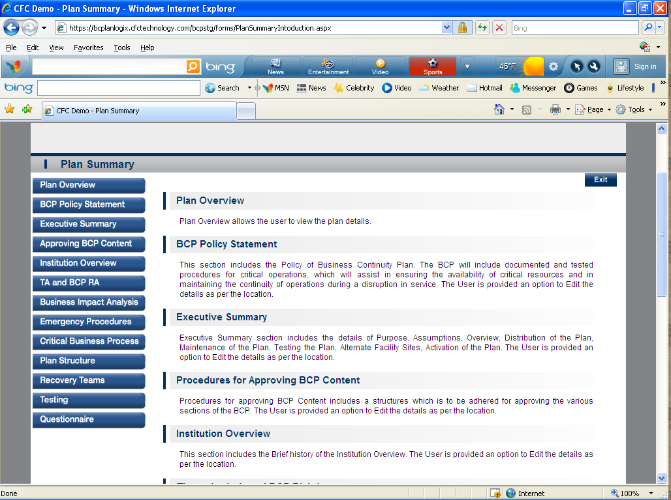
- Plan Overview-Plan Overview allows the user to view the plan details. You can customize the different parts of the plan in this module.
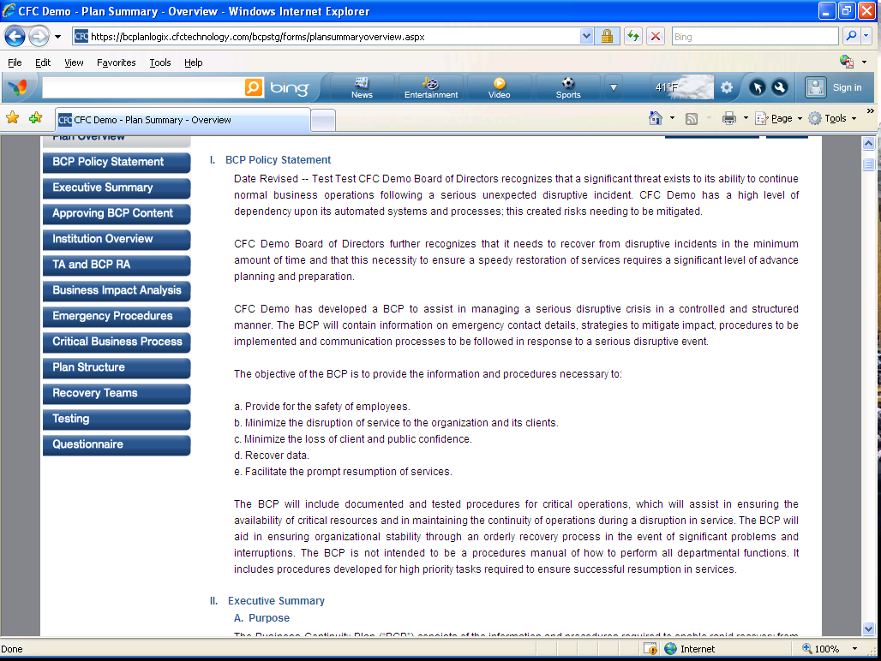
- BCP Policy Statement-This section includes the Policy of Business Continuity Plan. The BCP will include documented and tested procedures for critical operations, which will assist in ensuring the availability of critical resources and in maintaining the continuity of operations during a disruption in service. The User is provided an option to edit the details as per the location. 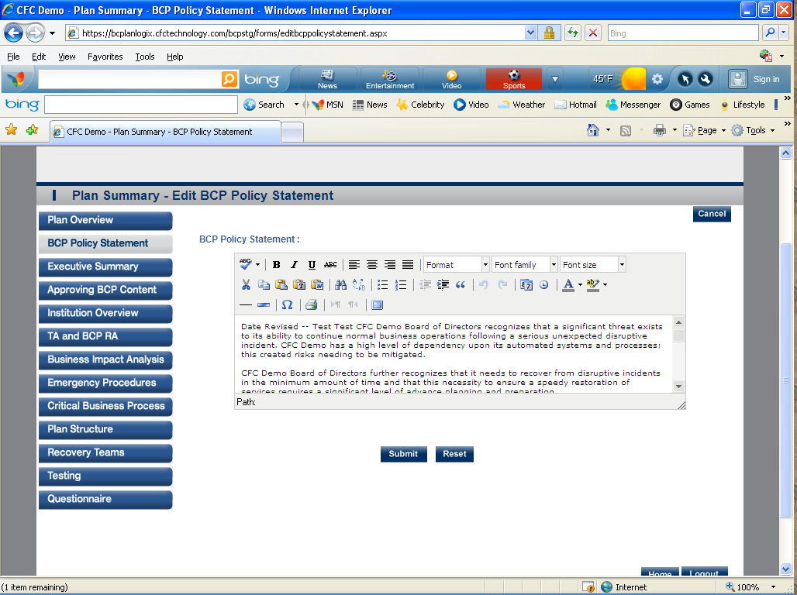
- Executive Summary-Executive Summary section includes the details of Purpose, Assumptions, Overview, and Distribution of the Plan, Maintenance of the Plan, Testing the Plan, Alternate Facility Sites, and Activation of the Plan. The User is provided an option to Edit the details as per the location.
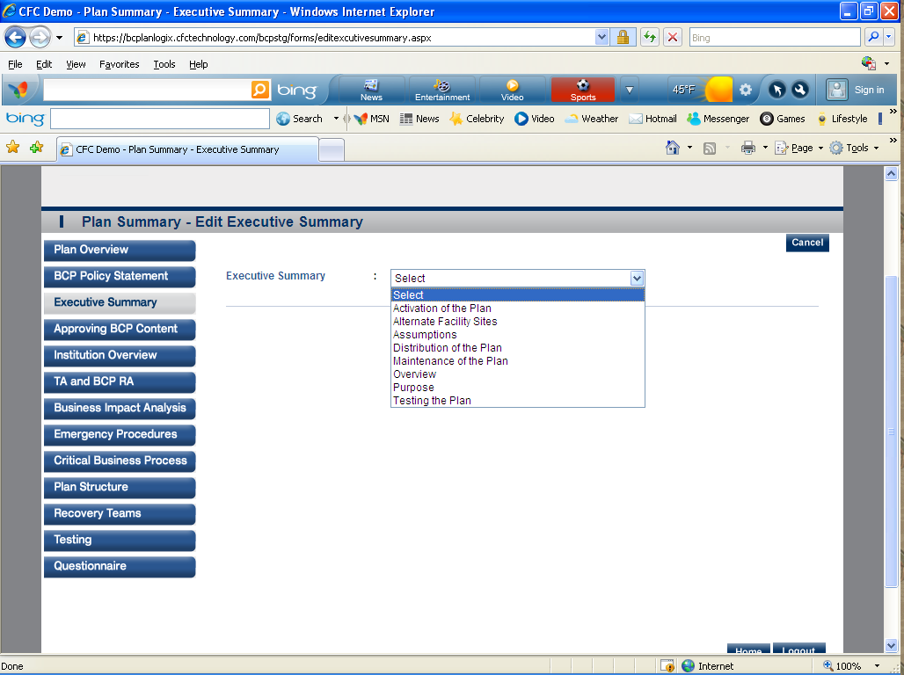
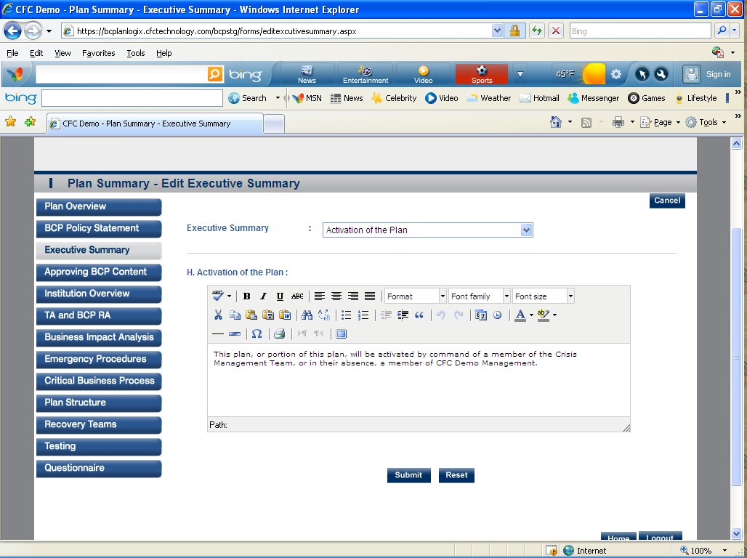

- Approving BCP Content-Procedures for approving BCP Content includes a structure which is to be adhered for approving the various sections of the BCP. The User is provided an option to Edit the details as per the location.
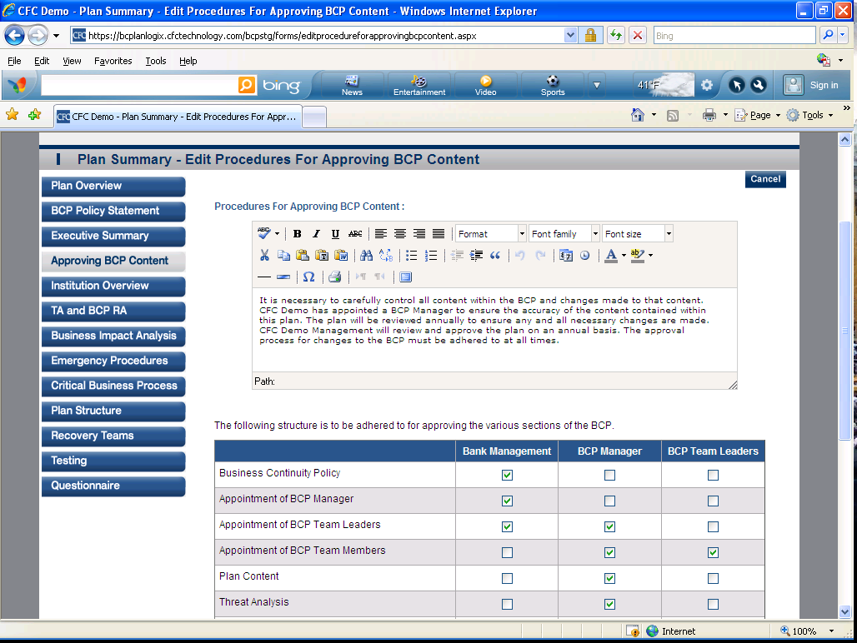
- Institution Overview-This section includes the Brief history of the Institution Overview. The User is provided an option to edit the details as per the location. 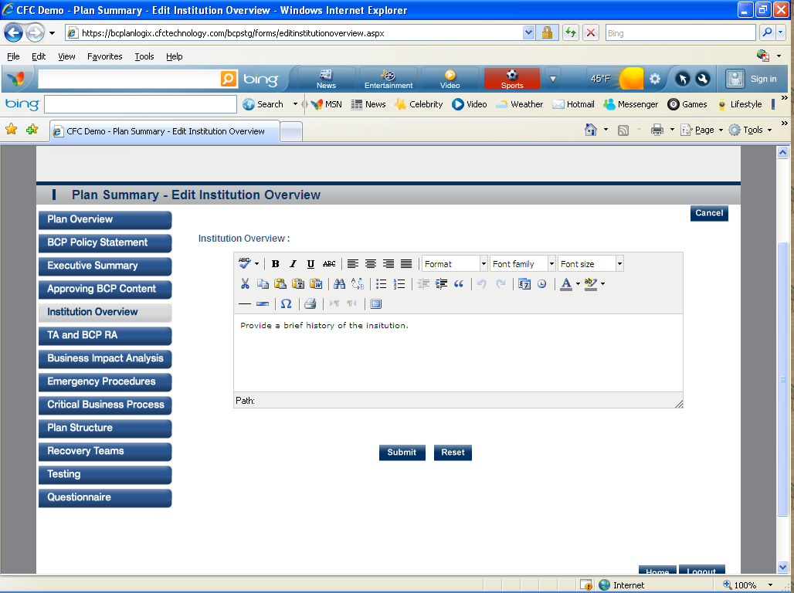
- TA and BCP RA-This section includes the Overview of Threat Analysis and BCP Risk assessment. The User is provided an option to edit the details as per the location. 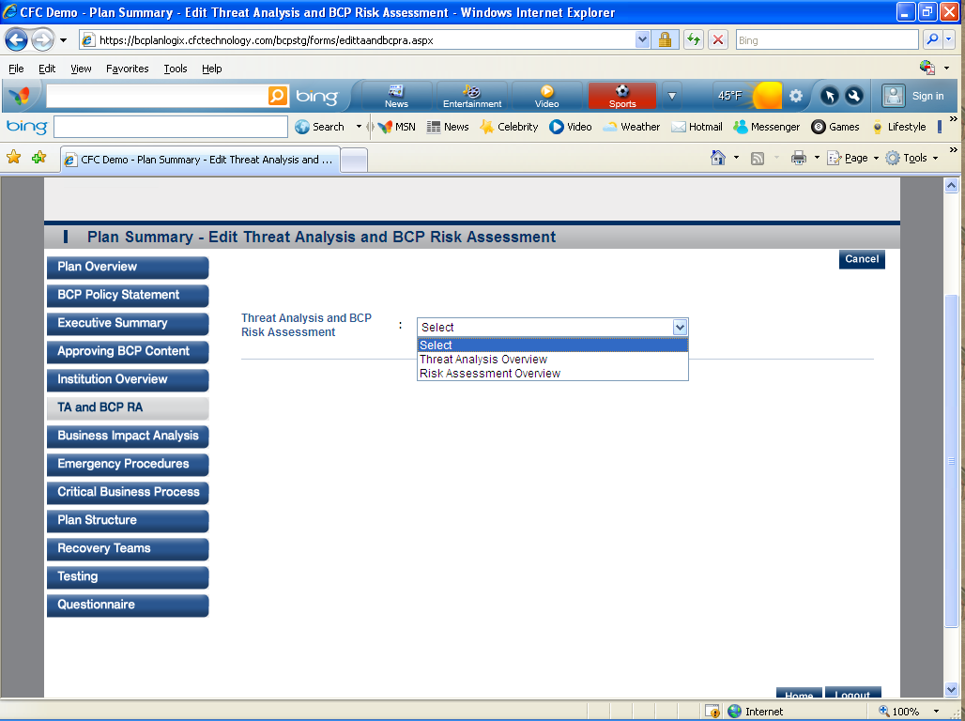

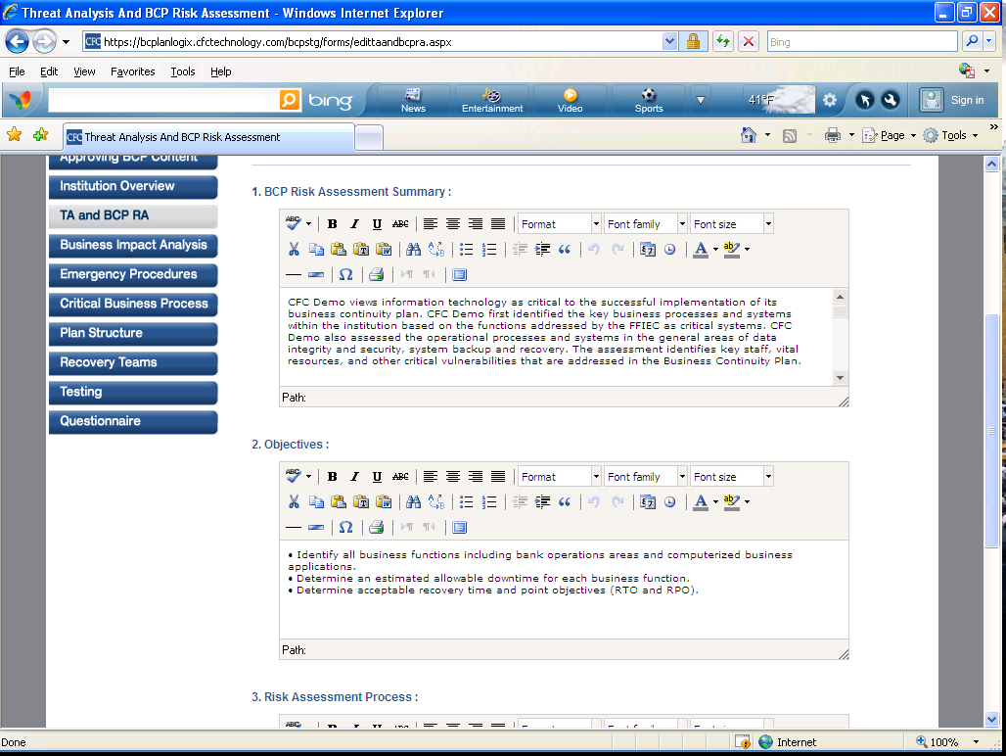
- Business Impact Analysis-This section includes an overview of Business Impact Analysis Process. The user is provided an option to Edit the details as per the location.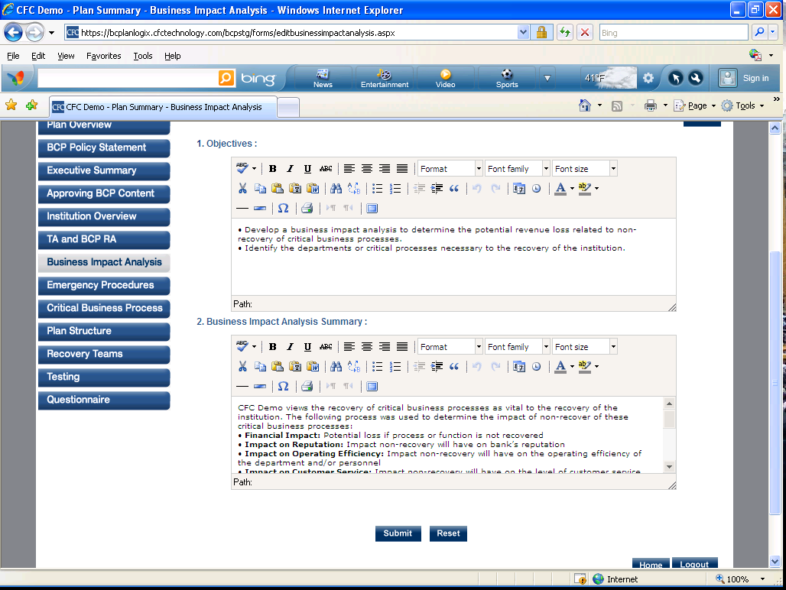
- Emergency Procedures-This section includes the details of Potential Emergency Events response such as Bomb Threat, Kidnapping Threat, Chemical Spill Release, Fire / Explosion, Flood, Power Outage, Telecommunications Failure, Severe Weather/ Tornado, Severe Weather/Winter Storm. The user is provided an option to edit the details as per the location. 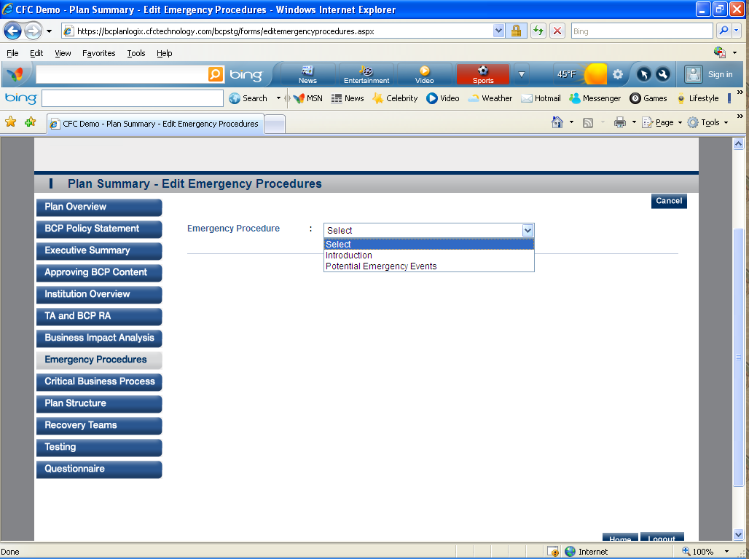
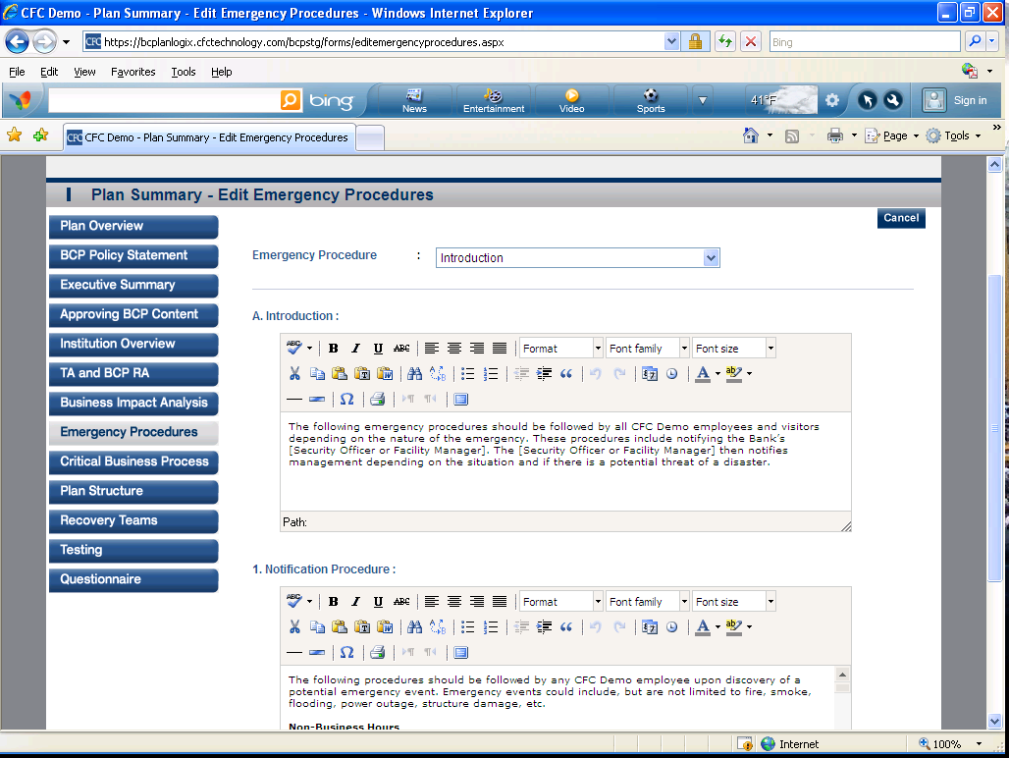
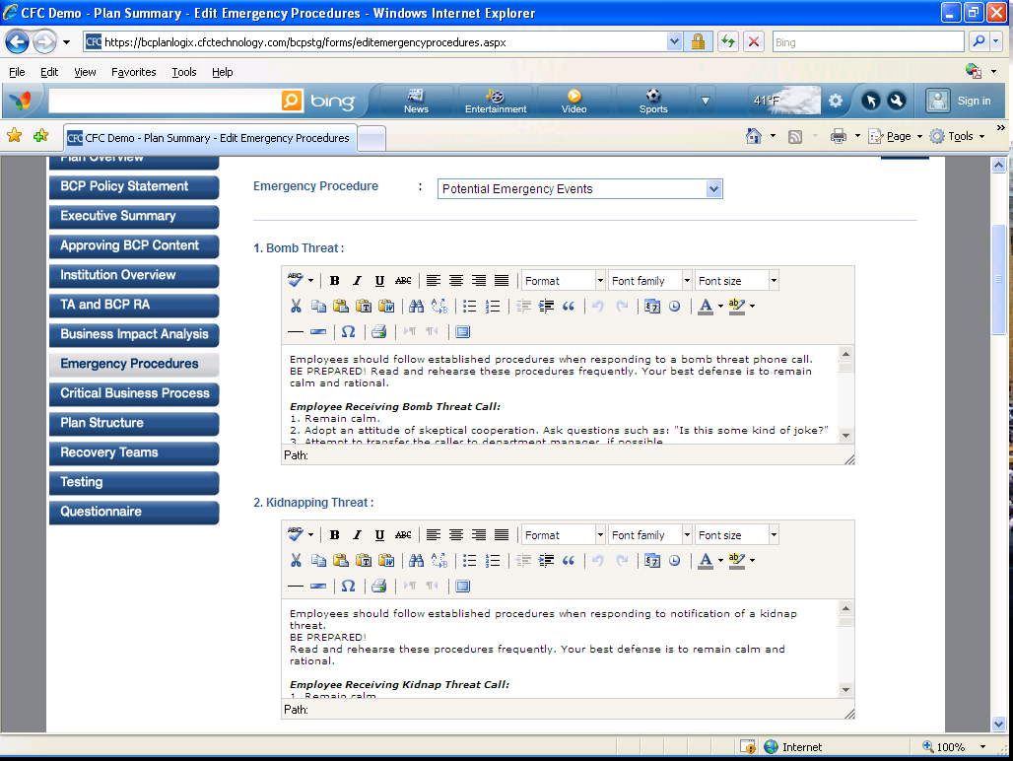

- Critical Business Process-This section includes an overview of Critical Business Processes including a brief description of the business process. The user is provided an option to edit the details as per the location. 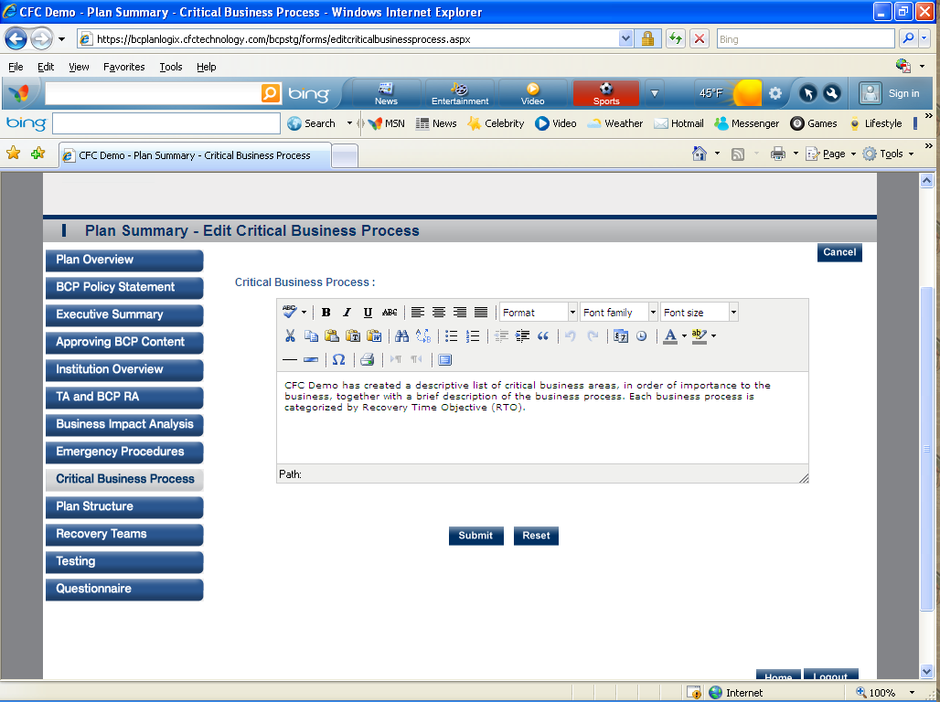
- Plan Structure-This section includes the details for Pre-Disaster Planning and Preparation, Alternate Facilities/Emergency Operations Center, Emergency Preparation, Emergency Situations, Immediate Communication, Information and Assets, Business Recovery. The user is provided an option to Edit the details as per the location.
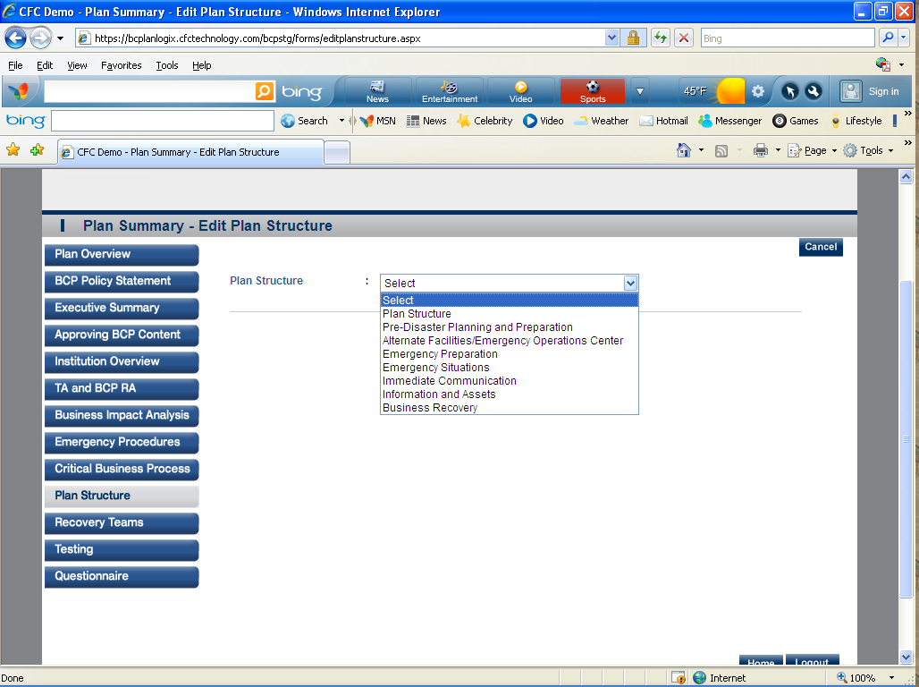
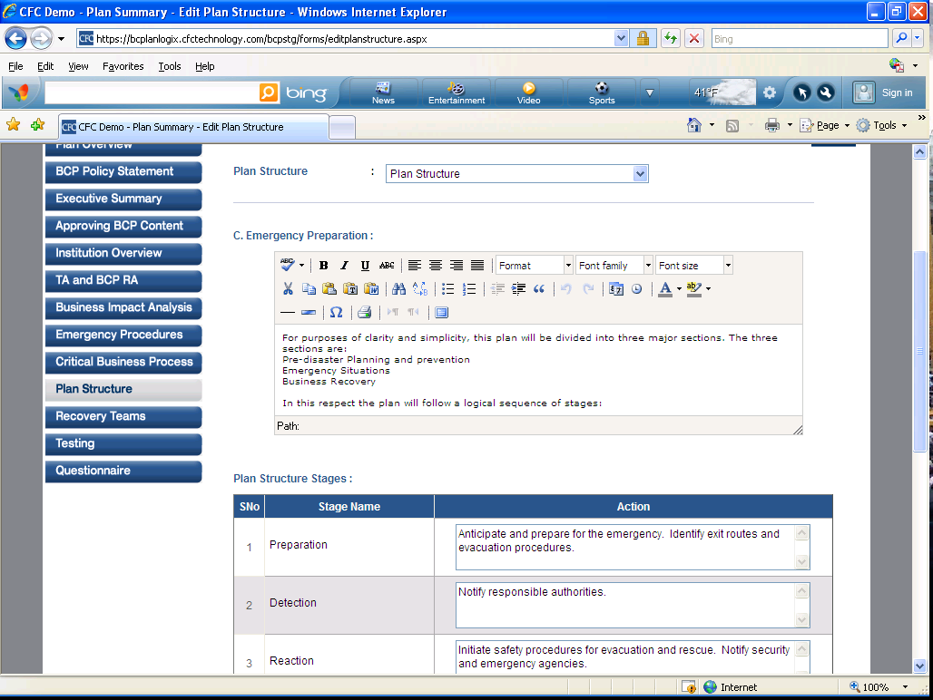

- Recovery Teams-This section includes the Recovery Teams which expand the capabilities and divide the responsibilities of the recovery effort. Each Recovery Team has a specific Recovery Team plan. In the event of a disaster, the procedures included in this plan are designed to assist in the recovery of the individual departments. The user is provided an option to Edit the details as per the location.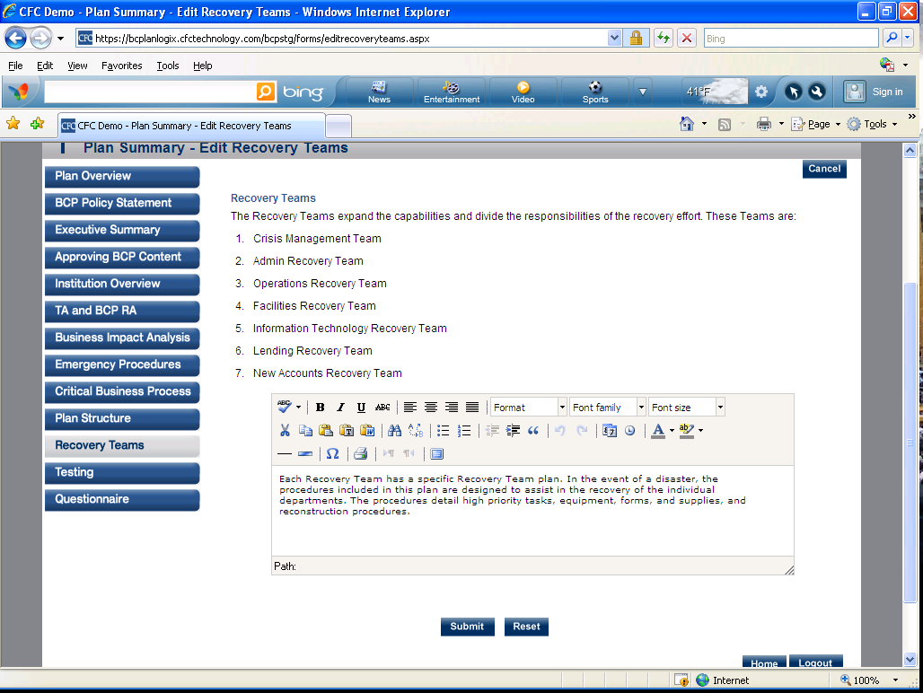
- Testing-This section includes the details of Considerations for Developing Testing Plans, Types of Tests, Development of Testing Plans, Structured Walk-Through Test Example, Current Testing. The user is provided an option to edit the details as per the location. 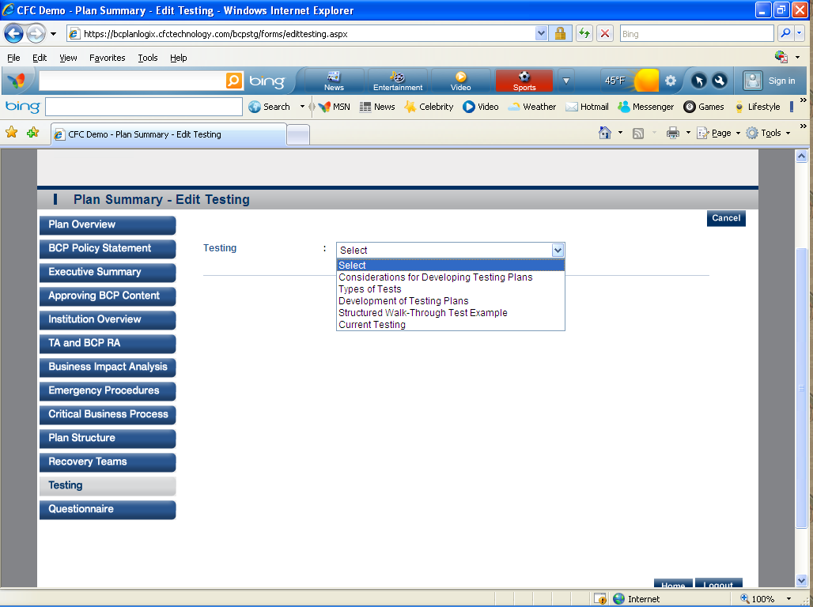

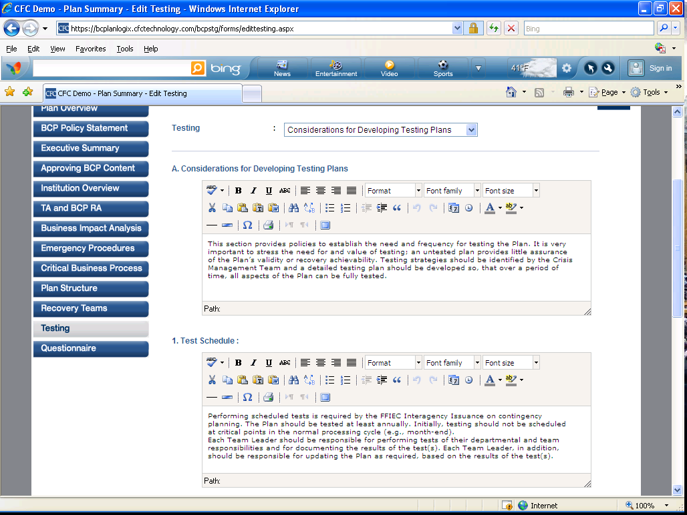
- Questionnaire- The questionnaire is a form to help you establish the information that you will need for an emergency.
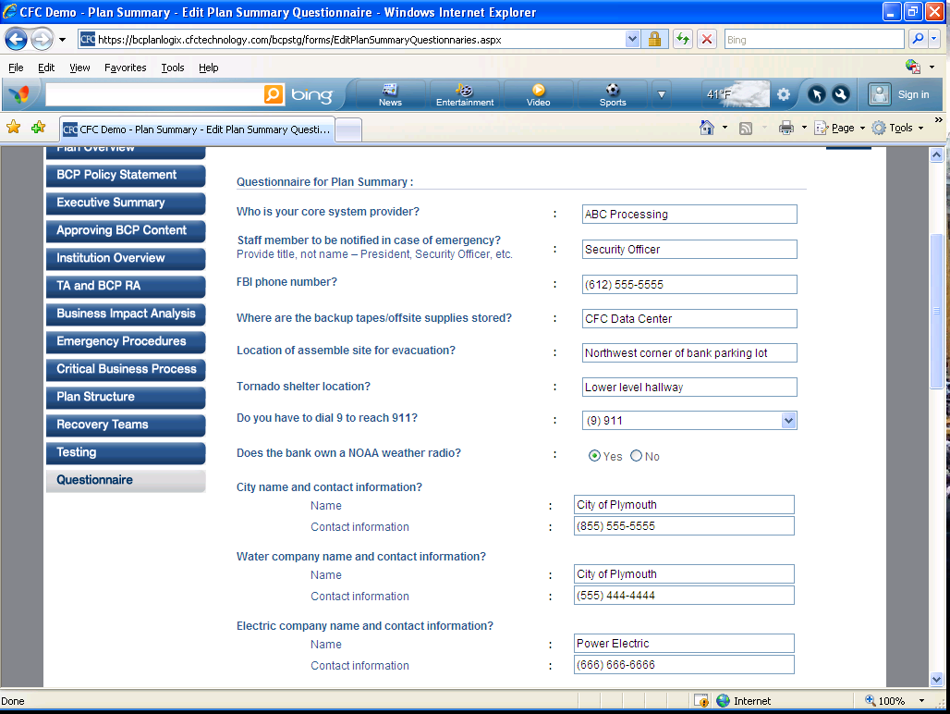

Team Plans
- BCP Teams – with view of Plan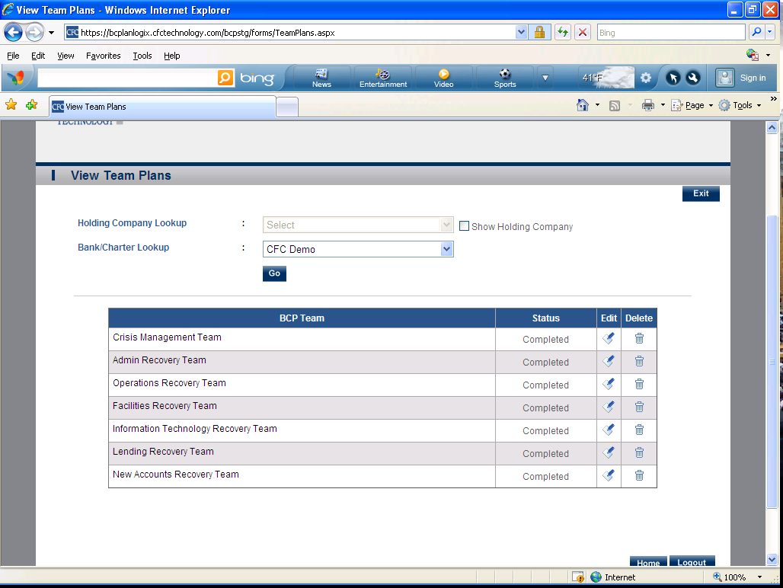

Plan Worksheets (3 Sections Listed Below)
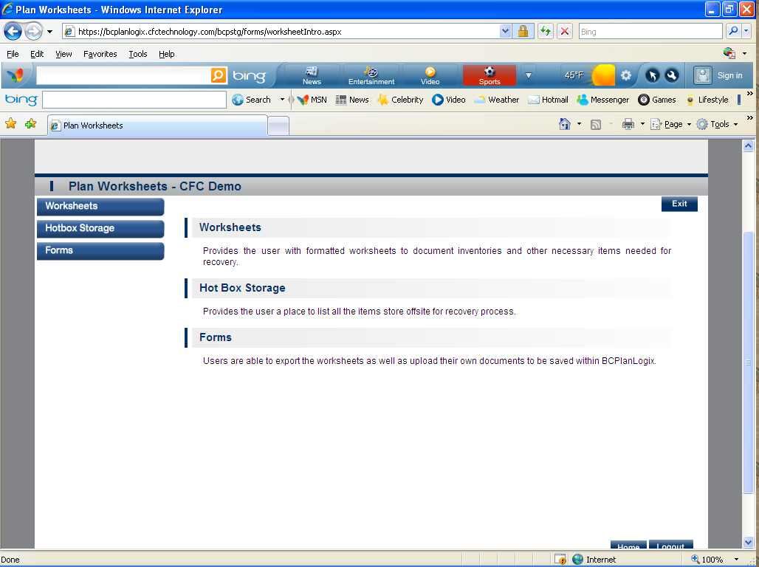
- Worksheets-Provides the user with formatted worksheets to document inventories and other necessary items needed for recovery.
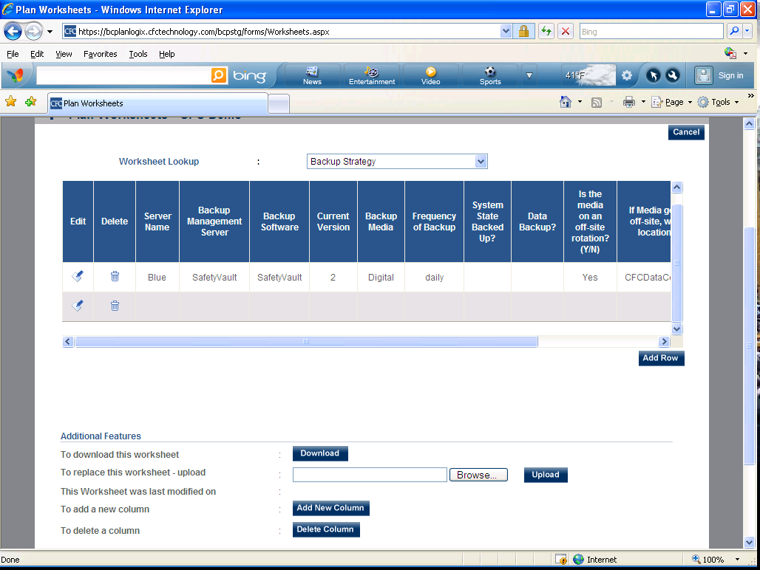

- Hotbox Storage-Provides the user a place to list all the items store offsite for recovery process.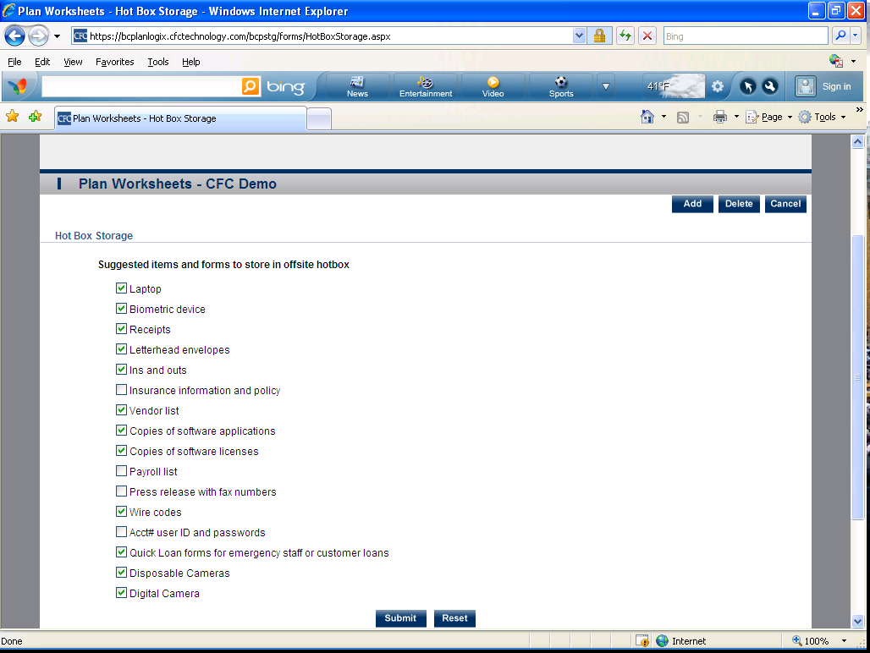
- Forms-Users are able to export the worksheets as well as upload their own documents to be saved within BCPlanLogix.
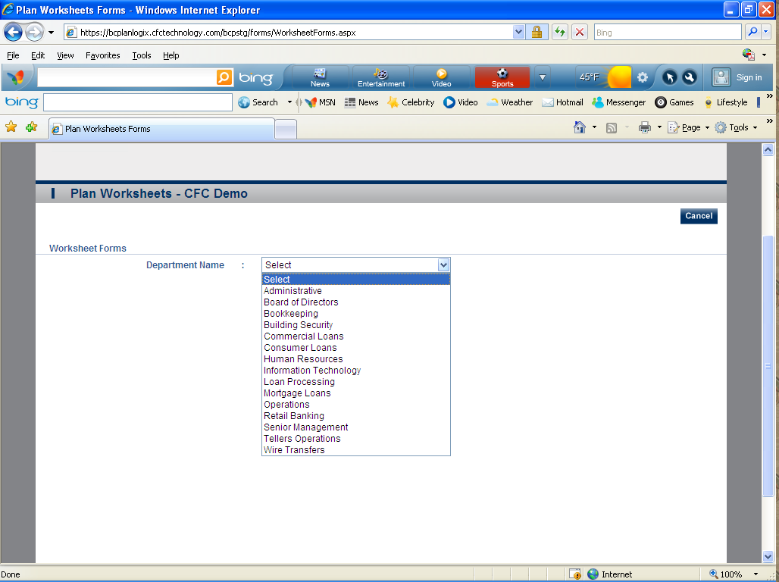

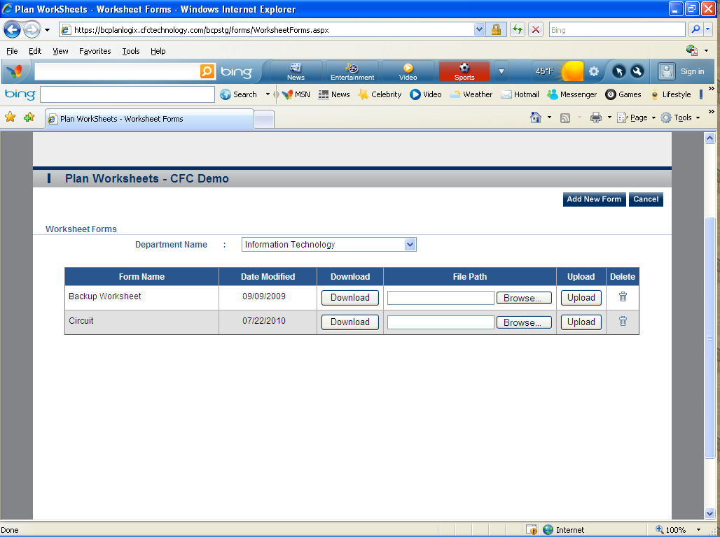

Pandemic Flu (19 Sections Listed Below)
- Plan Overview-Plan Overview allows the user to view the plan details.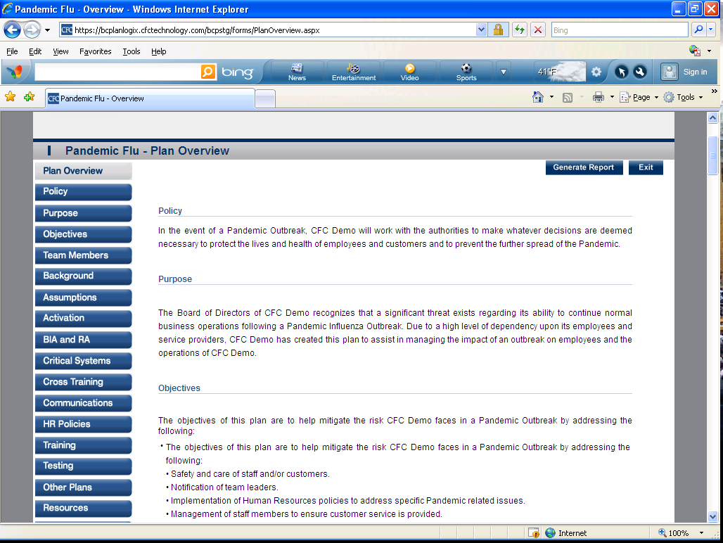

- Policy-This section includes the Policy of Pandemic Plan response. 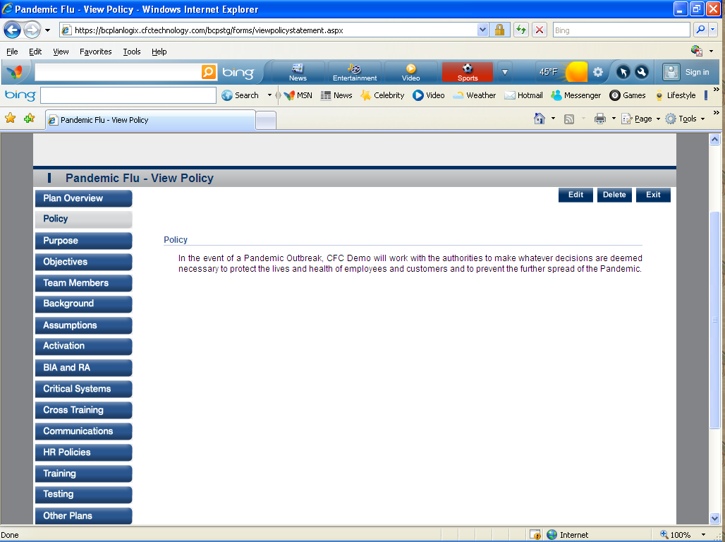
- Purpose-This section allows the user to define the purpose of the Pandemic Plan. 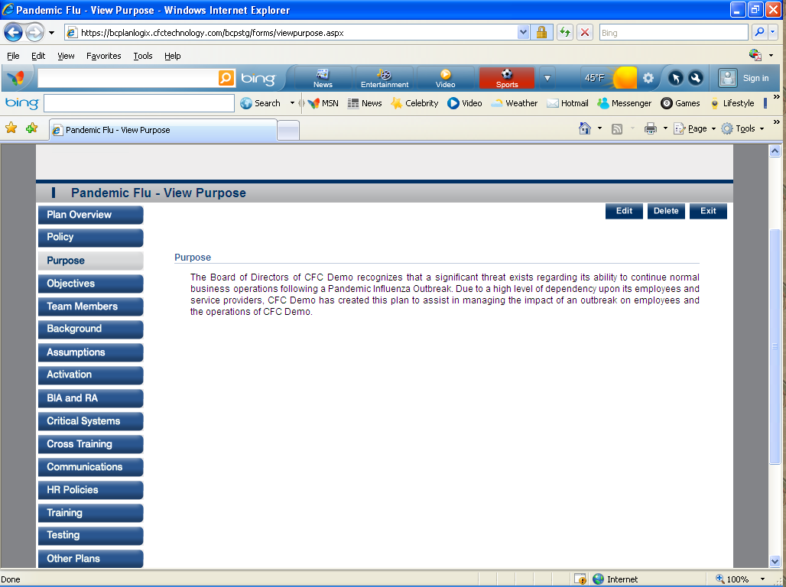

- Objectives-This section allows user to define objectives of the Pandemic Plan. 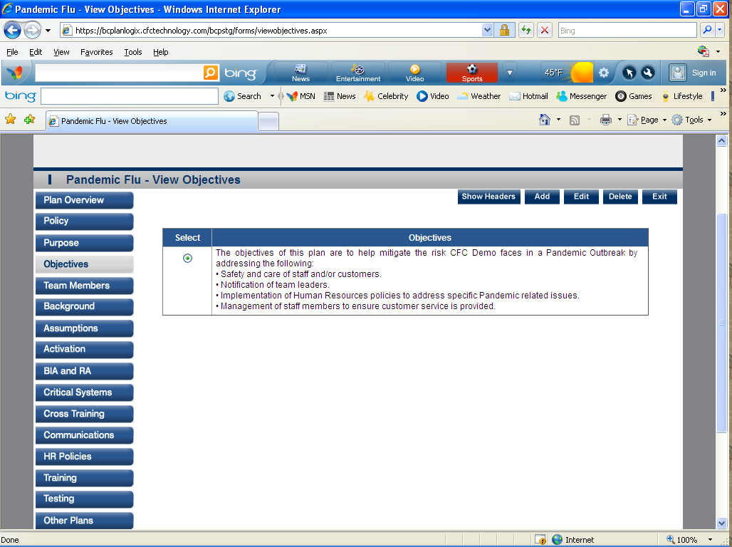

- Team Members- Teams Members allow user to assign employees to the Pandemic Recovery process.
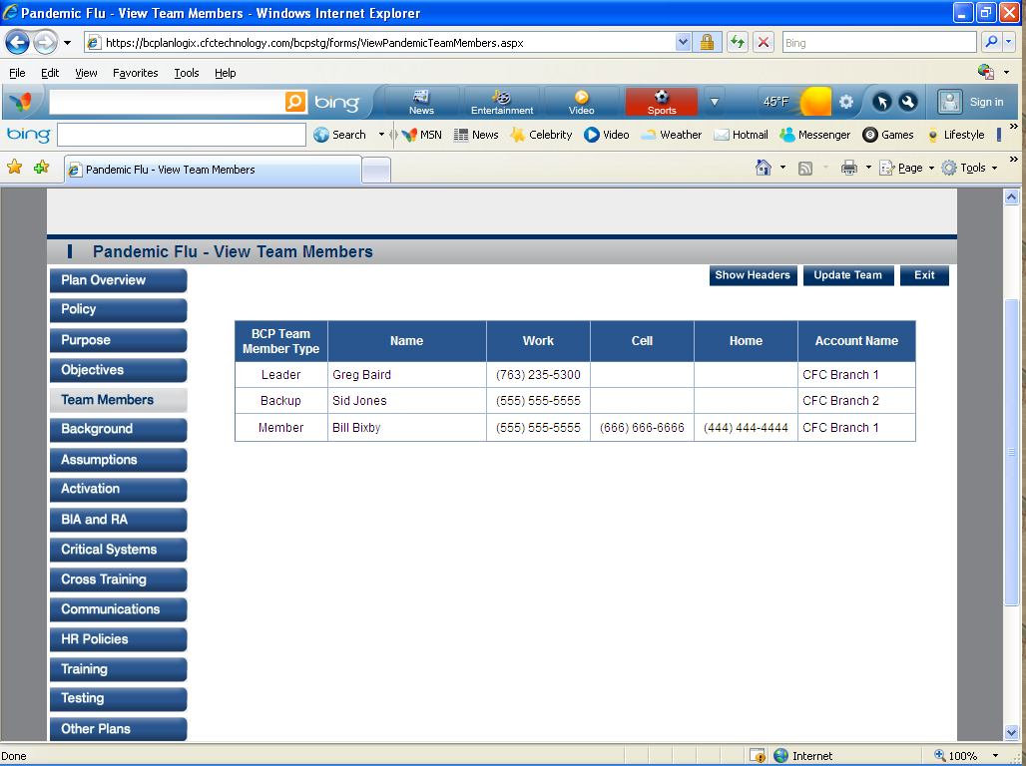

- Background- Background helps in finding the probability of the occurrences of Pandemic Flu and it’s in the past.
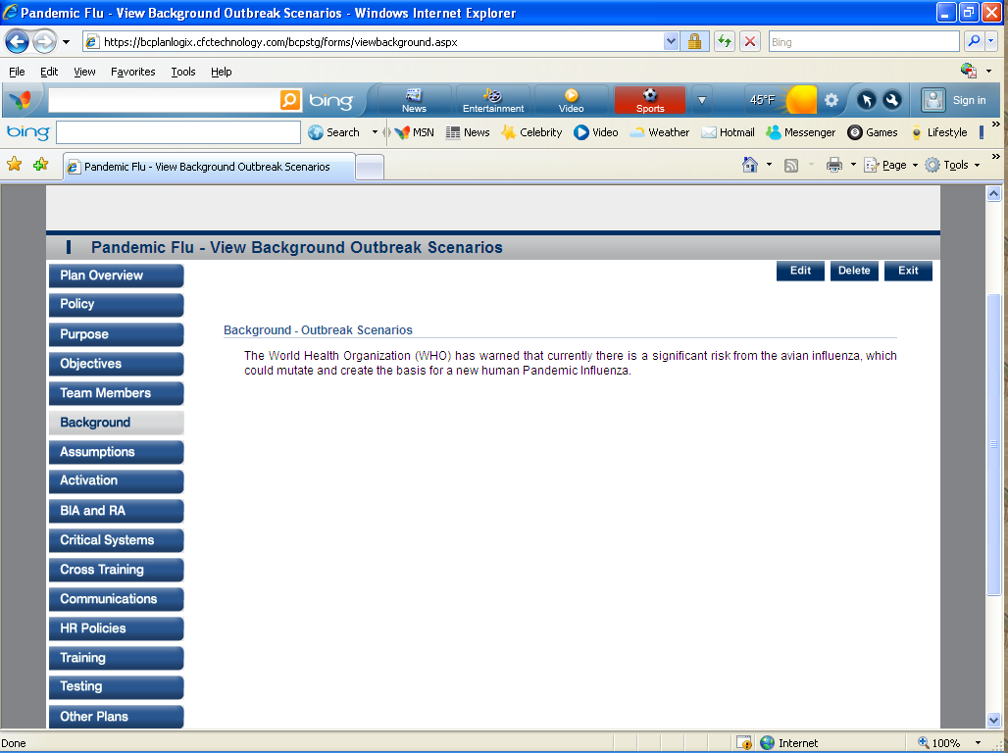
- Assumptions- This allows the user to add assumptions that are to be considered when there is a Pandemic Outbreak.
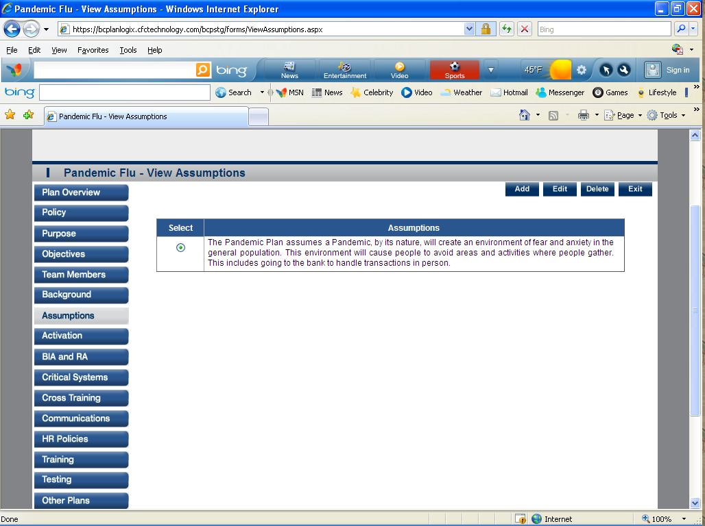

- Activation- Defines the way the Pandemic Plan will be activated. 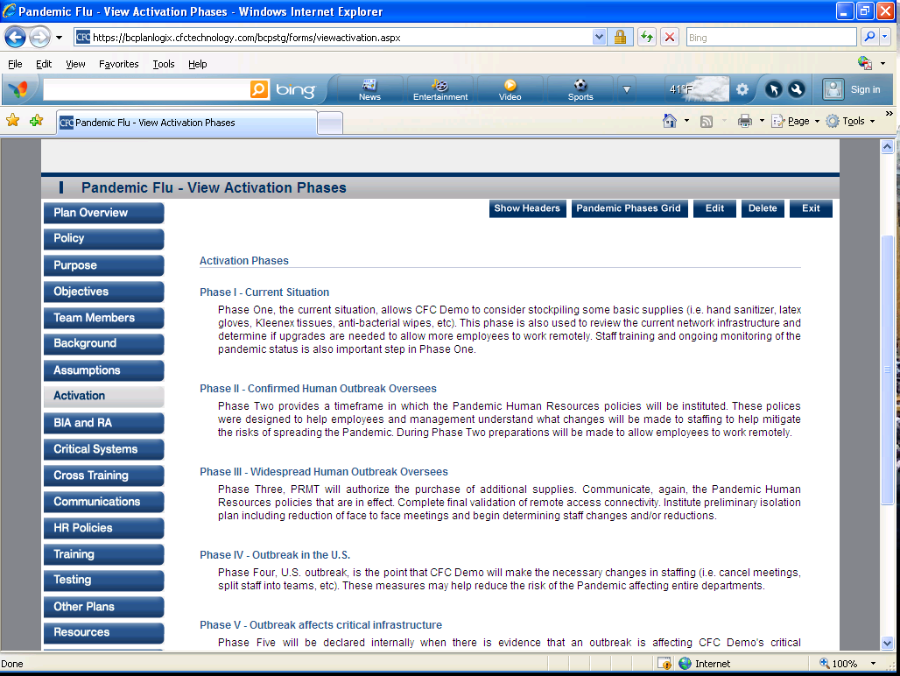

- BIA and RA- BIA and RA help to identify the risks the bank faces with regard to Pandemic Planning.
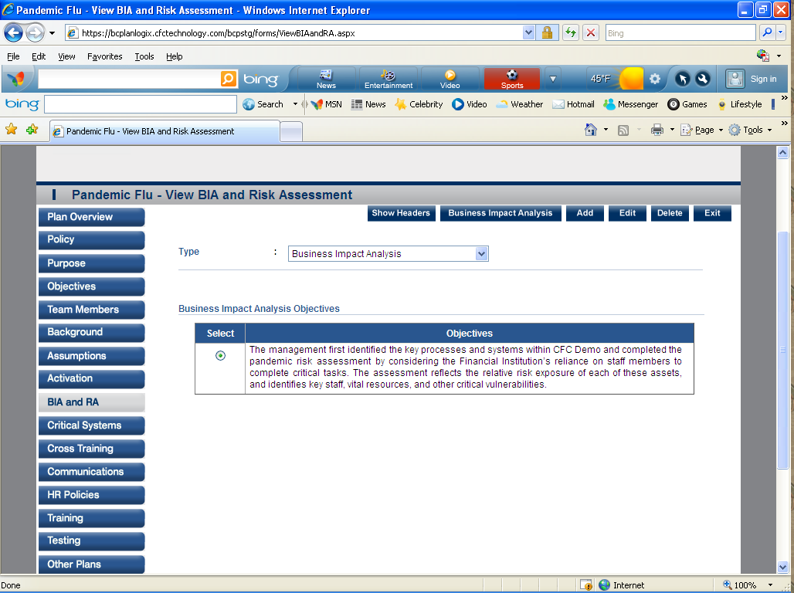

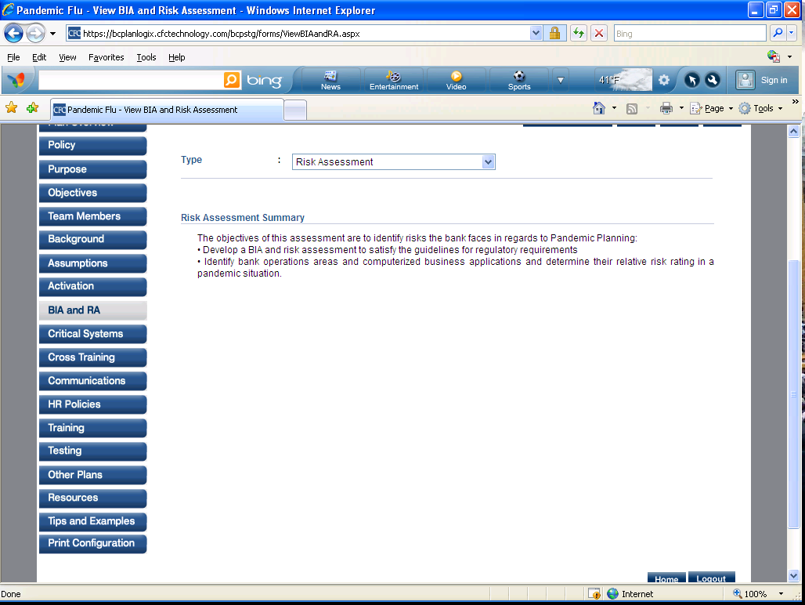
- Critical Systems- This section includes an overview of Critical Business Processes including a brief description of the business process.
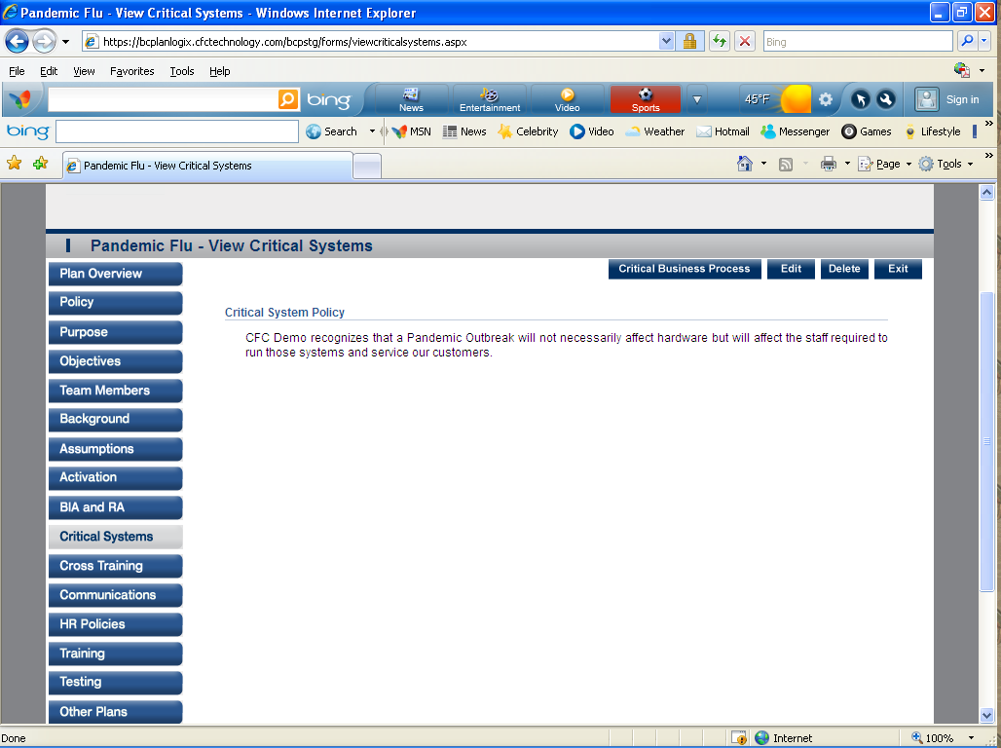

- Cross Training- This section will allow user to define critical processes and the document the cross training in place.
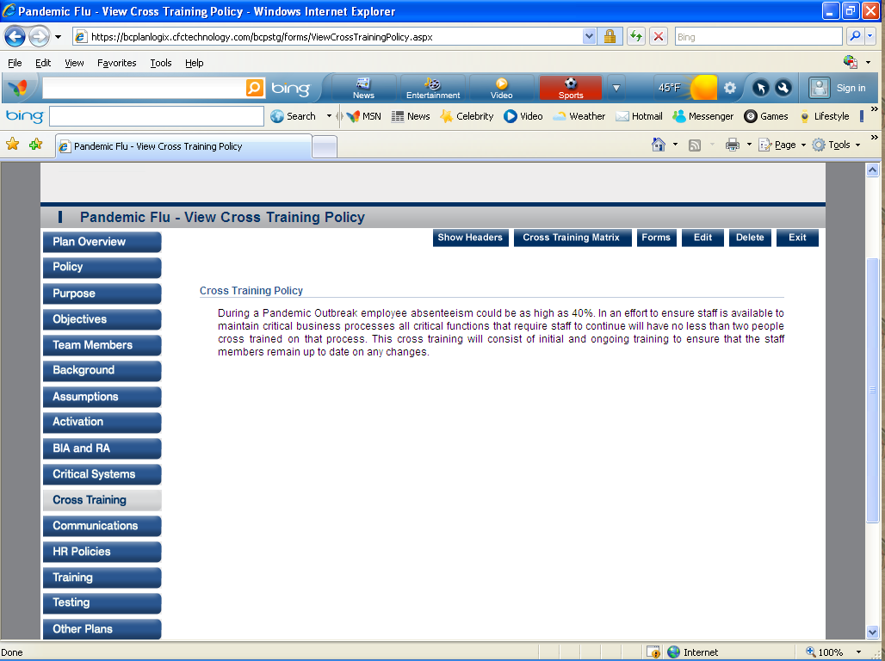
- Communication- This section allows the user to define how the Pandemic Plan will be communicated to customers.
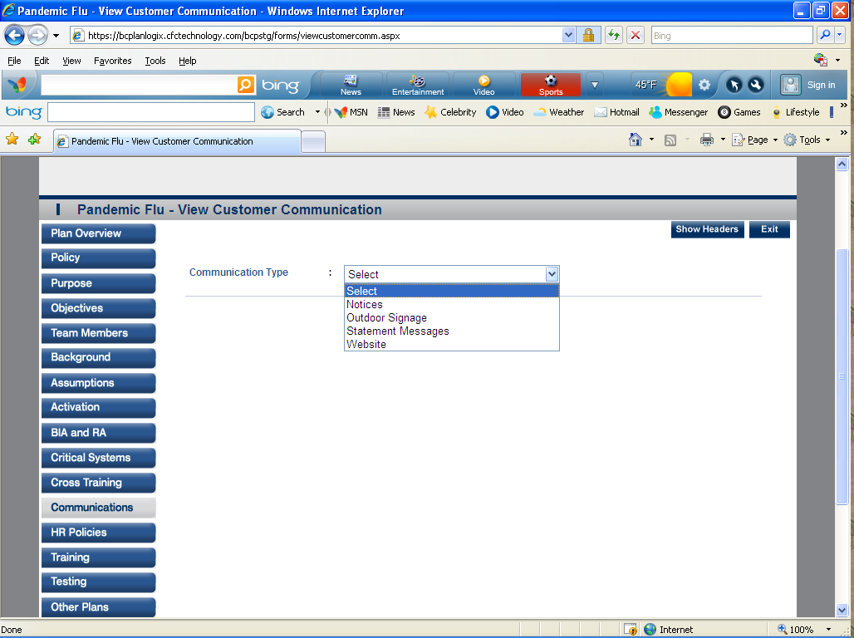

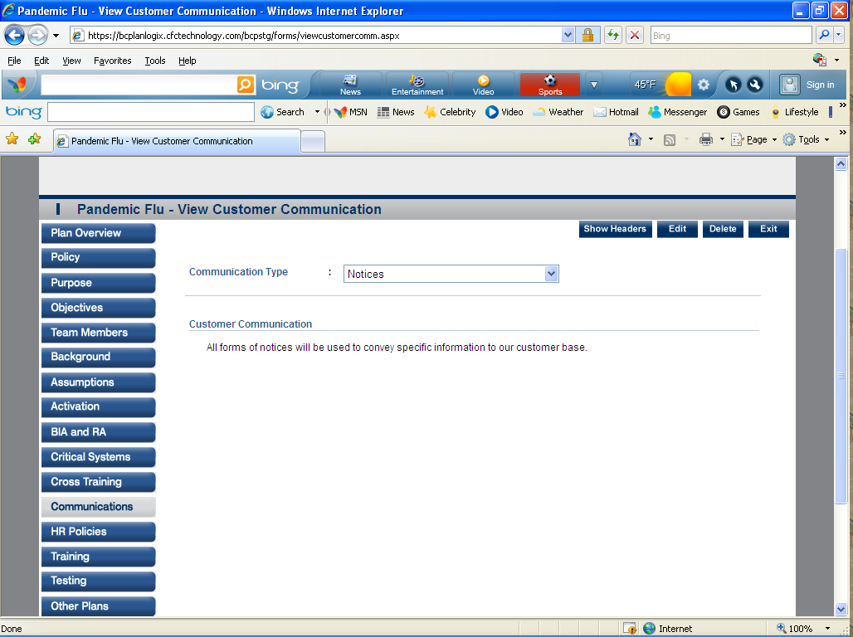
- HR Policy- Human Resource policies are an important part of your Pandemic Plan. This section will allow you define and document your Pandemic HR policies. 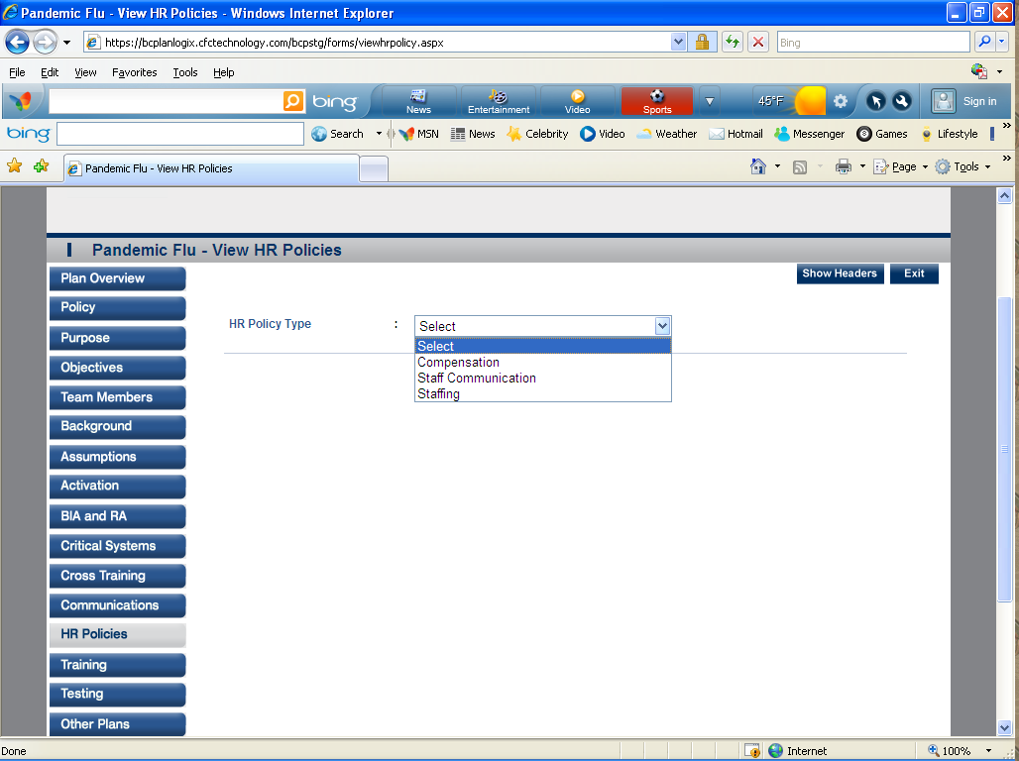

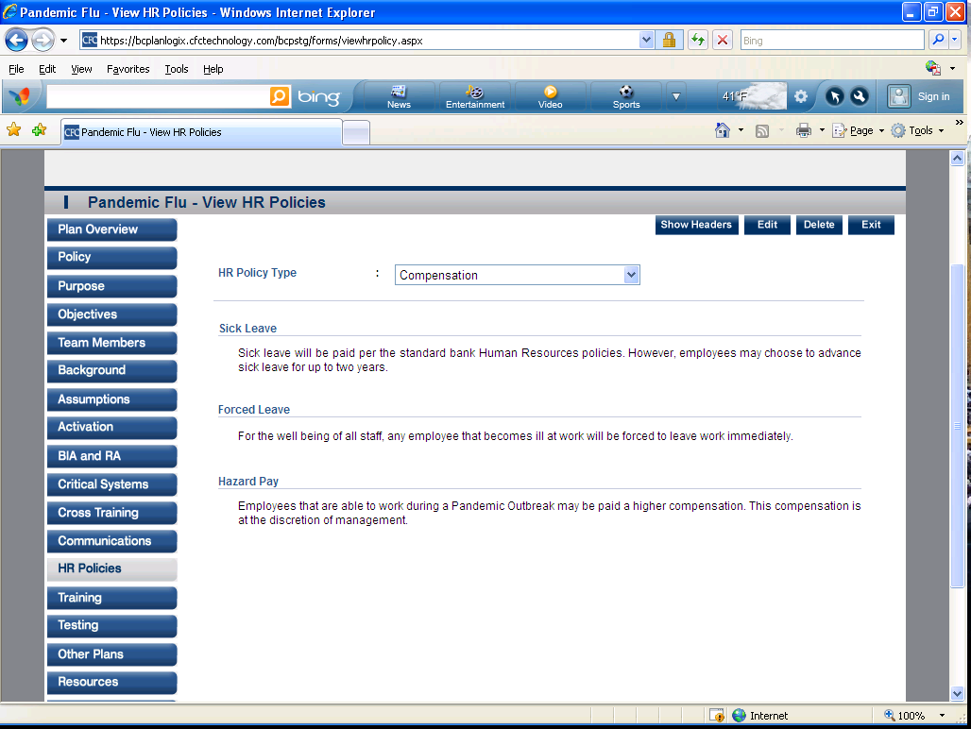

Training- This section will be used to define the training required to keep the staff informed and prepared for a Pandemic outbreak.

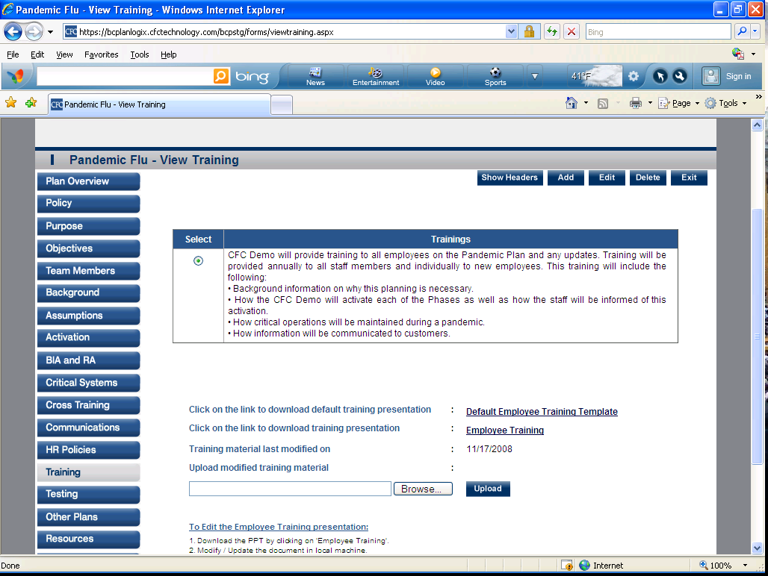

- Testing- This section includes allows the user to define the testing methodologies for the Pandemic Plan. 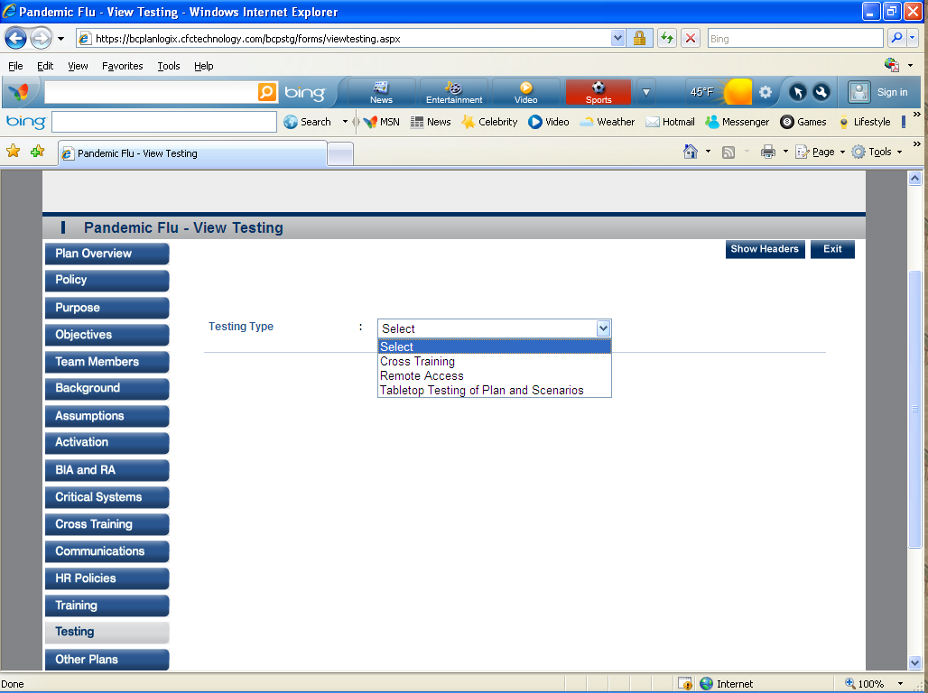
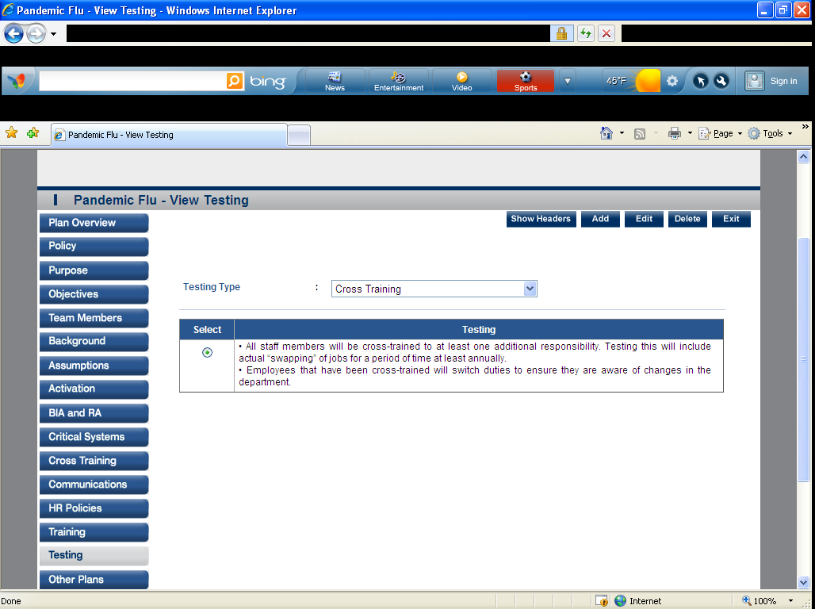

- Other Plans- This section provides a series of questions that will help determine the institutions position on
these topics.
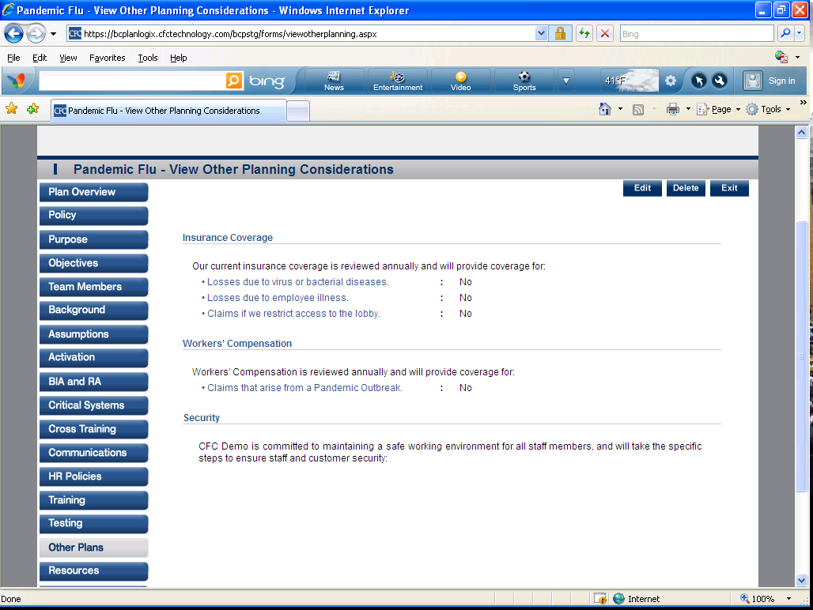
- Resources- This section is a reporting form for staff communications. 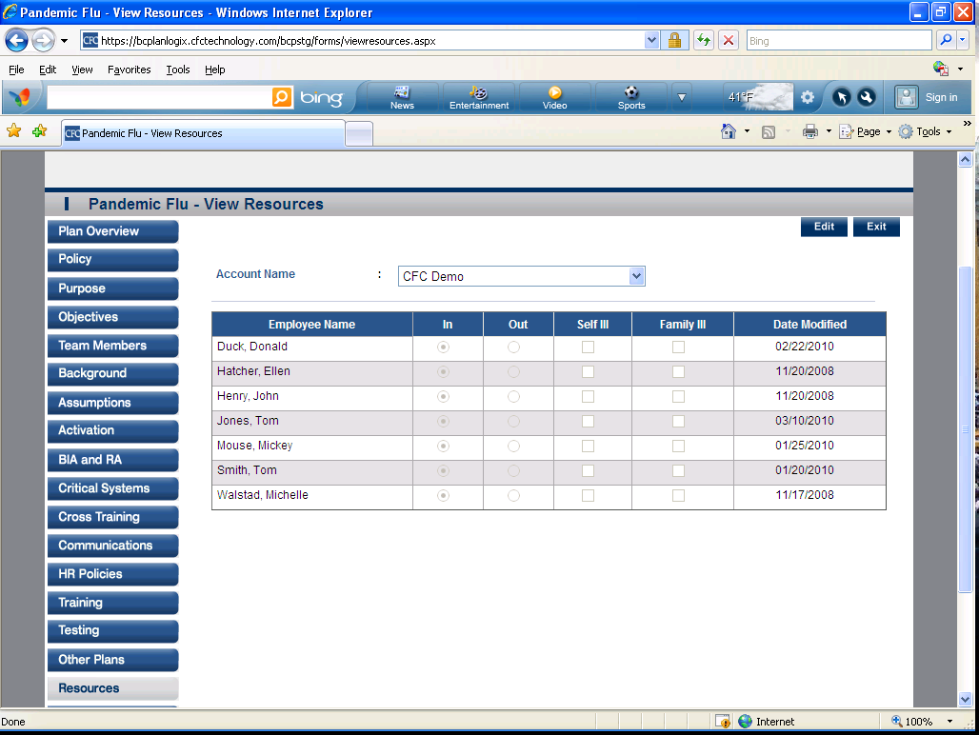

- Tips and Examples-This section gives you tips and examples for your Pandemic overview. 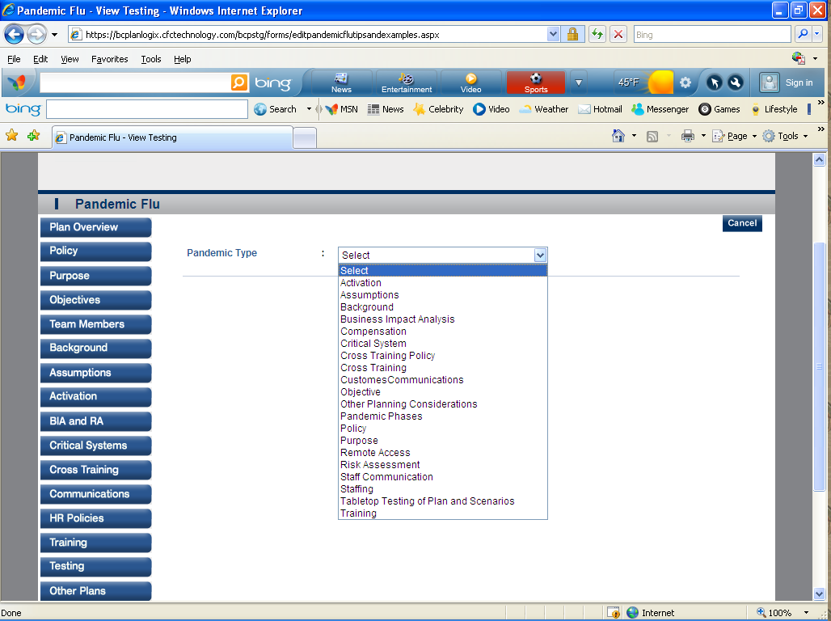
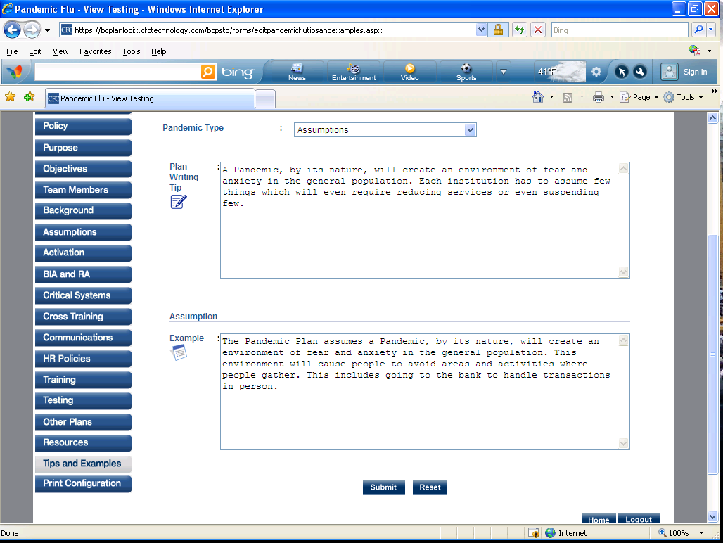

- Print Configurations-This section allows you to print the section that you want printed.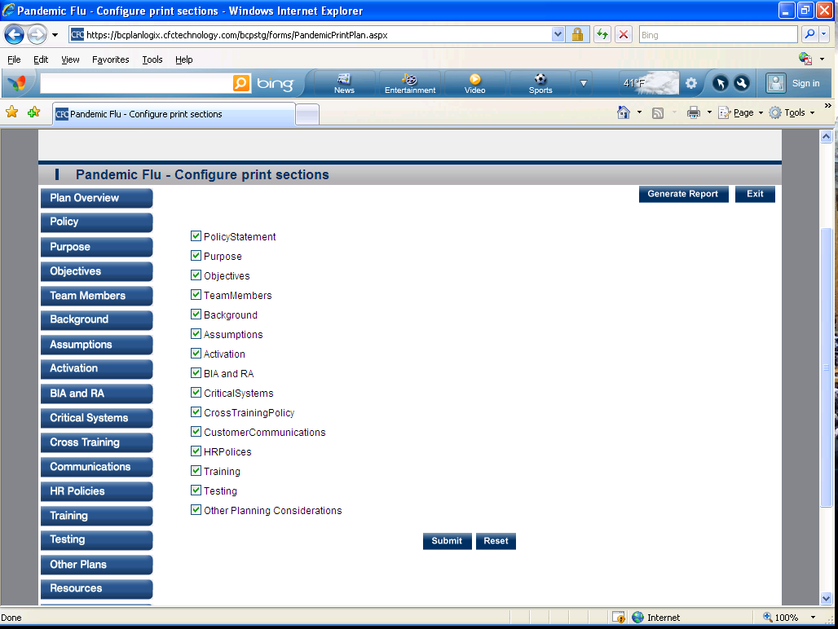

Testing (8 Sections Listed Below)
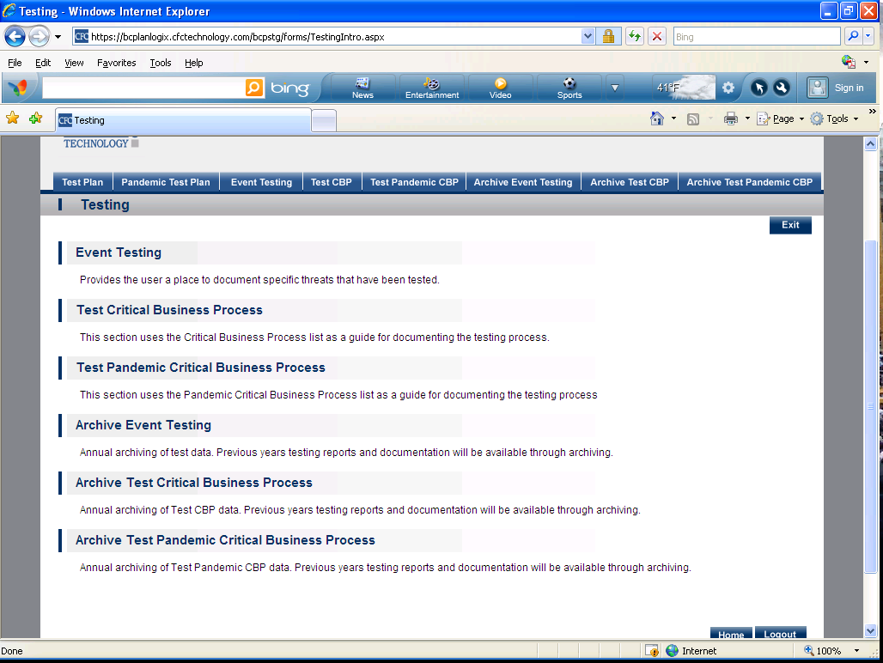
- Test Plan
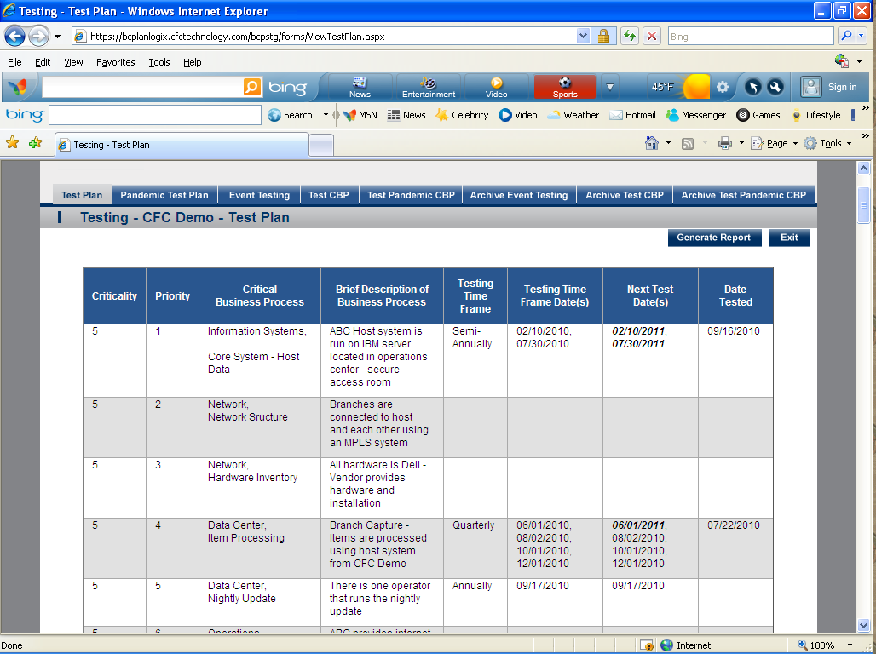

- Pandemic Test Plan
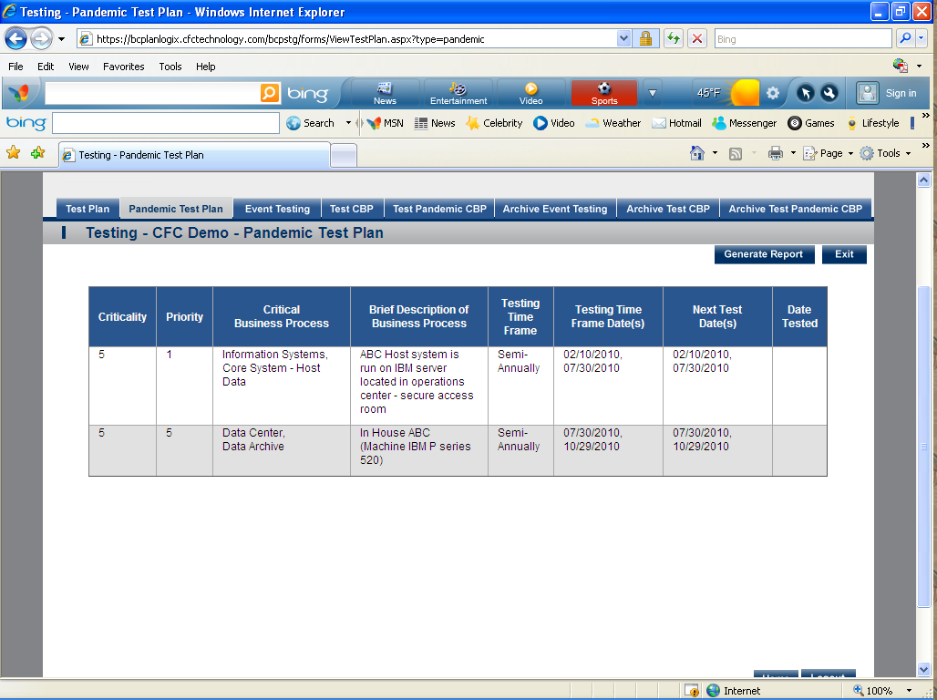

- Event Testing- Provides the user a place to document specific threats that have been tested. 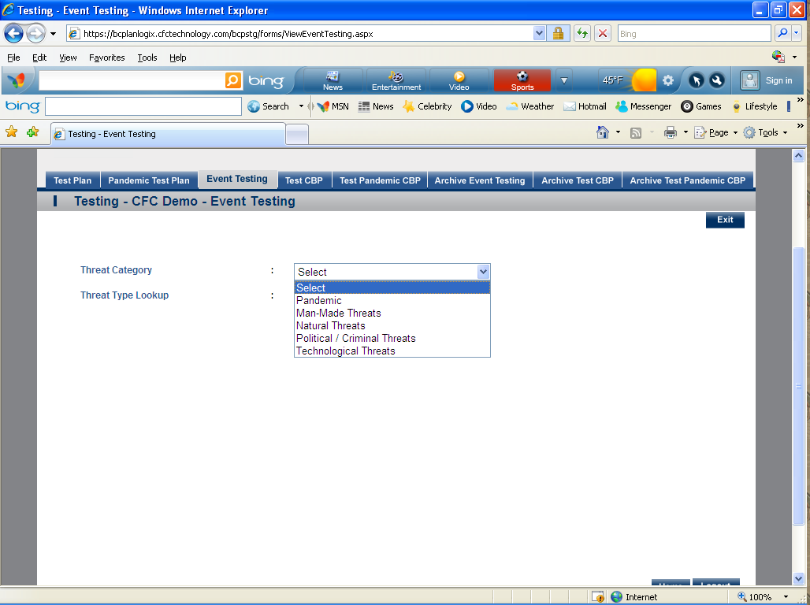
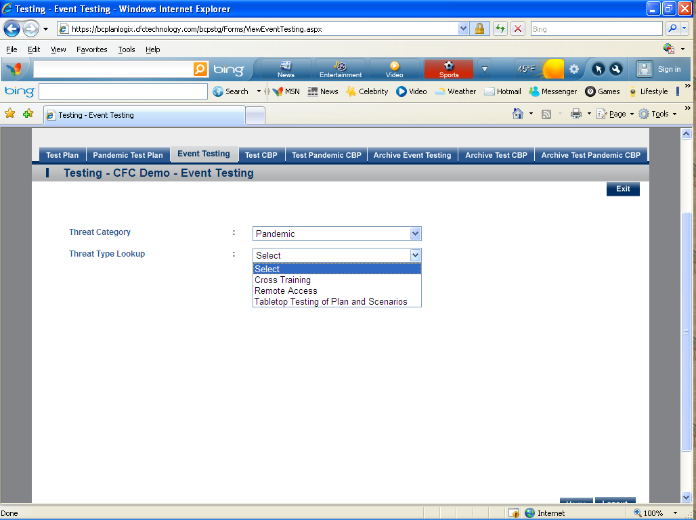

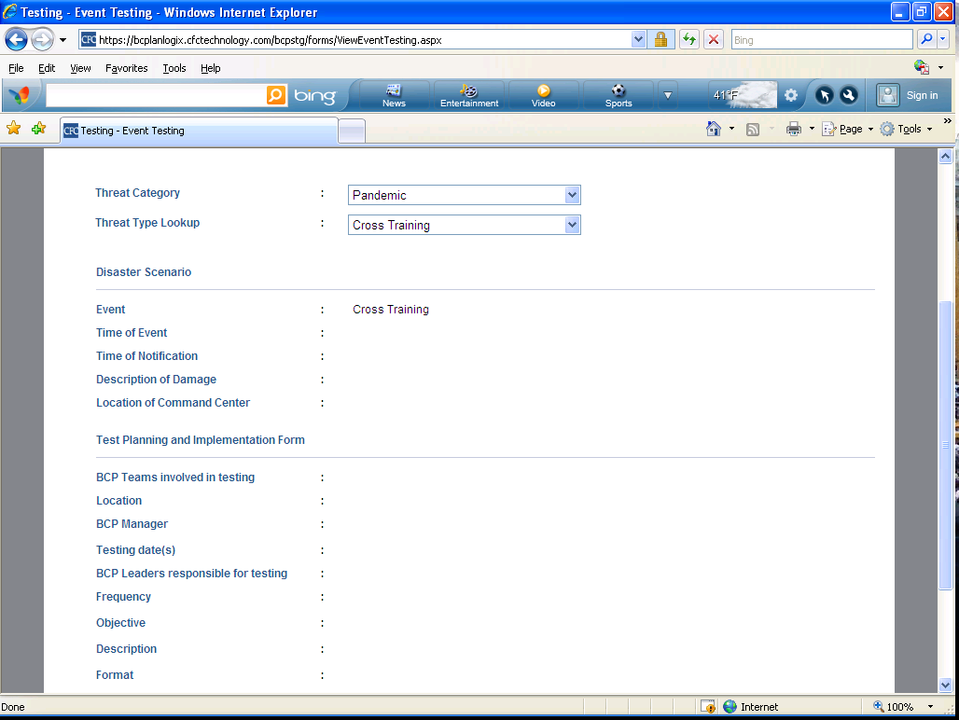
- Test CBP- This section uses the Critical Business Process list as a guide for documenting the testing process. 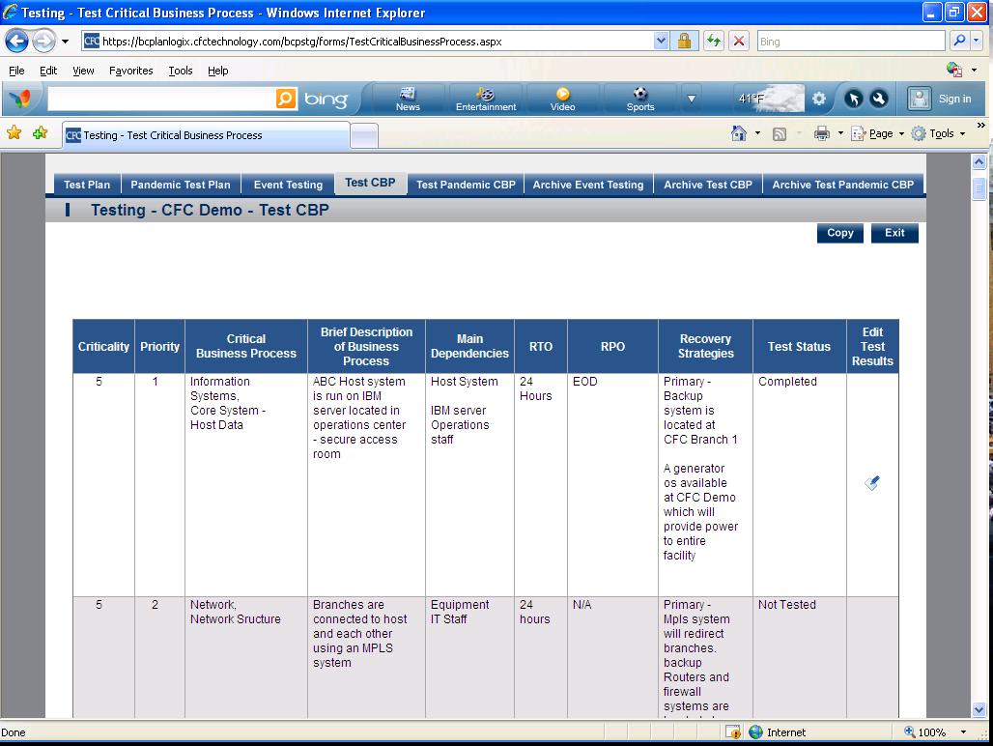

- Test Pandemic CBP- This section uses the Pandemic Critical Business Process list as a guide for documenting the testing process.
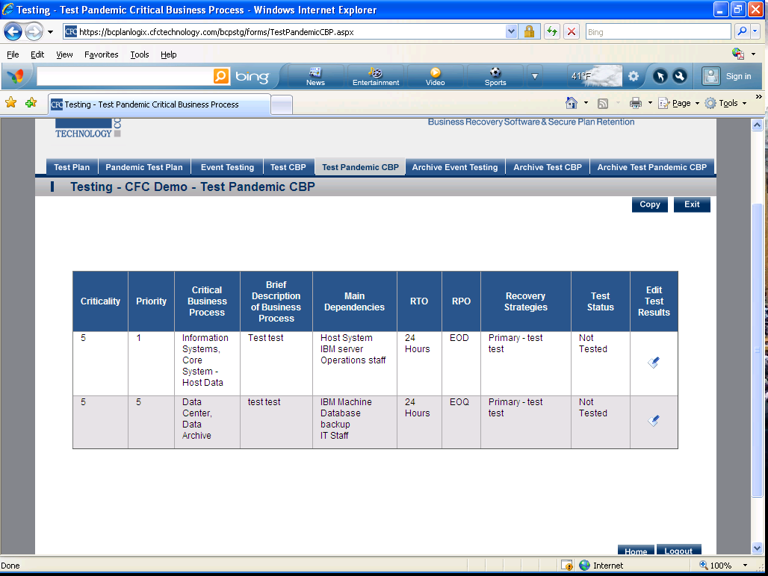

- Archive Event Testing- Annual archiving of test data. Previous years testing reports and documentation will be available through archiving.
- Archive Test CBP- Annual archiving of Test CBP data. Previous years testing reports and documentation will be available through archiving.
- Archive Test Pandemic CBP- Annual archiving of Test Pandemic CBP data. Previous years testing reports and documentation will be available through archiving.

Training (3 Sections Listed Below)
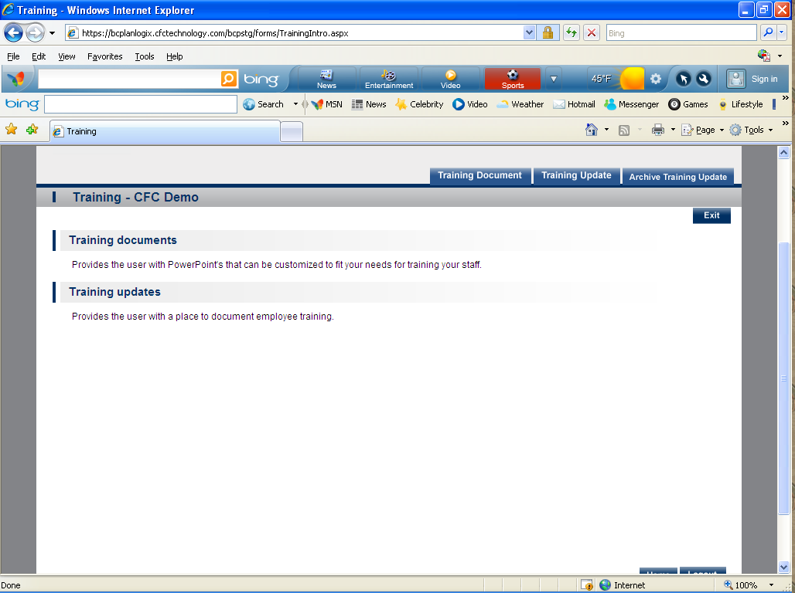

- Training Document- Provides the user with PowerPoint's that can be customized to fit your needs for training your staff.
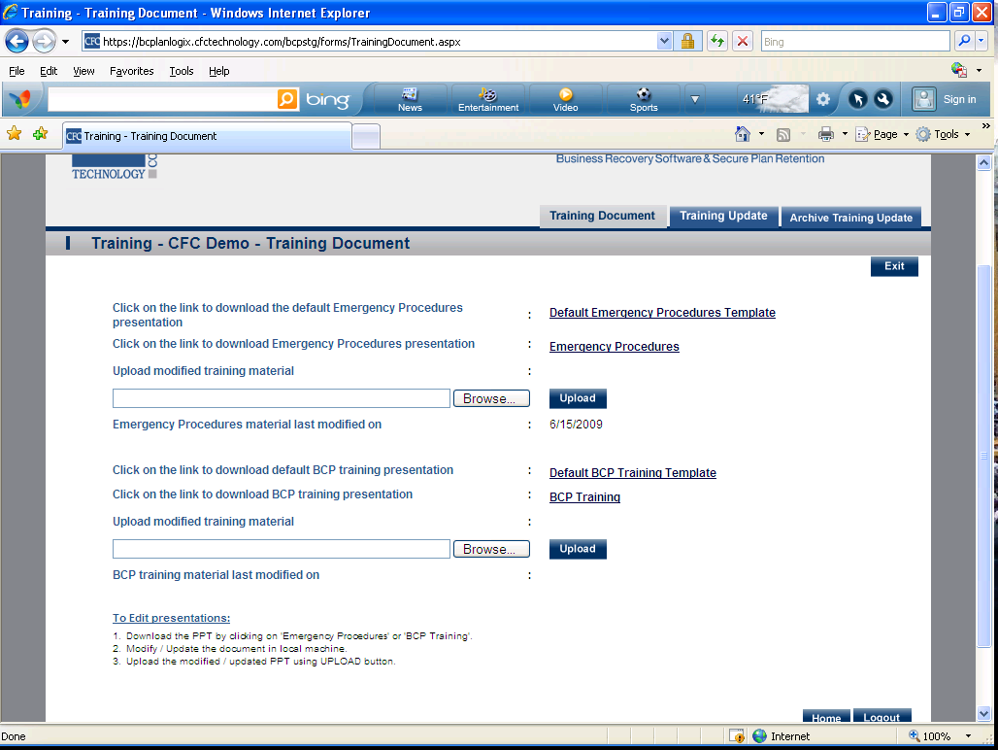

- Training Update- Provides the user with a place to document employee training. 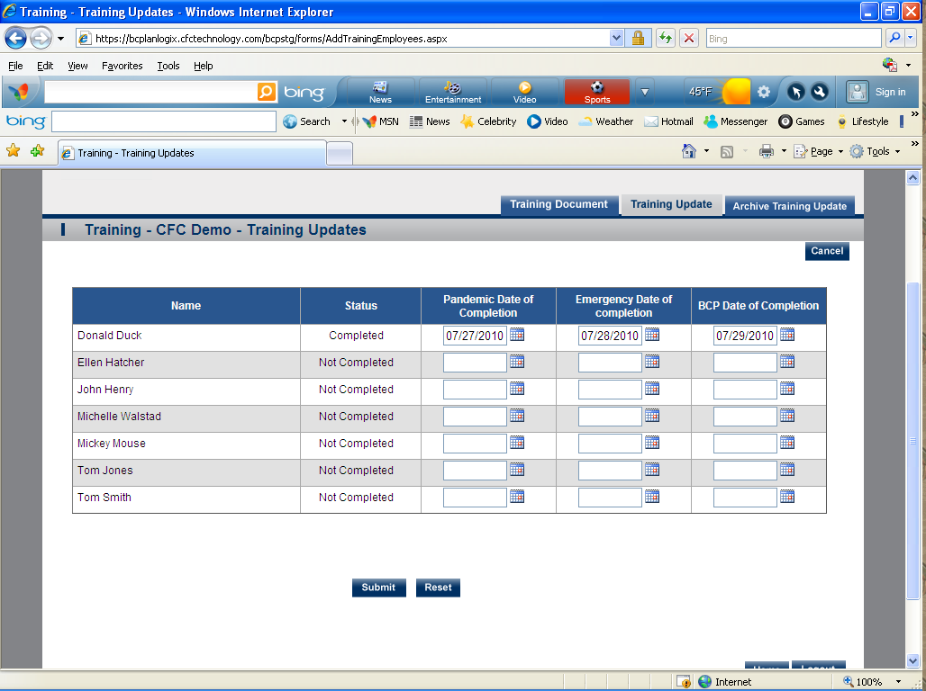
- Archive Training Update- Provides an archive of employee training and dates of completion. 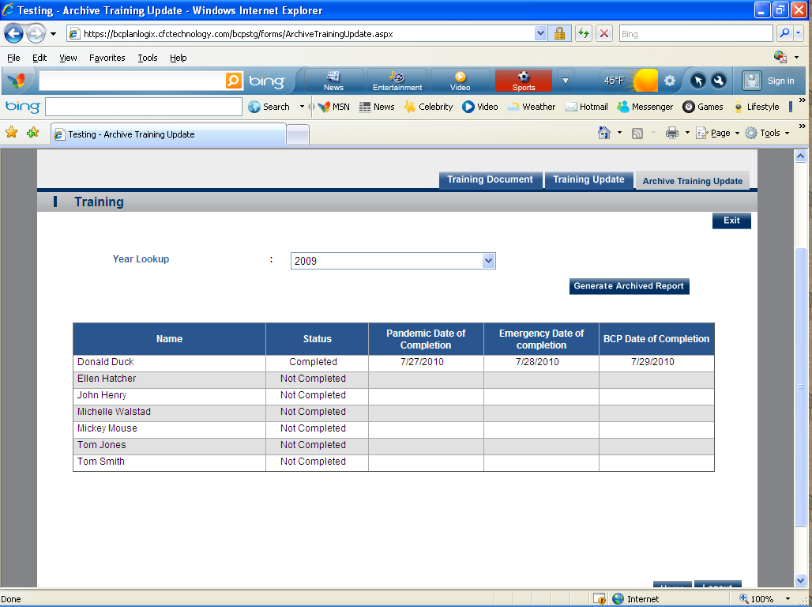

Milestone Manager
This is the login screen for the institution to enter their setup for Email\Text Notification.
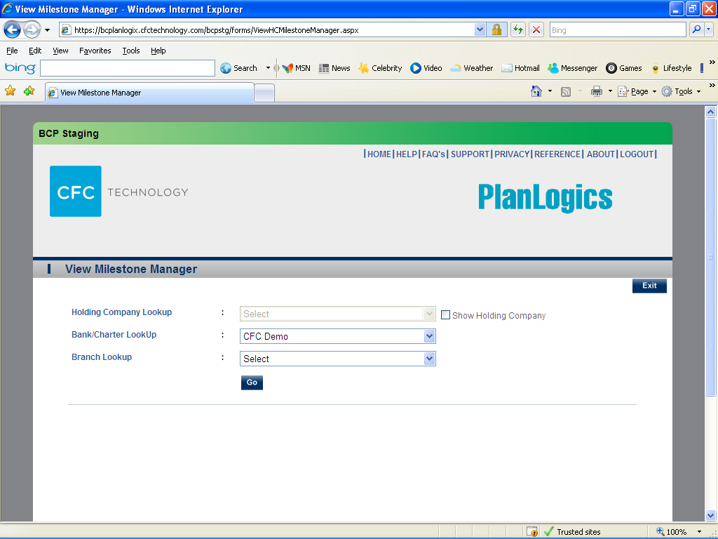
This is screen number one to setup the notification for emails and text (SMS) messages.
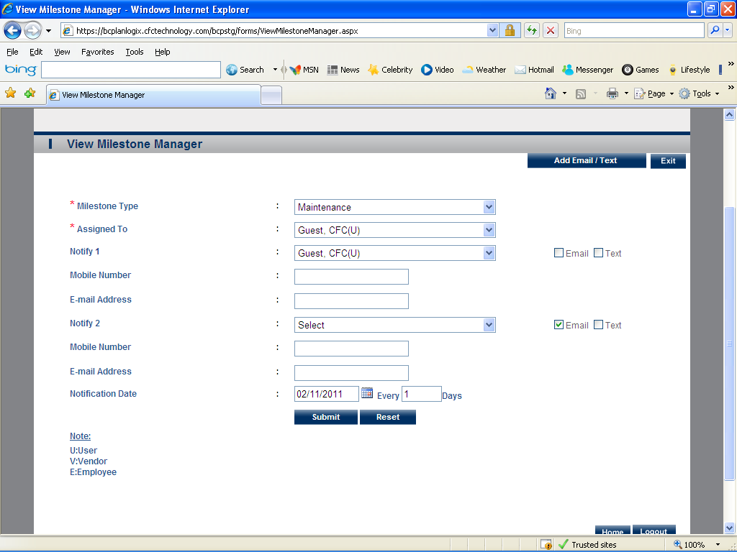
This is screen number two. It is where you will edit your emails and text messages for the notifications.
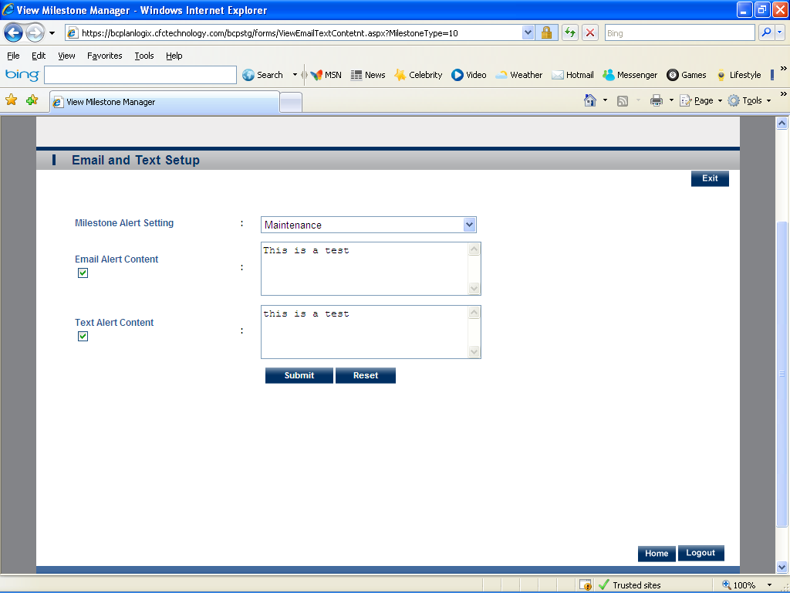

Vendor Management (5 Sections Listed Below)
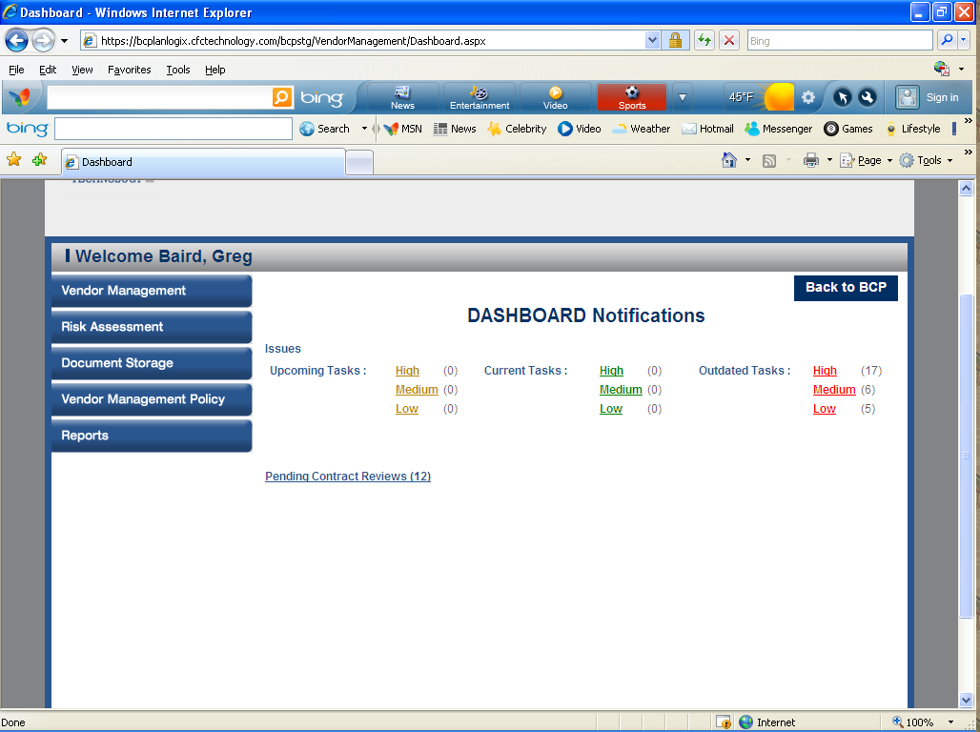

- Vendor Management (5 Sub Sections Listed Below)
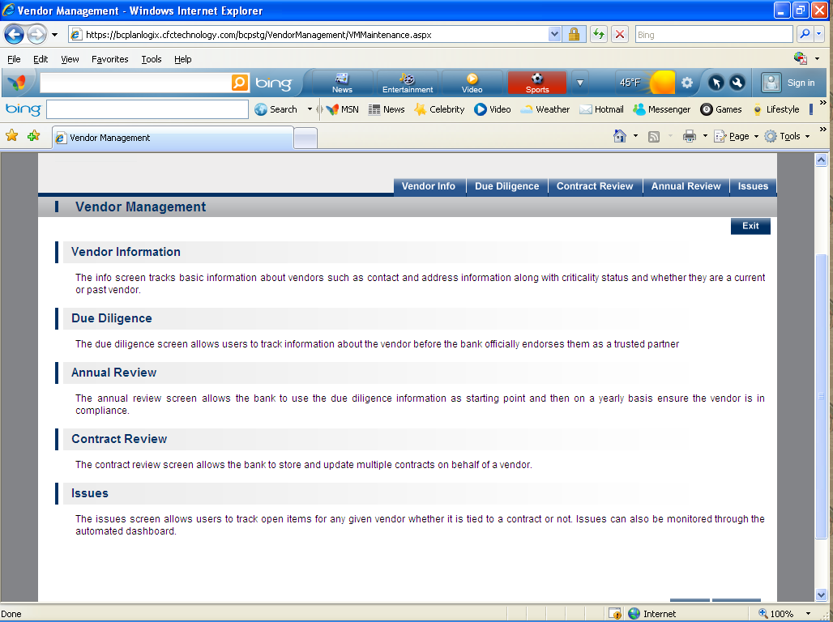

  - Vendor Information- The info screen tracks basic information about vendors such as contact and address information along with criticality status and whether they are a current or past vendor.
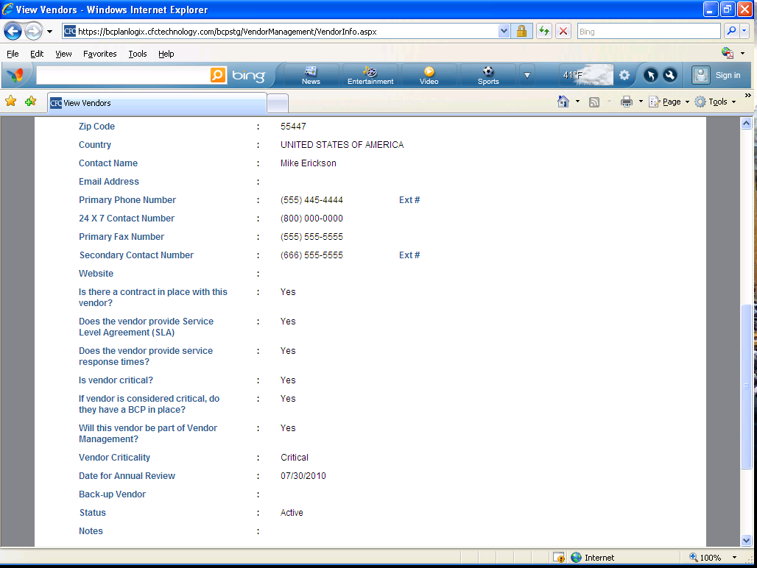

  - Due Diligence
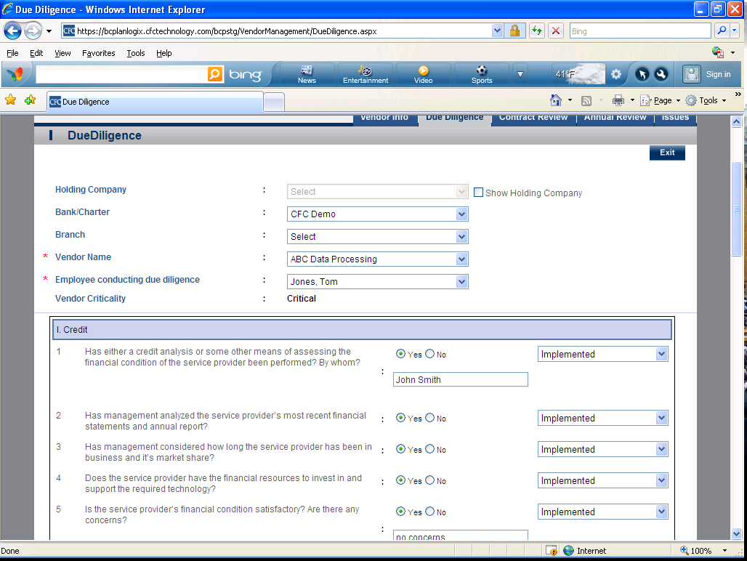

  - Annual Review
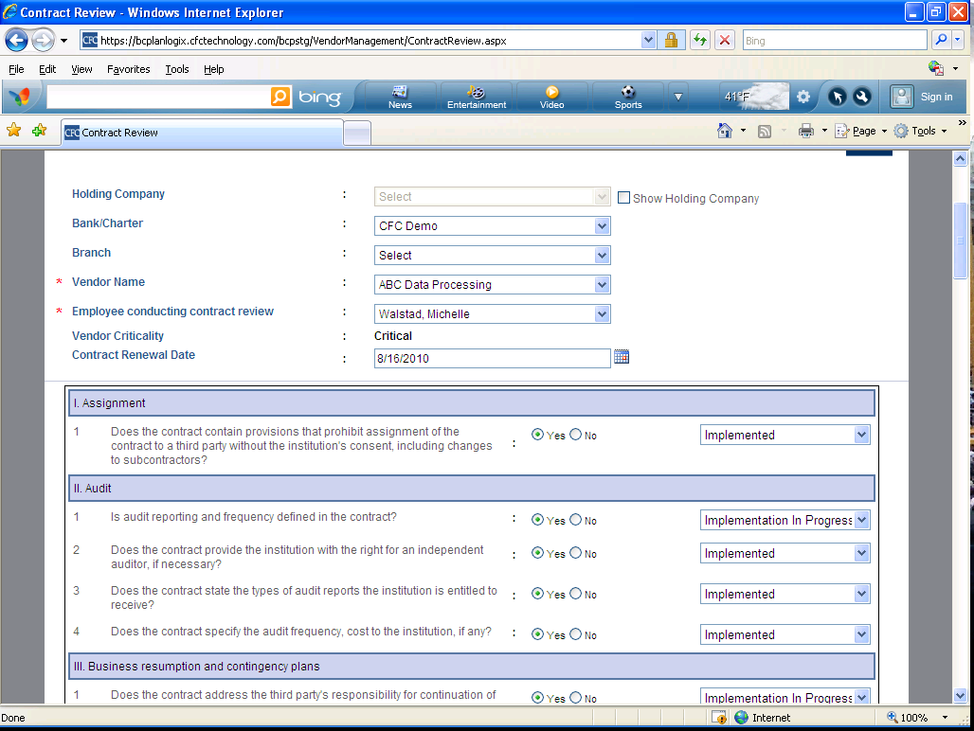

  - Contract Review
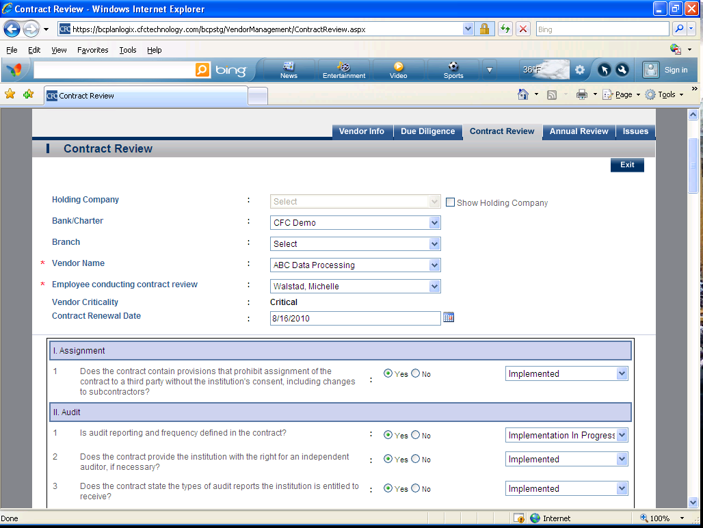

  - Issues
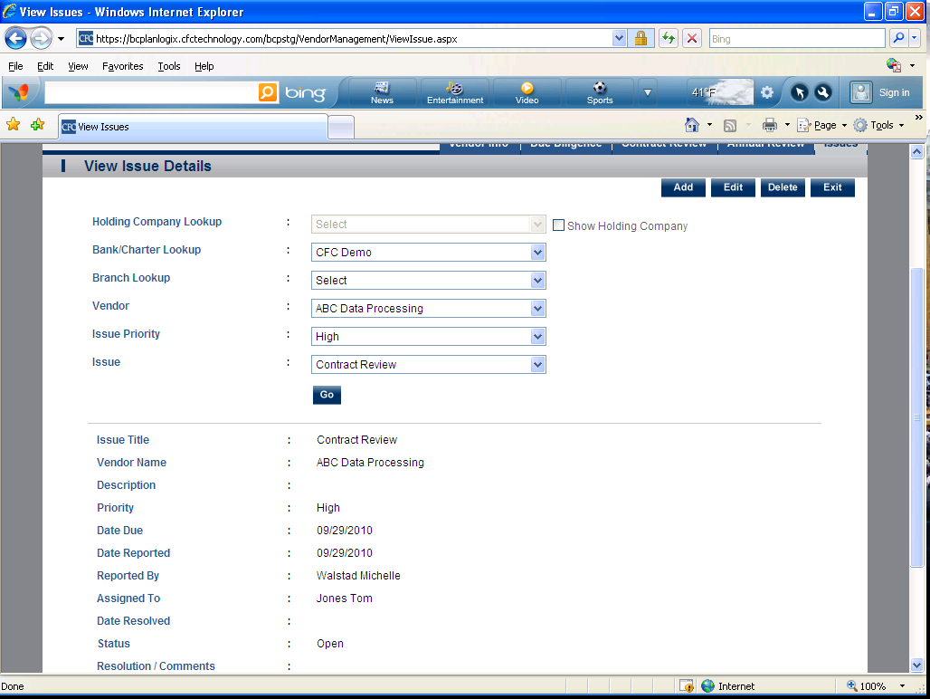
- Risk Assessment-This section describes the type and risk associated with this vendor.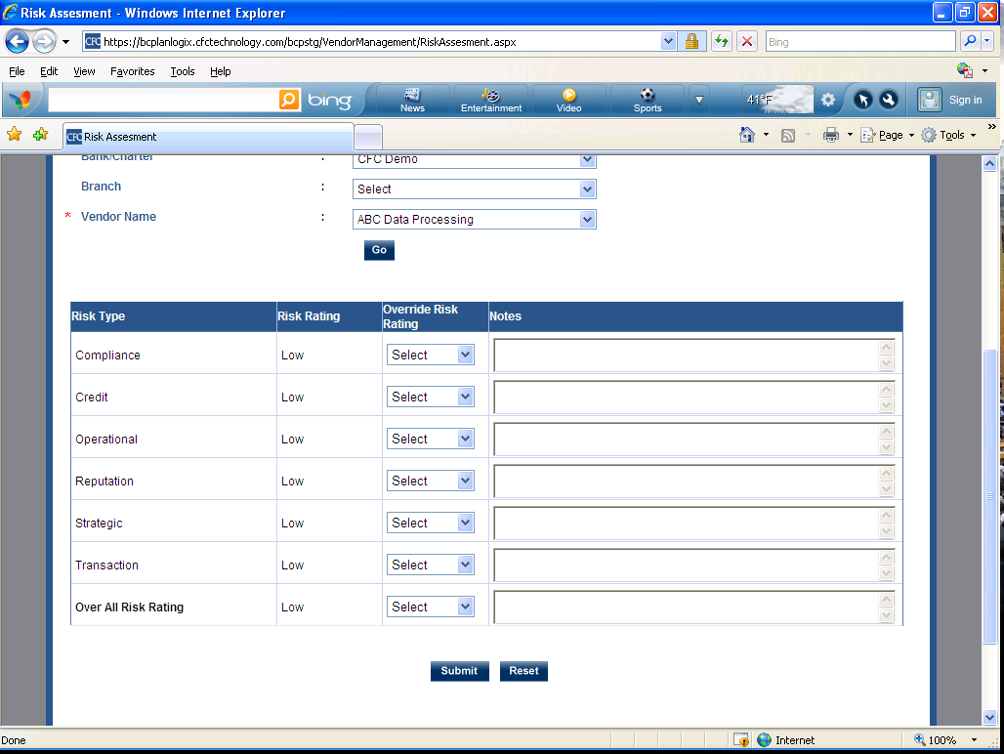

- Document Storage- This section allows you to upload and download the documents associated with this vendor.
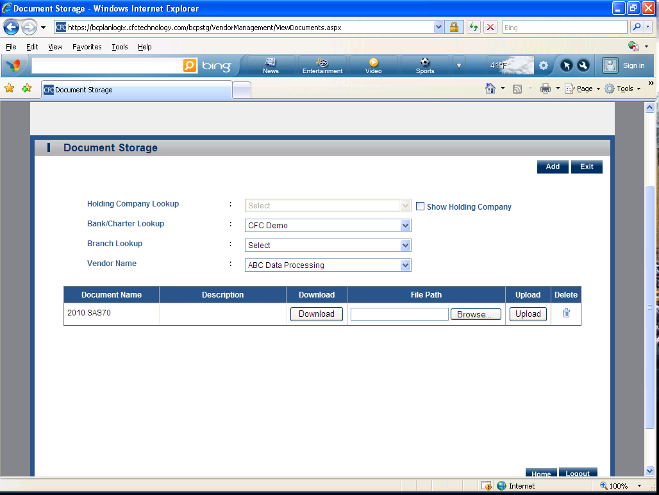
- Vendor Management Policy (5 Sub Sections Listed Below) 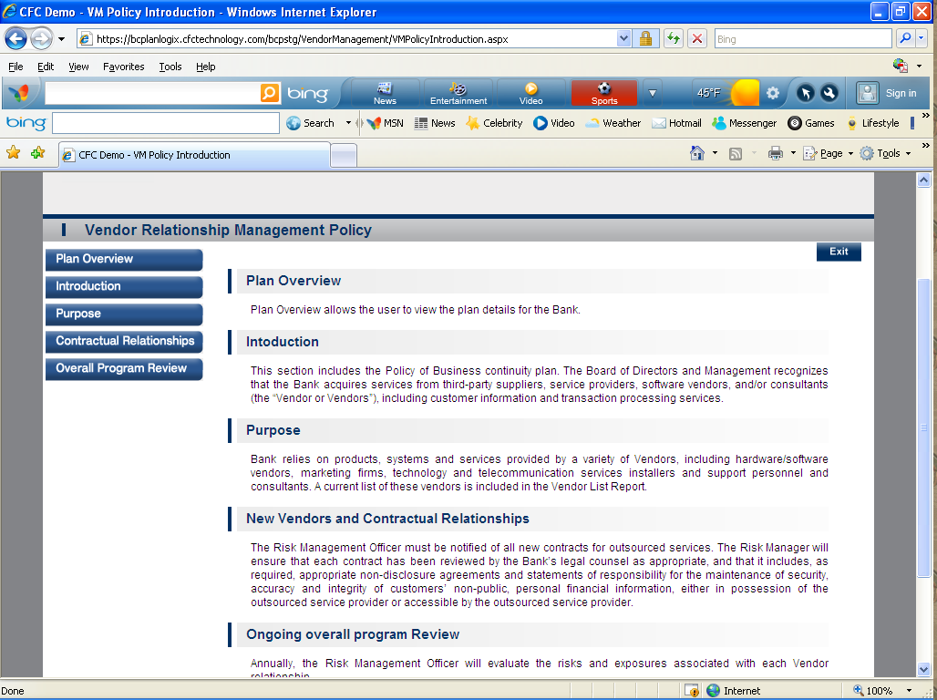

a. Vendor Relationship Management- Plan Overview
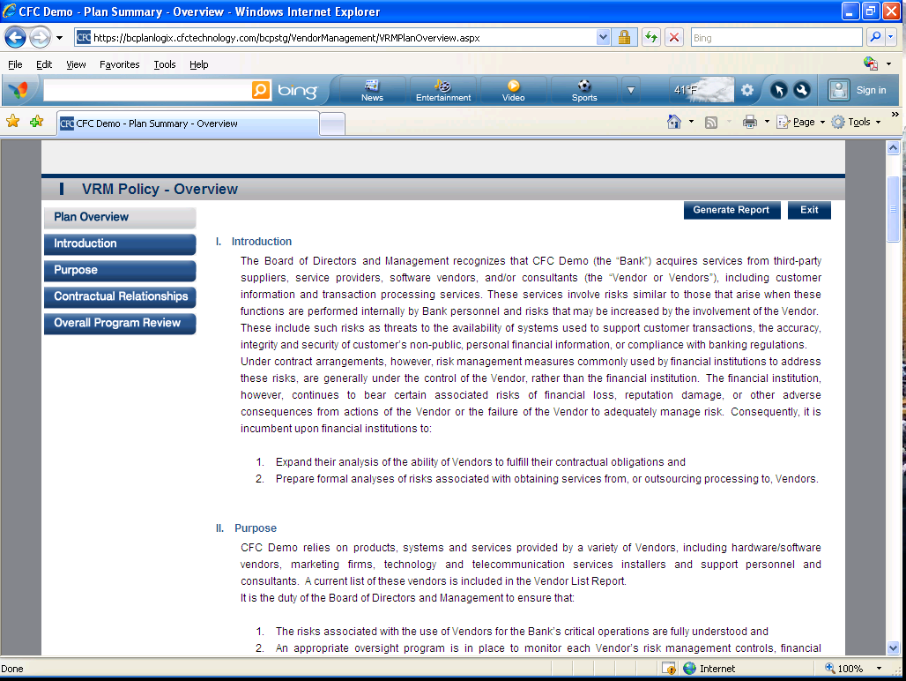

b. Introduction
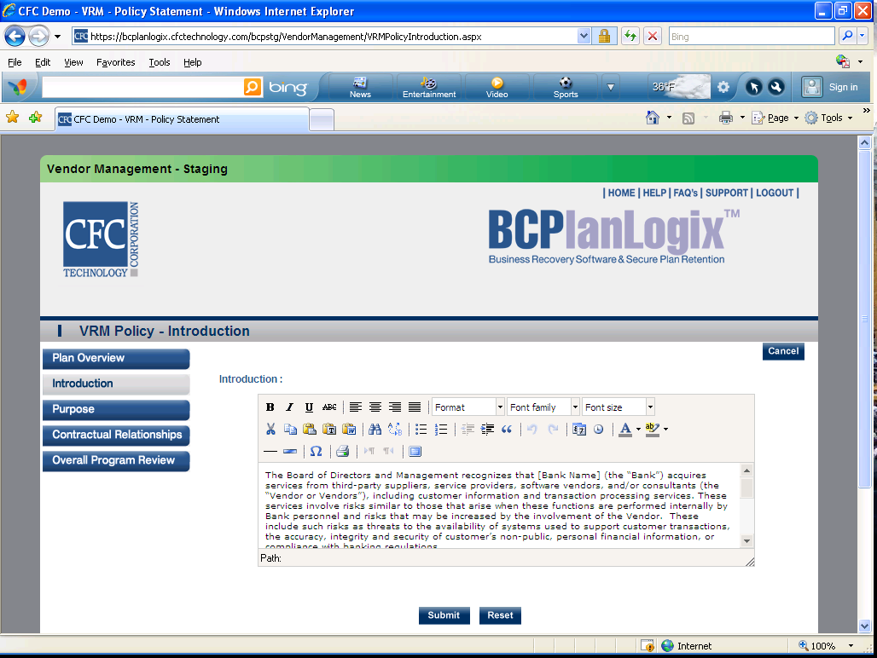

c. Purpose
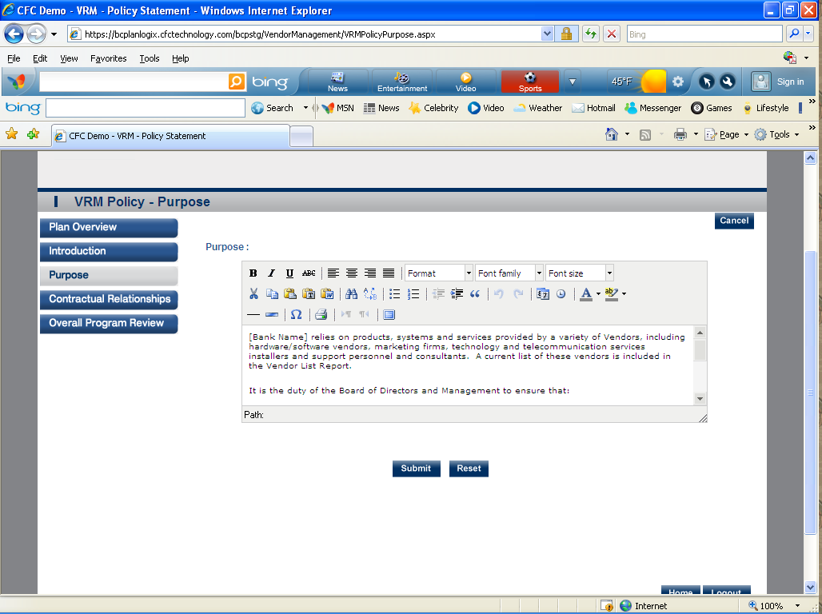

d. Contractual Relationships
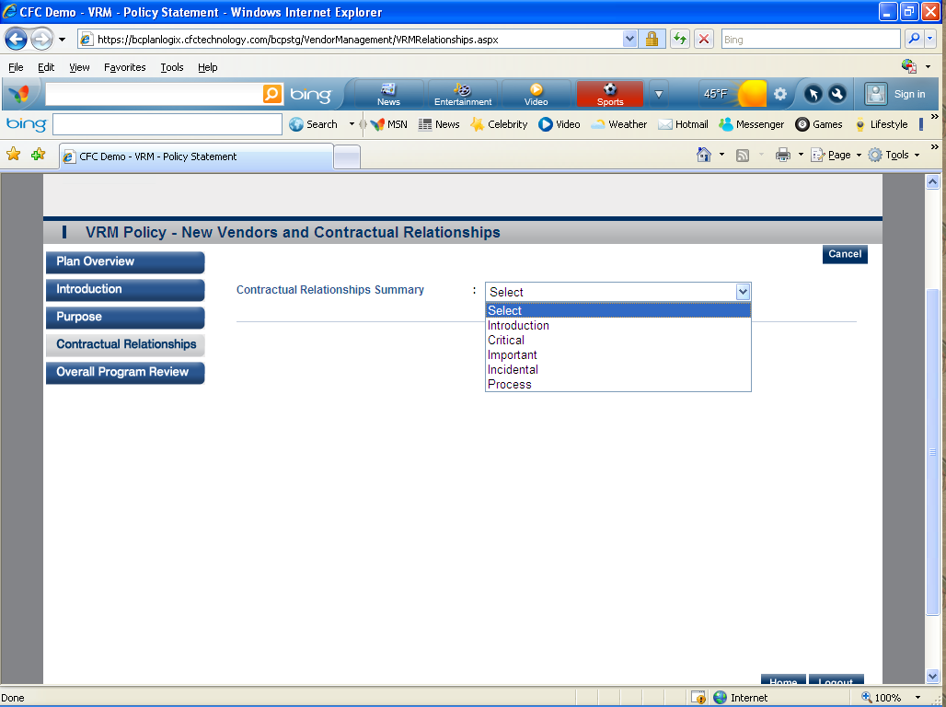

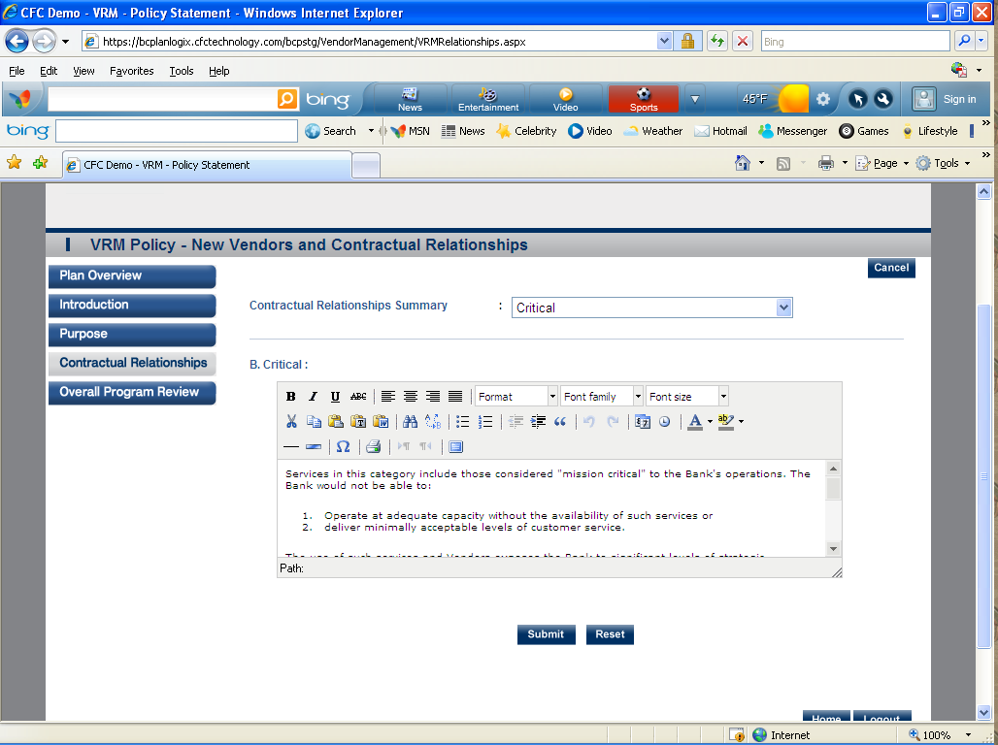

e. Overall Program Review
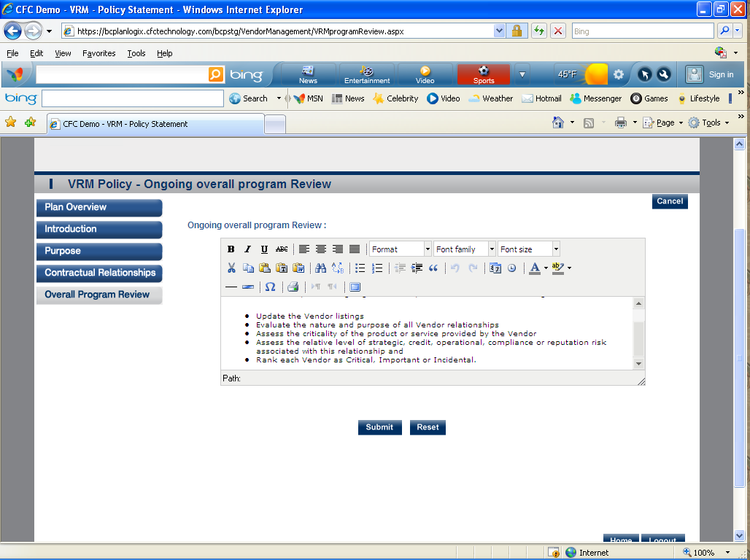

- Reports- Allows you to generate and print reports associated with Vendor Management. 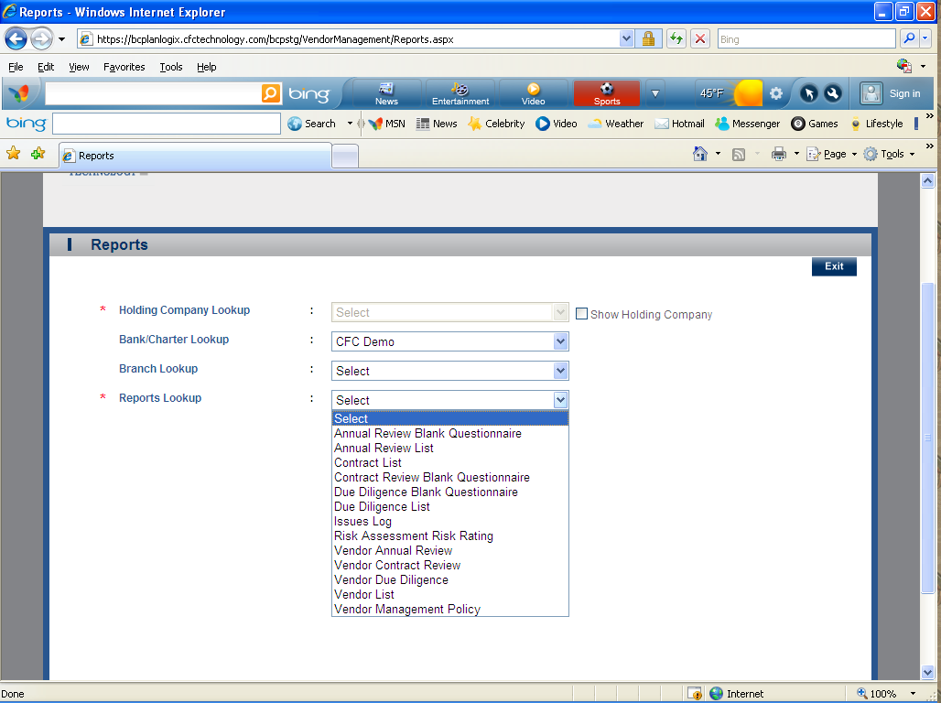

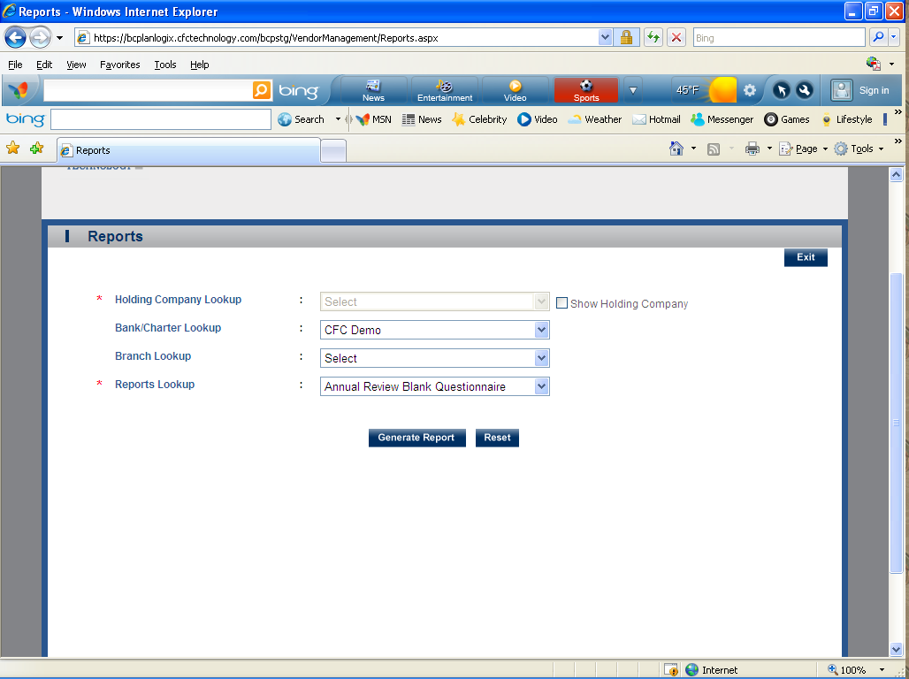

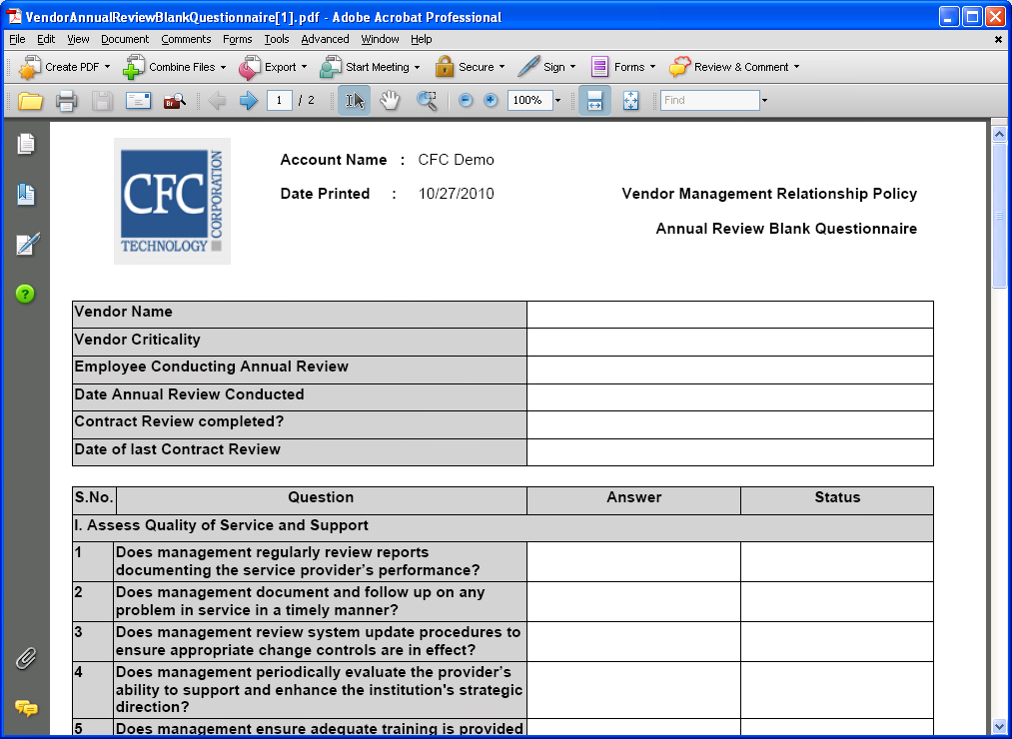

Typical Training Schedule:
1st Training Session - Maintenance, BIA – Risk Assessment, BIA – Business Impact Analysis, CBP (Reports)
2nd Training Session– Plan Summary, Team Plans and Plan Worksheets
3rd Training Session – Pandemic Flu
4th Training Session – Testing and Training
5th Training Session– Vendor Management

Maintenance (10 Sections Listed Below)
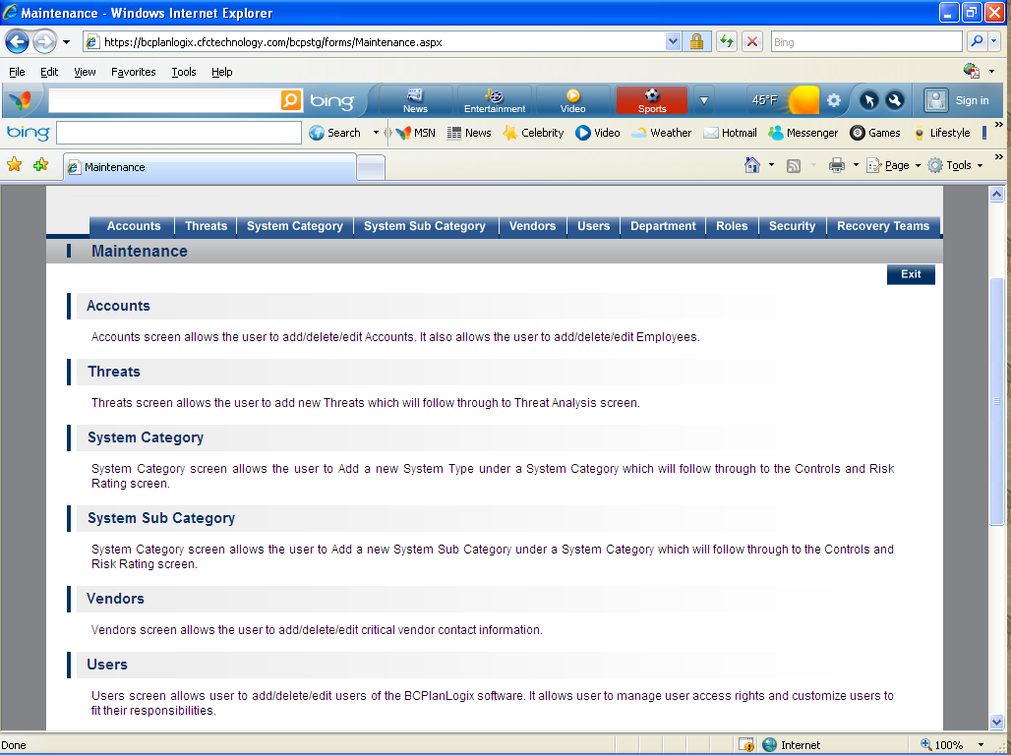
- Accounts- Accounts screen allows the user to add/delete/edit Accounts. It also allows the user to add/delete/edit Employees.
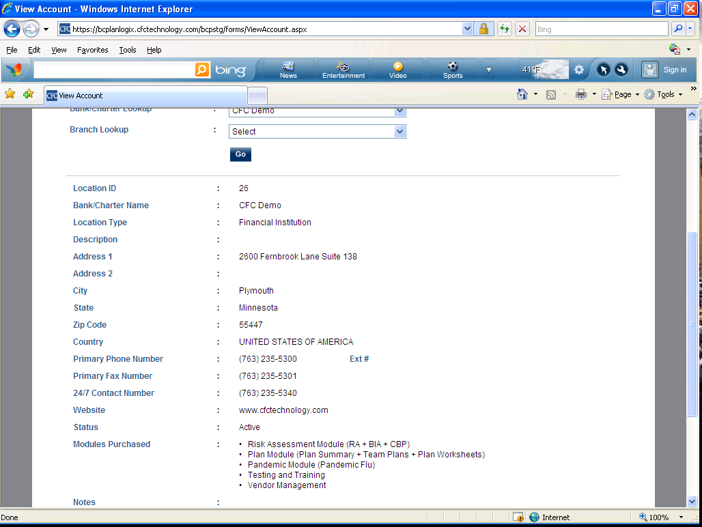

- Threats- Threats screen allows the user to add new Threats which will follow through to Threat Analysis screen. 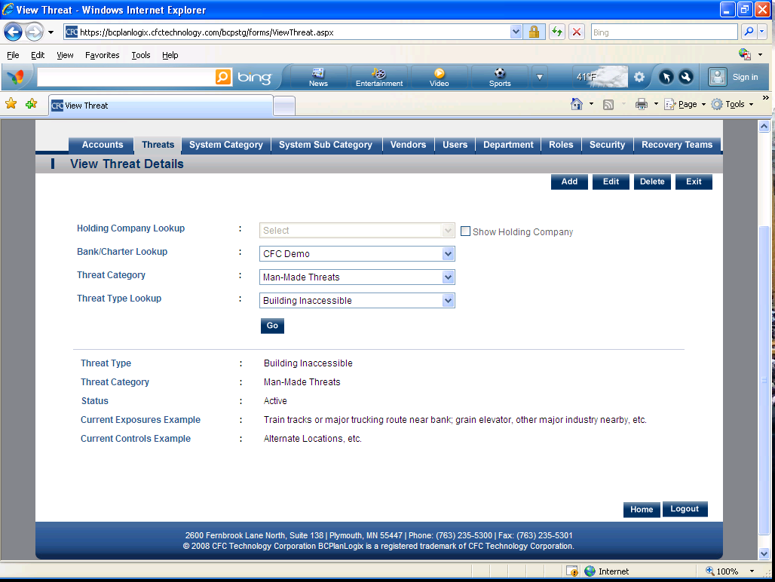
- System Category- System Category screen allows the user to Add a new System Type under a System Category which will follow through to the Controls and Risk Rating screen. 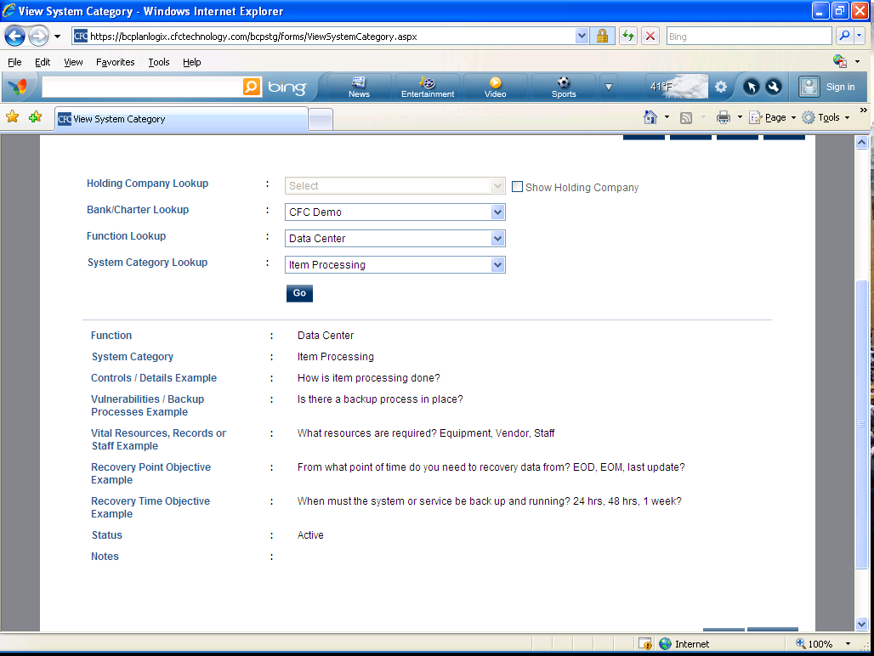

- System Sub Category- System Category screen allows the user to Add a new System Sub Category under a System Category which will follow through to the Controls and Risk Rating screen. 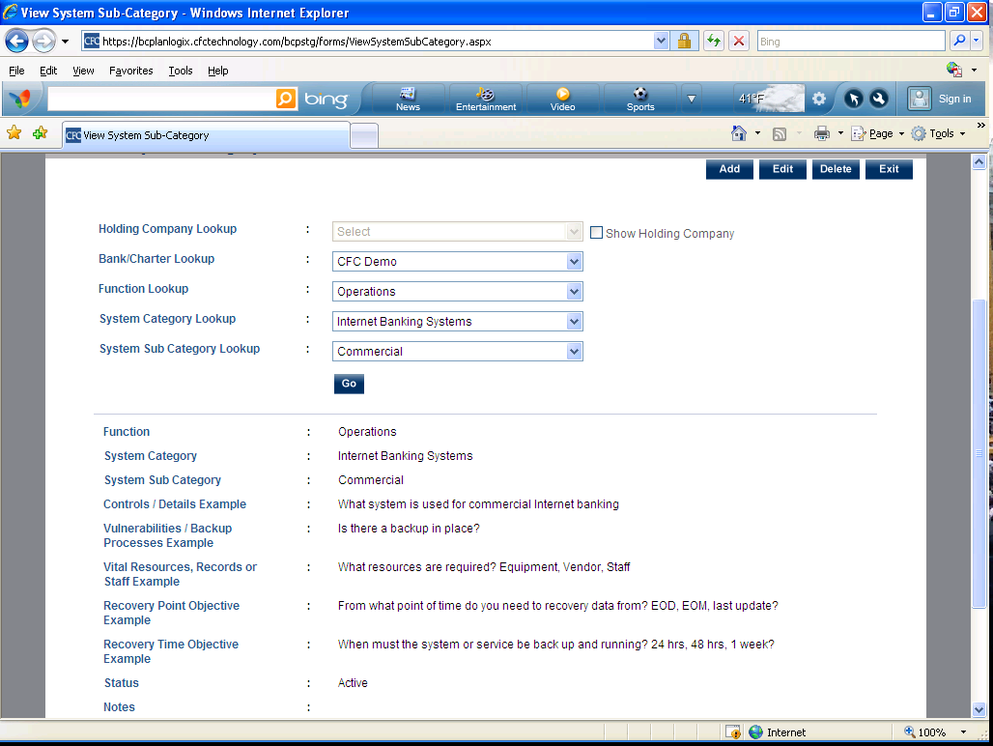
- Vendors- Vendors screen allows the user to add/delete/edit critical vendor contact information. 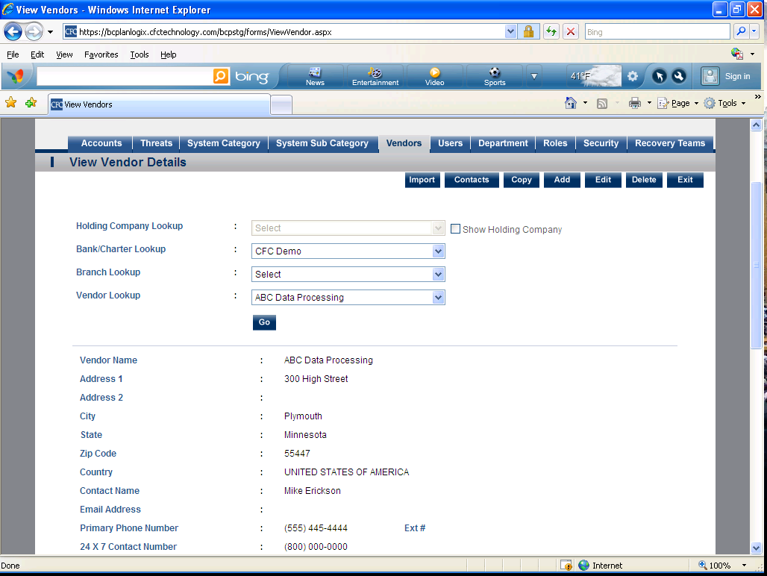

- Users- Users screen allows user to add/delete/edit users of the BCPlanLogix software. It allows user to manage user access rights and customize users to fit their responsibilities. 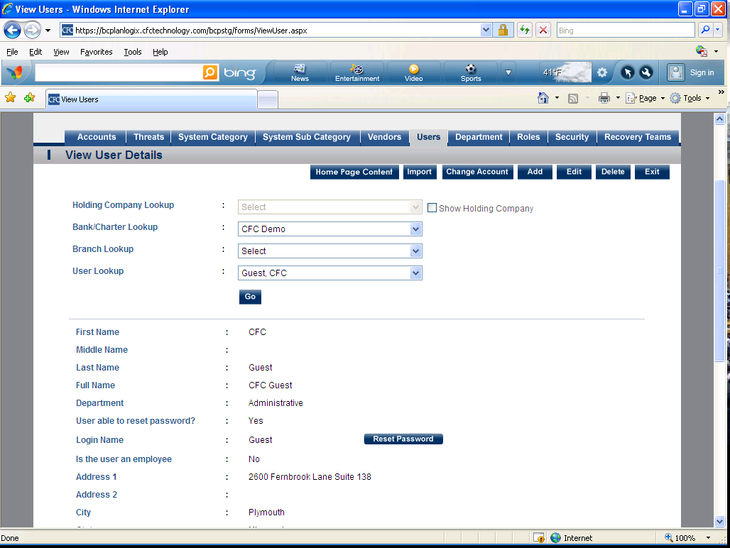
- Department- Departments is used to create custom departments for the institution. 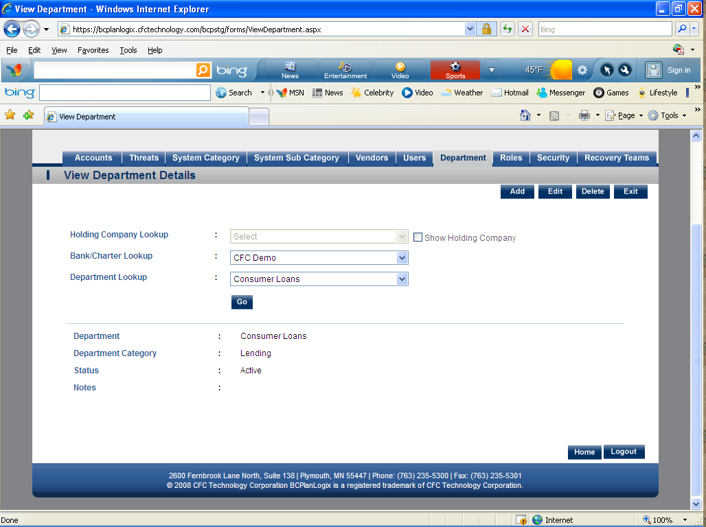

- Roles- Role provides the user the ability to customize the user access roles. 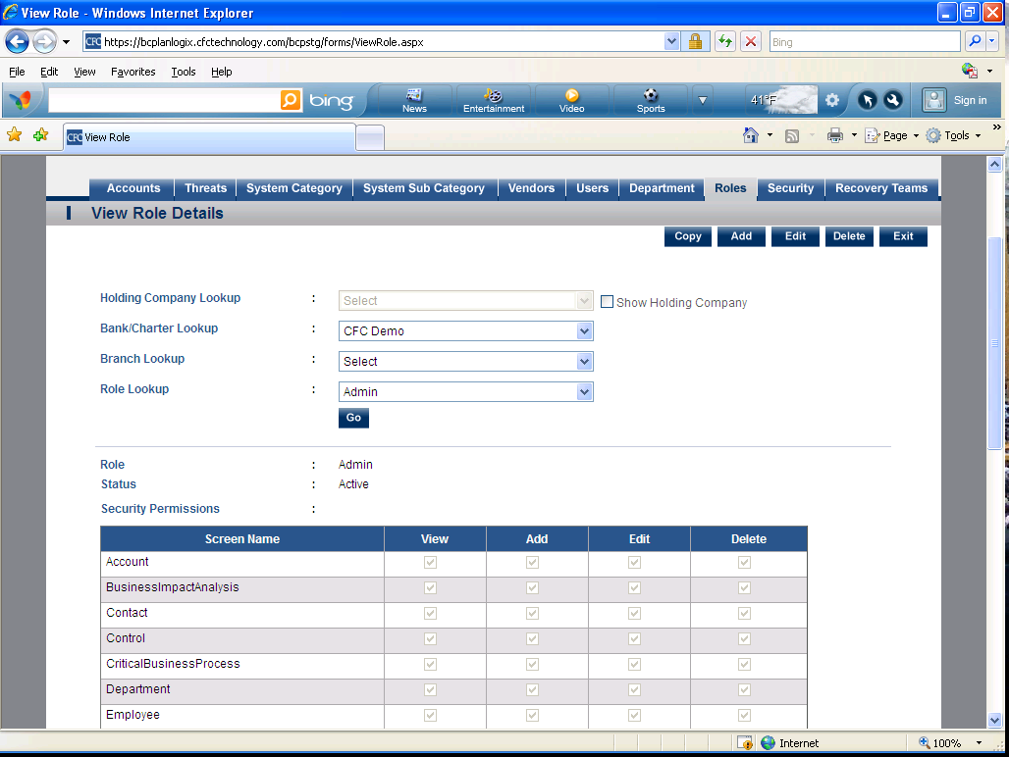
- Security- Security allows the user to link system users and access roles. 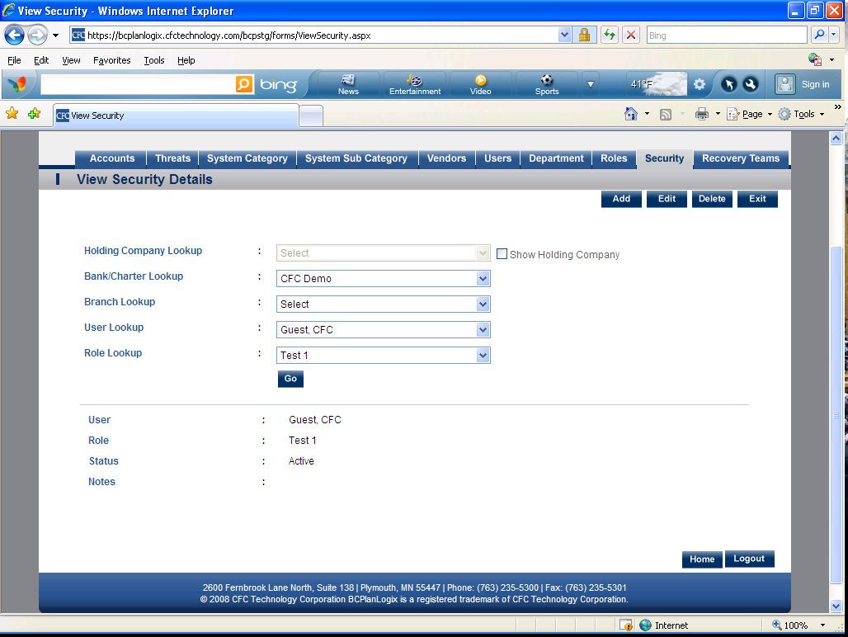

- Recovery Teams- Recovery Teams allows the user to customize the recovery team names and link departments to recovery teams. 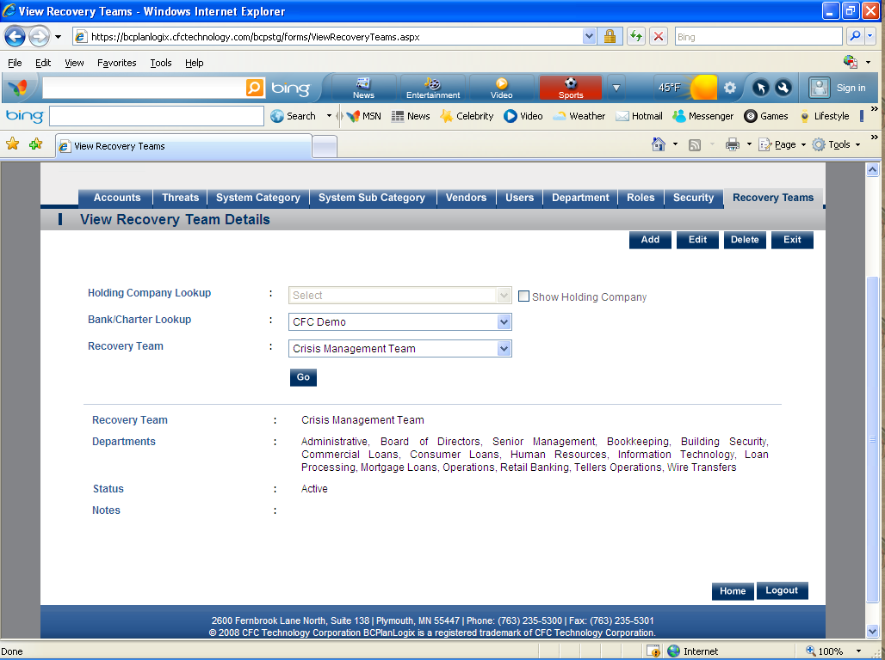

Reports (Modules)
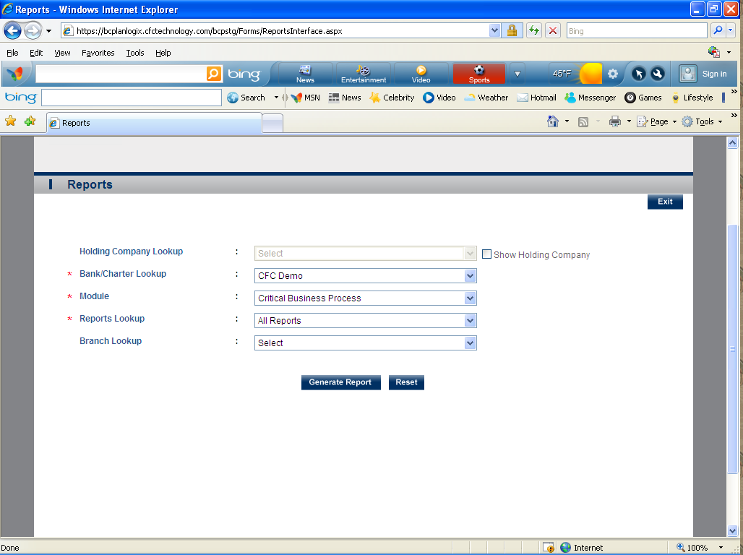
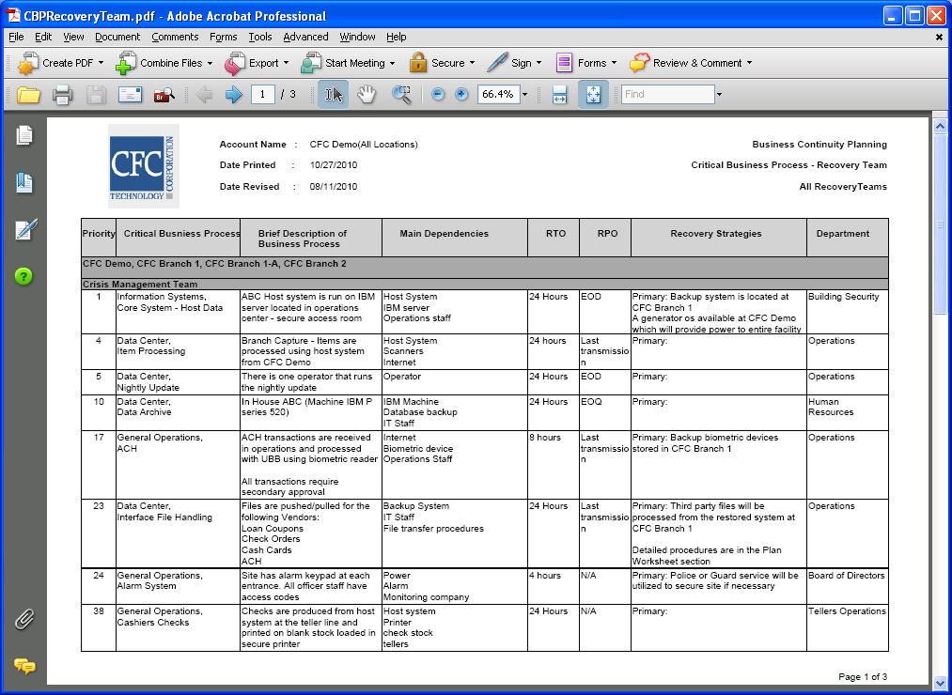

This is a module that allows you to generate reports for:
- Risk Assessments-
- Business Impact Analysis
- Critical Business Process
- Plan Summary
- Team Plans
- Plan Worksheets
- Pandemic Flu
- Testing
- Training
- Maintenance

